Text2SpeechEditor
Final Sprint Report
Georgiadis Ioannis, ID 398 johngeo235@gmail.com

Versions History
Date | Version | Description | Author
6/23/2020 | Final | Overview of the product alongside with details of execution/methodology. | Georgiadis Ioannis

Introduction
This document provides information concerning the final sprint of the project which is a text to speech editor as specified in the product backlog given by the instructor. Alongside with the basic implementation, we will provide additional details about how-to use the product and methodology.

Purpose
The purpose of this report is to give an overview of the final product that we implemented during this semester. This document will provide the details about implementation techniques and basic usage of the product for the reader to use the application as is. In addition, we will provide the reader with a future maintenance and what can be done better in order to improve the quality of the product.

Document Structure
The rest of the documents is as follows. In section 2 we provide the team members and the sprint backlog of the implemented and unimplemented stories accompanied with the passing/non-passing tests that are implemented. In section 3 we provide an overview of the architecture of the project by providing the corresponding UML’s, class details with CRC cards and the design patterns that we leverage in order to fulfill the project requirements (both functional/non-functional). In last section we provide the refences such as videos, URL’s and bibliography used in the process of developing the API.

Scrum team and Sprint Backlog
This section focuses on the user stories that are specified in the product backlog as given by the instructors of the course. We will analyze each of the implemented user stories and provide the technical difficulties that prevented the implementation of the unfulfilled user stories. The API is implemented by the author itself.

Sprint Backlog
Implemented User Stories
The user stories below are the corresponding stories in the product backlog that are implemented and tested in the project. We also provide a brief explanation of how we created the tests.
- [US-1] As a user, I want to create a new empty document, by giving its title and author. The application should automatically record the creation date. The test case of this is story is to create an new document and check in a JUnit test if the contents field in the document class is empty.
- [US-2] As a user, I want to edit the contents of the document, via the application's user interface. This story is more general in terms of how you consider the word ‘Edit’. In our API we can edit the contents of the text by changing, more specifically typing text, in our text area and then performing actions in that area (i.e. save, close, encode etc.). The appropriate unit test is to see if we change the contents of the area are
- [US-3] As a user, I want to save the contents of the document to disk by providing a particular
filename. The application should automatically record the save date. By saving a file, our application is saving the file in the current file that is open. Since our data holder class has a field of file, if we didn’t perform a create new or a save as operation, we need to call this command to create a new file. As for the test, we check if the current path has a file with that name and the contents we want are saved in that file.
- [US-4] As a user, I want to open the contents of an existing document from disk by providing a
file path, or by browsing the file system folders. We implemented a test that checks if the expected open command holds a file type with contents that we predefine in the JUnit test.
- [US-5] As a user, I want to transform the contents of the document to speech. For this story we didn’t implement a unit test.
- [US-7] As a user I want to transform the contents of the document to speech in reverse, i.e. play the
last word of the last line first and so on. For this user story, as well as for the user stories US-11, we user a type of testing method from cryptography because encoding is a type of symmetric key cryptography. We use testing vectors, that means, we calculated manually (or via validated software) the expected values of an encoding of a message and test the expected values if the match.
- [US-9] As a user I want to encode the contents of the document and then transform them to speech. This user story is not tested.
- [US-11] As a user I want to tune the text encoding technique. The application should
support at least the following encoding strategies:
  - Atbash: The Atbash cipher is formed by taking the alphabet and mapping it to its reverse, so
that the first letter becomes the last letter, the second letter becomes the second to last
letter, and so on.
  - Rot-13: Rot-13 is a letter substitution cipher that replaces a letter with the 13th letter after
it, in the alphabet. Rot-13 is a special case of the Caesar cipher, which was developed in
ancient Rome.
- [US-12] As a user I want to be able to tune the audio parameters, i.e., the volume, the speech rate
and the pitch. This is tested via the GUI of the API and the provided values should match the sliders outputs. The accompanied video in the project can give detailed information about this user story. We performed a boundary validation test for max/min values of those three attributes.
Important notice is that tests are locally implemented and do not use more than one class but in order to instantiate a fake document we use the class document to create a new object. This can be avoided by creating a fake static document with predefined fields in order to avoid unnecessary objects/classes. All thought the unit tests aren’t implemented with those principles, they can still validate the functionality of the components of the API.

Design
In this section we will provide the architecture of the system and the design patterns we used in order to satisfy non-functional requirements.

Architecture
In our project we leverage design patterns to fulfill no functional specifications that are include in the product backlog. The command pattern combined with factory method is used to implement the edit and text to speech operations in order to decouple the functionality of the API and GUI. We didn’t use the recommended adapter in our project due to a programming error in the build path. Template method with strategy pattern in encoding algorithms. This allows maintenance and we can extend the encoding strategies easily by adding them under the base template class. We didn’t use an Encoding Strategies field as provided in the product backlog since the data holder (document class) will be deleted after we close the application and there is no point to keep it while we process the file. Instead we implemented two buttons for those algorithms and used warning panes to inform user.

Design
In the design section we will provide the UML diagrams that define the API. We used objectAid as a framework to generate the UML diagrams. Some of the solid lines are not displayed from factories because the framework cannot enter in if statements to check creation of new objects!
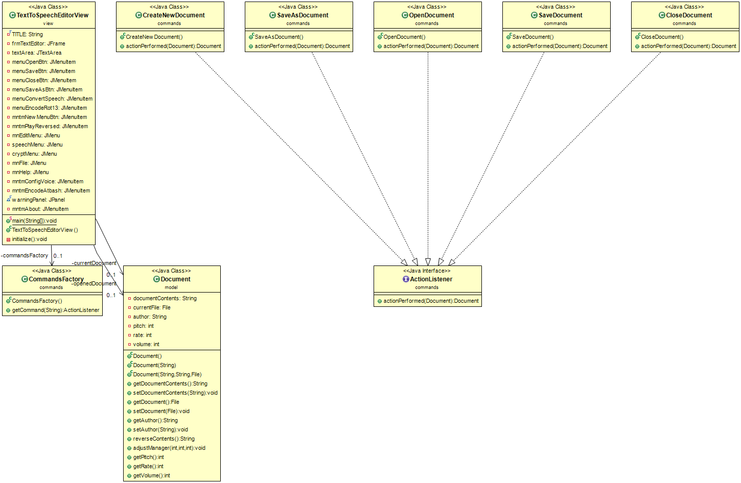
Figure 1: Basic file Operations UML Using Command pattern and factory method to decouplse logic from view and data structure in order to create an MCv model
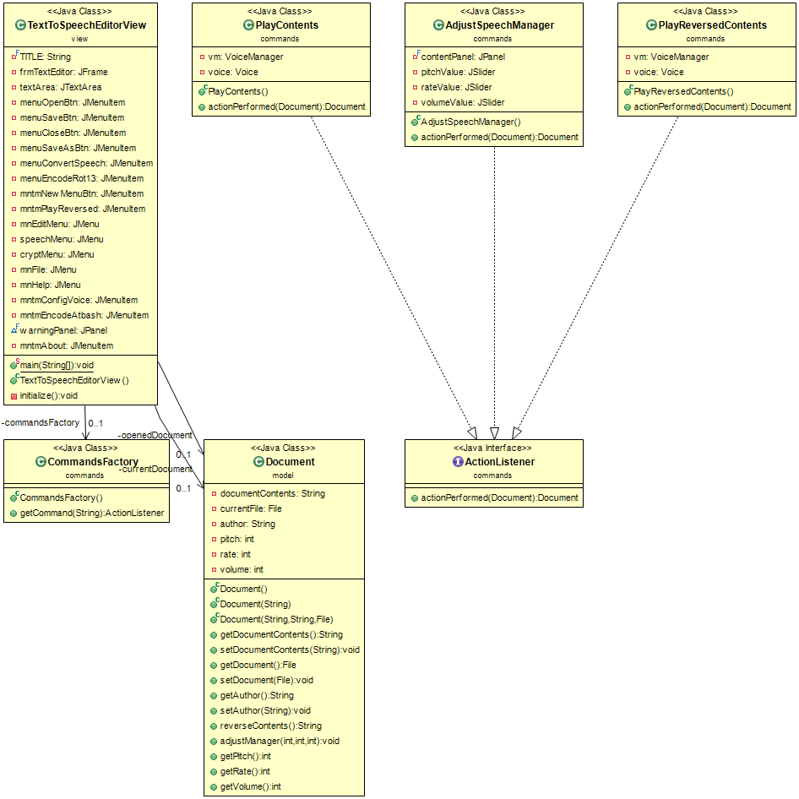
Figure 2: Text to speech operations UML Using Command pattern and factory method as above

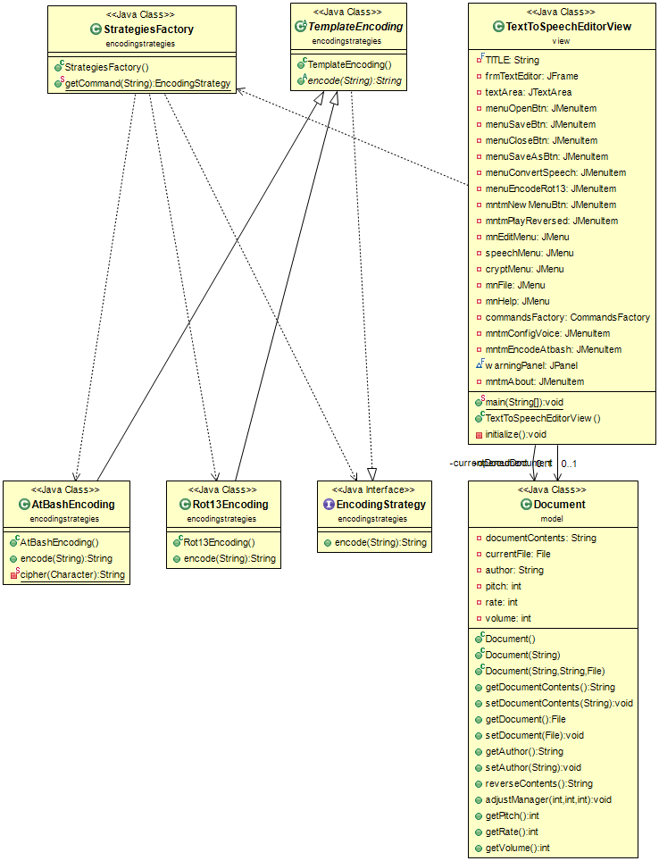
Figure 3: Strategy pattern combined with template method for encoding operations of the text
CRC cards of class responsibilities and collaborations.
Class Name: ActionListener
Responsibilities:  - Interface for commands  - Executes the commands when a GUI button is pressed via listener | Collaborations:  - Only commands concerning basic file operations and text to speech operations implement this interface
Class Name: CommandsFactory
Responsibilities:  - Creates a new command that is implemented by the action listener | Collaborations:  - Basic file operations: Save, Save as, Open, Close and Create New  - Audio manager configuration class AdjustSpeechManager and Play content commands
Class Name: OpenDocument
Responsibilities:  - Takes a parameter a document object and returns an opened document  - Sets the appropriate fields of Document object | Collaborations:  - Document Class
Class Name: SaveAsDocument
Responsibilities:  - Saves a document on disk with a filename and contents | Collaborations:  - Document Class
Class Name: CloseDocument
Responsibilities:  - Closes an opened document | Collaborations:  - Document Class
Class Name: SaveDocument
Responsibilities:  - Saves changes of test area on the opened Document | Collaborations:  - Document Class
Class Name: PlayContets
Responsibilities:  - Creates a voice from freeTTS package  - Transforms given text to voice | Collaborations:  - Document Class
Class Name: PlayReversedContents
Responsibilities:  - Plays as audio the contents of the file but reversed | Collaborations:  - Document Class
Class Name: EncodingStrategy
Responsibilities:  - Interface  - Executes encode method | Collaborations:  - Document class  - TemplateStrategy
Class Name: TemplateEncoding
Responsibilities:  - Provides an abstraction of encode method | Collaborations:  - Document Class  - StrategiesFactory
Class Name: AtBashEncoding and Rot13Encoding
Responsibilities:  - Implementing the encode method with the corresponding algorithms | Collaborations:  - TemplateEncoding

Class Name: Document
Responsibilities:  - Our data holder  - Keeps in memory contents of a document and a file type field in order to execute commands on it  - Holds data for the audio manager in order to configurate the voice  - Reverses the contents of the document  - Executes methods to mutate/access fields | Collaborations:  - User interface  - Commands concerning the basic editing of the document  - Commands that transform the text to speech  - Commands that encode text

Technical Difficulties Future Maintenance
Since we lack team members, we skipped the implementations of several requirements such as line specific operations and the replay manager.
The requirement that needed an author of the text wasn’t specified with details and we avoided to make an implementation since we need to store in text area. We still provide a filed in document for further implementations.
The voice library couldn’t be called in the build path while we implemented the adapter and we changed the designed pattern to the command and factory method as we did with basic file operations. We can improve that in future maintained in order to make the API more extensible.

