Incident Collaborative Map
Codex-ready product, architecture, and implementation specification
Purpose  Define a rebuild-ready specification for a production web application based only on the supplied UI shell, extracted PowerApps metadata, and legacy source artifacts. | Source basis  • index.html UI shell  • PowerApps metadata  • Extracted legacy scenario app source  • Extracted brand assets

1. Scope and framing
This specification separates confirmed current product surfaces from recommended production architecture. Confirmed items are those explicitly visible in the supplied materials. Recommended items are implementation guidance intended for a modern web rebuild and developer handoff.

2. Confirmed product surfaces from the provided materials
The supplied HTML shell shows a complete live-session workspace with owner controls, a landing workspace for session creation/join, a weather panel, a cost summary panel, selected-object editing, an isolation tool, playback controls, export modals, attachment/image handling, ICS 202 and ICS 207 workspaces, plus super-admin and department-admin surfaces. The extracted PowerApps materials show legacy scenario entities named GeoSims, GeoTrackings, and GeoSim Scenarios, along with training-oriented flows for creating, editing, listing, and watching scenarios.

3. Product goals for a production rebuild
- Provide a single shared operational picture for incident response teams.
- Support live multi-user collaboration with role-aware permissions.
- Treat geometry, icons, attachments, cost items, and playback events as first-class objects.
- Make the same session useful during planning, live incident command, training, and after-action review.
- Retain integrated ICS workspaces rather than relegating them to external documents.

4. Recommended system architecture
The recommended production architecture is a web client plus API layer plus realtime channel plus durable storage. Weather remains an external dependency. Export generation can be initiated client-side, server-side, or hybrid depending on scale and fidelity requirements.
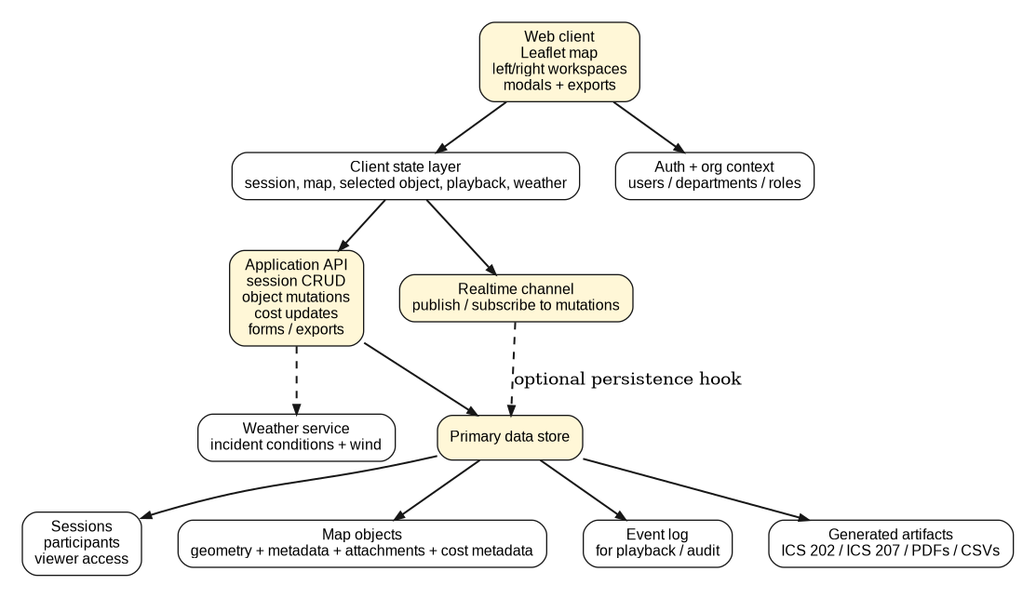
Architecture notes: the current HTML shell implies a stateful client UI with modal workflows and a shared session concept; the production version should formalize that into explicit services for sessions, objects, playback events, documents, and org access.

5. UX surface map
The UI is best understood as three primary surfaces: the landing workspace, the live collaborative map, and companion workspaces. The production rebuild should preserve that mental model.
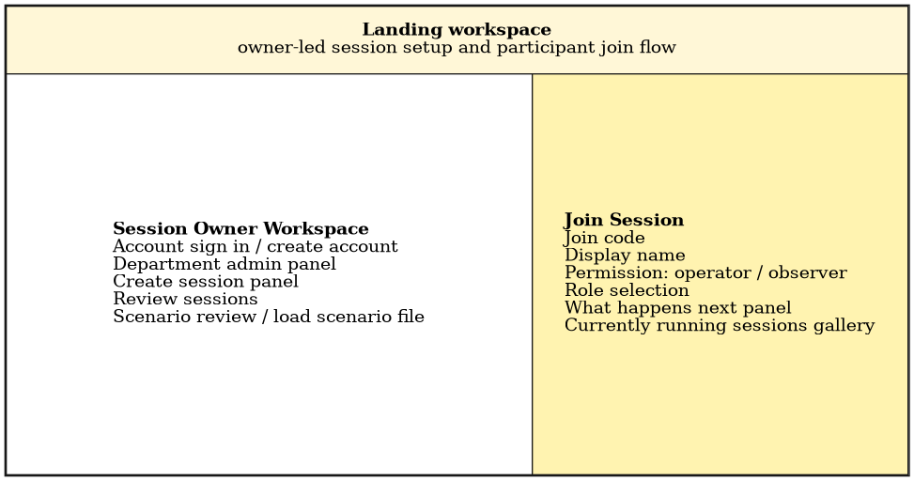
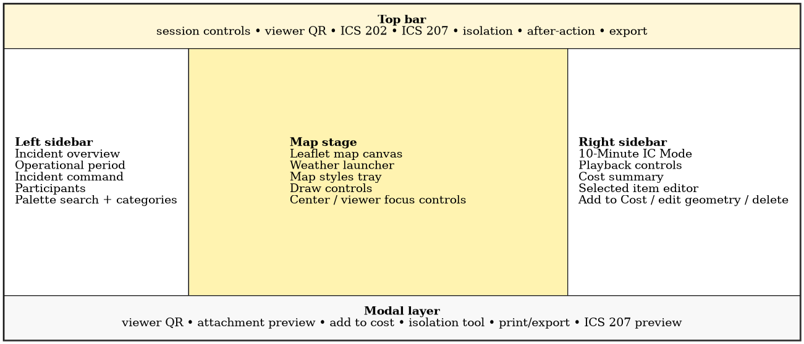
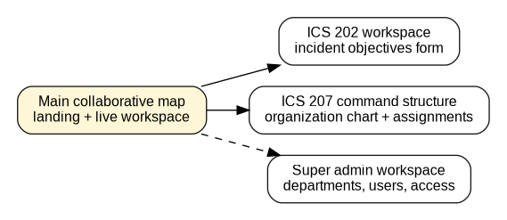

6. Core user journeys

Session/auth lifecycle
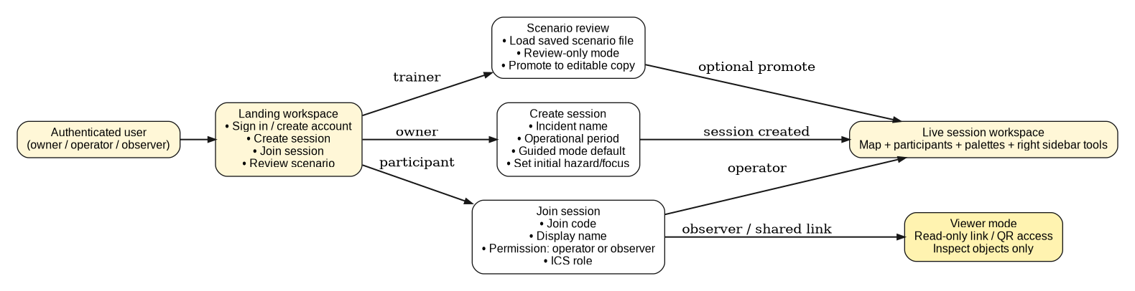

Map authoring lifecycle

Cost tracking lifecycle
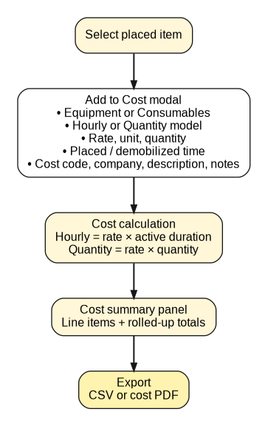

Playback lifecycle
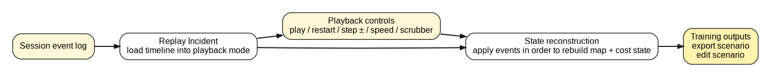

ICS/admin companion flows
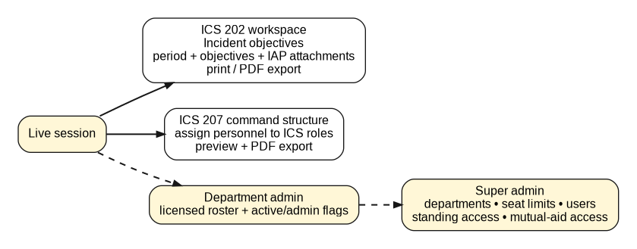

7. Domain model and schema recommendation
The legacy data sources point to GeoSims, GeoTrackings, and GeoSim Scenarios. For a production rebuild, those should be normalized into a session-centric domain model that separates persistent sessions from transient participants, spatial objects, attachments, cost items, events, and generated documents.
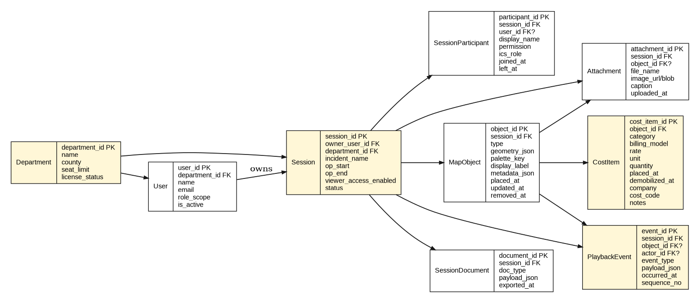
Recommended entity guidance:
- Department: tenant-like org boundary with seat limits and license status.
- User: identity and organization membership.
- Session: top-level incident container with owner, operational period, status, and viewer access.
- SessionParticipant: active or historical presence within a session, including permission and ICS role.
- MapObject: spatial entity with type, geometry, palette key, label, metadata, timestamps, and soft-delete capability.
- Attachment: image or file either session-level or attached to a specific object.
- CostItem: cost extension for a placed object so accounting data is additive rather than overloading the base object.
- PlaybackEvent: immutable event stream used for replay, audit, and state reconstruction.
- SessionDocument: persisted ICS form or export payload.

8. Object model details
Each map object should be represented as a common envelope plus typed metadata.
Field group | Required fields | Notes
Envelope | object_id, session_id, type, geometry, placed_at, updated_at | Applies to every object, including points, polygons, notes, isolation zones, and attachments-as-markers if supported.
Display fields | display_label, palette_key, icon_key, color, visibility | Keep these separate from operational metadata for UI flexibility.
Operational metadata | status, owner_role, notes, hazard/resource attributes | Stored as structured JSON or typed columns depending on reporting needs.
Audit | created_by, updated_by, removed_at | Soft delete supports playback and accountability.
Cost extension | cost_item_id or cost metadata link | Do not overload every object with cost columns if most objects are not costed.

9. Recommended API surface
The HTML shell does not define API contracts. The following endpoints are recommended to formalize the implied behaviors.
- POST /sessions — Create a session with incident name, op period, owner context, and guided mode flag.
- POST /sessions/{id}/join — Join as operator or observer with display name and role.
- PATCH /sessions/{id} — Update period, incident commander assignment, viewer access, or session status.
- POST /sessions/{id}/objects — Create spatial object.
- PATCH /sessions/{id}/objects/{objectId} — Update label, geometry, or metadata.
- DELETE /sessions/{id}/objects/{objectId} — Soft-delete object and emit replay event.
- POST /sessions/{id}/objects/{objectId}/cost — Create or update cost extension.
- POST /sessions/{id}/attachments — Upload session or object attachment.
- GET /sessions/{id}/events — Read ordered event stream for playback.
- POST /sessions/{id}/documents/ics202 — Save ICS 202 payload.
- POST /sessions/{id}/documents/ics207 — Save ICS 207 payload.
- POST /sessions/{id}/exports — Generate export job for map, cost, or ICS output.

10. Realtime event contract
The session workspace implies collaborative updates and replay. The cleanest approach is to standardize every meaningful change as an append-only event.
Event type | Purpose
SESSION_CREATED | Initial session record
PARTICIPANT_JOINED | Operator or observer presence
PARTICIPANT_LEFT | Presence end
SESSION_UPDATED | Period, IC, viewer access, or status changed
OBJECT_CREATED | New geometry or icon
OBJECT_UPDATED | Fields or geometry changed
OBJECT_REMOVED | Soft delete
ATTACHMENT_ADDED | Image/file added
ATTACHMENT_REMOVED | Attachment deleted
COST_CREATED_OR_UPDATED | Cost mutation for object
DOCUMENT_SAVED | ICS 202/207 saved
EXPORT_GENERATED | Artifact produced

11. Permissions model
- Owner: full session control, session lifecycle, viewer access, export control, and admin surfaces where authorized.
- Operator: create and update objects, contribute to cost and forms where permitted, no session ownership actions by default.
- Observer: read-only map view and object inspection only.
- Department admin: roster and seat administration inside a department boundary.
- Super admin: global department, seat, user, and mutual-aid/standing access management.
Recommendation: implement capability-based permissions rather than only role strings so the product can later support finer-grained rights such as export-only, forms-only, or playback-only users.

12. Client architecture recommendation
- Framework: React or Next.js web app with componentized workspace panels and modal manager.
- Map: Leaflet is already visible in the HTML shell and can be retained, though Mapbox GL or ArcGIS JS could also be evaluated if vector-heavy workflows expand.
- State management: normalized client store with separate slices for session, participants, objects, costs, playback, weather, and UI.
- Sync strategy: optimistic local mutation + server acknowledgement + conflict resolution policy for same-object edits.
- Document generation: dedicated printable layouts for map, cost summary, ICS 202, and ICS 207.

13. Non-functional requirements
Requirement | Recommended target
Realtime latency | Sub-second perceived update propagation for common object mutations.
Auditability | Immutable event log and soft deletion for replay completeness.
Availability | Session resilience during multi-user incident use.
Scalability | Support concurrent viewers and operators without large redraw penalties.
Security | Authenticated access, org scoping, signed viewer links, attachment controls.
Export fidelity | Consistent PDF/CSV output across browsers and screen sizes.

14. Testing strategy
- Unit tests for object reducers, cost calculation, permission checks, and playback state reconstruction.
- Integration tests for session creation, join flow, object edit flow, Add to Cost, attachment flow, and export flow.
- Multiplayer tests for simultaneous edits, participant presence, and viewer-mode propagation.
- Snapshot/render tests for ICS 202 and ICS 207 printable layouts.
- Disaster tests for dropped realtime connection, weather unavailability, and late event arrival.

15. Suggested phased roadmap
Phase 1 — session core
- Auth + org model
- Session creation/join
- Object CRUD
- Realtime sync
- Viewer mode
Phase 2 — operational tooling
- Cost tracking
- Attachments
- Weather
- Isolation tool
- Operational period and IC assignment
Phase 3 — review and command documentation
- Playback event log
- Scenario export/review
- ICS 202
- ICS 207
Phase 4 — enterprise control plane
- Department admin
- Super admin
- Seat limits
- Standing/mutual-aid access
- Reporting and analytics

16. Key open questions
- What current backend or persistence layer exists behind the browser shell?
- Is playback already event-sourced, or is it reconstructed from object history in another way?
- How should attachments be stored and governed for sensitive incident imagery?
- What export fidelity is required for formal agency use of ICS 202 and ICS 207 outputs?
- Will observer links be anonymous, authenticated, or mixed-mode?
- Does the production vision require offline-first behavior for field teams?

17. Implementation note for Codex / agentic development
A coding agent can implement this product faster if the project begins with explicit domain types, endpoint contracts, event schemas, and reference fixtures. This document is therefore written to be machine-translatable: the schema, event types, workflows, and phased backlog can be copied directly into tickets, scaffolding prompts, or code-generation tasks.

