Running head: MODULE 4 - CRITICAL THINKING - OPTION 2

Module 4 - Critical Thinking - Option 2

John Imbur

Colorado State University – Global Campus

July 7th, 2019

MODULE 4 - CRITICAL THINKING - OPTION 2

Module 4 - Critical Thinking - Option 2

install.packages("dplyr")

# Step 1: Load data

tScore_before <- c(40, 62, 74, 22, 64, 65, 49, 49, 49)

tScore_after <- c(68, 61, 64, 76, 90, 75, 66, 60, 63)

# Create a data frame

my_data <- data.frame(

group = rep(c("Score Before", "Score After"), each = 9),

scores = c(tScore_before, tScore_after)

)

# Step 2: Print all data

print(my_data)

# Step 3: Compute summary statistics by groups

library(dplyr)

group_by(my_data, group) %>%

summarise(

count = n(),

mean = mean(scores, na.rm = TRUE),

sd = sd(scores, na.rm = TRUE)

)

MODULE 4 - CRITICAL THINKING - OPTION 2

# Step 4: Compute Unpaired Two Sample t-test

res <- t.test(tScore_before, tScore_after, var.equal = TRUE)

res

# Step 5: Compute independent t-test

res <- t.test(scores ~ group, data = my_data, var.equal = TRUE)

res

# Step 6: test whether the average "Score Before" is less than the average "Score After"

t.test(scores ~ group, data = my_data, var.equal = TRUE, alternative = "less")

MODULE 4 - CRITICAL THINKING - OPTION 2

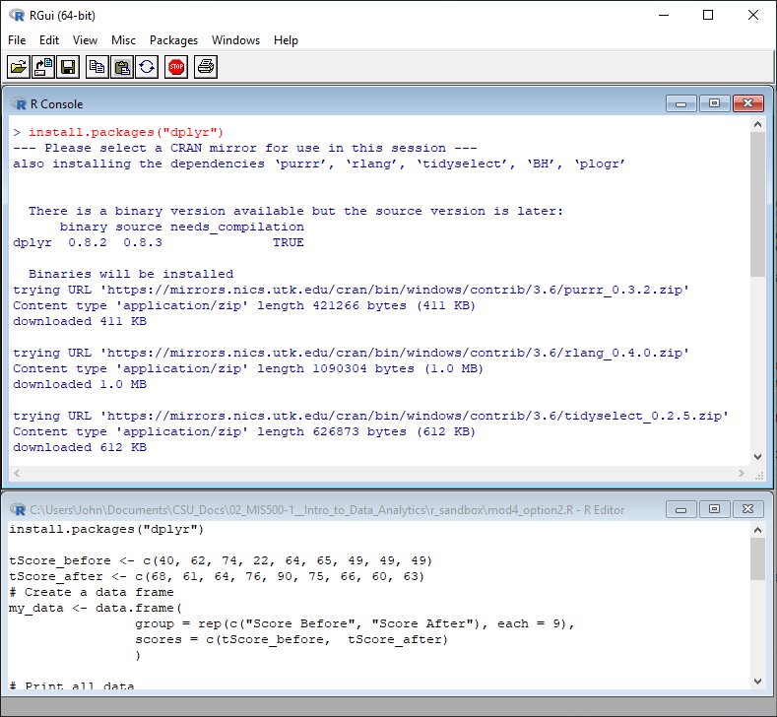

*Figure 1*. Installation of the “dplyr” package, part 1.

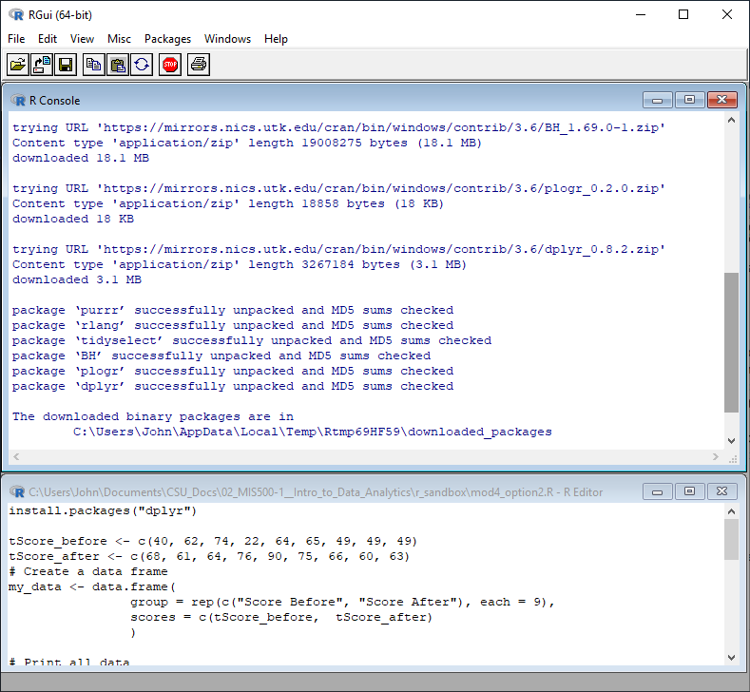

*Figure 2*. Installation of the “dplyr” package, part 2.

MODULE 4 - CRITICAL THINKING - OPTION 2

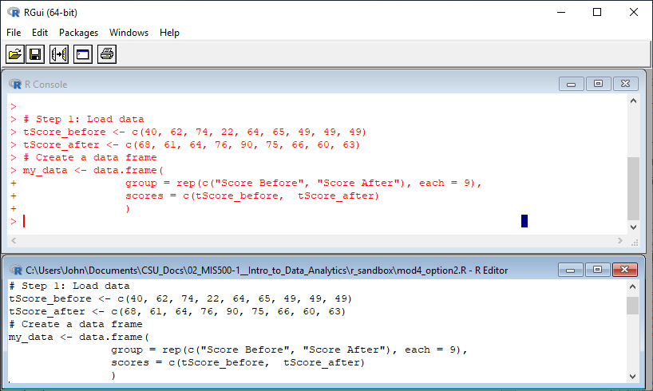

*Figure 3*. Step 1: Load data and create data frame.

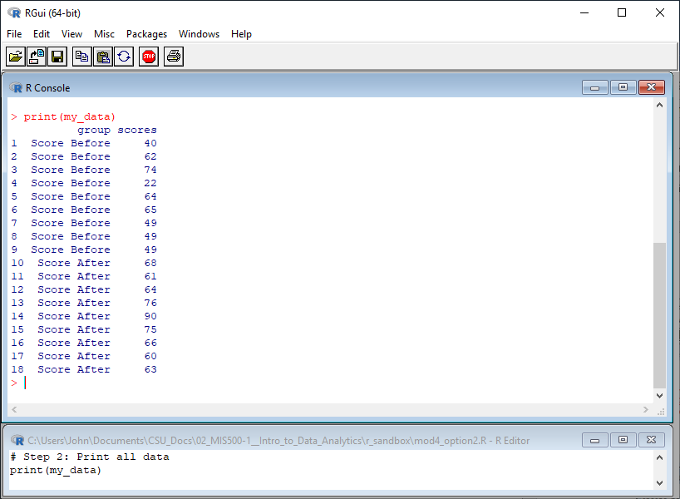

*Figure 4*. Step 2: Print all the data.

MODULE 4 - CRITICAL THINKING - OPTION 2

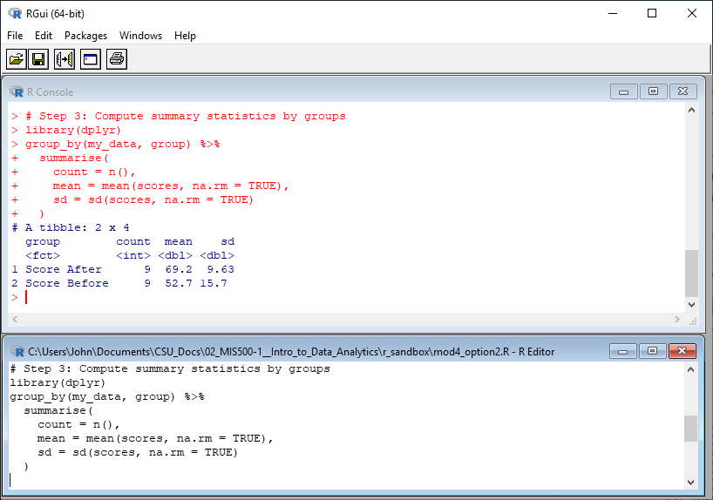

*Figure 5*. Step 3: Compute summary statistics by groups.

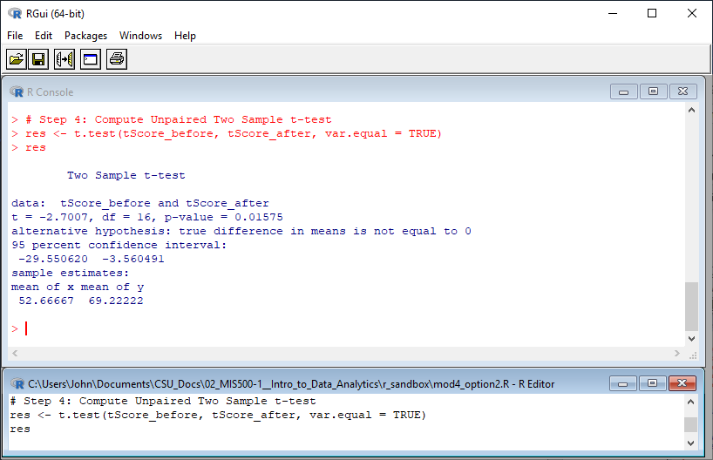

*Figure 6*. Step 4: Compute unpaired two sample t-test.

MODULE 4 - CRITICAL THINKING - OPTION 2

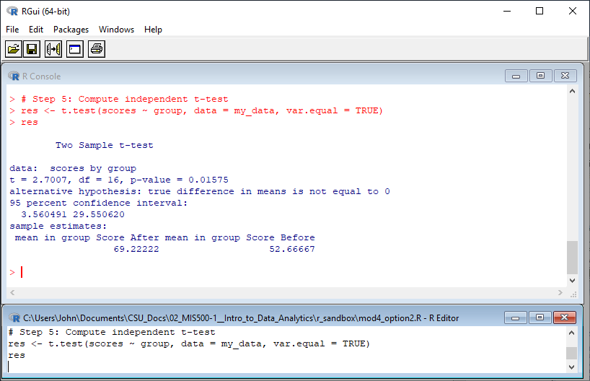

*Figure 7*. Step 5: Compute independent t-test.

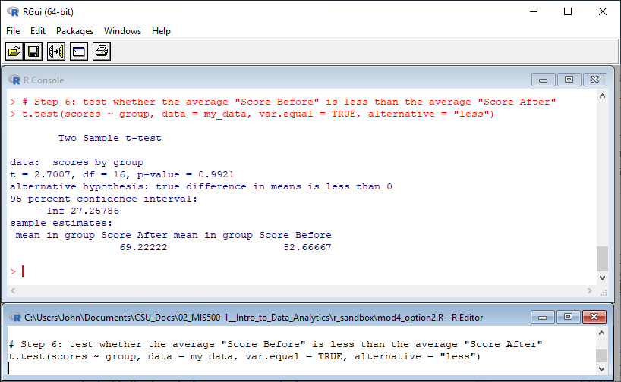

*Figure 8*. Step 6: Test whether the average “Score Before” is less than the average “Score After”.