https://github.com/johniscool1/cs-449-project
Sprint #0 Report

Instructions

Objectives
- Make decisions on the SOS software development project.
- Learn unit testing and GUI programming in the language of your choice.

Deliverables and Grading Policy
Read the “CS 449 Homework Overview” document carefully and make the key decisions for the software development. Use the following template to complete your report.

- Key Decisions of the SOS Project (2 points)

Object-oriented programming language | C++
GUI library (strongly encouraged) | FLTK
IDE (Integrated Development Environment) | Kdevelop
xUnit framework (e.g., JUnit for Java) | catch2
Programming style guide (must read it carefully) | GNU coding standards
Project hosting site | Github.com
Other decisions if applicable

Sample programming style guides:
- Google Java Style Guide: https://google.github.io/styleguide/javaguide.html
- Google C++ Style Guide: https://google.github.io/styleguide/cppguide.html
- Google Python Style Guide: https://google.github.io/styleguide/pyguide.html

- Unit testing (4 points)

Find a tutorial on the unit test framework you have chosen and write at least two xUnit tests of a program you have written or found elsewhere. Attach here (1) the screenshot of your program execution and (2) the source code of your program.

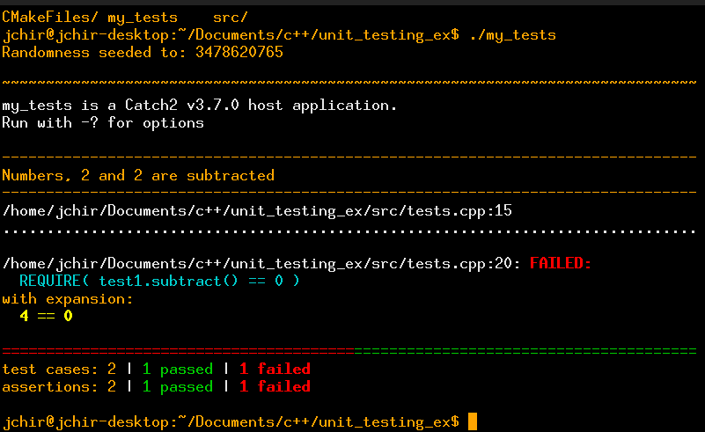
https://github.com/johniscool1/cs-449-project/tree/master/sprint0/unit_testing_ex

- GUI programming (4 points)

Write a GUI program in the language you have chosen for your SOS project. The GUI of your program must include text, lines, a check box, and radio buttons. While you are recommended to consider the GUI for the SOS game board, it is not required. In this assignment, any GUI program of your own work is acceptable.

Attach here (1) the screenshot of your program execution and (2) the source code of your program.

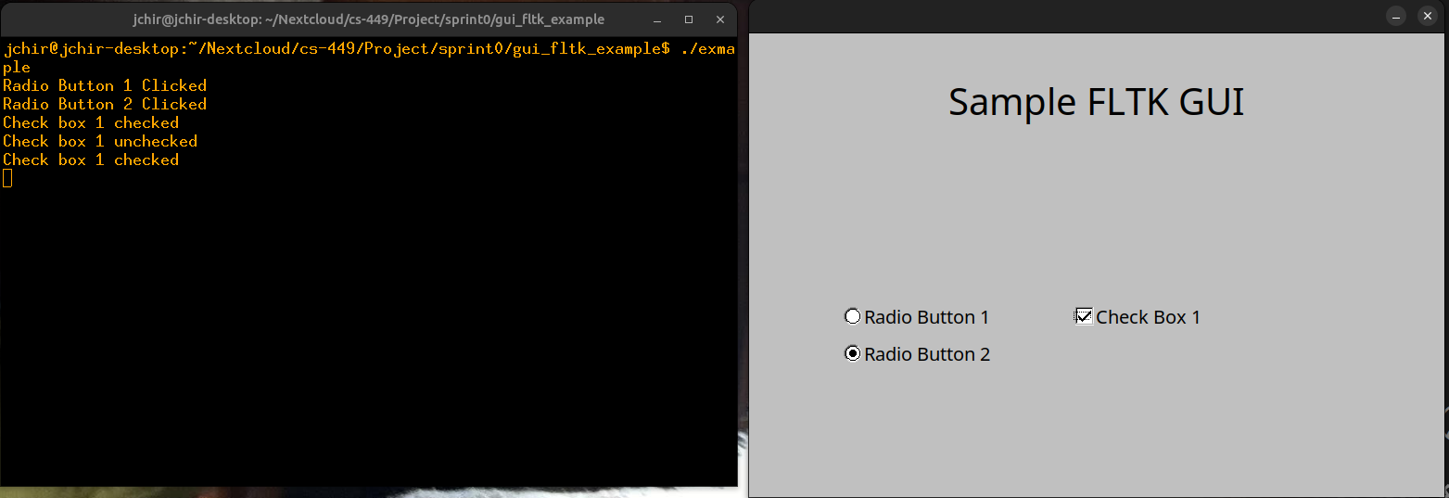
https://github.com/johniscool1/cs-449-project/tree/master/sprint0/gui_fltk_example

