Project sprint #1

John Chirpich Repo Link: https://github.com/johniscool1/cs-449-project

1. **User Stories**

|  |  |  |  |  |
| --- | --- | --- | --- | --- |
| **ID** | **User Story Nam** | **User Stor Desc.** | **Priority** | **Est Effort (hrs)** |
| 1 | Choose A board size | As a player, I want the board to be corectly made given the dimesions so that I can play the game with the correct di- mensions | 1 | 1 |
| 2 | Choose the game mode of a choosen board | As a Player, I want to choose what game mode I want to play so that I know the cri- teria for winning | 1 | 2 |
| 3 | Start a new game of the chosen board size and game mode | As a player, I want to choose the game board size and gamemode so that I can choose how difficult or how long the game might last. | 1 | 2 |
| 4 | Make a move in a simple game | As a player I want to make a move in a simple game so that I can form the se- quence SOS and win the game. | 2 | 2 |
| 5 | A simple game is over | As a player, I want to complete the first SOS sequence so that I win | 2 | 3 |
| 6 | Make a move in a general game | *AI:* As a player, I want to make a move during my turn in a general game so that I can strategically place my letters and work towards forming an SOS. | 1 | 2 |
| 7 | A general game is over | *AI :* As a player, I want to know when the general game is over so that I can under- stand the outcome and celebrate or reflect on my performance. | 3 | 2 |

1. **Acceptance Criteria**

*Player refers to a person taking a turn adn the computer taking a turn*

|  |  |  |  |
| --- | --- | --- | --- |
| **User Story ID and Name** | **AC ID** | **Description of acceptance criterion** | **Status** |
| 1. Choose a board size | 1.1 | AC 1.1 Player creates a valid board Given the board size x is > 2 and y > 2  When the user inputs x and y size of game board then show game board with given size | in progress |
| 1.2 | AC 1.2 Player creates an invalid board Given the board size x is < 2 and y < 2  When the user inputs x and y size of game board  Then give an error and tell the user to renter a valid size | TODO |
| 2.Choose the game mode of a chosen board | 2.1 | AC 2.1 User presses the simple game mode Given a user chooses the simple game mode When a user presses the simple game mode button Then initialize the simple game mode | toDo |
| 2.2 | AC 2.1 User presses the General game button Given the user chooses to play a general game When the general game button is pressed Then initialize the general game mode | toDo |
| 3. Start a new game of the chosen board and game size | 3.1 | AC 3.1 Start a new game Given the user has chosen a game mode and game size When the user wants to start the game Then Initialize the game And Show the game board | toDo |
| 4. Make a move in a simple game | 4.1 | AC 4.1 Player places a S or O Given The player make a move When It is their turn  and an S or O is selected  and the player chooses a valid space and an SOS sequence is not completed  then place the selected letter in the space | inProgress |
| 4.2 | AC 4.2 move in an invalid space Given a Player makes a move  When they click on a space occupied with a letter  Then tell the user they are trying to play in an invalid space | toDo |
| 5. A simple game is over | 5.1 | AC 5.1 simple game is over  Given a player places the last letter to complete an SOS se- quence  When the player has placed a letter Then end the game  And announce who won | toDo |

**Ai Generated**

|  |  |  |  |
| --- | --- | --- | --- |
| **User Story ID and Name** | **AC ID** | **Description of acceptance criterion** | **Status** |
| 6. Make a move in a gen- eral game | 6.1 | AC 6.1 Player places a letter (’S’ or ’O’) Given it is the player’s turn  When they select an empty space on the board Then place the selected letter in the chosen space | inProgress |
| 6.2 | AC 6.2 Form an SOS sequence Given it is the player’s turn  When the player successfully completes an SOS sequence Then the system should recognize and count the sequence | inProgress |
| 6.3 | AC 6.3 Attempt to place letter in occupied space Given it is the player’s turn  When they try to place a letter in an already occupied space Then the system should prevent the move and display an er- ror | inProgress |
| 7. A general game is over | 7.1 | AC 7.1 Game ends when board is full Given the board is full  When no more moves are possible  Then the system should declare the game over | inProgress |
| 7.2 | AC 7.2 Declare the winner Given the game is over  When one player has more SOS sequences Then the system declares that player the winner | inProgress |
| 7.3 | AC 7.3 Declare a draw Given the game is over  When both players have the same number of SOS se- quences  Then the system declares a draw | inProgress |

1. **Data Flow diagram**

**DFD: SOS Game application**

**UI / gameboard**

**User Player 1 ~~game input~~**

**SOS game application**

**U**

**Game input**

**UI/ gameboard**

**ser Player 2**

**DFD: SOS Game application Level 1**

**Scorboard**

**score**

**Game play request Game play response**

**Players**

**Web Site UI**

**Game play data I/O**

**Game logic**

**AI screenshots User stories**

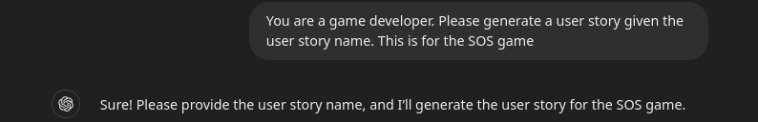

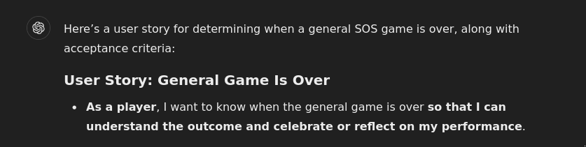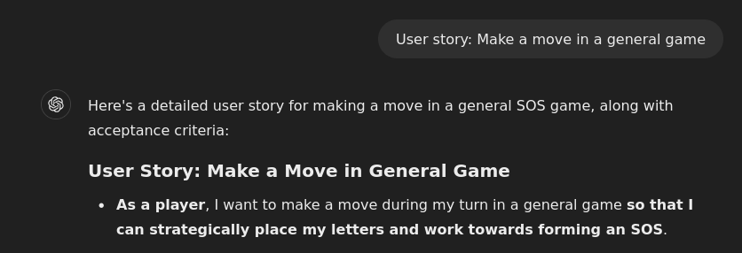

**Acceptance criteria**

