Preliminary description of the AV3 package

AV3 is a program package designed for 3D averaging from tomographic data. Its goal is to align subvolumes of a tomogram to a common origin to derive structural information of macromolecules such as membrane bound particles with higher resolution. Central element of this alignment procedure is the motivelist, abbreviated MOTL. It is a list that stores all necessary information about the individual particles: Rough coordinates within the tomogram (determine where they are extracted from), running number # of the particle (subvolumes are assumed to be stored as ‘filename_#.em’), index of tomogram they are taken from (if data from different tomograms are merged), shift within the subtomogram, and orientations. The latter two quantities are refined iteratively. Therefore the process of 3D alignment and averaging can be summarized as the task to create a motivelist and refine it till convergence. For exact format of MOTL see ‘av3_trans_rot_alig’ or ‘av3_scan_angles_exact’.

- The initial step is to determine the rough positions and orientations of tentative particles. There are two principle ways to realize this: (i) If some template for the structure is available one can start by global cross correlation of tomogram and template by means of ‘molmatch’, ‘mcf’, or ‘ominmatch’. All these programs are C-code standalone programs, which compute slightly different cross correlation functions. All programs provide both, coordinates of the particles AND orientations of the particles. (ii) If nothing is known about the macromolecule, a pragmatic way is to locate the individual copies manually in the tomogram. The matlab script ‘tom_picker’ provides an easy tool for interactive clicking of particles. However, an initial approximation for the orientation is not given. For membrane protein complexes, such as envelope proteins, an initial guess can be made by exploiting the knowledge that the particles should be oriented normal to the surface (procedure ‘normalvec’). The goal of both, (i) and (ii), is to generate a MOTL, which contains the coordinates of the particles, and, if accessible, orientations. For both approaches it is recommended to work with binned data, normally binning 2 is appropriate, to reduce computing time.
- The 2nd step is the reconstruction of the individual copies of the macromolecules on the basis of an existing MOTL. The procedure ‘av3_recparticles’ is designed for that purpose. As a prerequisite, the weighted projections of the tomogram should be generated first. Take care that the center of the reconstruction is the same as for the binned reconstruction in which you determined the coordinates of the particles. Otherwise, you will end up in nowhere…
- Finally, the fine alignment of the individual particles is performed. The script ‘av3_trans_rot_alig’ or ‘av3_scan_angles_exact’ (they are the same, but have different names for historical reasons) iteratively refines the MOTL of particles and computes novel averages based on the determined parameters. It is advised to start the script with binning, e.g. of 1, first and then to gradually change all parameters for higher resolution. The convergence of the MOTL can be visualized with ‘av3_motlanalyze’. The parameters for ‘av3_scan_angles_exact’ are the index and number of iterations, the angular scanning parameters, bandpass filter, imposed rotational symmetry along z, threshold for exclusion of particles to average according to average cross-correlation coefficient (CCC), angular ranges of the tomogram (=wedgelist), class, and binning. The angular scan is performed as illustrated in Fig.1.
- After convergence of the averaging procedure (criterion remains subjective), the resolution of the reconstruction should be determined. It is determined based on Fourier Ring correlation of 2 different averages resulting from 2 randomly divided sets of individual copies. ‘av3_resdet’ computes both, the 2 independent averages and the Fourier ring correlation (FRC). As a resolution criterion the decay of the FRC below 0.5 is suggested.
- What remains for the future:
  - Initial alignment from scratch like ‘common lines’ in single-particles.
  - A progressive alignment and averaging procedure for generation of a first reference.
  - 3D classification that accounts for missing wedge (like MSA in single-particles); note that av3_variance computes the (weighted) 3D variance which is a first step in that direction – however, it can give you only a rough idea.

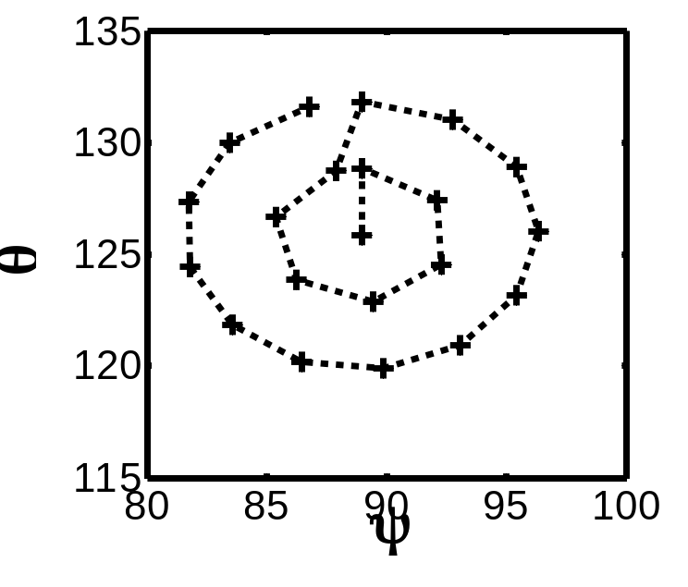
Figure 1: Angular scanning. The angles Psi and Theta are scanned around the angles from the previous iteration as denoted: The angles Psi and Theta are scanned around the old Psi and Theta, whereby the old values act as ‘poles’. Here angincr is 3deg, angiter is 2. That means, the vector (psi,theta) is rotated by Dtheta=3 two times (the visible rings). The increment along Psi is chosen as Dpsi=angincr/sin(Dtheta*iangiter) which accounts for the higher density of angles near the poles. The angle Phi is scanned with a constant increment Dphi=angincr from phi=phi_old-angiter*angincr to from phi=phi_old+angiter*angincr.

Example for interactive particle localization:

%-----------------------1-----------------------------------%
filt = tom_emread('SIV2_vir1.em');
Tomogram is called 'SIV2_vir1.em' and read in.
filt = tom_bin(filt.Value);
Binning is advised to accelerate any processing.
filt = tom_filter(filt,5,'circ');
For visualization STRONG filtering is proposed. The filtering should allow to distinguish the particles within the tomogram, however, resolving the internal structure of the macrmoelcules is not needed. The strong background noise will only be disturbing.
motl=tom_picker(filt);
Interactive picking of the particles.
motl(8:10,:) = motl.Value(8:10,:)*2;
Undo the binning.
motl = normalvec(motl, [181 181 181]);%get psi and theta
make initial guess for the orientation of the particles.
motl(17,:) = rand(1,size(motl,2))*360;% random phi
In this case, only the polar angles phi remains undetermined. A pragmatic way for the start is to randomize those. However, the more sophisticated ‘av3_spalig_phi’ is also available, which aligns all particles to one reference particle (preferably with very good SNR).

%---------------------------------------------------------------------2----------------------------------------------------------------%
Particle extraction. In this example, the particle are extracted from large (unbinned) tomograms
%%% extract the particles - to be edited %%%
motl = tom_emread('motl_df13_1.em');
motl = motl.Value;
read in an existing MOTL
motl(6,:)=1;
optional parameter – index of a feature (here virus) in tomogram
motl(4,:)=1:size(motl,2);
Set indices of the particles.
motl(5,:)=13;
Set index of the tomogram.
name = ['../virions_refined/df13_vir_1.em'];
Tomogram of virus number 1 in tomogram number 13.
vol = tom_emread(name);
for indx=1:size(motl,2)
x=motl(8,indx)*2;y=motl(9,indx)*2;z=motl(10,indx)*2;%take care for binning 1 during clicking
part = tom_red(vol.Value,[x-32,y-32,z-32],[64,64,64]);
% subtomograms have size 64x64x64
[mv, mx, mn, stdv, vari] = tom_dev(part,'noinfo');
part = (part-mv)/stdv;
% normalization according to rms. This is NOT mandatory, however I
% personally advise it.
name = ['../particles/particle_' num2str(indx) '.em'];
% name of the individual particles. This convention is assumed.
tom_emwrite(name,part);
disp([' wrote particle ' num2str(indx) ' ...']);
end;
Reconstruct particles of 1st virus first.
for ind=2:15 %here 15 tomograms exist. They are all from different virions in
% one tomogram
name = ['motl_df13_' num2str(ind) '.em'];
motl_new = tom_emread(name);
motl_new = motl_new.Value;
motl_new(6,:)=ind;
motl_new(4,:)=size(motl,2)+1:size(motl,2)+size(motl_new,2);
name = ['../virions_refined/df13_vir_' num2str(ind) '.em'];
vol = tom_emread(name);
for indx=1:size(motl_new,2)
x=motl_new(8,indx)*2;y=motl_new(9,indx)*2;z=motl_new(10,indx)*2;
part = tom_red(vol.Value,[x-32,y-32,z-32],[64,64,64]);
[mv, mx, mn, stdv, vari] = tom_dev(part,'noinfo');
part = (part-mv)/stdv;
name = ['../particles/particle_' num2str(size(motl,2)+indx) '.em'];
tom_emwrite(name,part);
disp([' wrote particle ' num2str(size(motl,2)+indx) ' ...']);
end;
motl(:,size(motl,2)+1:size(motl_new,2)+size(motl,2))=motl_new;
% all data is united in ONE motl
end;
Reconstruct particles originating from other virions.
motl(5,:)=13;% running number of the tomogram. All virions are from one tomogram.
motl = normalvec(motl, [201 201 201]); % initialize angles
Approximating angles as before – here the dimensions of the tomograms are 400x400x400, i.e. the center is (201,201,201).
motl(17,:) = rand(1,size(motl,2))*360;%randomize phi
tom_emwrite('MOTL_df13_1.em',motl);

%%% end particle extraction %%%%%%%%%%%%%%

%---------------------------------------------------------------------3----------------------------------------------------------------%
mask = tom_spheremask(ones(64,64,64),16,3);
Define a mask that surrounds your particles.
wedgelist = tom_emread('../../DF_average/wedgelist.em');
Read in a wedgelist. It contains the index of your tomogram, minimum, and maximum angle for each tomogram.
av3_scan_angles_exact('av_df13', 'MOTL_DF13', '../particles/particle', 1, 1,6, 4,mask,2,15,1,0.0,wedgelist.Value,0,0,0);
Start iterative averaging. IMPORTANT: Be sure that you set the threshold to 0.0 for the 1st iteration. For the next iterations you can set this parameter to a different number ~1. Best start scanning with a big angular increment (here 6 deg) and many angular iterations (here 4).
av3_scan_angles_exact('av_df13', 'MOTL_DF13', '../particles/particle', 2, 1,3, 3,mask,2,18,1,0.8,wedgelist.Value,0);

%---------------------------------------------------------------------4----------------------------------------------------------------%
motl=tom_emread(‘MOTL_DF13_10.em’);motl=motl.Value;
[average average2 frc] = av3_resdet(motl, ... ’../particles/particle',wedgelist,16,3,0.8)
Compute resolution: Here 16 Frequency shells, impose 3-fold symmetry along z and use only particles whose CCC is above 0.8 times the average CCC.

