Statistical Technique and General Procedure
- Descriptive statistics to analyse initial score results on the knowledge and awareness of the parents on immunization
Frequency Table

Results:

TREATMENT – Chilled / Not Chilled
Chilled | Obs | Not Chilled | Obs
Dried Red Pepper | 1 | Meat | 2
Milk | 3 | Mexican Cheese | 5
Raw Meat | 3 | Powdered Foods | 4
Raw Vegetables | 4
Ready to eat | 9 | Ready to eat | 14
Ready to reheat meal | 3
Rice | 2 | Rice | 1
Seafood | 5 | Seafood | 28
Vegetables | 5 | Vegetable | 7
Total | 35 | Total | 61
TREATMENT – TEMPERATURE (in C)
Chilled | Obs | Not Chilled | Obs
0-4 | 8 | 30 | 16
5 | 5 | 32 | 29
7 | 11 | 37 | 16
8.5 | 5
12 | 6
Total | 35 | Total | 61

Total of 96 samples were undertaken for this study.

The researchers were able to sample more not chilled food products wherein majority of it are seafood and
ready to eat products. In the Chilled Group, majority of the sample are from Ready to Eat, Seafood, and
Vegetables.

Temperature for chilled products is in the 0-12 degrees Celsius range, majority on the 7 degrees. For Not Chilled, the researchers were able to sample 30,32, and 27. This is treated as categorical in subsequent statistical tests.

Notes:
- Pasteurized Milk is excluded in the analysis since the values are not actual.
- The 8.5 temperature is imputed for chilled vegetables. The imputation is computed but the average of 5-12C for chilled vegetables
- Two samples for chilled rice but with different temperatures are observed

CFU/g Data Distribution and Box Plot

Results:

By Treatment Group – Chilled / Not Chilled

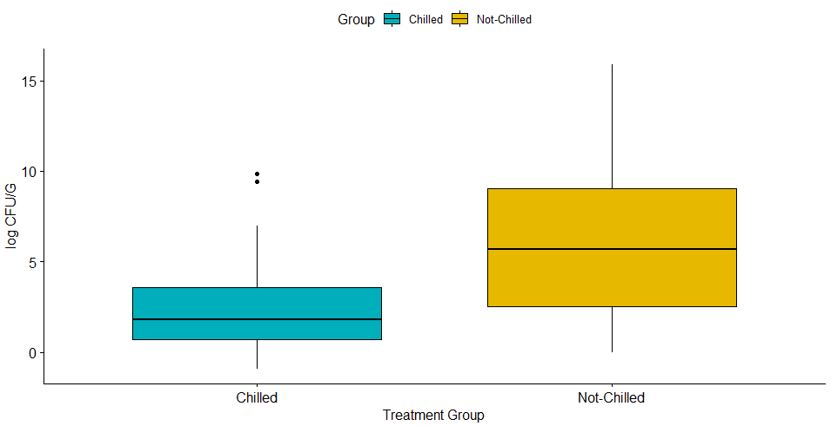
Note: Log CFUG was used to rescale data to have a better visual of the box plots

There are more samples in the not chilled food products. Average and Median CFU/g are greater for the not chilled products. The not chilled product range has evidently wider range of data as shown in their box plots and IQRs. Both groups are positively skewed which means there are large outlier values present for both groups. The kurtosis confirms this as it shows positive values. This means extreme values are present for both groups, that is, non-chilled products are more prone to these extreme values.

By Temperature

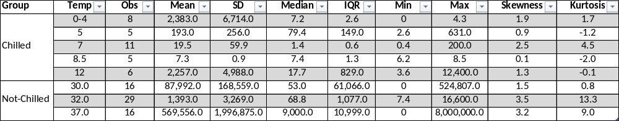

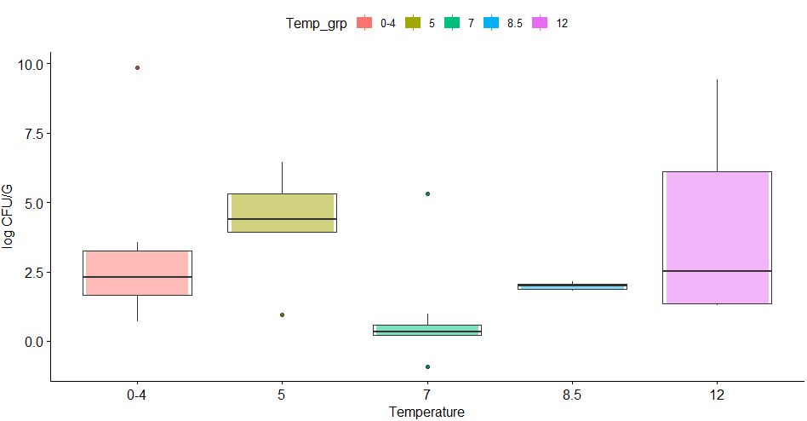
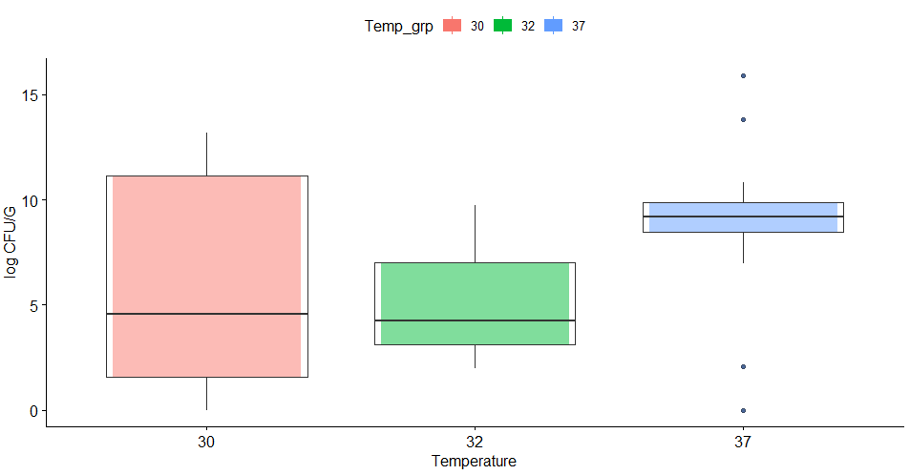
Note: Log CFUG was used to rescale data to have a better visual of the box plots

Breaking this down further by temperature (treated as categorical variable),

Chilled – median CFU/g is highest on 7 degrees and higher on the 8.5 and 12 temperature compared to other
groups. The variability of the mean and median can be attributed to the low number of samples and sampling
method. Lastly, they are all generally, positively skewed.

Not-Chilled – there seems to be a positive correlation for the median CFU/g as temperature increases, median
CFU/g of the group also increases (line of the boxplots). All three groups have wide range of data and are
much more skewed than the temperature under the chilled group.

- Inferential statistics to analyse statistically significant difference for treatment and temperature groups. In this analysis, the researchers considered α = 0.05 as statistically significant for the following formal tests

- Shapiro Wilk Data Normality Test for Chilled and Not-Chilled Groups

Null and Alternative Hypothesis for Chilled/Not Chilled Groups:

Ho: Data distribution for Chilled group/Not Chilled group is normally distributed
Ha: Data distribution for Chilled group/Not Chilled group is not normally distributed

Results:



For both groups, there are sufficient evidence to conclude that data are not normally distributed at alpha = 0.05. This is also shown in the descriptive statistics above as both groups are highly skewed.

- Wilcoxon Rank Sum (Mann-Whitney) unpaired test to check for difference of bacteria growth (CFU/g) between treatment groups, Chilled and Not Chilled

Null and Alternative Hypothesis:

Ho: There is less or equal significant growth of B. cereus in non-chilled food products compared to chilled food products.
Ha: There is a greater significant growth of B. cereus in non-chilled food products compared to chilled food products.

The following assumptions of the Wilcoxon Rank Sum (Mann-Whitney) are satisfied:
- The variable of interest CFU/g is at least ordinal
- The samples are independent
- Data is not normally distributed
Results:
Formal Test
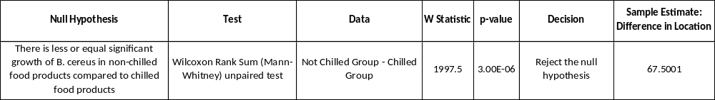
Median Confidence Limit
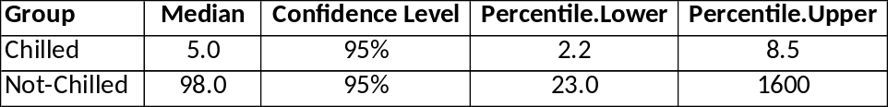
The 95% Confidence interval for Chilled is 2.2 to 8.5 whereas Not-Chilled is from 23.0 to 1600. The intervals are not overlapping, which suggest statistical difference in terms of their medians and distribution. Now looking at the result of the Wilcoxon Rank Sum Test, the null hypothesis is rejected since p-value is less than 0.05. There is sufficient evidence to conclude that there is greater significant growth of B.cerus in nonchilled food products compared to chilled food products. In other words, the distribution of the not chilled products is shifted to the right.
67.5001 is the median CFU/g difference between the sample from Not Chilled and Chilled. It is positive which means that median CFU/g is significantly higher for Not Chilled foods at alpha =0.05. The W statistic is 1997.5 which means that the bacteria growth of the Not Chilled groups is 1997.5 times the CFU/g of Chilled product.
- Kruskal-Wallis (Non-Parametric One-way ANOVA) test to further analyse CFU/g growth differences between Temperature groups
Null and Alternative Hypothesis:
Ho: There is no significant difference in CFU/g growth between the temperature groups
Ha: There is significant difference in CFU/g growth between the temperature groups
The following assumptions of the Kruskal-Wallis test are satisfied:
- The variable of interest temperature (interval level) is treated as categorical because of small sample size
- Temperature group has three or more independent groups
- The samples are independent
- Data normality assumption is violated at alpha = 0.05
Results:
With p-value<0.05, there is sufficient evidence to conclude that there is significant difference in the CFU/g growth between at least two of the temperature groups. To find out which temperature groups are different, a post-hoc analysis was implemented.
Post-Hoc Analysis Result:
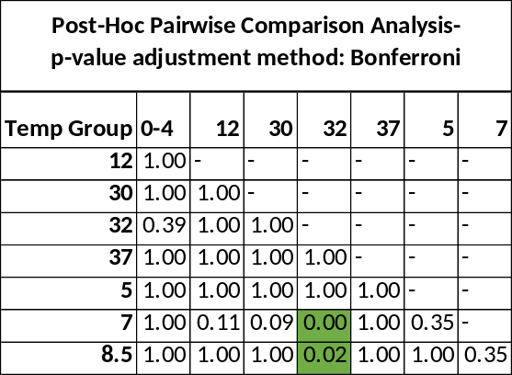
Based on the post-hoc analysis test, the difference in the growth of bacteria between chilled and non-chilled can largely be attributed to the 7C vs 32C and the imputed 8.5C vs 32C.
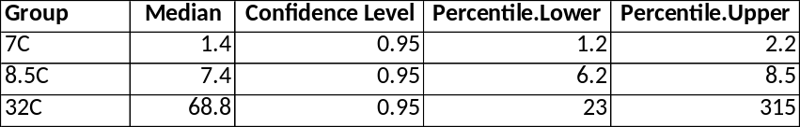
Descriptive statistics indicate that the median value with 95% confidence intervals for 7C is 1.4 CI[1.4,2.2], 8.5C is 7.4 CI[6.2,8.5], and 32C is 68.8 CI[23,315]. That is to say, the difference between the median values of each 32C vs 7C is about 67.4 CFU/g (p=.00) and 32C vs 8.5 is about 61.4 CFU/g (p=0.02). The result of this test supports the literature: The growth of B. cereus was observed to occur in temperatures ranging from 8-50°C and highest cfu/g growth at 30-42°C (Jessberger, et al., 2020), since non-chilled products ranges from 30-37 based on the sample.
Caveats
- Different temperature effect on CFU/g are ignored in this analysis
- The sample might not be representative of the population because of the sampling method done. IATF restrictions might affect the sampling method.

