**How To Run The Setup And Run 5g Latency Measurement With Ptp**

Project git hub page: https://github.com/johnjegede/5G_latency

**Install the ubuntu VM using virtual box**

Install Virtual Box

Download and install Ubuntu server (18.04 LTS)

This link can help https://www.free5gc.org/installations/stage-3-vm-basics/

**Installing free5gc-compose**

**1)Install gtp5g kernel engine**

cd ~

git clone https://github.com/free5gc/gtp5g.git

cd gtp5g

make

sudo make install

**2) Install free5gc-compose**

# Clone the project

git clone https://github.com/free5gc/free5gc-compose.git

cd free5gc-compose

# Build the images

make base

docker-compose build

before you run the docker-compose command in the free5gc-compose file you will see a docker-compose.yaml file, edit this file by adding a second ueransim container.

The docker-compose file used in this project can be found on the project GitHub page

# Run it

sudo docker-compose up # add -d to run in background mode

As we see below we have two ueransim’s

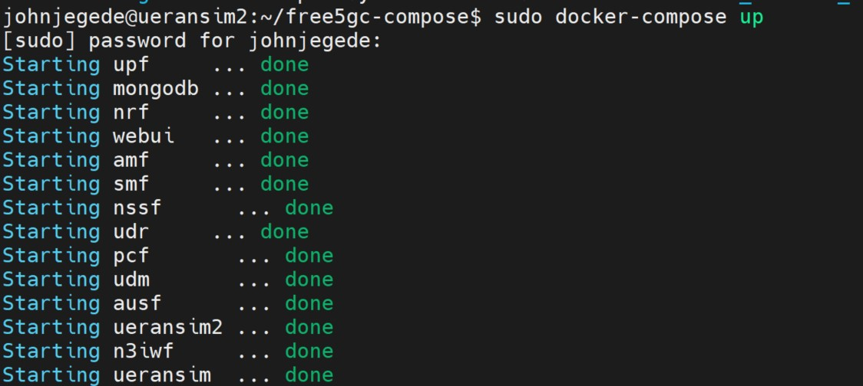

**3) Configure the webUI**

On you web browser access the webUI using the IP address of the VM and the the port number 5000 which is assign for the webUI

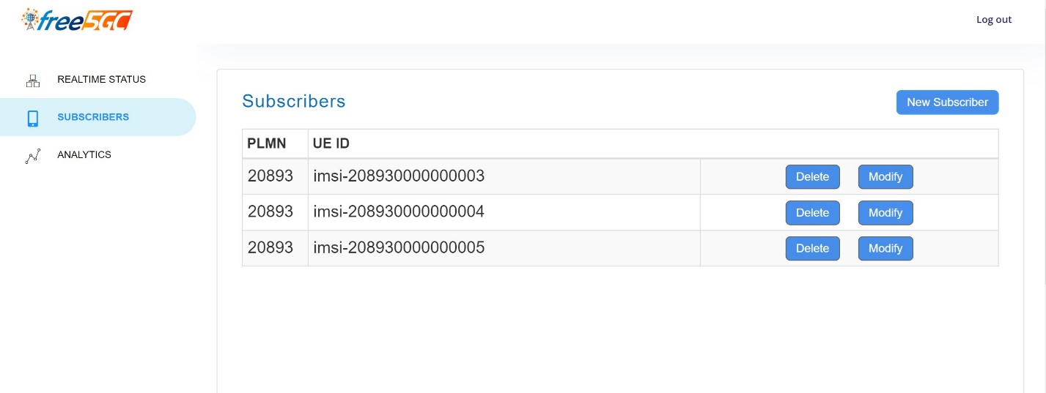

Register at least two UE’s one as the master the other the slave

**4) Configuration of the UE’s in each of the ueransim container**

Multiple terminals should be open

On one terminal

Check the ueransim log

docker logs ueransim (make sure you see this)

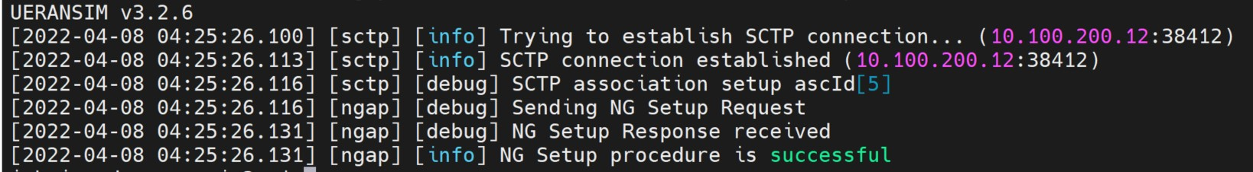

Sudo docker ps

sudo docker exec -it ueransim bash

nano config/uecfg.yaml (make necessary changes to make sure the UE config file match with that of the webUI UE)

./nr-ue -c config/uecfg.yaml

If it goes well you should see the image below with the tunnel been created with the IP as 60.60.0.1

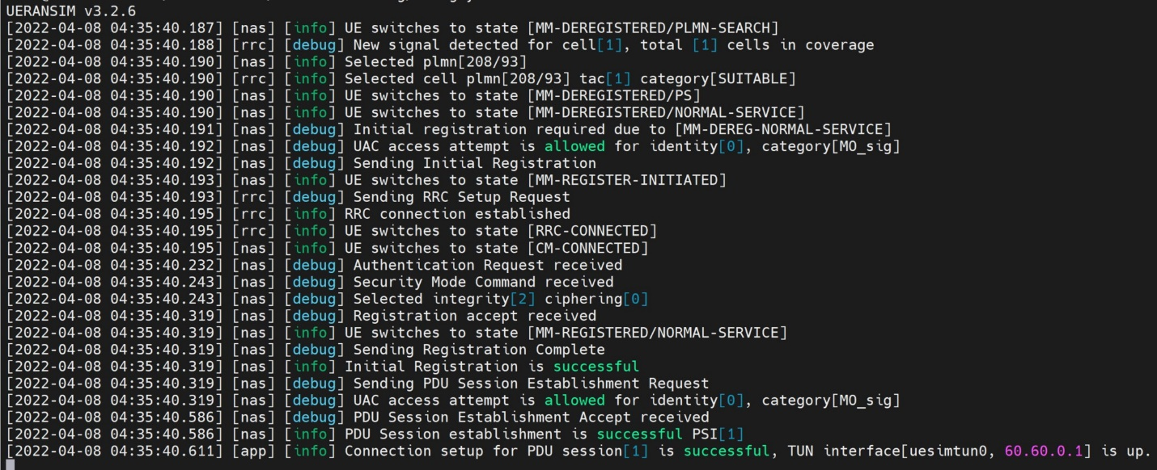

The above commands should be done for the second ueransim on a new terminal. If all goes well you should see a new tunnel with the IP address 60.60.0.2

**5) Configure PTPd for UE in each of the ueransim containers**

Enter the ueransim and install the following in the ueransim container

Pick a UE container to be master and the other UE container to be slave

sudo docker exec -it ueransim bash

apt-get update

apt-get upgrade -y

apt-get install -y net-tools

apt-get install -y git

apt-get install sudo

apt-get install -y make

apt-get install -y autoconf

apt-get install apt-utils

apt-get install procps

sudo apt install ptpd

sudo apt install nano

apt-get install -y grep

git clone <https://github.com/dapopescu/ptpd.git>

cd ptpd

./install.sh

git clone <https://github.com/johnjegede/5G_latency>

cd 5G_latency

cd ptptest

the README.md has the information on how to configure the master and the slave UE

./run.sh on both the master and the slave UE

On the Master UE container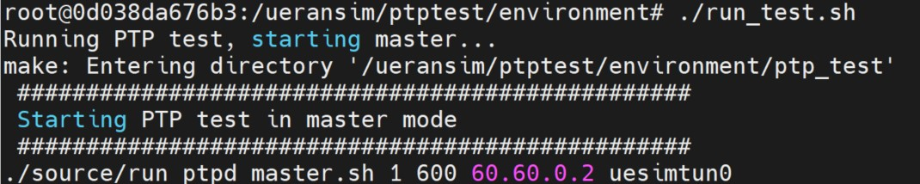

On the Slave UE container

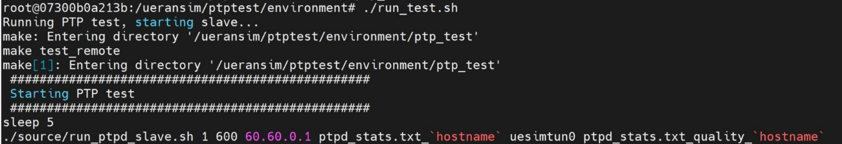

After the ptpd test ends after the time set

The output file is in the ptp_test folder

The output of this project is in the project github folder and its called ptpd_statso.txt. The cumulative distribution function is plot against the one way delay on a graph and this is in the project report.