**Figures.**



**Fig. 1, Excitation coefficients in air as a function of electric field, from [6].**



**Fig. 2 Calculated field enhancement factor of background fields by conducting cylinders as a function of ratio of cylinder length L to radius R.**

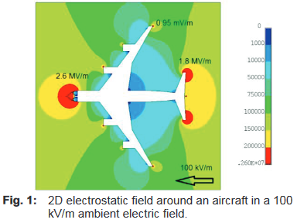

**Fig. 3 Calculated electric fields of ~ 25 kV cm-1 at extremities of an Airbus fuselage from an ambient field of 1 kV cm-1; from [16], with permission.**



**Fig. 4 Corona “horns”, marked in blue, on metal conductors, shown by narrow lines, within the black radome; Photo from US Air Force, Wright Patterson.**

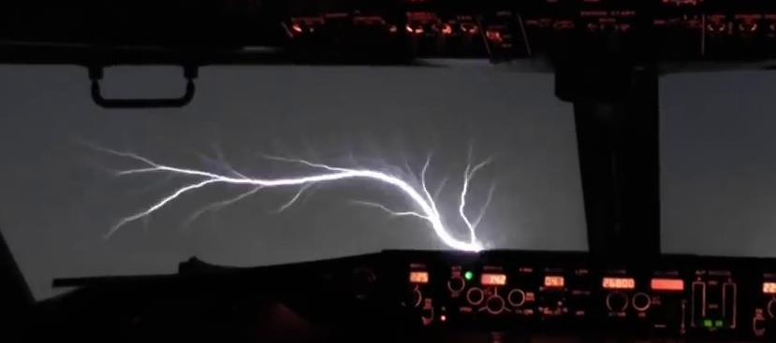

**Fig. 5 Electric discharge on the surface of an aircraft window travelling from the window frame to the glass. From YouTube/PilotsTubeHD, with permission.**

1. 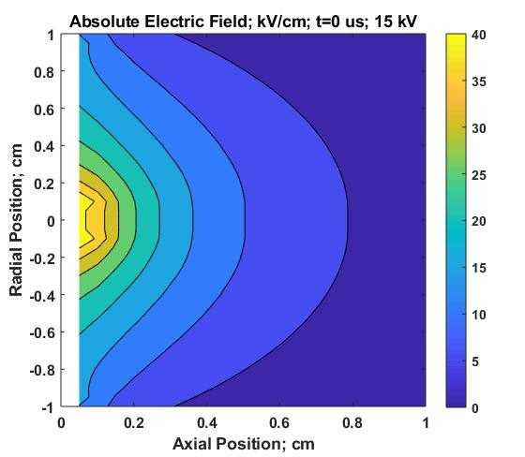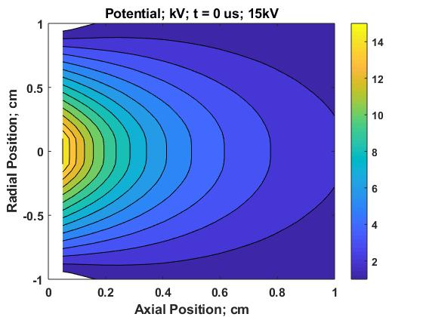 **(b)**

**Fig. 6 Initial conditions of calculations of Figs 7, 8, 10.**

1. **Shows input boundary potentials. (b) Derived initial electric fields.**

**Fig. 7 Calculated Particle Densities at maximum of first current pulse; 0.6 μs.**

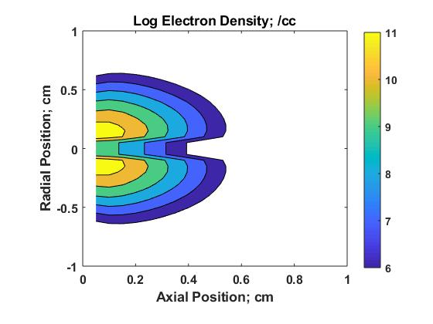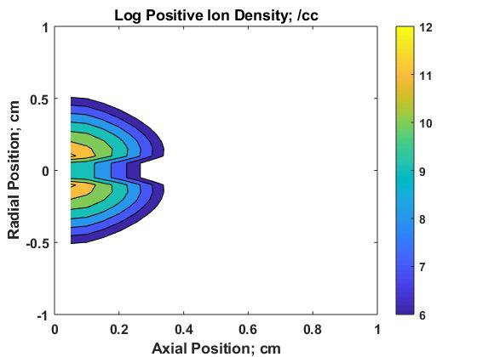

**Fig. 7a Electron Density. Fig. 7b Positive Ion Density.**

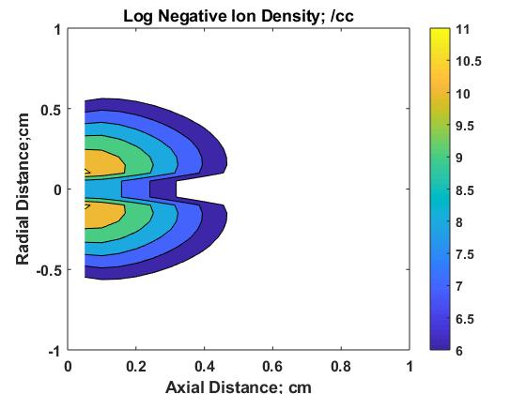

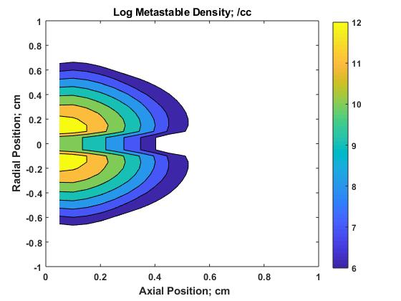

**Fig. 7c Negative Ion Density. Fig. 7d Metastable Density.**

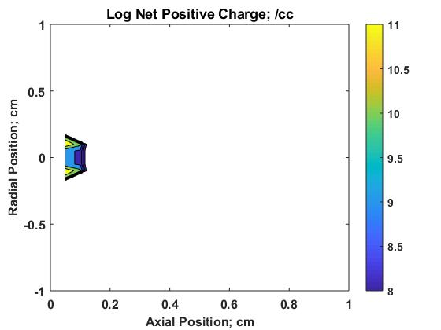

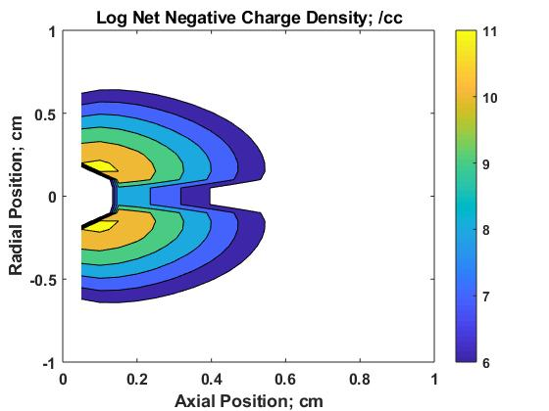

**Fig. 7e Net Positive Ion Density. Fig. 7f Net Negative Ion Density.**

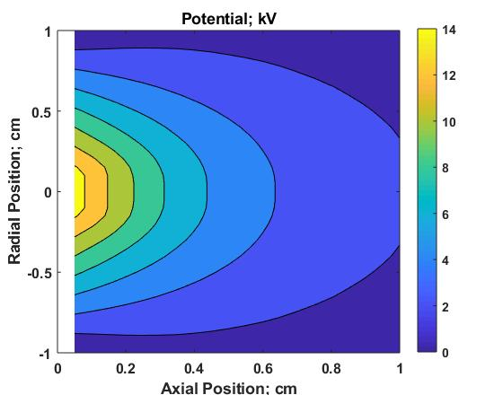

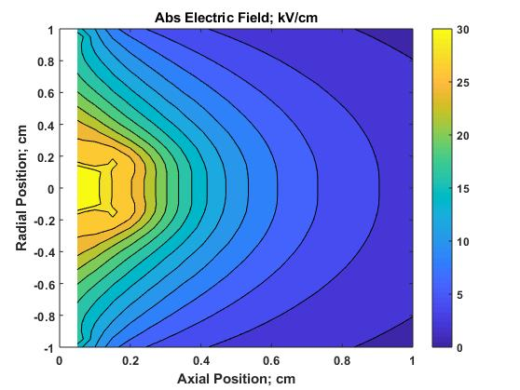

**Fig. 7g. Potential Fig. 7h Absolute Electric Field.**

**Fig. 8 Calculated Particle Densities and fields before second current pulse; 2 μs.**

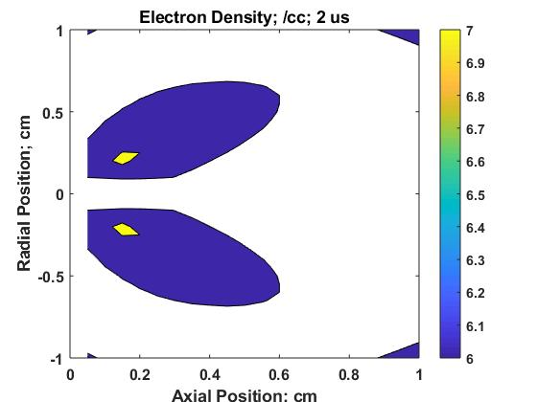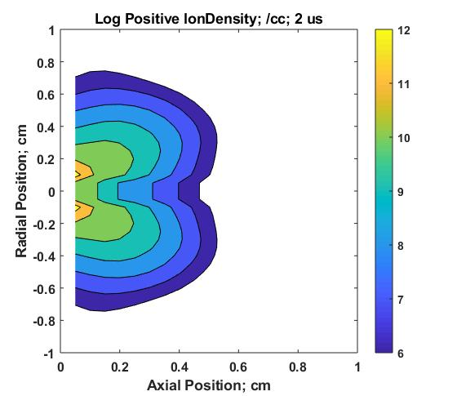

**Fig. 8a Electron Density. Fig. 8b Positive Ion Density**

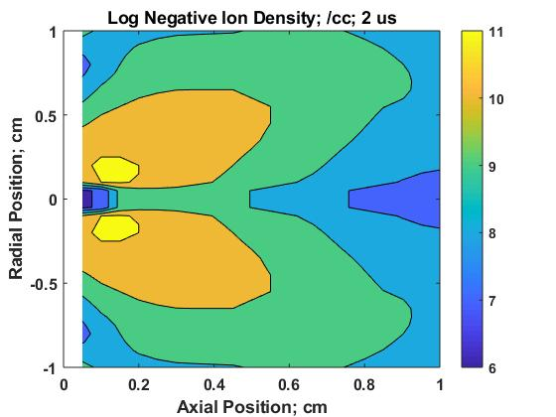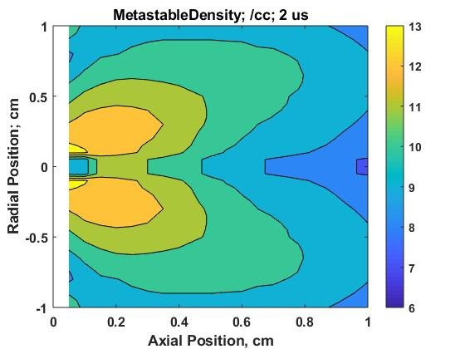

**Fig. 8c Negative Ion Density. Fig. 8d Metastable Density.**

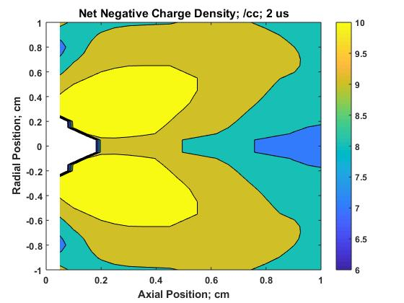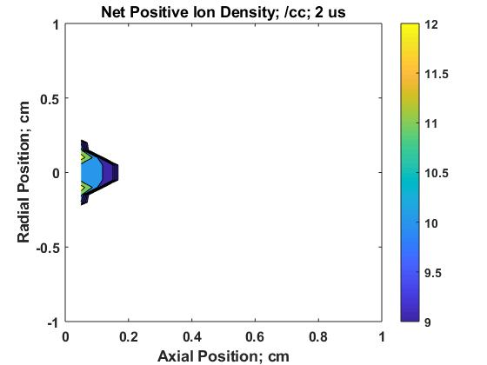

**Fig. 8e Net Positive Ion Density. Fig. 8f Net Negative Charge Density.**

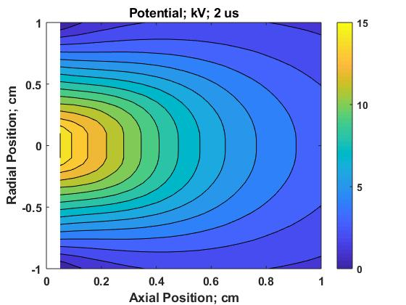

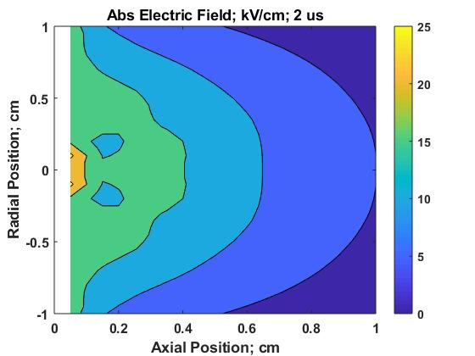

**Fig. 8g. Potential Fig. 8h. Abs. Electric Field.**

**Figure 9; Current Pulses corresponding to Figs 7 and 8.**

**Fig. 9. Current Pulses – analagous to Trichel pulses.**

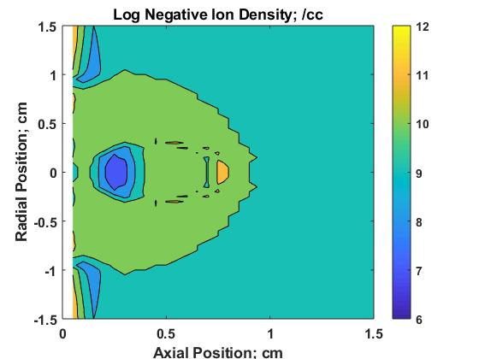**Fig 10. Inserted Metastable Ball.**

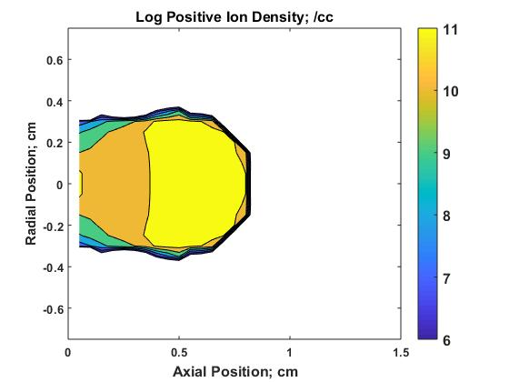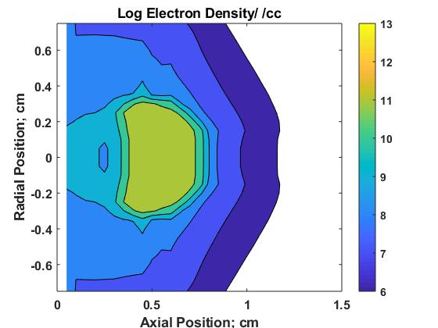

**Fig. 10a. Electron Density. Fig. 10b Positive Ion Density.**

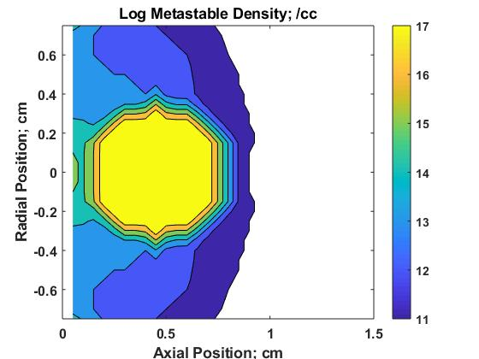

**Fig. 10c. Negative Ion Density. Fig. 10d. Metastable Density.**

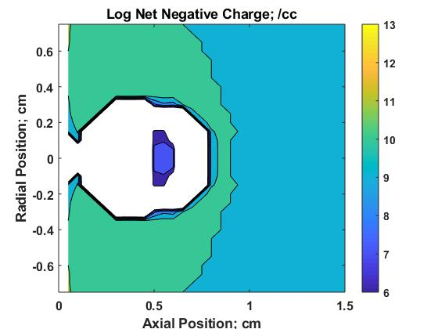

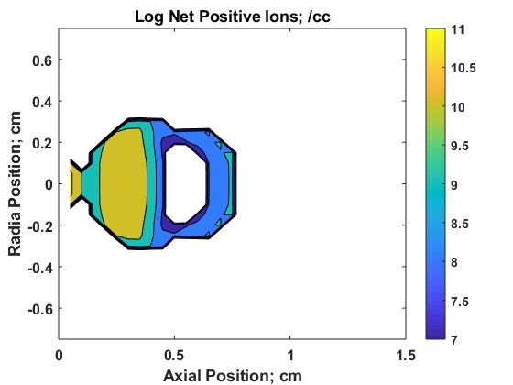

**Fig. 10e. Net Negative Charge Density. Fig. 10f. Net Positive Ion Density.**

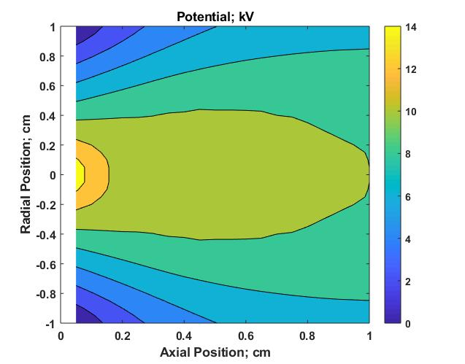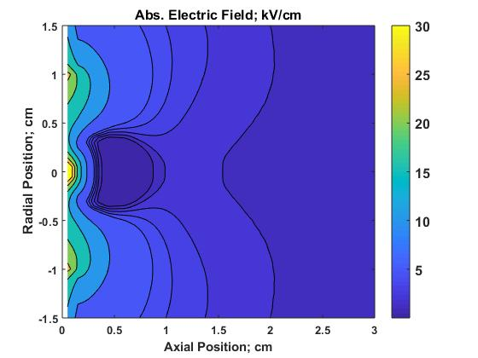

**Fig. 10g. Potential . Fig. 10h. Electric Field.**

**Fig. 11 Calculated electric fields at ball boundaries.**

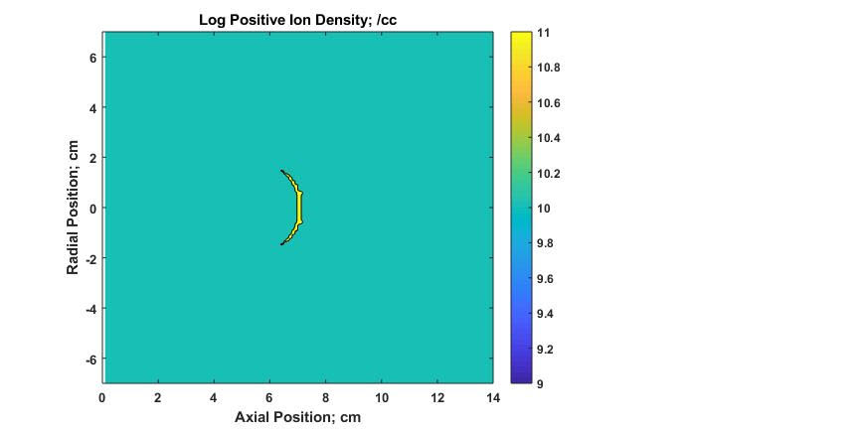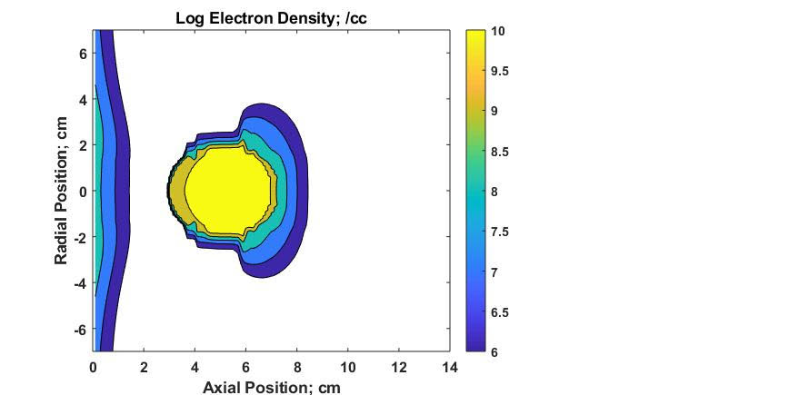

-

**Fig. 11a Electron Density. Fig. 11b Positive Ion Density**

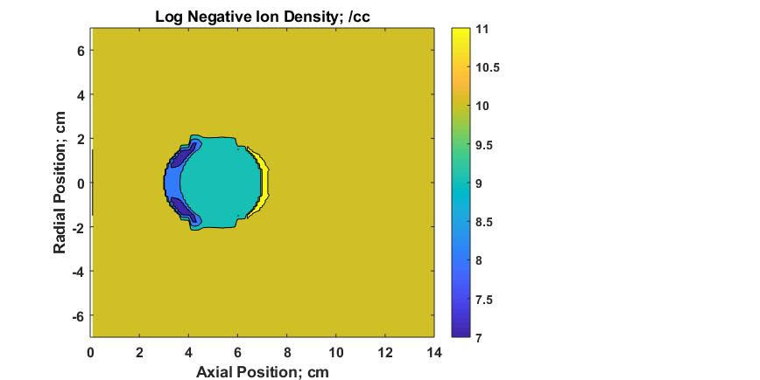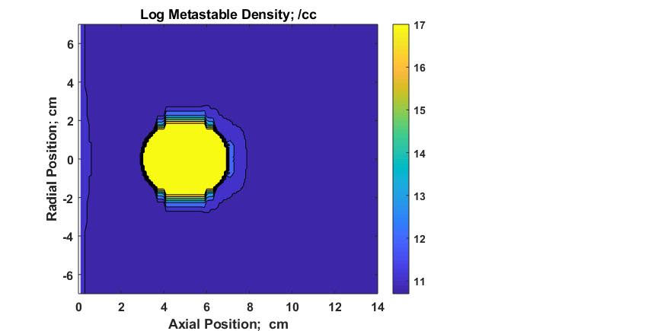

**Fig. 11c Negative Ion Density. Fig. 11d Metastable Density**

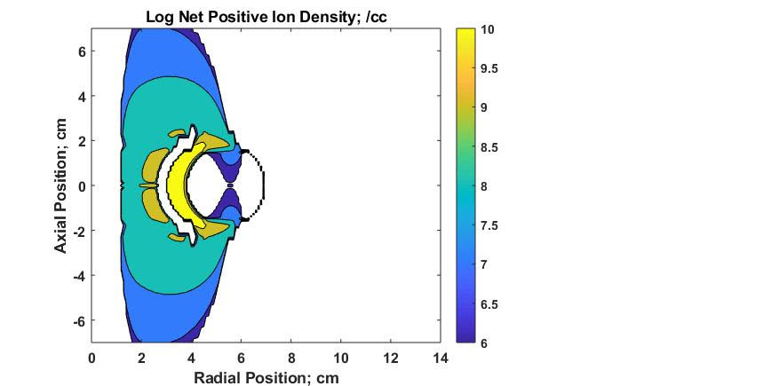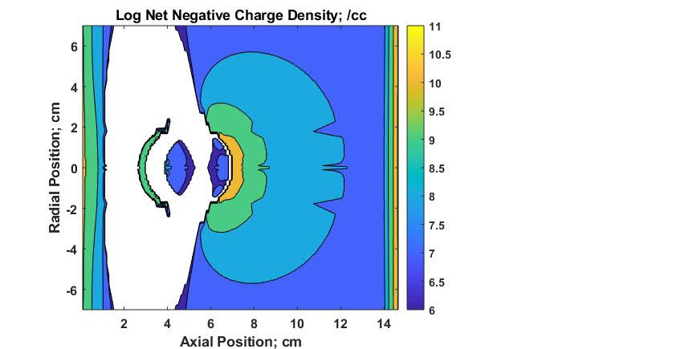

**Fig. 11e Net Negative Charge Density. Fig. 11f Net Positive Ion Density**

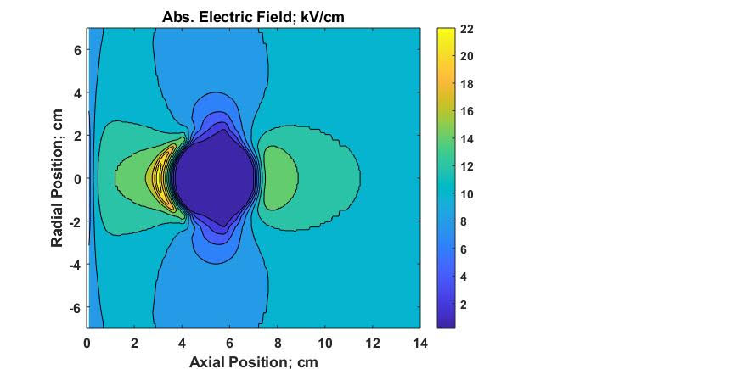

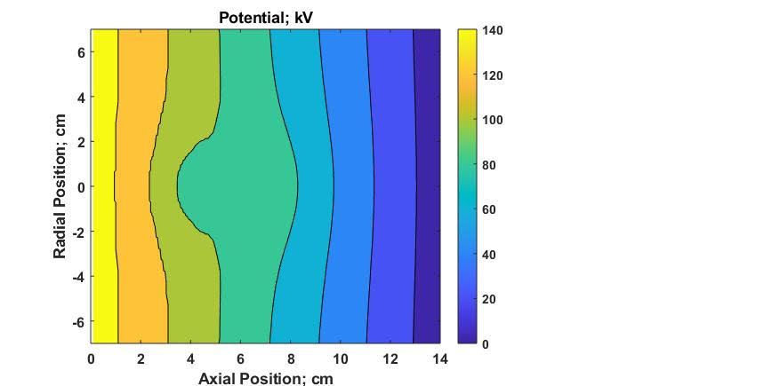

**Fig. 11g Potential. Fig. 11h Electric Fields.**

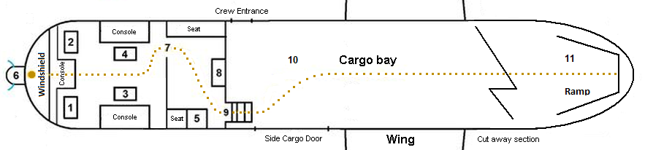

**Fig. 12 Ball Lightning path within US Air Force plane C-133A shown by dotted line within Cockpit and Flight Deck. Positions show Pilot 1, Copilot 2, Navigator 3, Flight Engineer 4, Loadmaster 5, Radome 6, with Saint Elmo’s Horns, Doorway (open) 7, Coffee console 8, Stairs down to cargo bay 9, Cargo bay 10, Ramp & Tail Door 11. The ball lightning travelled the total distance of about 55 m from the windshield to the end of the cargo bay in approximately 25-35 seconds. Drawing by D. Smith, flight navigator.**

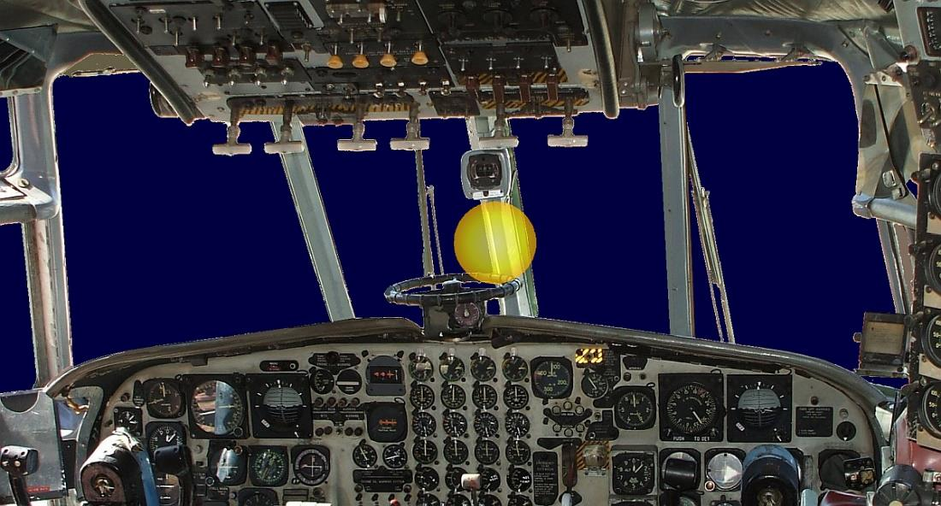

**Fig. 13 - The ball lightning originated immediately next to the metal divider post at the centre of the windscreen, just under the C-12 standby magnetic compass which was attached near the top of the metal post.**



**Fig. 14. Ball Lightning in farm house.**