Using SVN as versioning system
IT IS RECOMMEND TO READ THE HELP FOR THE SUBCLIPSE PLUGIN FROM THE ECLIPSE HELP.
Versioning in the case of RMA10S can be used to save developed and implemented states of the software. The three main possibilities to hold code/documents in the SVN are:
- the TRUNK: this is the main line of development, where the new things will be committed to.
- a BRANCH: this is a line of development parallel to the trunk, e.g. for maintaining code of a release.
- a TAG: this is a snapshot-marker to mark a collection of files with a name, e.g. with a release version number or revision version number etc.
For maintenance and development of source codes/ documents/ projects the SVN offers:
- automated saving all changes in a (user commented) history to allow users to look into old files
- splitting into/ merging from different directions (‘branch’), e.g.
- for maintaining a stable version/release/distribution and separation from new developments
- …
- saving and recovering from a certain state of the code into a ‘tag’ to be able to restore a stable situation, where it is not necessary to split into a new branch. Tags should be namely in line with the history entry of the developers.
- Saving a version, that is stable and is/will be distributed. This enables the developers to recover a certain status of the model.
- being able to role back to a stable version, if commits include not working stuff
- …

tags
If user wants to create a tag from a version, he has to use the ‘branch/tag…’ entry from the team menu. The occurring dialog is shown in figure 1. Following things he has to do:
- Choosing the location, where the file content of the tag is copied to (e.g. via Browse-button)
- Choosing the HEAD or a particular revision number of the code he wants to tag. This number is related to the code, that is placed in the ‘From URL’ field.
- Edit a comment to the branch. This should be really meaningful! You can use old comments from the selection box, too.
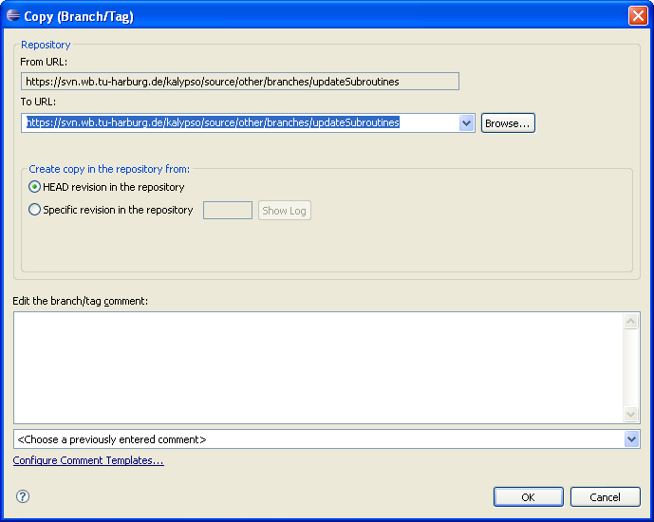
figure 1 ‚Branch/Tag...’ dialogimportant hint:
A tag should be created for each release that is made!
In opposite to the usage of CVS, there is not just an attribute on the file-collection, that was said to have a tag, but the current state is really copied to a given new location. THAT MEANS: USE THE TAG LOCATIONS JUST FOR RESTORING AND NOT FOR COMMITTING. COMMITTING JUST TAKES PLACE IN THE TRUNK OR IN A BRANCH! The problem with this copying behaviour is, that tagging doesn’t leave an information in the branch behind, where the tag comes from. The user is therefore not able to look into the history of the branch to see where a tag was created. It is only possible to look into the tag-directory and look for the tags, where they come from. This information is kept there.
application hint:
There is a possibility of setting a property, that displays a tag. From the workspace, the developer can access the TEAM>configure Branches/Tags… menu. There he can chose a file set in the SVN-repository and add a tag by right-clicking on the selection and chosing the ‘Add tag’ context menu task. The Tag needs to be adapted. For this the tag needs to be selected and edited. Afterwards the ‘Apply’ button must be pressed. This tag property is referenced to a certain revision number. If the user enters the history view in the workspace or in the SVN repository browser, he can see the tag in the Tags-column.
The setting of a tag property can be made automatically: For this purpose the project has to get the property ‘subclipse:tag’. The tag property will then be generated automatically, if the developer chooses to create a ‘Branch/Tag’ location from the Team-menu in the workspace.

branches
<!Has to be filled!>
Technically a branch is nothing else than a tag. You use the same dialog above (figure 1) to create a branch. Only the purpose is different. Branches should only be created for:
- EXPERIMENTAL FEATURES, try then to maintain your branch in the way, that you’re always up to date with the TRUNK
- MAINTENANCE OF A DISTRIBUTED VERSION. Branching a distributed version is recommend, if a from the TRUNK independent bug fix basis should be created.

Conventions

rma10sk
For the names/branches/tags of rma10sk, please follow the following convention, which you can find in the Twiki under (LINK), too. For the other modules this is not necessary, we can create another convention. Of course we can also discuss about the rma10sk naming/tagging/branching convention!
locations in the SVN:
Main location of the trunk development:
https://svn.wb.tu-harburg.de/calypso/source/other/trunk/fortran/RMA10S_TUHH
The trunk folder contains following subfolders, feel free to add new folders, if necessary:
- source (containing the source code)
- …
Locations for branches
https://svn.wb.tu-harburg.de/calypso/source/other/branches/<BranchName>/RMA10S_TUHH
A branch not necessarily consists of the same content of folders, that the trunk does. Only the ‘source’ folder should be fixed.
Branches should be made for:
- stable version maintenance
- difficult feature implementations
The BranchName folder must created on the SVN manually in advance. The creation of a branch doesn’t support the creation of SVN subfolders.
Locations for Tags
https://svn.wb.tu-harburg.de/calypso/source/other/tags/<V_X.X.X(Zusatz)>/RMA10S_TUHH
A tag not necessarily consists of the same content of folders, that the trunk does. Only the ‘source’ folder should be fixed.
NEVER commit into a tag location!
A tag should be created for each release that is made!
The V_X.X.X(Zusatz) folder must created on the SVN manually in advance. The creation of a branch doesn’t support the creation of SVN subfolders.

Versioning and roadmap
The version/release number consists of 3 parts. The meaning should be as follows:
Leading number: REALLY BIG CHANGES
Second number: FOR NEW FEATURES
Third number: FOR BUG FIXES, IMPROVEMENTS AND MINOR CHANGES. Important is, not for each new compilation to make a new version number. Collect changes. After a certain status is reached. It can be decided to generate a version. Please update the automake.fig file and the Intel make file with the new version number!
Zusatz: alpha or beta for the status of the version, if it is in testing phase
For each branch two files should always be present: commits.history and the roadmap.future. These files contain the implemented and committed stuff on one side and the planned things on the other side. In the roadmap.future, It must be differed in three sections:
- bugs and improvements (related to last number)
- features for the next version (Leading or second number)
- features for the future

