# Social Network Analytics Project: Gowalla

Analyzing the Marketability of a User Base

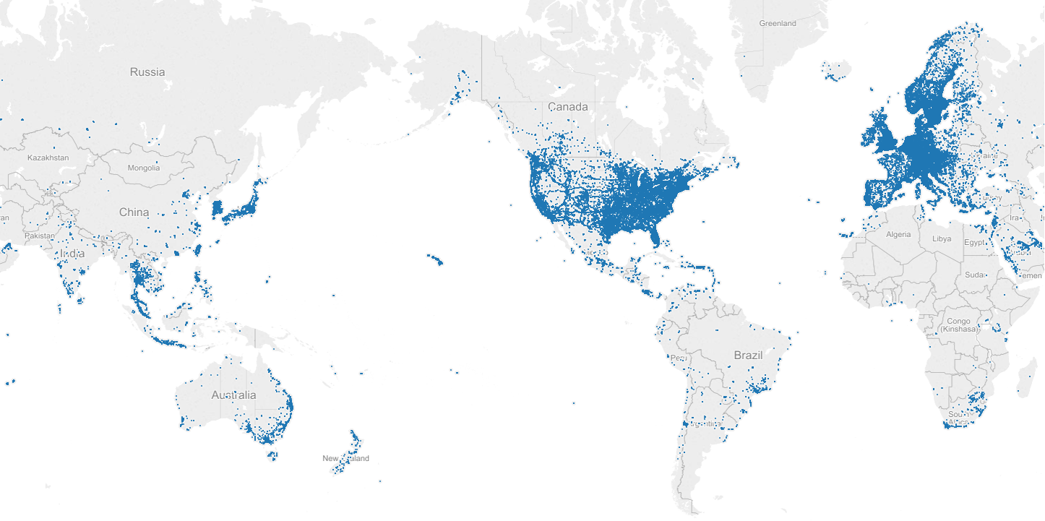

**Introduction**

**[INSERT SOME GENERAL TALK HERE]**

**In our analysis, we would like to assess the possibility of using key Gowalla users as a part of different marketing campaigns. Users with high reachability, dense subgroups and reasonable eigenvector value would be of great value to businesses that want to run effective promotions and marketing efforts. It would be prudent for a marketing agency to leverage a user’s network for promotional activities.**

**The dataset2 that we will be using for our analysis contains 6.4 million check-ins and 1.9 million nodes in an undirected network.**

**Complete Network Graph**

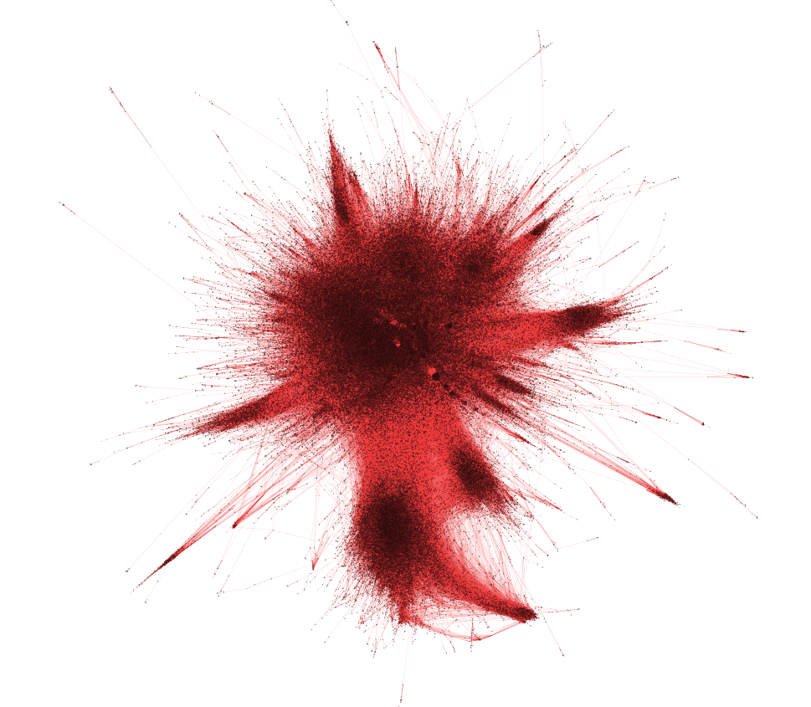

**Gowalla friendship graph metrics:**

**Density: 4.917880929251338e-05**

**Nodes: 196,591**

**Edges: 950,327**

**Transitivity (fraction of possible triangles that exist): 0.0235**

**Number of Three Cores that Exist: 106,417**

**Node 308 Metrics:**

**Member of 276,870 cliques**

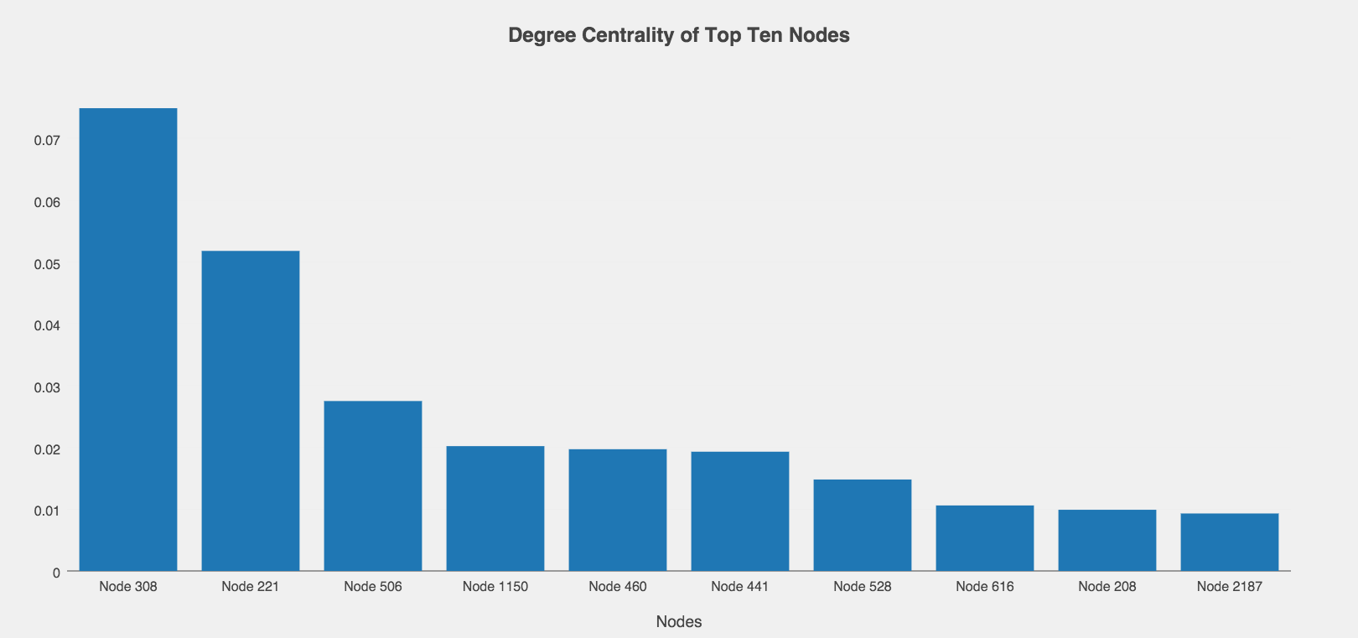

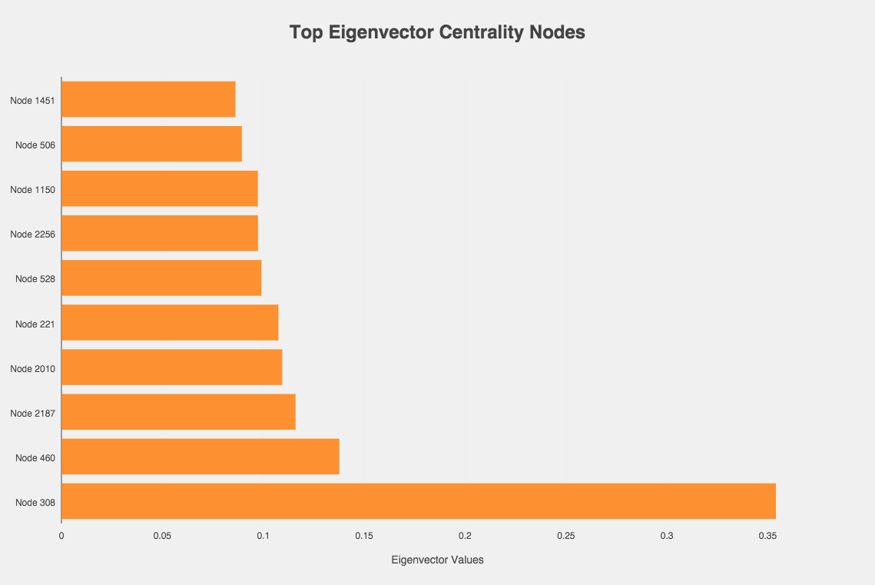

Using the fast greedy modularity optimization algorithm for finding community structure1, we were able to identify 1,882 communities with group sizes ranging from 2 to 13,688. The maximum modularity score for this complete network structure was 0.63. This indicates that the Gowalla network has somewhat dense connections within each of the communities.

The mean degree for this undirected network is 9.668. The degree distribution for the top 100 nodes exhibits a power law distribution, with the top nodes possessing 14,730 degrees.

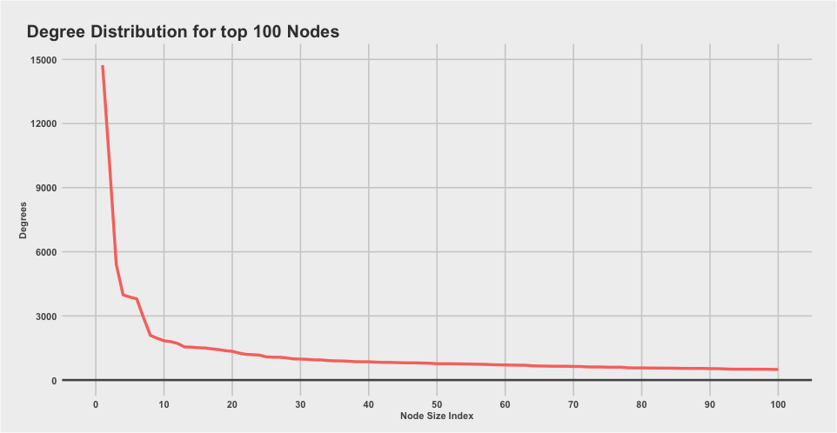

1 <http://arxiv.org/abs/cond-mat/0408187>

2 <https://snap.stanford.edu/data/loc-gowalla.html>

|  |  |  |  |
| --- | --- | --- | --- |
| **Node** | **Eigenvector** | **PageRank** | **Degree** |
| 308 | 0.354 | 0.3540 | 0.0749 |
| 460 | 0.1377 | 0.1377 | 0.0197 |
| 2187 | 0.116 | 0.0005 | 0.0093 |
| 2010 | 0.1094 | 0.0005 | 0.0087 |
| 221 | 0.1075 | 0.1075 | 0.0518 |
| 528 | 0.0991 | 0.0991 | 0.0148 |
| 2256 | 0.0974 | 0.0004 | 0.0079 |
| 1150 | 0.0973 | 0.0973 | 0.0202 |
| 506 | 0.0894 | 0.0894 | 0.0275 |
| 1451 | 0.0862 | 0.0005 | 0.0077 |

|  |  |
| --- | --- |
| ***Node*** | ***Clustering Coefficient*** |
| 308 | 0.00086 |
| 460 | 0.00554 |
| 2187 | 0.02033 |
| 2010 | 0.02064 |
| 221 | 0.00039 |
| 528 | 0.00512 |
| 2256 | 0.02197 |
| 1150 | 0.00272 |
| 506 | 0.00117 |
| 1451 | 0.01644 |