The Goodspeed Manuscript Collection Project
University of Chicago Library
Institute of Museum and library Services
National Leadership Grants
Grant Award Number: LG-05-05-02030-05
Interim report covering April 1, 2008 – September 30, 2008

Introduction

The Goodspeed Manuscript Collection Project was scheduled to conclude on September 30, 2008. We requested and received a one-year, no-cost extension for the project through September 30, 2009. With remaining funds we will continue scanning, editing and quality control to complete scanning of an additional 3,050 pages, or nine complete manuscripts, bringing the total scanned in the project to 66% of the Goodspeed Manuscript Collection.

During this period covered by this Interim report, the Library designed a new web interface to the Goodspeed Manuscript Collection, http://goodspeed.lib.uchicago.edu/. The interface brings together digital images and metadata and provides several browse lists to access manuscript-level and page-level descriptions that are linked to page images.

Digital Production

During this Interim period 1,453 master digital images of pages from 5.5 manuscripts were created and inspected. Over 10,000 thumbnail images were produced for the new interface. Final documentation about the digitization process was written and included in the “About the Digital Project” portion of the new interface.

Metadata and Web Interface Development

The graphical design of the interface has been completed. It incorporates images from a sample of the different types of manuscripts in the collection. Explanatory front matter has been expanded. Each manuscript is represented by a description, a set of thumbnail images of each page and a Zoomify interface that enables manipulation of high-resolution images. Descriptive records for the manuscripts are encoded in the xml tag set for manuscript description (TEI P5: Guidelines for Electronic Text Encoding and Interchange). Embedded within the manuscript description are links to specific pages that contain images or text divisions described within the record.

Several changes were made in response to reactions to the new web interface, for example the “Browse the Collection: label in the right panel is now clickable to a page that contains the explanations of a few of the browses that needed clarification. The creation of “printable” jpegs for each image is in process.

Assessment

The Goodspeed Assessment group plans to do usability testing, statistical analysis of web site use and a survey of researchers’ use of the content. These activities form part of the Library’s ongoing effort to understand user needs and the use of our digital collections.

Respectfully submitted,
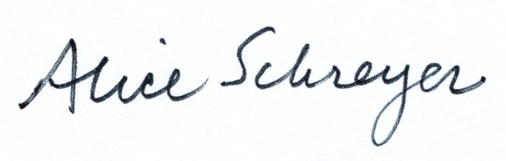
Alice Schreyer
Project Investigator

