8Name:Katana John Zito
Reg No:IN16/00002/24
1.Creat a trigger that should not allow removal of an employee from the employee table S001.
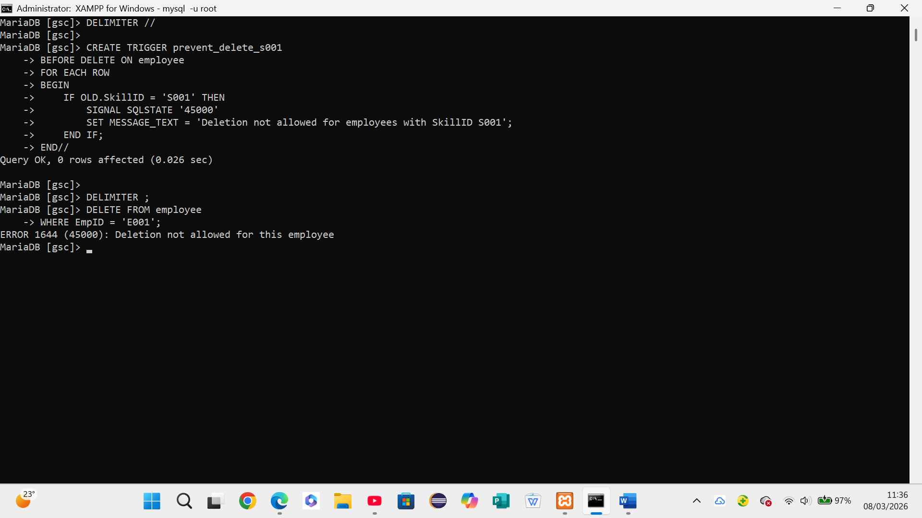
2.Create a trigger that should not allow the actual cost to be more than estimated cost of project P010 and P011.
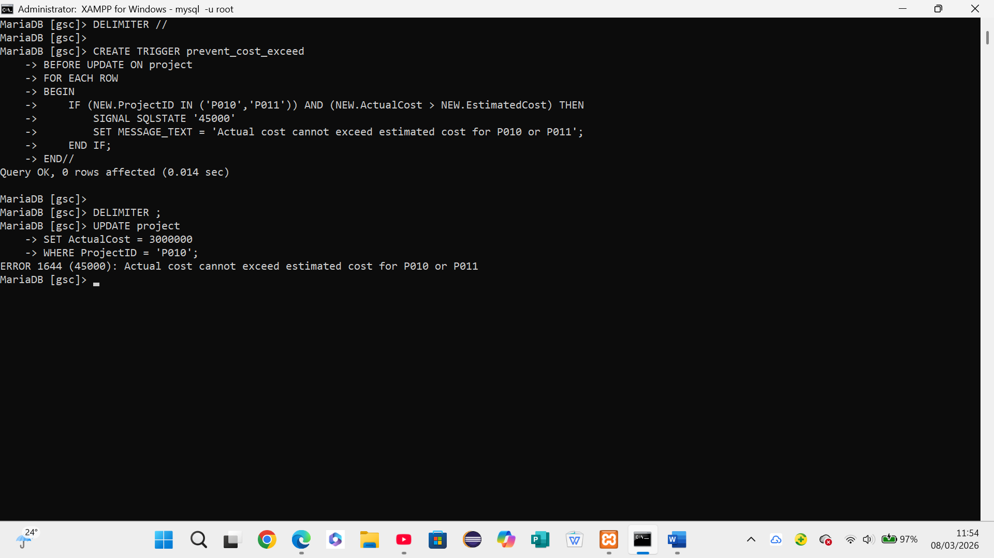
3.Create a trigger that should not allow adjustment of salary of employee who belong to S004.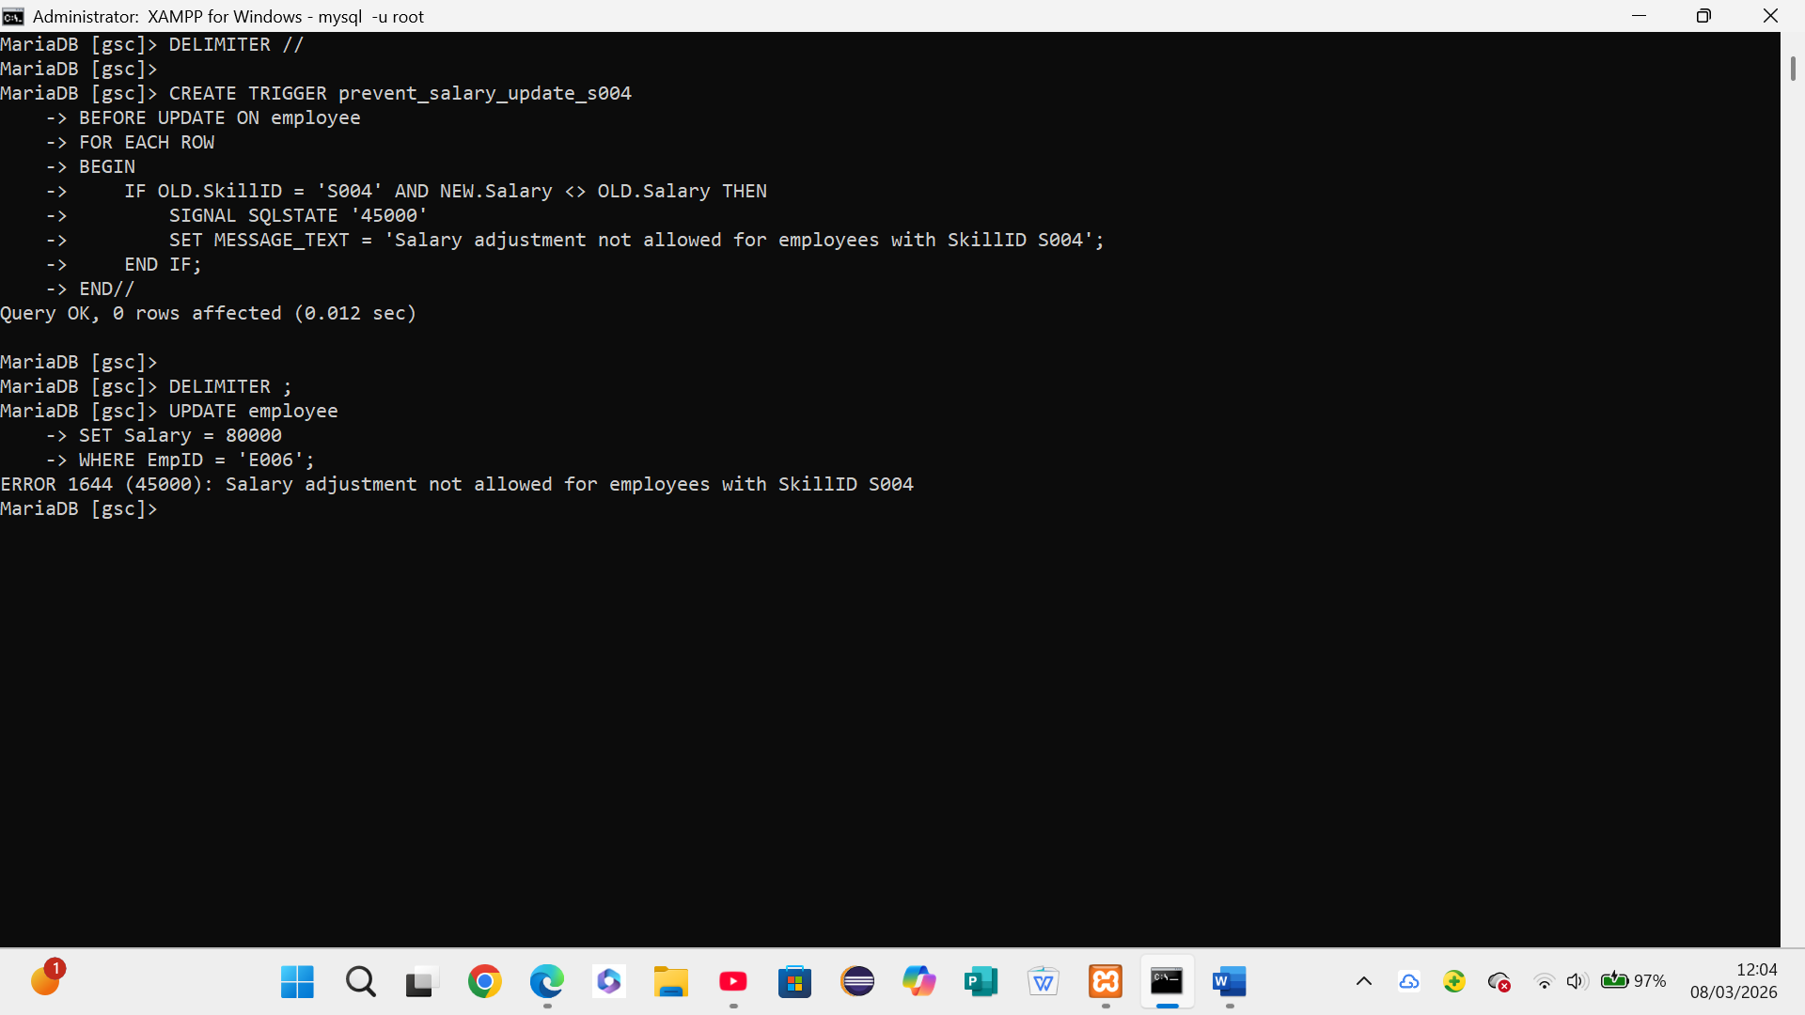
4.Create a trigger that should not allow new employee to s002.

