**QUALITY ASSURANCE REPORT**

**Project name: SmashAudio**

**Version: 2.0.1**

**Test Environment: Android 6.0**

**Test Device: Infinix X600-LTE**

**Date: 08/04/2019**

**QA Officer: John Kelvin Aondoakaa**

**Mode: Music**

|  |  |  |  |  |  |  |  |
| --- | --- | --- | --- | --- | --- | --- | --- |
| Case# | Test Case | Expected Result | | | Actual Result | | Remarks |
| 01 | Launch App | App should load home screen quickly | | | Home screen loads in 5 secs | | Pass |
| 02 | Display home screen features | Home button, music, recognition, radio & video buttons should display | | | Home screen features displayed as expected | | Pass |
| 03 | Home screen sectioning | Music, video and radio mode should be properly partitioned | | | Music, video and radio mode not properly partitioned on home screen | | Fail |
| 04 | Click on view all on either music, radio or video mode on the home screen | Display all music, all radio stations or all videos as the case may be | | | As expected | | Pass |
| 05 | Click the search button and search for either music, radio or video | Search field should return anything a user searches for that is available in the app | | | Search field returns only songs | | Search button should be specific |
| 06 | Click the dropdown on the top right | Display settings button and equalizer buttons | | | Equalizer and settings buttons displayed | | Pass |
| 07 | Click the menu button on the top left of the home screen | Menu should display: music library, recognition, radio, video, settings, about, rate us, signup/login, & exit buttons | | | All the functions displayed as expected | | Pass |
|  | **Music Mode** | | | | | |  |
| 08 | Click on music button | Music library should load up songs, albums, artists, playlist and folders | | | Music library loads up as expected | | Pass |
| 09 | Click on songs | List of all songs in the library should display | | | All songs displayed successfully | | Pass |
| 10 | Scroll songs list up and down | Songs lists should be scrollable | | | Songs list scrollable | | Pass |
| 11 | Click on any song | App should be able to play songs | | | SmashAudio played songs as expected | | Pass |
| 12 | Play Audio files | SmashAudio should be able to play songs in any Audio format | | | Songs in mp3, wma, wav played successfully | | Pass |
| 13 | Ability to check song details | User should be able to view the format and other details of a song | | | Song details not displayed | | Fail |
| 14 | Play, Pause and Resume functionality | User should be able to play, pause and resume playing on songs playlist | | | Play, pause and resume functionality not working on playlist | | Fail |
| 15 | Click on play next | Music player should play the song selected to play next | | | Song added to queue and duplicated | | Fail (not properly implemented) |
| 16 | Click on add to queue | Song should be added to the playlist queue | | | Song added to queue successfully | | Pass |
| 17 | Click on share button | Player should be able to share songs via different share medias | | | Songs shared successfully | | Pass |
| 18 | Click on add song to playlist | Player should be able to add songs to playlist | | | Songs added to playlist successfully | | Pass |
| 19 | Click on edit button | User should be able to edit song details | | | Song details edited as expected | | Pass |
| 20 | Click on go to album | Song list from the album of the chosen song should display | | | Folders displayed | | Fail |
| 21 | Click on go to artist | Display the list of songs of the particular artist | | | Displayed as expected | | Pass |
| 22 | Click on delete song | User should be able to delete songs from their device through the music player | | | Song deleted successfully from device | | Pass |
| 22. | Ability of user to play songs by album, artist, and folders | User should be able to play songs either by album, artist or folders | | | As expected | | Pass |
| 23 | Ability of user to create playlist | Users should be able to create their own playlist on SmashAudio | | | Playlist created successfully | | Pass |
| 24 | Ability repeat playing song | User should be able to place a song on repeat mode | | | Repeat mode functional | | Pass |
| 25 | Ability to play song at random | User should be able to shuffle and play songs at random | | | As expected | | Pass |
|  | **Recommendations of Music Module** | | | | | | |
| 03 | The home screen should be partitioned to accommodate music, radio & video player | | | | | | |
| 05 | The Search functionality should be specific on the home screen i.e. search music | | | | | | |
| 13 | Song details feature should be included to enable user check song info | | | | | | |
| 14 | The songs list should be implemented so to give the user a play, pause, and resume functionality | | | | | | |
| 15 | The play next functionality should be implemented in a way that when user selects a song to play next, what the user should experience is the player going to play the song which has been selected to play next after the current song, instead of a duplicated song list. | | | | | | |
| 20 | User should be taken to album instead of folders when user clicks on go to album | | | | | | |
|  | **General Recommendations** | | | | | | |
| #1 | All songs should load up even when a particular song is searched and played | | | | | | |
| #2 | After playing the song that is in queue, the player should continue with the next song in the list instead of jumping back to the point of the former. | | | | | | |
| #3 | The responsiveness of the entire app needs to be worked on as most menus and buttons takes a while to responds when they are clicked upon. | | | | | | |
|  | **Recognition Module** | | | | | | |
| Case# | Test case | | Expected Result | Actual Result | | Remarks | |
| 01 | Click on Recognition button | | Recognition screen should display | Recognition screen displayed | | Pass | |
| 02 | Tap the recognition symbol | | App should be able to listen and recognize songs | Recognition feature working as expected | | Pass | |
| 03 | Lyrics display | | Users should be able to view lyrics of songs recognized | Lyrics of songs displayed successfully | | Pass | |
| 04 | Ability of user to play recognized video | | Users should be able to stream videos of songs recognized from the recognition module | Videos not available | | Fail | |
| 05 | When music is not recognized | | User should be prompted when a song search for is not recognized | No result | | Pass | |
| Recommendation | | | | | | | |
| 04 | Video functionality should be properly implemented so that users can stream videos of recognized songs | | | | | | |
|  | **Radio Mode** | | | | | | |
| Case# | Test Case | | Expected Result | Actual Result | | Remarks | |
| 01 | Click the radio button | | The radio screen should load up country, Genres, & Favorites menus | Radio screen displayed with results as expected | | Pass | |
| 02 | Click on any country (Nigeria) | | List of radio stations should load up | Radio stations loads up over 2 mins with 4G-LTE network | | Radio stations takes too long to load up | |
| 03 | Click to stream a radio station | | User should be able to stream radio available stations | User able to stream radio within users metropolis | | Pass (response time is slow though) | |
| 04 | Click to stop radio | | User should be able to stop radio from streaming when the stop button is clicked | Radio streaming stopped successfully | | Pass (response time still slow) | |
| 05 | Back arrow screen | | Return user to radio screen menu | SmashAudio crashed | | Fail | |
| 06 | Click on Genre | | Display list of radio stations base on genre | Genre displayed | | Pass | |
| 07 | Stream station by genre | | Load radio station base on genre category | Stations loaded up successfully | | Pass (takes too long to load up) | |
| 08 | Click on favorites | | User should be able to add & play favorite radio stations | As expected | | Pass | |
| 09 | Ability to scroll up & down the app in the radio module | | User should be able to scroll up radio stations from top to bottom | Radio stations are scrollable | | Pass (The scrolling functionality hooks at some point) | |
| 10 | Ability to deselect a station as favorite station | | User should be able to deselect a radio station as favorite | Favorite radio station deselected | | Pass | |
| 11 | Search country | | User should be able to search radio stations by country | Radio stations can be search through countries | | Pass | |
| Recommendations | | | | | | | |
| 02 | Radio Stations should be able to load from a cache so to minimize the loading time | | | | | | |
| 03 | The responsiveness when user clicks on radio stations needs to be improved | | | | | | |
| 04 | The response time needs to be worked upon | | | | | | |
| 05 | The delay in response most often cause the app to crash, this should be checked | | | | | | |
|  |  | |  |  | |  | |
| **Video Module** | | | | | | | |
| Case# | Test Case | | Expected Result | Actual Result | | Remarks | |
| 01 | Click on the video button | | Video screen should display/load up library videos | Video screen loads up successfully as expected | | Pass | |
| 02 | Play video | | User should be able to play video clips | User can play videos with SmashAudio | | Pass | |
| 03 | Check video formats | | SmashAudio should be able to play different video formats | MP4, 3gp, & AVI video formats can be played on SmashAudio | | Pass (MPEG format can’t be played) | |
| 04 | Check play, pause, resume functionality | | User should be able to pause playing videos and resume at appropriate place where user paused or stopped | Play, pause and resume functionality works as expected | | Pass | |
| 05 | Check video details | | User should be able to check detail info about their videos | No functionality for video details | | Fail | |
| 06 | Ability to set video on repeat mode | | User should be able to set video on repeat mode | Repeat feature not implemented | | Fail | |
| 07 | Ability to play single or play all | | User should be able to play video either singly or play an entire video set | Play single/all functionality not implemented | | Fail | |
| 08 | Check different screen ratios | | Video should be able to fit different screen ratios | Video fits horizontally(16:9) vertically (4:3) & center | | Pass | |
| 09 | Check video quality | | Video quality should be HD, clean and clear | Video quality not up to best quality | | Fail | |
| 10 | Ability to share video | | User should be able to share video via different share mediums | No share functionality implemented | | Fail | |
| Recommendations | | | | | | | |
| 03 | SmashAudio should include more video playing formats such as mpeg, wmv, flv | | | | | | |
| 05 | A details button should be included so that user can be able to check video info | | | | | | |
| 06 | Repeat feature should be implemented | | | | | | |
| 07 | Play Single/play all feature should be implemented | | | | | | |
| 09 | The video quality needs to be improved | | | | | | |
| 10 | Share video functionality should be included in video module | | | | | | |
|  |  | |  |  | |  | |
| General | | | | | | | |
| Case# | Test Case | | Expected Result | Actual Result | | Remarks | |
| 01 | Sign up | | New users should be able to create a user id on smashAudio | User can create a user id | | Pass | |
| 02 | Login | | Existing users should be able to login to the app | Existing user logged in successfully | | Pass | |
| 03 | Forgot password | | User should be able to explore the forgot password feature to recover their password | SmashAudio crashes when user tries to explore this option | | Fail | |
| 04 | Ability to logout | | User should be able to logout from the app | User logged out successfully | | Pass | |
| 05 | Ability to view and edit user profile | | User should be able to view & edit his/her profile when user navigate to profile | View and edit profile functionality working as expected | | Pass | |
| 06 | Invite friend | | User should be able to invite their friends via different sms medias to download smashaudio | Play store download link for smashaudio successfully sent with user referral id | | Pass | |
| 07 | About us screen | | User should be able to video details about smashaudio including version | About us screen displayed with expected results | | Pass | |
| 08 | Rate us | | User should be able to give feedback about smashaudio | User redirected to play store for appropriate rating and review | | Pass | |
| 09 | Exit | | User should be able to close the app with the exit button | App closed at once with exit button | | Pass | |
| Recommendation | | | | | | | |
| 03 | The forgot functionality should be implemented properly for password recovery | | | | | | |
|  |  | |  |  | |  | |
| **Settings** | | | | | | | |
| Case# | Test Case | | Expected Result | Actual Result | | Remarks | |
| 01 | Click on settings button | | Setting screen should display with settings functions | Settings screen displayed as expected | | Pass | |
| 02 | Click on now playing | | User should be able to select different now playing screens when user explores this functionality | Now playing screens selected successfully | | Pass | |
| 03 | Theme | | User should be able to personalize their theme | Dark and blue theme available for personalization | | More themes should be included | |
| 04 | Primary Color | | User should be able to customize their theme color | Different color sets available for them customization | | Pass | |
| Recommendation | | | | | | | |
| 03 | More themes should be made available if possible user should be able to use pictures to customize their theme | | | | | | |
| # | Some of the functionalities in the settings have no explicit relevance or effect when they are checked such as lastFM, playing queue support in notification. | | | | | | |
| # | The lastFM feature crashes the app. This needs to be improved on | | | | | | |
|  |  | | | | | | |
|  | General Remark | | | | | | |
|  | The Revamped SmashAudio (Version 2.0.1) app is experiencing lots of crashes and slow response thus it is worth to say it is not ready to be pushed to play store. | | | | | | |

Below are screen shots for the notice defects

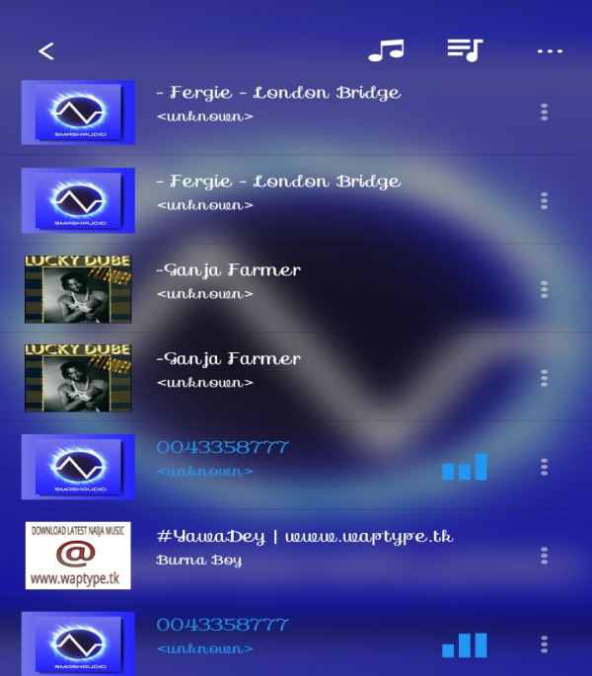

Duplicate of song when user clicks on play next

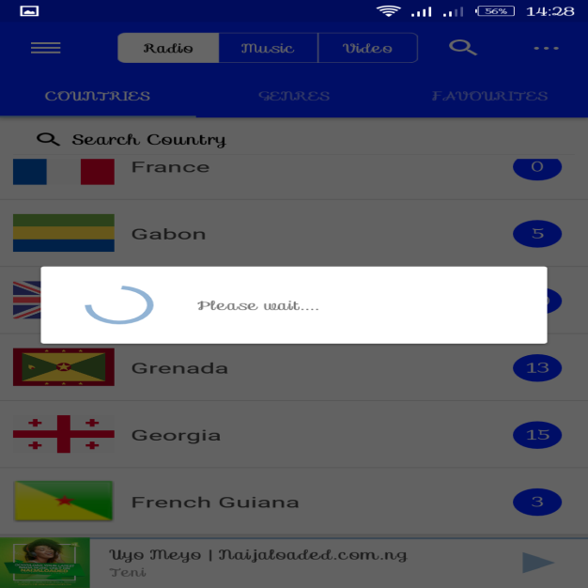

Radio Stations Taking a while to load up

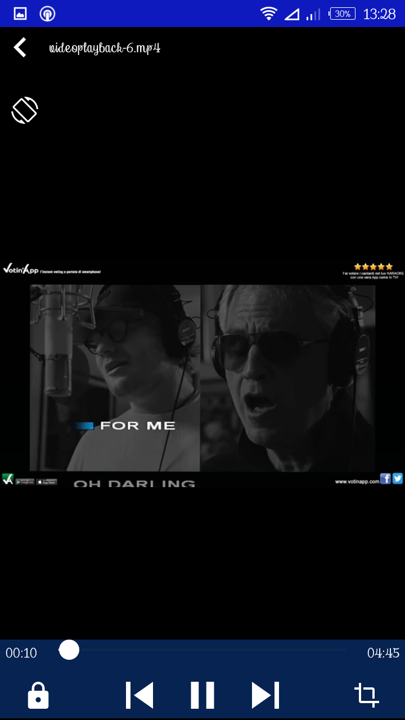

No functionalities on video mode

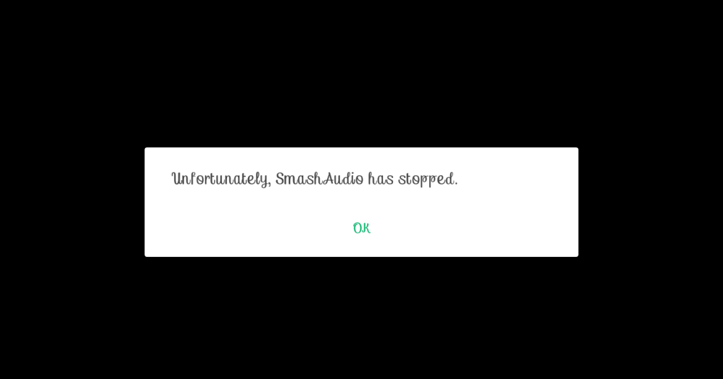

Crashed messages while exploring SmashAudio