**CERTIFICATE**

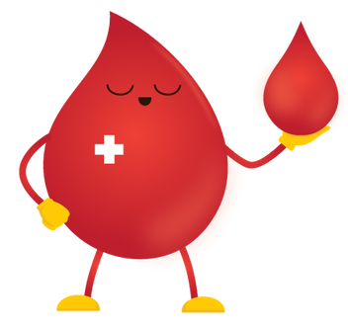

*OF APPRECIATION FOR BLOOD DONATION*

This certificate is presented to

${fullname}

${date}

In recognition of their generous act of donating blood. Their selfless contribution will help save the lives of many and is greatly appreciated by the community.

DIANE TY-OLBES, RMT

REGISTERED MED. TECHNOLOGIST