**CERTIFICATE**

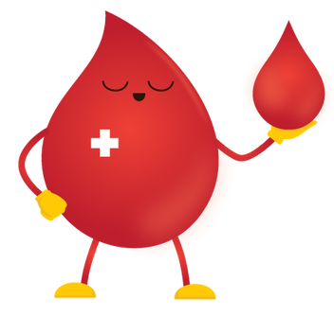

*OF APPRECIATION FOR BLOOD DONATION*

This certificate is presented to

Violet Mccray

January 31, 2023

In recognition of their generous act of donating blood. Their selfless contribution will help save the lives of many and is greatly appreciated by the community.

DIANE TY-OLBES, RMT

REGISTERED MED. TECHNOLOGIST