1.

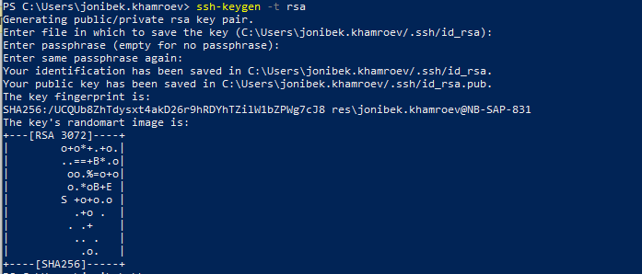

2. Get list of all OS processes sorted by PID and save to a file

🡪 create a file

Vim myscript

🡪 add script

#!/bin/bash

## List of all active OS processes sorted by PID and save to a file

ps aux --sort pid > processes.txt

🡪 add execute permission

chmod a+x myscript

🡪 run the file

./myscript