John Reagan

SE 554

Quiz Master

**Overview:**

A simple quiz administration application allowing registered users to create quizzes, take quizzes, view high scores and invite others to take a quiz.

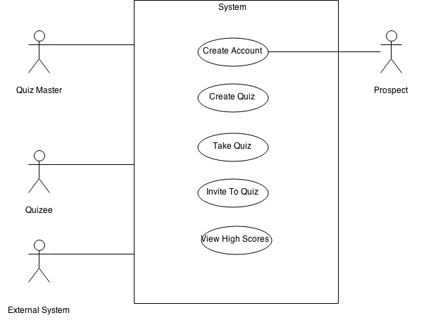

**Description of problem:**

Basic quiz administration functionality for quiz masters, quizees, prospects and an external system. The application currently supports multiple choice quiz formats, but expanding the scope to include text, numerical and picture answers is planned.

**UML Diagrams**:

Quiz-Question-Answer Diagram:

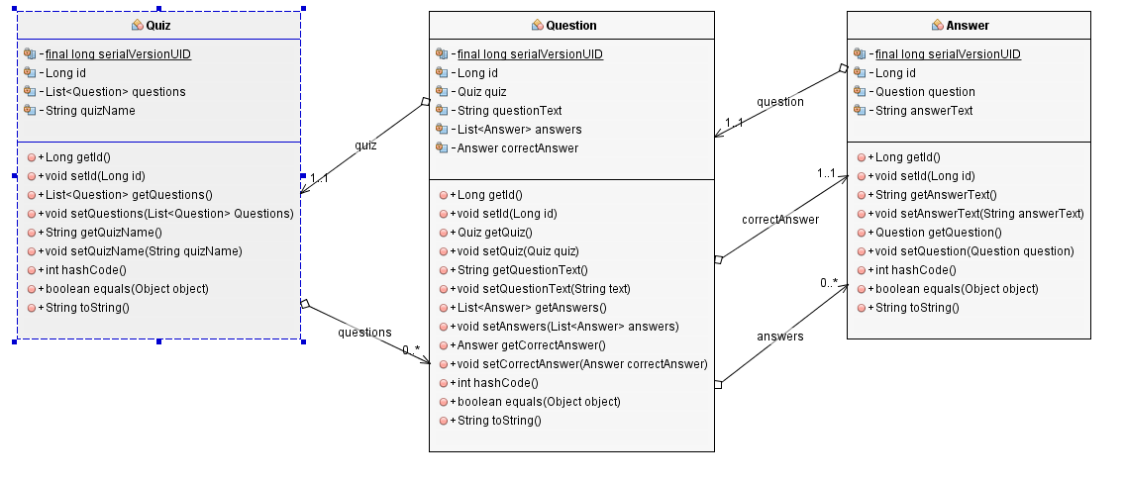

Complete Diagram showing relationships with player & quizmatch:

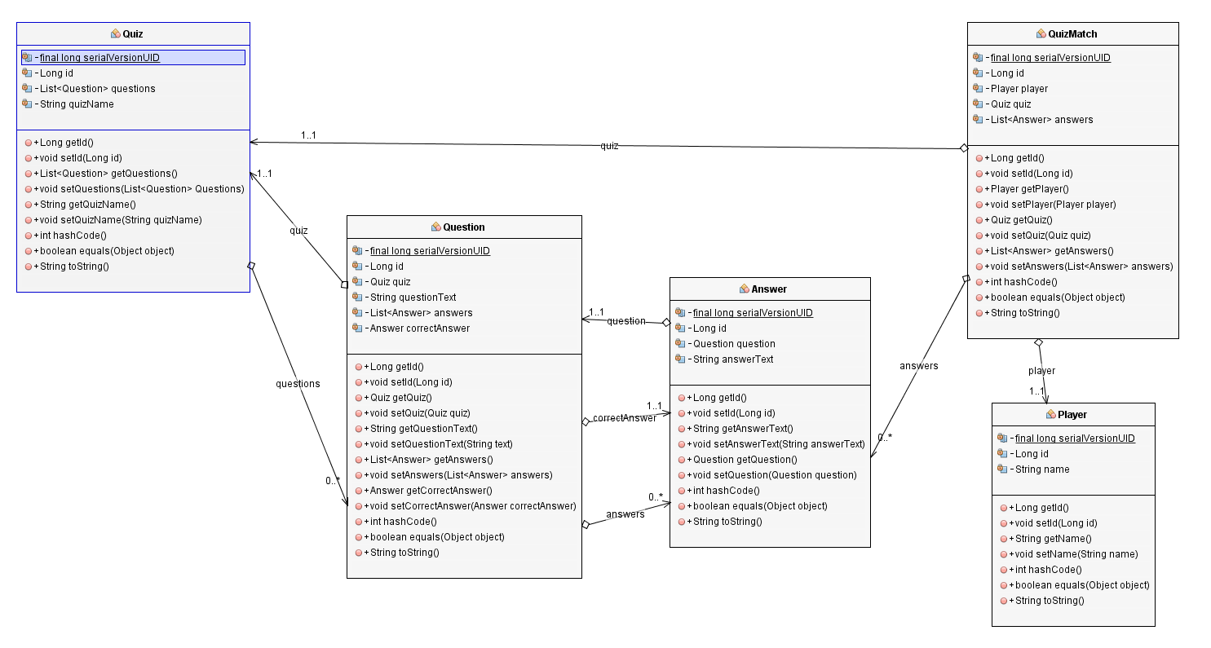

**Table Structure:**

|  |  |  |  |
| --- | --- | --- | --- |
| |  | | --- | | QUIZ | | ID  QUIZ_NAME | | A quiz is created by a user and contains a list of questions which in turn hold answers. |
| |  | | --- | | QUESTION | | ID  QUESTION_TEXT  QUIZ_ID  CORRECTANSWER_ID | | A question is a question in a quiz. It holds a reference to the quiz which holds it as well as the correct answer for the question.  Ex: What color is the sky? |
| |  | | --- | | ANSWER | | ID  ANSWER_TEXT  QUESTION_ID | | Stores an answer associated with a quiz. May or may not be the correct answer for the question.  Ex:  Blue  Brown |
| |  | | --- | | QUIZMATCH | | ID  PLAYER_ID  QUIZ_ID | | A quizmatch represents an instance of a quiz being taken. Accordingly, it holds a reference to the quiz being taken as well as the player taking it. |
| |  | | --- | | PLAYER | | ID  PLAYER_NAME | | A player, or quizee, is a user of the application who is taking a quiz. |
| |  | | --- | | QUIZMATCH_ANSWER | | QUIZMATCH _ID  ANSWER _ID | | Table used to maintain the maintain the many to many relationship between the quizmatch and answer tables. Essentially, this table stores the supplied answers for a quiz by a player. |
| |  | | --- | | SEQUENCE | | SEQ_NAME  SEQ_COUNT | |  |

**Github repository:**

<https://github.com/johnkreagan/QuizMaster/>