John Kucera

Prof. Mark Muñoz

CMIS 242

28 March 2019

Week 2, Project 1

|  |  |  |  |
| --- | --- | --- | --- |
| **Input**  (from data.txt) | **Expected Output** | **Actual Output** | **Pass?** |
| 2014 Employee Washington,George 2000 | 2014 Report:  Employee Name: Washington,George  Monthly Salary: $2000  Annual Salary: $24000.00 | 2014 Report:  Employee Name: Washington,George  Monthly Salary: $2000  Annual Salary: $24000.00 | YES. All data matches for a **2014 Employee**. |
| 2015 Employee Madison,James 4000 | (Under 2015 Report:)  Employee Name: Madison,James  Monthly Salary: $4000  Annual Salary: $48000.00 | (Under 2015 Report:)  Employee Name: Madison,James  Monthly Salary: $4000  Annual Salary: $48000.00 | YES. All data matches for a **2015 Employee**. |
| 2014 Salesman Pierce,Franklin 9900 300000 | (Under 2014 Report:)  Employee Name: Pierce,Franklin  Monthly Salary: $9900  Annual Sales: $300000  Annual Salary: $124800.00 | (Under 2014 Report:)  Employee Name: Pierce,Franklin  Monthly Salary: $9900  Annual Sales: $300000  Annual Salary: $124800.00 | YES. All data matches for a **2014 Salesman**, **Annual Sales  < $20000** |
| 2014 Salesman Monroe,James 6500 1500000 | (Under 2014 Report:)  Employee Name: Monroe,James  Monthly Salary: $6500  Annual Sales: $1500000  Annual Salary: $98000.00 | (Under 2014 Report:)  Employee Name: Monroe,James  Monthly Salary: $6500  Annual Sales: $1500000  Annual Salary: $98000.00 | YES. All data matches for a **2014 Salesman**, **Annual Sales  > $20000** |
| 2015 Salesman Adams,John 3000 100000 | 2015 Report:  Employee Name: Adams,John  Monthly Salary: $3000  Annual Sales: $100000  Annual Salary: $38000.00 | 2015 Report:  Employee Name: Adams,John  Monthly Salary: $3000  Annual Sales: $100000  Annual Salary: $38000.00 | YES. All data matches for a **2015 Salesman**, **Annual Sales  < $20000** |
| 2015 Salesman Johnson,Andrew 400 2000000 | (Under 2015 Report:)  Employee Name: Johnson,Andrew  Monthly Salary: $400  Annual Sales: $2000000  Annual Salary: $24800.00 | (Under 2015 Report:)  Employee Name: Johnson,Andrew  Monthly Salary: $400  Annual Sales: $2000000  Annual Salary: $24800.00 | YES. All data matches for a **2015 Salesman**, **Annual Sales  > $20000** |
| 2014 Executive Taylor,Zachary 2700 30 | (Under 2014 Report:)  Employee Name: Taylor,Zachary  Monthly Salary: $2700  Stock Price: $30.00  Annual Salary: $32400.00 | (Under 2014 Report:)  Employee Name: Taylor,Zachary  Monthly Salary: $2700  Stock Price: $30.00  Annual Salary: $32400.00 | YES. All data matches for a **2014 Executive**, **Stock Price < $50** |
| 2014 Executive Jefferson,Thomas 5000 55 | (Under 2014 Report:)  Employee Name: Jefferson,Thomas  Monthly Salary: $5000  Stock Price: $55.00  Annual Salary: $90000.00 | (Under 2014 Report:)  Employee Name: Jefferson,Thomas  Monthly Salary: $5000  Stock Price: $55.00  Annual Salary: $90000.00 | YES. All data matches for a **2014 Executive**, **Stock Price > $50** |
| 2015 Executive Buchanan,James 8700 15 | (Under 2015 Report:)  Employee Name: Buchanan,James  Monthly Salary: $8700  Stock Price: $15.00  Annual Salary: $104400.00 | (Under 2015 Report:)  Employee Name: Buchanan,James  Monthly Salary: $8700  Stock Price: $15.00  Annual Salary: $104400.00 | YES. All data matches for a **2015 Executive**, **Stock Price < $50** |
| 2015 Executive Jackson,Andrew 2000 80 | (Under 2015 Report:)  Employee Name: Jackson,Andrew  Monthly Salary: $2000  Stock Price: $80.00  Annual Salary: $54000.00 | (Under 2015 Report:)  Employee Name: Jackson,Andrew  Monthly Salary: $2000  Stock Price: $80.00  Annual Salary: $54000.00 | YES. All data matches for a **2015 Executive**, **Stock Price > $50** |
| data.txt  Annual Salaries (2014) | (Under 2014 Report:)  Average Salary among Employees in 2014: $606500.00 | (Under 2014 Report:)  Average Salary among Employees in 2014: $606500.00 | YES. This is the correctly calculated **Average Annual Salary among Employees in 2014.** |
| data.txt Annual Salaries  (2015) | (Under 2015 Report:)  Average Salary among Employees in 2015: $97384.00 | (Under 2015 Report:)  Average Salary among Employees in 2015: $97384.00 | YES. This is the correctly calculated **Average Annual Salary among Employees in 2015**. |

**ACTUAL OUTPUT SCREENSHOTS (Netbeans IDE)**

**Full Report using the file “data.txt”:**

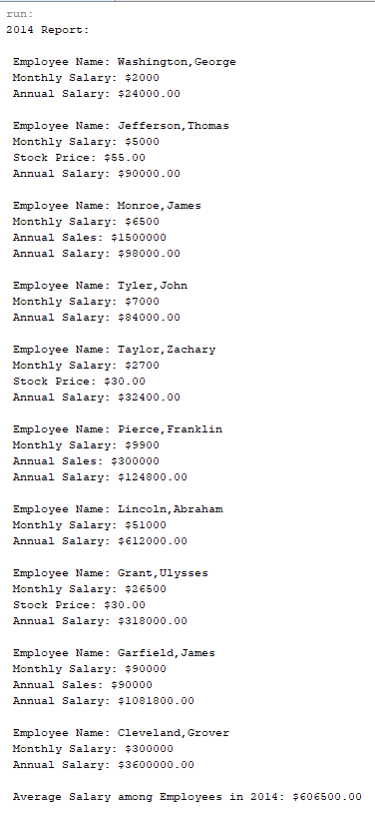 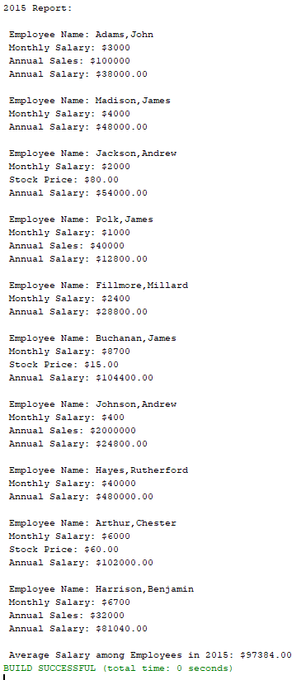

1. 2014 Employee  
    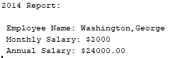
2. 2015 Employee (Under 2015 Report:)  
   
3. 2014 Salesman, Annual Sales < $20000 (Under 2014 Report:)  
   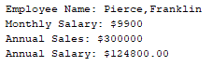
4. 2014 Salesman, Annual Sales > $20000 (Under 2014 Report:)  
   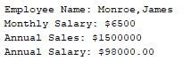
5. 2015 Salesman, Annual Sales < $20000  
   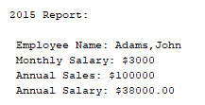
6. 2015 Salesman, Annual Sales > $20000 (Under 2015 Report:)  
   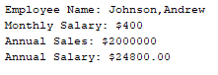
7. 2014 Executive, Stock Price < $50 (Under 2014 Report:)  
   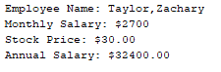
8. 2014 Executive, Stock Price > $50 (Under 2014 Report:)  
   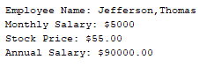
9. 2015 Executive, Stock Price < $50 (Under 2015 Report:)  
   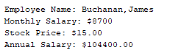
10. 2015 Executive, Stock Price > $50 (Under 2015 Report:)  
    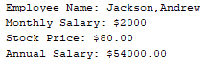
11. Average Annual Salary among Employees in 2014 (Under 2014 Report:)  
    
12. Average Annual Salary among Employees in 2015 (Under 2015 Report:)  
    