John Kucera

Prof. Mark Muñoz

CMIS 242

7 May 2019

Week 8, Project 4

HOW IT LOOKS:

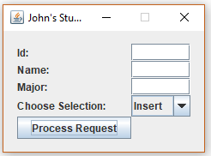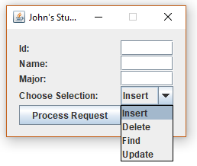

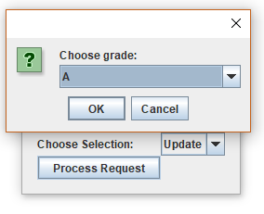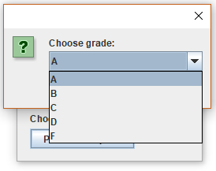

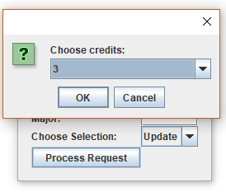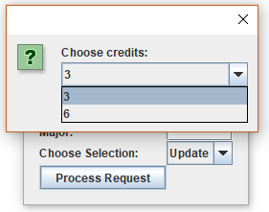

|  |  |  |  |
| --- | --- | --- | --- |
| **Input  (into GUI)** | **Expected Output** | **Actual Output (SCREENSHOTS from Netbeans IDE)** | **Pass?** |
| Insert: Empty ID | Message Dialog Box: A valid ID must be entered. Please try again. |  | YES |
| Delete: Empty ID | Message Dialog Box: A valid ID must be entered. Please try again. |  | YES |
| Delete: Nonexistent ID | Message Dialog Box: This ID does not exist in the database. Please try again. |  | YES |
| Find: Empty ID | Message Dialog Box: A valid ID must be entered. Please try again. |  | YES |
| Find: Nonexistent ID | Message Dialog Box: This ID does not exist in the database. Please try again. |  | YES |
| Update: Empty ID | Message Dialog Box: A valid ID must be entered. Please try again. |  | YES |
| Update: Nonexistent ID | Message Dialog Box: This ID does not exist in the database. Please try again. |  | YES |
| Insert: Valid ID, Name, Major  123, John Kucera, Computer Science | Message Dialog Box: Success! This student has been added to the database. |  | YES |
| Insert: Duplicate ID  123, John Kucera, Computer Science | Message Dialog Box: This student ID already exists in the database. Please try again. |  | YES |
| Find: ^Valid ID  123, John Kucera, Computer Science | Message Dialog Box: Success! This student is in the database.  Id: 123  Name: John Kucera  Major: Computer Science  GPA: 4.00 |  | YES |
| Update: ^Valid ID. Grade B, Credits 3.  123, John Kucera, Computer Science | Message Dialog Box: Success! This student’s record has updated. |  | YES |
| Find: ^Valid ID after updating  123, John Kucera, Computer Science | Message Dialog Box: Success! This student is in the database.  Id: 123  Name: John Kucera  Major: Computer Science  GPA: 3.00 |  | YES |
| Delete: ^Valid ID  123, John Kucera, Computer Science | Message Dialog Box: Success! This student has been removed from the database. |  | YES |
| Insert: 456, Guts Griffith, Bodybuilding  3 Updates: Grade C, Credits 6. Grade F, Credits 3.  Grade D, Credits 3.  Find: 456 | Message Dialog Box: Success! This student is in the database.  Id: 456  Name: Guts Griffith  Major: Bodybuilding  GPA: 1.25 |  | YES |
| Insert: 789, Shinji Ikari, Crying  5 Updates: Grade A, Credits 6. Grade B, Credits 3.  Grade A, Credits 3.  Grade A,  Credits 3.  Grade C,  Credits 3.  Find: 789 | Message Dialog Box: Success! This student is in the database.  Id: 789  Name: Shinji Ikari  Major: Crying  GPA: 3.50 |  | YES |
| Insert: 000, Popuko Pipimi, Education  5 Updates: Grade D, Credits 6. Grade C, Credits 6.  Grade A, Credits 3.  Grade F,  Credits 3.  Grade D,  Credits 3.  Find: 000 | Message Dialog Box: Success! This student is in the database.  Id: 000  Name: Popuko Pipimi  Major: Education  GPA: 1.57 |  | YES |