John Kucera

Prof. Didier Vergamini

CMSC 335 Object-Oriented and Concurrent Programming

01 November 2020

Week 2: Project 1 Documentation & Solution Description

**Class Hierarchy for Shapes + Command-line Driven Menu**

**Assumptions + Design decisions:**

* java.lang.Object is the parent class of Shape.
* Attribute numberOfDimensions refers to a Shape being two-dimensional (numberOfDimensions = 2) or three-dimensional (numberOfDimensions = 3). Variables in the Main Menu such as dimension1 and dimension2 refer to the user input dimensions for each construction.
* The String name attribute for each Shape is arguably unnecessary, but I wanted to add something to the parent Shape class besides numberOfDimensions.
* I included at least one unique characteristic to each Shape grandchild class. Examples: Circle has circumference, Rectangle has diagonal, Sphere has spherical cap volume.
* **Negative double** or **zero** values are NOT ALLOWED for dimension input. In this program, every shape must have positive dimensions. Example: Inputting a height of 0 or -6 for a Cylinder will result in Number Format Exception being thrown and the user must try again.
* White space (before and after) is allowed for all input.
* No-argument constructors are not used in the Main Menu, but still included in each class. No-argument constructors assume dimensions of 0, as there is no input information in these cases. No-argument constructor of a Shape assumes numberOfDimensions = 1 as a minimum.
* There is never any user input for the variables int numberOfDimensions and String name, but the variables are still included in each Class for consistency.
* Triangles with non-existent area or 0 area are not allowed. Example: Triangle with sides of 2, 4, and 6 has an area of 0. Triangle with sides of 1, 3, and 50 cannot exist. When this occurs, the user is notified to try again with proper dimensions.
* A Spherical Cap’s Height cannot be more than the Sphere’s Radius, as that would technically turn the Cap into a Hemisphere. This is not allowed in this program. Example: Inputting a Sphere Radius of 5 and a Spherical Cap Height of 6 will result in notifying the user to try again with proper dimensions.
* There is no known formula for the volume of a Spindle Torus. I could not find one when researching.
* Assuming my audience is looking for the most accurate answers, I did not round any decimals from the returned double values.
* When the menu asks the user if they want to continue or exit after constructing a shape, the same boolean continueOrExit() method is used after every different shape. So, I found it unnecessary to have many test cases of it being used after EVERY shape since it’s going to be the same method every time. There are still sufficient test cases for it in this document.

**UML Class diagram:** See Fig. 1. “Has-a” attributes and methods are listed in each Class.

Figure : Project 1 UML Class Diagram. (Kucera, 2020)

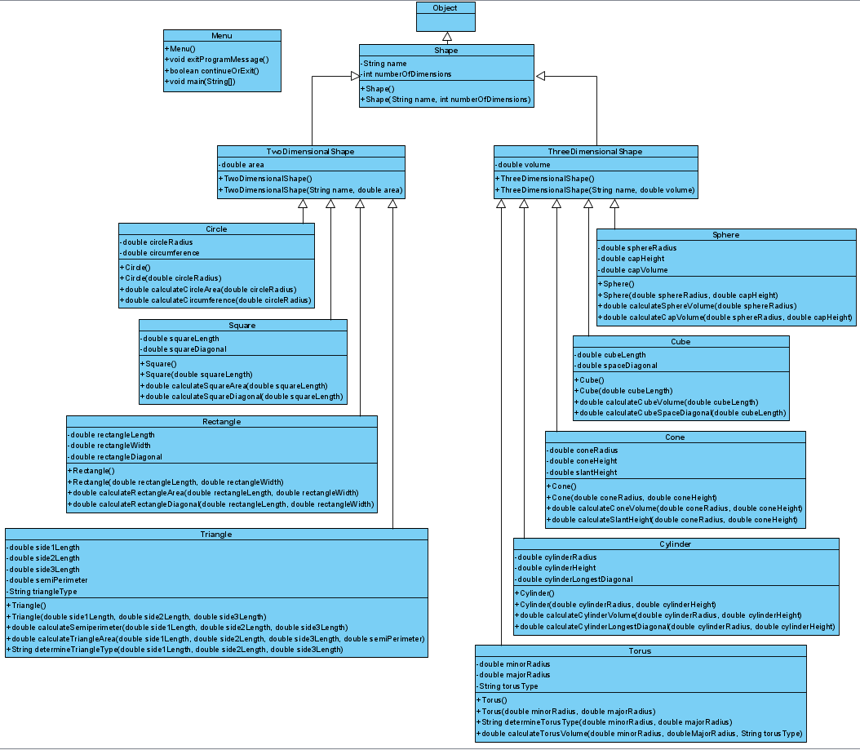

**User’s Guide: How to set up and run this application**

1. With a software tool that can manage .zip and .rar files such as WinRAR, unzip my submitted zip file **JohnKuceraProject1.zip**. You can do this easily by right-clicking **JohnKuceraProject1.zip** and clicking **Extract Files**, then click **OK** (See Fig. 2). This gives you a readable folder with the application files inside (See Fig. 3).

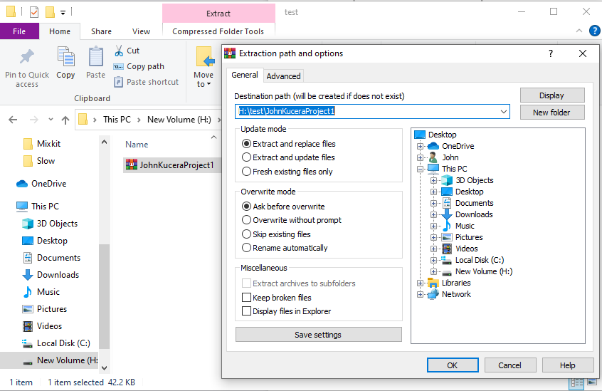

Figure 2: Unzipping a .zip file. (Kucera, 2020)

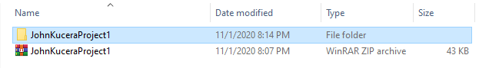

Figure 3: .zip file has been unzipped. (Kucera, 2020)

1. Open your IDE and create a new project (any IDE will work). Select Java Application (See Fig. 4 for example in Netbeans IDE).

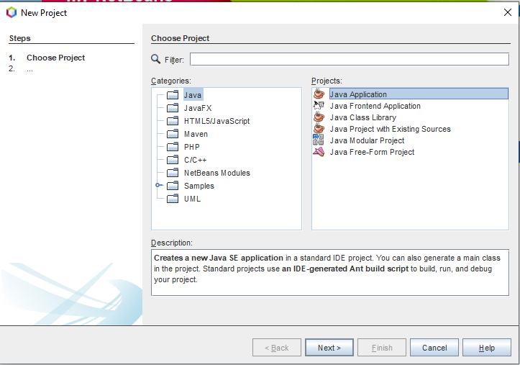

Figure 4: Creating Java Application Project in Netbeans. (Kucera, 2020)

1. (See Fig. 5) Name the project “**Test Kucera Project 1**”. Identify the project location (which is where the application files will be saved). **DO NOT allow the IDE to automatically create main class**.

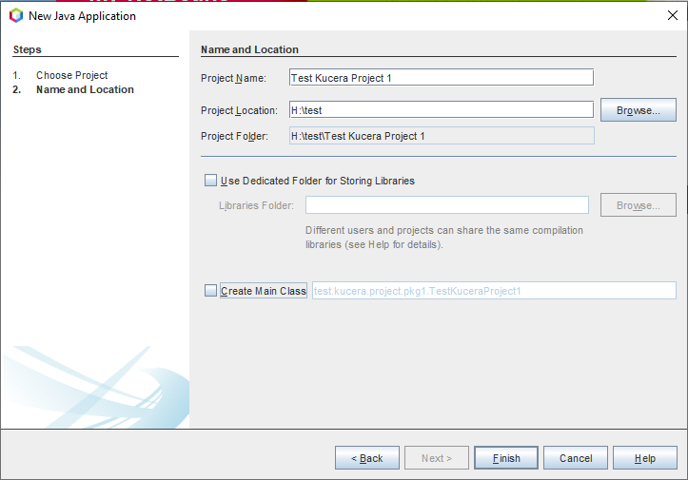

Figure 5: Creating Test Kucera Project 1. (Kucera, 2020)

1. In your File Explorer, go to the unzipped **JohnKuceraProject1 > src** folder and copy the 13 .java source files: **Circle.java, Cone.java, Cube.java, Cylinder.java, Menu.java, Rectangle.java, Shape.java, Sphere.java, Square.java, ThreeDimensionalShape.java, Torus.java, Triangle.java, TwoDimensionalShape.java** (See Fig. 6).

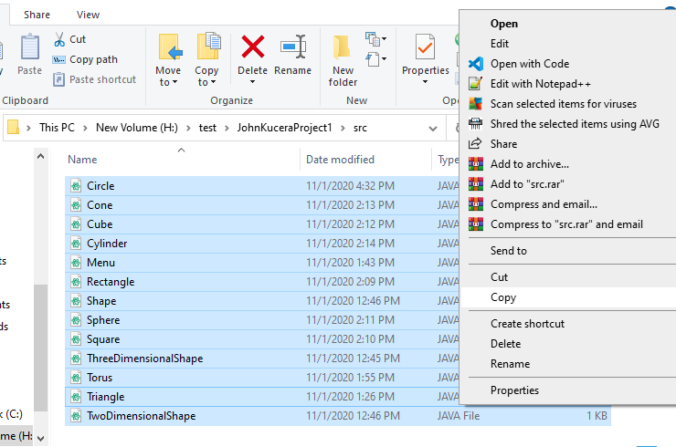

Figure 6: Copying Application Source Files. (Kucera, 2020)

1. Paste them into the **src** folder in YOUR project folder: **Test Kucera Project 1 > src** (See Fig. 7). They will appear in your IDE under the new project’s Source Packages (See Fig. 8).

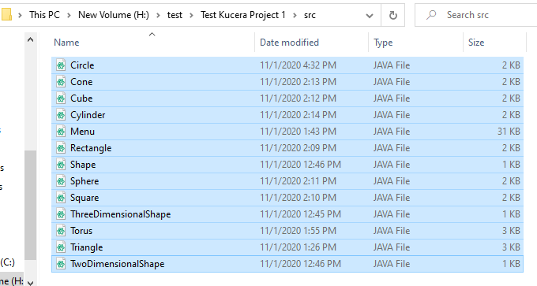

Figure 7: Pasting Application Source Files in Test Project. (Kucera, 2020)

Figure 8: Pasted Source Files appear in IDE. (Kucera, 2020)

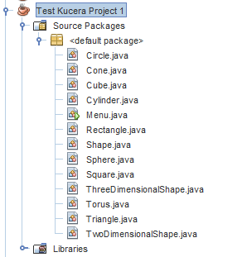

1. In the IDE, open the **Project Properties** of **Test Kucera Project 1**. You can do this by right-clicking **Test Kucera Project** 1 and clicking **Properties**. In the “Run” options, change the Main Class to “**Menu**”, since the Main Method for this application is in **Menu.java** (See Fig. 9).

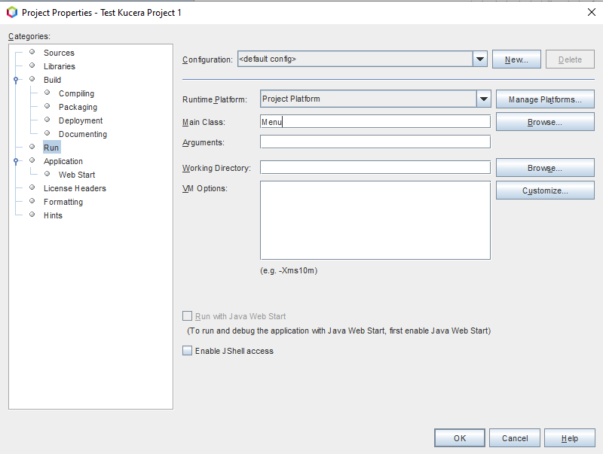

Figure 9: Project Properties > Run, type in Main Class. (Kucera, 2020)

1. You can click on each source file to open them and view the Java code in each. To run the application, make sure **Menu.java** is open and click **Run Project** (See Fig. 10).

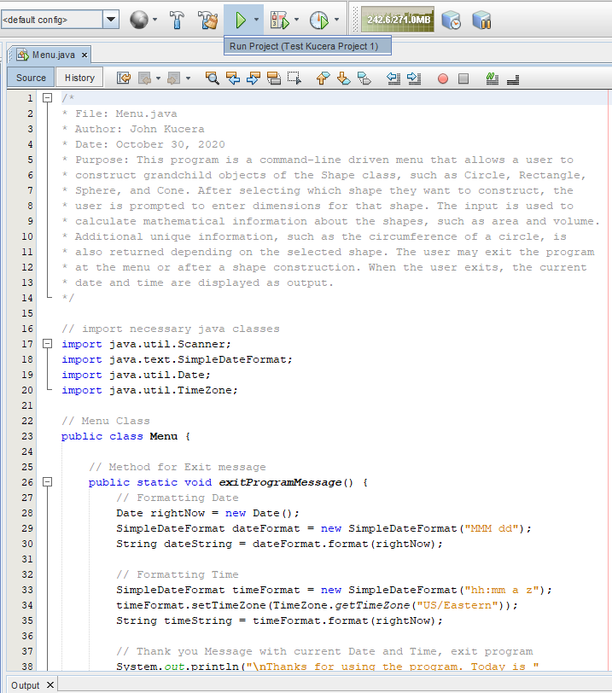

Figure 10: Open Menu.java, click Run Project. (Kucera, 2020)

1. Go down to the output console to see that the main menu has been output for the user to view and respond to (See Fig. 11).

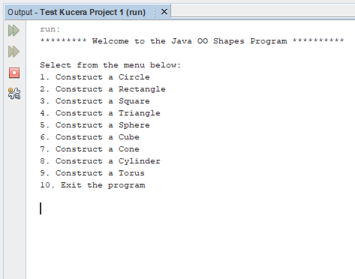

Figure 11: Run project, menu displayed. (Kucera, 2020)

1. User input is allowed in the console as the application runs. Try testing the application by performing the Test Cases shown below.

**Test Cases (Summary)**

Test cases are numbered and are organized according to the shape construction they test.

|  |  |
| --- | --- |
| **Aspect Tested** | **Test Case #** |
| Menu invalid input | 1 to 5 |
| 1. Circle | 6 to 17 |
| 1. Rectangle | 18 to 32 |
| 1. Square | 33 to 41 |
| 1. Triangle | 42 to 65 |
| 1. Sphere | 66 to 79 |
| 1. Cube | 80 to 85 |
| 1. Cone | 86 to 96 |
| 1. Cylinder | 97 to 107 |
| 1. Torus | 108 to 119 |
| 1. Exit the program | 120 |
| Results: **120 out of 120 Test Cases PASSED. The program is successful.** | |

**Test Cases**

1. **Aspect Tested:** Menu: Input integer outside of 1 to 10. (Not allowed)

**Input:** 23

**Expected Output:** Invalid input. Only integers 1 to 10 are accepted as input. Please try again. (Menu is displayed again and prompts for user input)

**Actual Output**: See Fig. 12.

Figure 12: Test Case 1 Output. (Kucera, 2020)

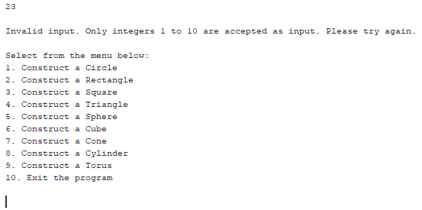

**Pass or Fail?**: PASS

1. **Aspect Tested:** Menu: Input character. (Not allowed)

**Input:** e

**Expected Output:** Invalid input. Only integers 1 to 10 are accepted as input. Please try again. (Menu is displayed again and prompts for user input)

**Actual Output**: See Fig. 13.

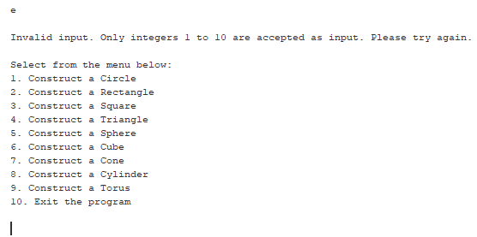

Figure 13: Test Case 2 Output. (Kucera, 2020)

**Pass or Fail?**: PASS

1. **Aspect Tested:** Menu: Input String (Not allowed)

**Input:** One

**Expected Output:** Invalid input. Only integers 1 to 10 are accepted as input. Please try again. (Menu is displayed again and prompts for user input)

**Actual Output**: See Fig. 14.

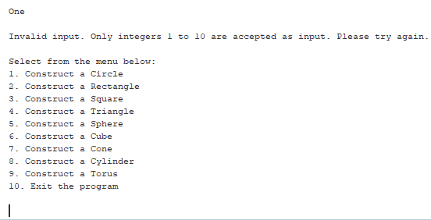

Figure 14: Test Case 3 Output. (Kucera, 2020)

**Pass or Fail?**: PASS

1. **Aspect Tested:** Menu: Input symbol. (Not allowed)

**Input:** $

**Expected Output:** Invalid input. Only integers 1 to 10 are accepted as input. Please try again. (Menu is displayed again and prompts for user input)

**Actual Output**: See Fig. 15.

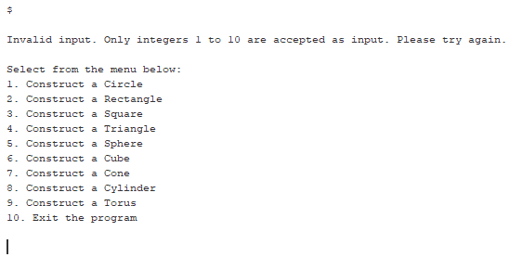

Figure 15: Test Case 4 Output. (Kucera, 2020)

**Pass or Fail?**: PASS

1. **Aspect Tested:** Menu: Input double. (Not allowed)

**Input:** 2.6

**Expected Output:** Invalid input. Only integers 1 to 10 are accepted as input. Please try again. (Menu is displayed again and prompts for user input)

**Actual Output**: See Fig. 16.

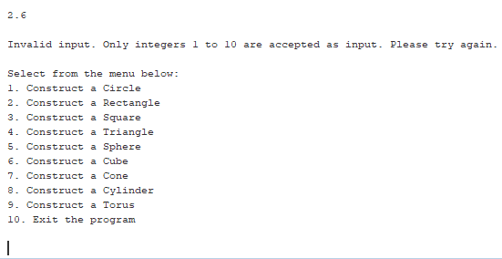

Figure 16: Test Case 5 Output. (Kucera, 2020)

**Pass or Fail?**: PASS

1. **Aspect Tested:** Menu: Input 1. (Allowed)

**Input:** 1

**Expected Output:** You have selected a Circle. What is the Radius? (Prompt for user input for radius)

**Actual Output**: See Fig. 17.

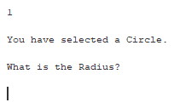

Figure 17: Test Case 6 Output. (Kucera, 2020)

**Pass or Fail?**: PASS

1. **Aspect Tested:** Circle: Input characters (Not allowed)

**Input:** jyp

**Expected Output:** Invalid input. Only a positive double is accepted here. Please try again. (Prompt for user input for radius)

**Actual Output**: See Fig. 18.

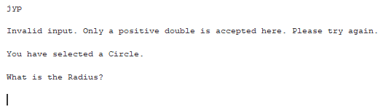

Figure 18: Test Case 7 Output. (Kucera, 2020)

**Pass or Fail?**: PASS

1. **Aspect Tested:** Circle: Input symbol (Not allowed)

**Input:** @

**Expected Output:** Invalid input. Only a positive double is accepted here. Please try again. (Prompt for user input for radius)

**Actual Output**: See Fig. 19.

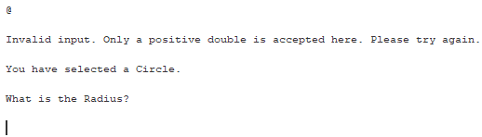

Figure 19: Test Case 8 Output. (Kucera, 2020)

**Pass or Fail?**: PASS

1. **Aspect Tested:** Circle: Input negative for radius (Not allowed)

**Input:** -5.6

**Expected Output:** Invalid input. Only a positive double is accepted here. Please try again. (Prompt for user input for radius)

**Actual Output**: See Fig. 20.

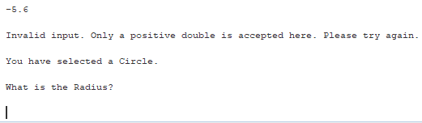

Figure 20: Test Case 9 Output. (Kucera, 2020)

**Pass or Fail?**: PASS

1. **Aspect Tested:** Circle: Input zero for radius (Not allowed)

**Input:** 0

**Expected Output:** Invalid input. Only a positive double is accepted here. Please try again. (Prompt for user input for radius)

**Actual Output**: See Fig. 21.

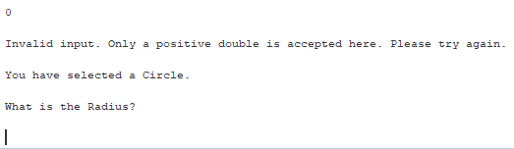

Figure 21: Test Case 10 Output. (Kucera, 2020)

**Pass or Fail?**: PASS

1. **Aspect Tested:** Circle: Input positive double for radius (Allowed)

**Input:** 7.92

**Expected Output:** The area of the Circle is 197.0607974261348. The circumference of the Circle is 49.762827632862326. Would you like to continue? (Y or N) (Prompt user for input)

**Actual Output**: See Fig. 22.

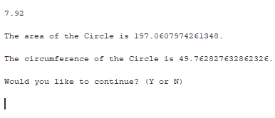

Figure 22: Test Case 11 Output. (Kucera, 2020)

**Pass or Fail?**: PASS

1. **Aspect Tested:** Circle: Input positive integer for radius (Allowed)

**Input:** 11

**Expected Output:** The area of the Circle is 380.132711084365. The circumference of the Circle is 69.11503837897544. Would you like to continue? (Y or N) (Prompt user for input)

**Actual Output**: See Fig. 23.

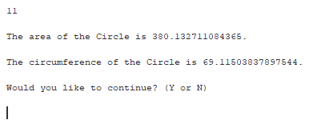

Figure 23: Test Case 12 Output. (Kucera, 2020)

**Pass or Fail?**: PASS

1. **Aspect Tested:** Circle (after construction): Input integer (Not allowed)

**Input:** 3

**Expected Output:** Invalid input. Please try again and enter Y or N. (Prompt user for input)

**Actual Output**: See Fig. 24.

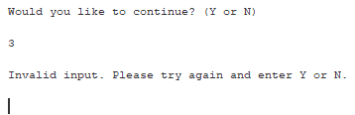

Figure 24: Test Case 13 Output. (Kucera, 2020)

**Pass or Fail?**: PASS

1. **Aspect Tested:** Circle (after construction): Input symbol (Not allowed)

**Input:** ^

**Expected Output:** Invalid input. Please try again and enter Y or N. (Prompt user for input)

**Actual Output**: See Fig. 25.

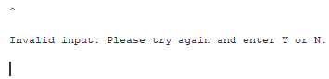

Figure 25: Test Case 14 Output. (Kucera, 2020)

**Pass or Fail?**: PASS

1. **Aspect Tested:** Circle (after construction): Input character, not Y/y/N/n (Not allowed)

**Input:** t

**Expected Output:** Invalid input. Please try again and enter Y or N. (Prompt user for input)

**Actual Output**: See Fig. 26.

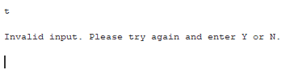

Figure 26: Test Case 15 Output. (Kucera, 2020)

**Pass or Fail?**: PASS

1. **Aspect Tested:** Circle (after construction): Input N to Exit application. (Allowed)

**Input:** N (uppercase)

**Expected Output:** Thanks for using the program. Today is [current date] at [current time]. (Program ends)

**Actual Output**: See Fig. 27.

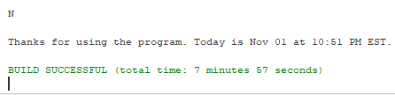

Figure 27: Test Case 16 Output. (Kucera, 2020)

**Pass or Fail?**: PASS

1. **Aspect Tested:** Circle (after construction): Input y to Continue application. (Allowed)

**Input:** y (lowercase)

**Expected Output:** (Display main menu again, prompt for user input)

**Actual Output**: See Fig. 28.

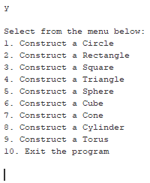

Figure 28: Test Case 17 Output. (Kucera, 2020)

**Pass or Fail?**: PASS

1. **Aspect Tested:** Menu: Input 2 (Allowed)

**Input:** 2

**Expected Output:** You have selected a Rectangle. What is the Length? (Prompt for user input)

**Actual Output**: See Fig. 29.

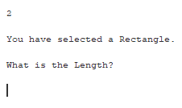

Figure 29: Test Case 18 Output. (Kucera, 2020)

**Pass or Fail?**: PASS

1. **Aspect Tested:** Rectangle Length: Input characters (Not Allowed)

**Input:** no

**Expected Output:** Invalid input. Only a positive double is accepted here. Please try again. (Prompt for user input for length)

**Actual Output**: See Fig. 30.

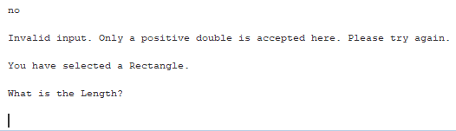

Figure 30: Test Case 19 Output. (Kucera, 2020)

**Pass or Fail?**: PASS

1. **Aspect Tested:** Rectangle Length: Input symbol (Not Allowed)

**Input:** !

**Expected Output:** Invalid input. Only a positive double is accepted here. Please try again. (Prompt for user input for length)

**Actual Output**: See Fig. 31.

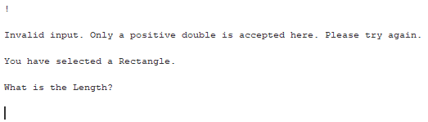

Figure 31: Test Case 20 Output. (Kucera, 2020)

**Pass or Fail?**: PASS

1. **Aspect Tested:** Rectangle Length: Input negative (Not Allowed)

**Input:** -32.5

**Expected Output:** Invalid input. Only a positive double is accepted here. Please try again. (Prompt for user input for length)

**Actual Output**: See Fig. 32.

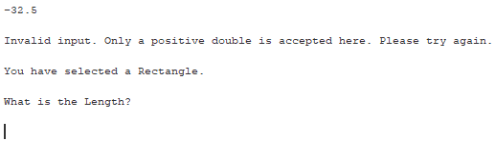

Figure 32: Test Case 21 Output. (Kucera, 2020)

**Pass or Fail?**: PASS

1. **Aspect Tested:** Rectangle Length: Input zero (Not Allowed)

**Input:** 0

**Expected Output:** Invalid input. Only a positive double is accepted here. Please try again. (Prompt for user input for length)

**Actual Output**: See Fig. 33.

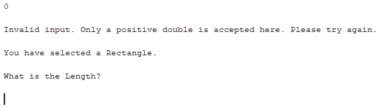

Figure 33: Test Case 22 Output. (Kucera, 2020)

**Pass or Fail?**: PASS

1. **Aspect Tested:** Rectangle Length: Input positive double (Allowed)

**Input:** 12.2

**Expected Output:** What is the Width? (Prompt for user input for length)

**Actual Output**: See Fig. 34.

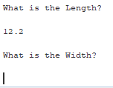

Figure 34: Test Case 23 Output. (Kucera, 2020)

**Pass or Fail?**: PASS

1. **Aspect Tested:** Rectangle Length: Input positive integer (Allowed)

**Input:** 451

**Expected Output:** What is the Width? (Prompt for user input for length)

**Actual Output**: See Fig. 35.

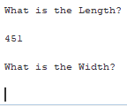

Figure 35: Test Case 24 Output. (Kucera, 2020)

**Pass or Fail?**: PASS

1. **Aspect Tested:** Rectangle Width: Input characters (Not Allowed)

**Input:** why

**Expected Output:** Invalid input. Only a positive double is accepted here. Please try again. (Prompt for user input for length)

**Actual Output**: See Fig. 36.

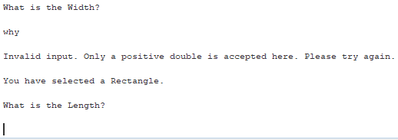

Figure 36: Test Case 25 Output. (Kucera, 2020)

**Pass or Fail?**: PASS

1. **Aspect Tested:** Rectangle Width: Input symbol (Not Allowed)

**Input:** #

**Expected Output:** Invalid input. Only a positive double is accepted here. Please try again. (Prompt for user input for length)

**Actual Output**: See Fig. 37.

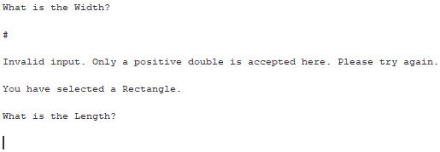

Figure 37: Test Case 26 Output. (Kucera, 2020)

**Pass or Fail?**: PASS

1. **Aspect Tested:** Rectangle Width: Input negative (Not Allowed)

**Input:** -2.333

**Expected Output:** Invalid input. Only a positive double is accepted here. Please try again. (Prompt for user input for length)

**Actual Output**: See Fig. 38.

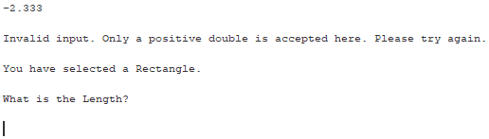

Figure 38: Test Case 27 Output. (Kucera, 2020)

**Pass or Fail?**: PASS

1. **Aspect Tested:** Rectangle Width: Input zero (Not Allowed)

**Input:** 0

**Expected Output:** Invalid input. Only a positive double is accepted here. Please try again. (Prompt for user input for length)

**Actual Output**: See Fig. 39.

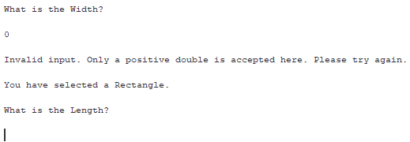

Figure 39: Test Case 28 Output. (Kucera, 2020)

**Pass or Fail?**: PASS

1. **Aspect Tested:** Rectangle Width: Input positive double (Allowed)

**Input:** 8.65 for Length. 1.777 for Width.

**Expected Output:** The area of the Rectangle is 15.37105. The diagonal of the Rectangle is 8.8306414829275. Would you like to continue? (Y or N) (Prompt for user input)

**Actual Output**: See Fig. 40.

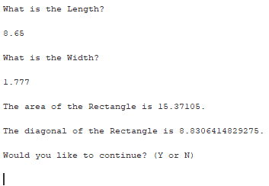

Figure 40: Test Case 29 Output. (Kucera, 2020)

**Pass or Fail?**: PASS

1. **Aspect Tested:** Rectangle Width: Input positive integer (Allowed)

**Input:** 4.9 for Length. 13 for Width.

**Expected Output:** The area of the Rectangle is 63.7. The diagonal of the Rectangle is 13.89280389266328. Would you like to continue? (Y or N) (Prompt for user input)

**Actual Output**: See Fig. 41.

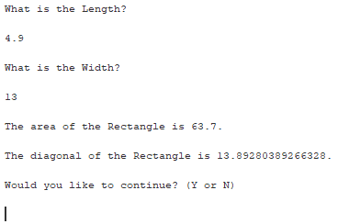

Figure 41: Test Case 30 Output. (Kucera, 2020)

**Pass or Fail?**: PASS

1. **Aspect Tested:** Rectangle (after construction): Input n to Exit application. (Allowed)

**Input:** n (lowercase)

**Expected Output:** Thanks for using the program. Today is [current date] at [current time]. (Program ends)

**Actual Output**: See Fig. 42.



Figure 42: Test Case 31 Output. (Kucera, 2020)

**Pass or Fail?**: PASS

1. **Aspect Tested:** Rectangle (after construction): Input Y to Continue application. (Allowed)

**Input:** Y (uppercase)

**Expected Output:** (Display main menu again, prompt for user input)

**Actual Output**: See Fig. 43.

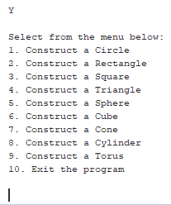

Figure 43: Test Case 32 Output. (Kucera, 2020)

**Pass or Fail?**: PASS

1. **Aspect Tested:** Menu: Input 3 (Allowed)

**Input:** 3

**Expected Output:** You have selected a Square. What is the Length or Width? (Prompt for user input)

**Actual Output**: See Fig. 44.

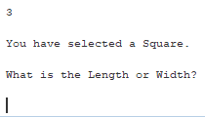

Figure 44: Test Case 33 Output. (Kucera, 2020)

**Pass or Fail?**: PASS

1. **Aspect Tested:** Square Length or Width: Input character (Not Allowed)

**Input:** W

**Expected Output:** Invalid input. Only a positive double is accepted here. Please try again. (Prompt for user input for length or width)

**Actual Output**: See Fig. 45.

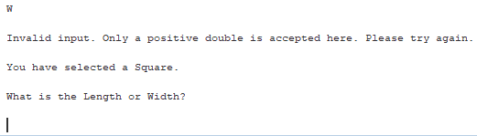

Figure 45: Test Case 34 Output. (Kucera, 2020)

**Pass or Fail?**: PASS

1. **Aspect Tested:** Square Length or Width: Input symbol (Not Allowed)

**Input:** &

**Expected Output:** Invalid input. Only a positive double is accepted here. Please try again. (Prompt for user input for length or width)

**Actual Output**: See Fig. 46.

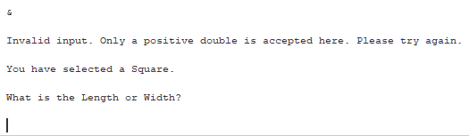

Figure 46: Test Case 35 Output. (Kucera, 2020)

**Pass or Fail?**: PASS

1. **Aspect Tested:** Square Length or Width: Input negative (Not Allowed)

**Input:** -105.20

**Expected Output:** Invalid input. Only a positive double is accepted here. Please try again. (Prompt for user input for length or width)

**Actual Output**: See Fig. 47.

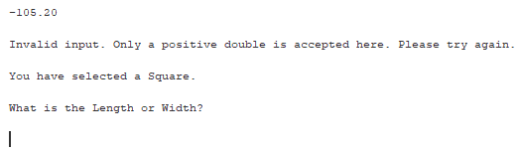

Figure 47: Test Case 36 Output. (Kucera, 2020)

**Pass or Fail?**: PASS

1. **Aspect Tested:** Square Length or Width: Input zero (Not Allowed)

**Input:** 0

**Expected Output:** Invalid input. Only a positive double is accepted here. Please try again. (Prompt for user input for length or width)

**Actual Output**: See Fig. 48.

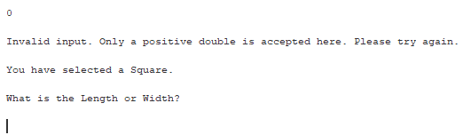

Figure 48: Test Case 37 Output. (Kucera, 2020)

**Pass or Fail?**: PASS

1. **Aspect Tested:** Square Length/Width: Input positive double with white space (Allowed)

**Input:** 992.2654 (4 spaces before value)

**Expected Output:** The area of the Square is 984590.62403716. The diagonal of the Square is 1403.2751861535642. Would you like to continue? (Y or N) (Prompt for user input)

**Actual Output**: See Fig. 49.

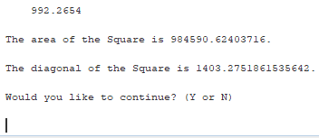

Figure 49: Test Case 38 Output. (Kucera, 2020)

**Pass or Fail?**: PASS

1. **Aspect Tested:** Square Length/Width: Input positive integer with whitespace (Allowed)

**Input:** 558 (13 spaces before value, 8 spaces after value)

**Expected Output:** The area of the Square is 311364.0. The diagonal of the Square is 789.131167804187. Would you like to continue? (Y or N) (Prompt for user input)

**Actual Output**: See Fig. 50.

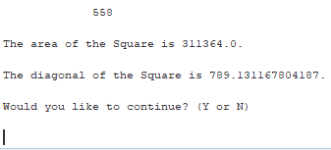

Figure 50: Test Case 39 Output. (Kucera, 2020)

**Pass or Fail?**: PASS

1. **Aspect Tested:** Square (after construction): Input N (with whitespace) to Exit application. (Allowed)

**Input:** N (6 spaces before value, 2 spaces after value)

**Expected Output:** Thanks for using the program. Today is [current date] at [current time]. (Program ends)

**Actual Output**: See Fig. 51.

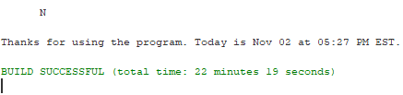

Figure 51: Test Case 40 Output. (Kucera, 2020)

**Pass or Fail?**: PASS

1. **Aspect Tested:** Square (after construction): Input Y (with whitespace) to Continue application. (Allowed)

**Input:** Y (20 spaces before value)

**Expected Output:** (Display main menu again, prompt for user input)

**Actual Output**: See Fig. 52.

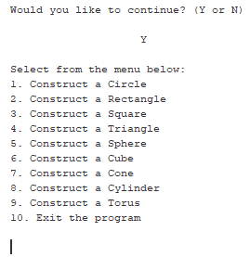

Figure 52: Test Case 41 Output. (Kucera, 2020)

**Pass or Fail?**: PASS

1. **Aspect Tested:** Menu: Input 4 with whitespace (Allowed)

**Input:** 4 (9 spaces before value, 10 spaces after)

**Expected Output:** You have selected a Triangle. What is the Length of Side 1? (Prompt for user input for Side 1)

**Actual Output**: See Fig. 53.

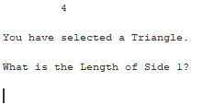

Figure 53: Test Case 42 Output. (Kucera, 2020)

**Pass or Fail?**: PASS

1. **Aspect Tested:** Triangle Side 1: Input character with number (Not Allowed)

**Input:** d4

**Expected Output:** Invalid input. Only a positive double is accepted here. Please try again. (Prompt for user input for side 1)

**Actual Output**: See Fig. 54.

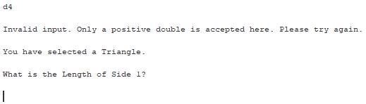

Figure 54: Test Case 43 Output. (Kucera, 2020)

**Pass or Fail?**: PASS

1. **Aspect Tested:** Triangle Side 1: Input symbol (Not Allowed)

**Input:** *

**Expected Output:** Invalid input. Only a positive double is accepted here. Please try again. (Prompt for user input for side 1)

**Actual Output**: See Fig. 55.

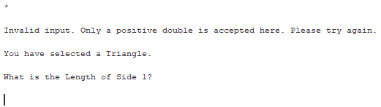

Figure 55: Test Case 44 Output. (Kucera, 2020)

**Pass or Fail?**: PASS

1. **Aspect Tested:** Triangle Side 1: Input negative (Not Allowed)

**Input:** -6

**Expected Output:** Invalid input. Only a positive double is accepted here. Please try again. (Prompt for user input for side 1)

**Actual Output**: See Fig. 56.

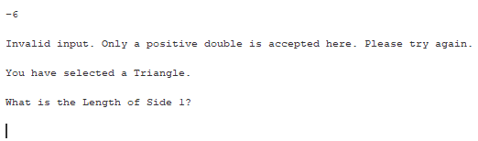

Figure 56: Test Case 45 Output. (Kucera, 2020)

**Pass or Fail?**: PASS

1. **Aspect Tested:** Triangle Side 1: Input zero (Not Allowed)

**Input:** 0

**Expected Output:** Invalid input. Only a positive double is accepted here. Please try again. (Prompt for user input for side 1)

**Actual Output**: See Fig. 57.

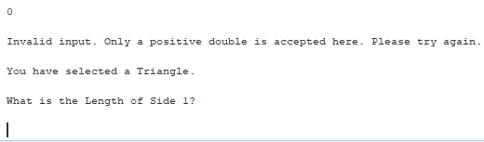

Figure 57: Test Case 46 Output. (Kucera, 2020)

**Pass or Fail?**: PASS

1. **Aspect Tested:** Triangle Side 1: Input positive double (Allowed)

**Input:** 35.49999

**Expected Output:** What is the Length of Side 2? (Prompt for user input for side 2)

**Actual Output**: See Fig. 58.

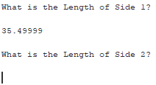

Figure 58: Test Case 47 Output. (Kucera, 2020)

**Pass or Fail?**: PASS

1. **Aspect Tested:** Triangle Side 1: Input positive integer (Allowed)

**Input:** 46

**Expected Output:** What is the Length of Side 2? (Prompt for user input for side 2)

**Actual Output**: See Fig. 59.

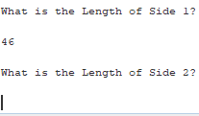

Figure 59: Test Case 48 Output. (Kucera, 2020)

**Pass or Fail?**: PASS

1. **Aspect Tested:** Triangle Side 2: Input white space (Not Allowed)

**Input:** (10 white spaces)

**Expected Output:** Invalid input. Only a positive double is accepted here. Please try again. (Prompt for user input for side 1)

**Actual Output**: See Fig. 60.

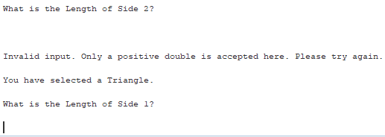

Figure 60: Test Case 49 Output. (Kucera, 2020)

**Pass or Fail?**: PASS

1. **Aspect Tested:** Triangle Side 2: Input symbol (Not Allowed)

**Input:** (

**Expected Output:** Invalid input. Only a positive double is accepted here. Please try again. (Prompt for user input for side 1)

**Actual Output**: See Fig. 61.

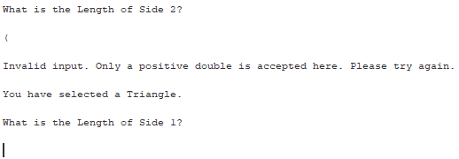

Figure 61: Test Case 50 Output. (Kucera, 2020)

**Pass or Fail?**: PASS

1. **Aspect Tested:** Triangle Side 2: Input negative (Not Allowed)

**Input:** -19.01

**Expected Output:** Invalid input. Only a positive double is accepted here. Please try again. (Prompt for user input for side 1)

**Actual Output**: See Fig. 62.

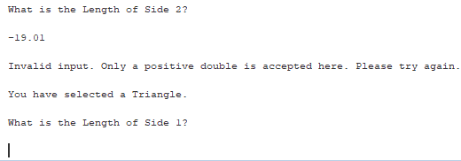

Figure 62: Test Case 51 Output. (Kucera, 2020)

**Pass or Fail?**: PASS

1. **Aspect Tested:** Triangle Side 2: Input zero (Not Allowed)

**Input:** 0

**Expected Output:** Invalid input. Only a positive double is accepted here. Please try again. (Prompt for user input for side 1)

**Actual Output**: See Fig. 63.

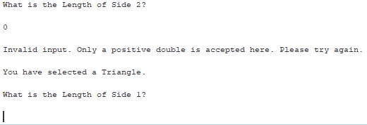

Figure 63: Test Case 52 Output. (Kucera, 2020)

**Pass or Fail?**: PASS

1. **Aspect Tested:** Triangle Side 2: Input positive double with whitespace (Allowed)

**Input:** 7.214 (7 spaces before value, 3 spaces after)

**Expected Output:** What is the Length of Side 3? (Prompt for user input for side 3)

**Actual Output**: See Fig. 64.

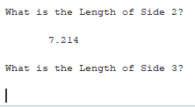

Figure 64: Test Case 53 Output. (Kucera, 2020)

**Pass or Fail?**: PASS

1. **Aspect Tested:** Triangle Side 2: Input positive integer with whitespace (Allowed)

**Input:** 10 (3 spaces before value, 10 spaces after)

**Expected Output:** What is the Length of Side 3? (Prompt for user input for side 3)

**Actual Output**: See Fig. 65.

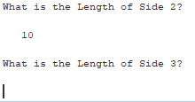

Figure 65: Test Case 54 Output. (Kucera, 2020)

**Pass or Fail?**: PASS

1. **Aspect Tested:** Triangle Side 3: Input characters (Not Allowed)

**Input:** delicious

**Expected Output:** Invalid input. Only a positive double is accepted here. Please try again. (Prompt for user input for side 1)

**Actual Output**: See Fig. 66.

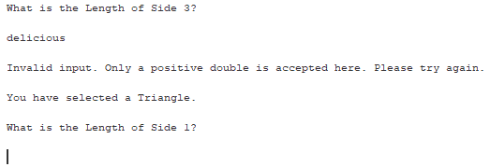

Figure 66: Test Case 55 Output. (Kucera, 2020)

**Pass or Fail?**: PASS

1. **Aspect Tested:** Triangle Side 3: Input symbol (Not Allowed)

**Input:** +

**Expected Output:** Invalid input. Only a positive double is accepted here. Please try again. (Prompt for user input for side 1)

**Actual Output**: See Fig. 67.

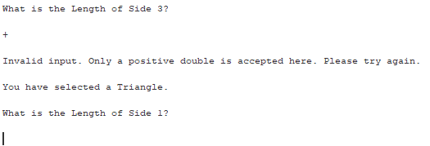

Figure 67: Test Case 56 Output. (Kucera, 2020)

**Pass or Fail?**: PASS

1. **Aspect Tested:** Triangle Side 3: Input negative (Not Allowed)

**Input:** -78

**Expected Output:** Invalid input. Only a positive double is accepted here. Please try again. (Prompt for user input for side 1)

**Actual Output**: See Fig. 68.

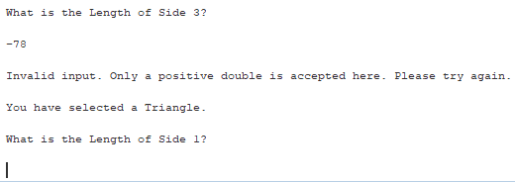

Figure 68: Test Case 57 Output. (Kucera, 2020)

**Pass or Fail?**: PASS

1. **Aspect Tested:** Triangle Side 3: Input zero (Not Allowed)

**Input:** 0

**Expected Output:** Invalid input. Only a positive double is accepted here. Please try again. (Prompt for user input for side 1)

**Actual Output**: See Fig. 69.

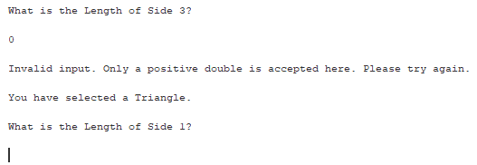

Figure 69: Test Case 58 Output. (Kucera, 2020)

**Pass or Fail?**: PASS

1. **Aspect Tested:** Triangle Side 1-3: Input positive doubles, resulting in nonexistent triangle (Not Allowed)

**Input:** Sides 1-3: 5.6, 7.8, 26.22.

**Expected Output:** This Triangle cannot exist with the dimensions provided. Please try again. (Prompt for user input for side 1)

**Actual Output**: See Fig. 70.

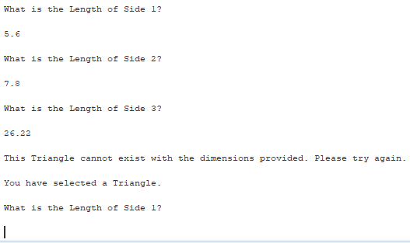

Figure 70: Test Case 59 Output. (Kucera, 2020)

**Pass or Fail?**: PASS

1. **Aspect Tested:** Triangle Side 1-3: Input positive doubles, resulting in triangle with area 0 (Not Allowed)

**Input:** Sides 1-3: 5, 5, 10.

**Expected Output:** This Triangle cannot exist with the dimensions provided. Please try again. (Prompt for user input for side 1)

**Actual Output**: See Fig. 71.

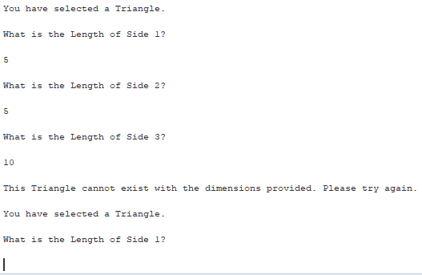

Figure 71: Test Case 60 Output. (Kucera, 2020)

**Pass or Fail?**: PASS

1. **Aspect Tested:** Triangle Side 1-3: Input positive doubles, resulting equilateral triangle (Allowed)

**Input:** Sides 1-3: 13. 476, 13. 476, 13. 476.

**Expected Output:** The area of the Triangle is 78.63622210434713. The Triangle is Equilateral. Would you like to continue? (Y or N) (Prompt for user input)

**Actual Output**: See Fig. 72.

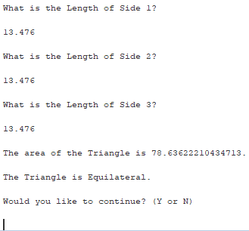

Figure 72: Test Case 61 Output. (Kucera, 2020)

**Pass or Fail?**: PASS

1. **Aspect Tested:** Triangle Side 1-3: Input positive doubles, resulting isosceles triangle (Allowed)

**Input:** Sides 1-3: 55.9, 78.1, 55.9.

**Expected Output:** The area of the Triangle is 1561.9548477849005. The Triangle is Isosceles. Would you like to continue? (Y or N) (Prompt for user input)

**Actual Output**: See Fig. 73.

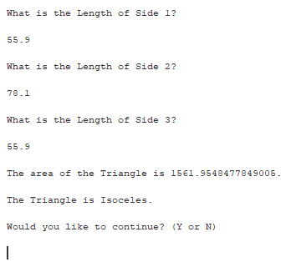

Figure 73: Test Case 62 Output. (Kucera, 2020)

**Pass or Fail?**: PASS

1. **Aspect Tested:** Triangle Side 1-3: Input positive doubles, resulting scalene triangle (Allowed)

**Input:** Sides 1-3: 23, 14, 17.

**Expected Output:** The area of the Triangle is 118.490505948789. The Triangle is Scalene. Would you like to continue? (Y or N) (Prompt for user input)

**Actual Output**: See Fig. 74.

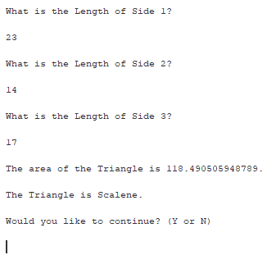

Figure 74: Test Case 63 Output. (Kucera, 2020)

**Pass or Fail?**: PASS

1. **Aspect Tested:** Triangle (after construction): Input n (with whitespace) to Exit application. (Allowed)

**Input:** n (8 spaces before value) (lowercase)

**Expected Output:** Thanks for using the program. Today is [current date] at [current time]. (Program ends)

**Actual Output**: See Fig. 75.

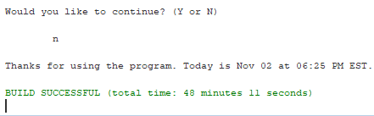

Figure 75: Test Case 64 Output. (Kucera, 2020)

**Pass or Fail?**: PASS

1. **Aspect Tested:** Triangle (after construction): Input y (with whitespace) to Continue application. (Allowed)

**Input:** y (20 spaces after value) (lowercase)

**Expected Output:** (Display main menu again, prompt for user input)

**Actual Output**: See Fig. 76.

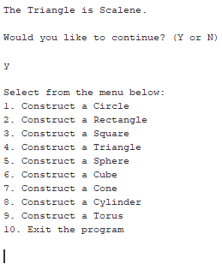

Figure 76: Test Case 65 Output. (Kucera, 2020)

**Pass or Fail?**: PASS

1. **Aspect Tested:** Menu: Input 5 with whitespace (Allowed)

**Input:** 5 (7 spaces after value)

**Expected Output:** You have selected a Sphere. What is the Radius? (Prompt for user input for radius)

**Actual Output**: See Fig. 77.

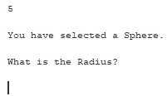

Figure 77: Test Case 66 Output. (Kucera, 2020)

**Pass or Fail?**: PASS

1. **Aspect Tested:** Sphere radius: Input non-double (Not Allowed)

**Input:** =great

**Expected Output:** Invalid input. Only a positive double is accepted here. Please try again. (Prompt for user input for radius)

**Actual Output**: See Fig. 78.

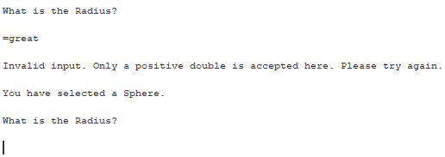

Figure 78: Test Case 67 Output. (Kucera, 2020)

**Pass or Fail?**: PASS

1. **Aspect Tested:** Sphere radius: Input negative (Not Allowed)

**Input:** -24

**Expected Output:** Invalid input. Only a positive double is accepted here. Please try again. (Prompt for user input for radius)

**Actual Output**: See Fig. 79.

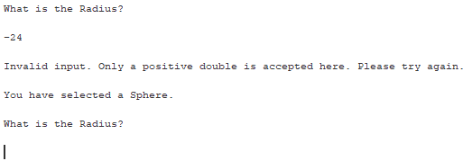

Figure 79: Test Case 68 Output. (Kucera, 2020)

**Pass or Fail?**: PASS

1. **Aspect Tested:** Sphere radius: Input zero (Not Allowed)

**Input:** 0

**Expected Output:** Invalid input. Only a positive double is accepted here. Please try again. (Prompt for user input for radius)

**Actual Output**: See Fig. 80.

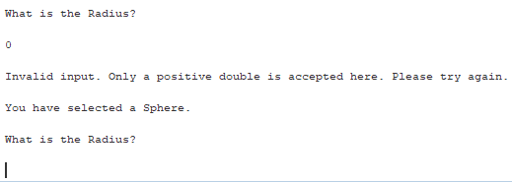

Figure 80: Test Case 69 Output. (Kucera, 2020)

**Pass or Fail?**: PASS

1. **Aspect Tested:** Sphere radius: Input positive double with whitespace (Allowed)

**Input:** 5.5 (3 spaces before and after value)

**Expected Output:** Give the Height of a Spherical Cap in this Sphere. (Prompt for user input for spherical cap height)

**Actual Output**: See Fig. 81.

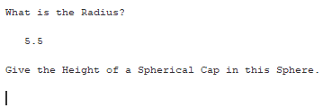

Figure 81: Test Case 70 Output. (Kucera, 2020)

**Pass or Fail?**: PASS

1. **Aspect Tested:** Sphere radius: Input positive integer with whitespace (Allowed)

**Input:** 45 (11 spaces before value)

**Expected Output:** Give the Height of a Spherical Cap in this Sphere. (Prompt for user input for spherical cap height)

**Actual Output**: See Fig. 82.

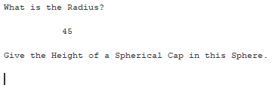

Figure 82: Test Case 71 Output. (Kucera, 2020)

**Pass or Fail?**: PASS

1. **Aspect Tested:** Sphere cap height: Input non-double (Not Allowed)

**Input:** holycow

**Expected Output:** Invalid input. Only a positive double is accepted here. Please try again. (Prompt for user input for radius)

**Actual Output**: See Fig. 83.

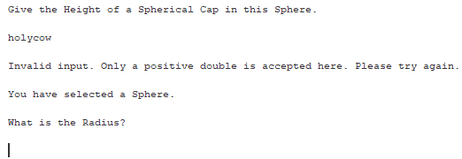

Figure 83: Test Case 72 Output. (Kucera, 2020)

**Pass or Fail?**: PASS

1. **Aspect Tested:** Sphere cap height: Input negative (Not Allowed)

**Input:** -78.888

**Expected Output:** Invalid input. Only a positive double is accepted here. Please try again. (Prompt for user input for radius)

**Actual Output**: See Fig. 84.

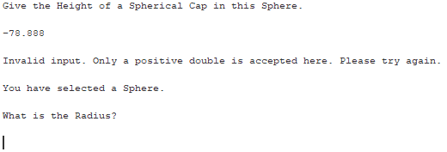

Figure 84: Test Case 73 Output. (Kucera, 2020)

**Pass or Fail?**: PASS

1. **Aspect Tested:** Sphere cap height: Input zero (Not Allowed)

**Input:** 0

**Expected Output:** Invalid input. Only a positive double is accepted here. Please try again. (Prompt for user input for radius)

**Actual Output**: See Fig. 85.

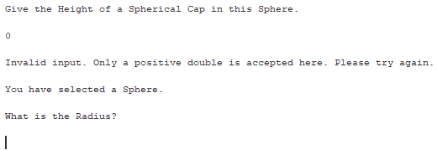

Figure 85: Test Case 74 Output. (Kucera, 2020)

**Pass or Fail?**: PASS

1. **Aspect Tested:** Sphere cap height: Input greater than radius (Not Allowed)

**Input:** Radius: 8.8. Cap height: 10.7

**Expected Output:** The Spherical Cap cannot have a Height greater than or equal to the Sphere's Radius. Please try again. (Prompt for user input for radius)

**Actual Output**: See Fig. 86.

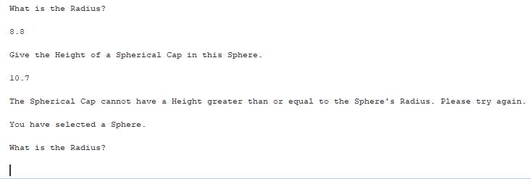

Figure 86: Test Case 75 Output. (Kucera, 2020)

**Pass or Fail?**: PASS

1. **Aspect Tested:** Sphere cap height: Input positive double (Allowed)

**Input:** Radius: 4.5. Spherical Cap: 3.224359.

**Expected Output:** The volume of the Sphere is 381.7035074111598. The volume of this Spherical Cap in the Sphere is 111.87275190072137. Would you like to continue? (Y or N) (Prompt for user input)

**Actual Output**: See Fig. 87.

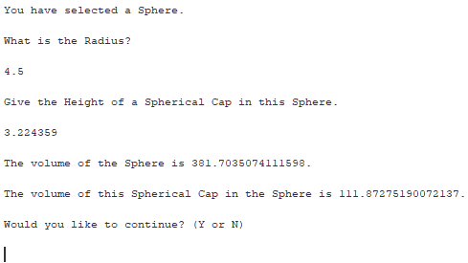

Figure 87: Test Case 76 Output. (Kucera, 2020)

**Pass or Fail?**: PASS

1. **Aspect Tested:** Sphere cap height: Input positive integer with whitespace (Allowed)

**Input:** Radius: 40.3. Cap Height: 20 (12 spaces before value)

**Expected Output:** The volume of the Sphere is 274159.7830327685. The volume of this Spherical Cap in the Sphere is 42264.893166294685. Would you like to continue? (Y or N)

**Actual Output**: See Fig. 87.

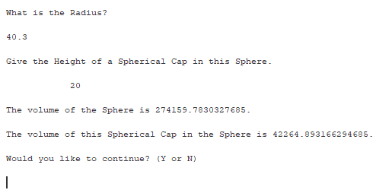

Figure 87: Test Case 77 Output. (Kucera, 2020)

**Pass or Fail?**: PASS

1. **Aspect Tested:** Sphere (after construction): Input N to Exit application. (Allowed)

**Input:** N (uppercase)

**Expected Output:** Thanks for using the program. Today is [current date] at [current time]. (Program ends)

**Actual Output**: See Fig. 89.

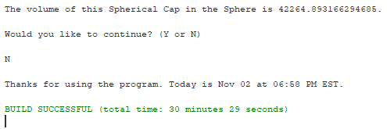

Figure 89: Test Case 78 Output. (Kucera, 2020)

**Pass or Fail?**: PASS

1. **Aspect Tested:** Sphere (after construction): Input Y to Continue application. (Allowed)

**Input:** Y (uppercase)

**Expected Output:** (Display main menu again, prompt for user input)

**Actual Output**: See Fig. 90.

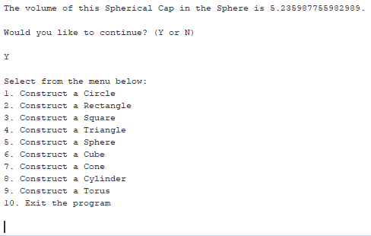

Figure 90: Test Case 79 Output. (Kucera, 2020)

**Pass or Fail?**: PASS

1. **Aspect Tested:** Menu: Input 6 (Allowed)

**Input:** 6

**Expected Output:** You have selected a Cube. What is the Length or Width or Height? (Prompt for user input for length/width/height)

**Actual Output**: See Fig. 91.

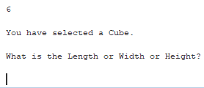

Figure 91: Test Case 80 Output. (Kucera, 2020)

**Pass or Fail?**: PASS

1. **Aspect Tested:** Cube length/width/height: Input non-double (Not Allowed)

**Input:** iguess

**Expected Output:** Invalid input. Only a positive double is accepted here. Please try again. (Prompt for user input for length)

**Actual Output**: See Fig. 92.

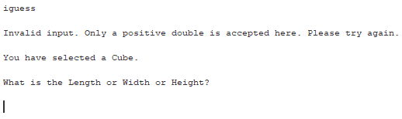

Figure 92: Test Case 81 Output. (Kucera, 2020)

**Pass or Fail?**: PASS

1. **Aspect Tested:** Cube length/width/height: Input negative (Not Allowed)

**Input:** -99.1

**Expected Output:** Invalid input. Only a positive double is accepted here. Please try again. (Prompt for user input for length)

**Actual Output**: See Fig. 93.

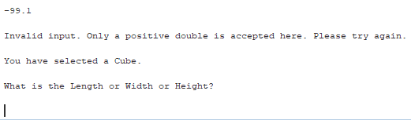

Figure 93: Test Case 82 Output. (Kucera, 2020)

**Pass or Fail?**: PASS

1. **Aspect Tested:** Cube length/width/height: Input zero (Not Allowed)

**Input:** 0

**Expected Output:** Invalid input. Only a positive double is accepted here. Please try again. (Prompt for user input for radius)

**Actual Output**: See Fig. 94.

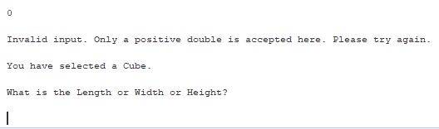

Figure 94: Test Case 83 Output. (Kucera, 2020)

**Pass or Fail?**: PASS

1. **Aspect Tested:** Cube Length/Width/height: Input positive double with white space (Allowed)

**Input:** 33.909 (14 spaces after value)

**Expected Output:** The volume of the Cube is 38989.255908429. The space diagonal of the Cube is 58.732110833853056. Would you like to continue? (Y or N) (Prompt for user input)

**Actual Output**: See Fig. 95.

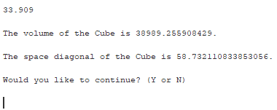

Figure 95: Test Case 84 Output. (Kucera, 2020)

**Pass or Fail?**: PASS

1. **Aspect Tested:** Cube Length/Width/height: Input positive integer (Allowed)

**Input:** 15

**Expected Output:** The volume of the Cube is 3375.0. The space diagonal of the Cube is 25.980762113533157. Would you like to continue? (Y or N) (Prompt for user input)

**Actual Output**: See Fig. 96.

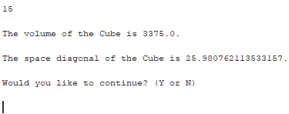

Figure 96: Test Case 85 Output. (Kucera, 2020)

**Pass or Fail?**: PASS

1. **Aspect Tested:** Menu: Input 7 (Allowed)

**Input:** 7

**Expected Output:** You have selected a Cone. What is the Radius? (Prompt for user input for radius)

**Actual Output**: See Fig. 97.

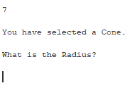

Figure 97: Test Case 86 Output. (Kucera, 2020)

**Pass or Fail?**: PASS

1. **Aspect Tested:** Cone radius: Input non-double (Not Allowed)

**Input:** \\

**Expected Output:** Invalid input. Only a positive double is accepted here. Please try again. (Prompt for user input for radius)

**Actual Output**: See Fig. 98.

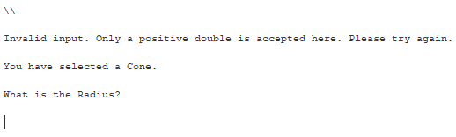

Figure 98: Test Case 87 Output. (Kucera, 2020)

**Pass or Fail?**: PASS

1. **Aspect Tested:** Cone radius: Input negative (Not Allowed)

**Input:** -1.8

**Expected Output:** Invalid input. Only a positive double is accepted here. Please try again. (Prompt for user input for radius)

**Actual Output**: See Fig. 99.

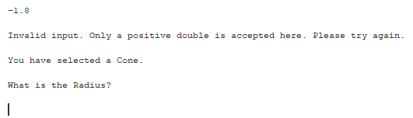

Figure 99: Test Case 88 Output. (Kucera, 2020)

**Pass or Fail?**: PASS

1. **Aspect Tested:** Cone radius: Input zero (Not Allowed)

**Input:** 0

**Expected Output:** Invalid input. Only a positive double is accepted here. Please try again. (Prompt for user input for radius)

**Actual Output**: See Fig. 100.

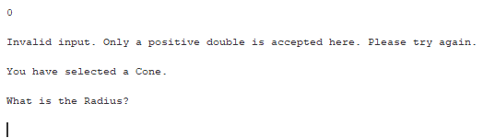

Figure 100: Test Case 89 Output. (Kucera, 2020)

**Pass or Fail?**: PASS

1. **Aspect Tested:** Cone radius: Input positive double with white space (Allowed)

**Input:** 47.80 (4 spaces after value)

**Expected Output:** What is the Height? (Prompt for user input for height)

**Actual Output**: See Fig. 101.

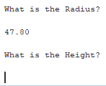

Figure 101: Test Case 90 Output. (Kucera, 2020)

**Pass or Fail?**: PASS

1. **Aspect Tested:** Cone radius: Input positive integer with white space (Allowed)

**Input:**  9 (6 spaces before value)

**Expected Output:** What is the Height? (Prompt for user input for height)

**Actual Output**: See Fig. 102.

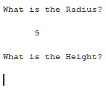

Figure 102: Test Case 91 Output. (Kucera, 2020)

**Pass or Fail?**: PASS

1. **Aspect Tested:** Cone height: Input non-double (Not Allowed)

**Input:** __

**Expected Output:** Invalid input. Only a positive double is accepted here. Please try again. (Prompt for user input for radius)

**Actual Output**: See Fig. 103.

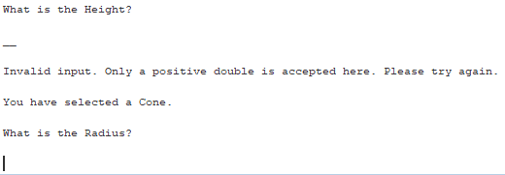

Figure 103: Test Case 92 Output. (Kucera, 2020)

**Pass or Fail?**: PASS

1. **Aspect Tested:** Cone height: Input negative (Not Allowed)

**Input:** -3

**Expected Output:** Invalid input. Only a positive double is accepted here. Please try again. (Prompt for user input for radius)

**Actual Output**: See Fig. 104.

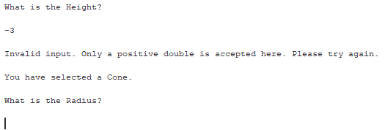

Figure 104: Test Case 93 Output. (Kucera, 2020)

**Pass or Fail?**: PASS

1. **Aspect Tested:** Cone height: Input zero (Not Allowed)

**Input:** 0

**Expected Output:** Invalid input. Only a positive double is accepted here. Please try again. (Prompt for user input for radius)

**Actual Output**: See Fig. 105.

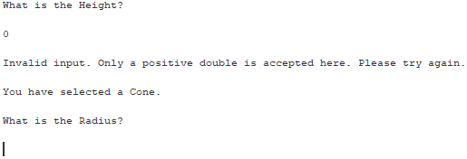

Figure 105: Test Case 94 Output. (Kucera, 2020)

**Pass or Fail?**: PASS

1. **Aspect Tested:** Cone height: Input positive double (Allowed)

**Input:** Radius: 23. Height: 3.3

**Expected Output:** The volume of the Cone is 1828.0927651239006. The slant height of the Cone is 23.235533133543548. Would you like to continue? (Y or N) (Prompt for user input)

**Actual Output**: See Fig. 106.

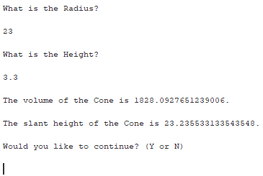

Figure 106: Test Case 95 Output. (Kucera, 2020)

**Pass or Fail?**: PASS

1. **Aspect Tested:** Cone height: Input positive integer (Allowed)

**Input:** Radius: 6.6. Height: 13

**Expected Output:** The volume of the Cone is 593.0070292916092. The slant height of the Cone is 14.579437574886077. Would you like to continue? (Y or N) (Prompt for user input)

**Actual Output**: See Fig. 107.

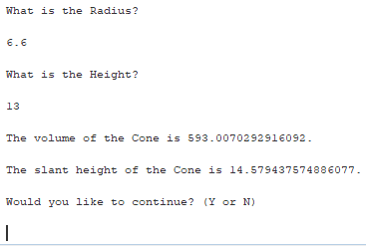

Figure 107: Test Case 96 Output. (Kucera, 2020)

**Pass or Fail?**: PASS

1. **Aspect Tested:** Menu: Input 8 (Allowed)

**Input:** 8

**Expected Output:** You have selected a Cylinder. What is the Radius? (Prompt for user input for radius)

**Actual Output**: See Fig. 108.

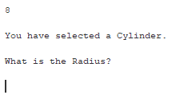

Figure 108: Test Case 97 Output. (Kucera, 2020)

**Pass or Fail?**: PASS

1. **Aspect Tested:** Cylinder radius: Input non-double (Not Allowed)

**Input:** hurryup

**Expected Output:** Invalid input. Only a positive double is accepted here. Please try again. (Prompt for user input for radius)

**Actual Output**: See Fig. 109.

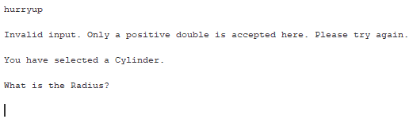

Figure 109: Test Case 98 Output. (Kucera, 2020)

**Pass or Fail?**: PASS

1. **Aspect Tested:** Cylinder radius: Input negative (Not Allowed)

**Input:** -6.1

**Expected Output:** Invalid input. Only a positive double is accepted here. Please try again. (Prompt for user input for radius)

**Actual Output**: See Fig. 110.

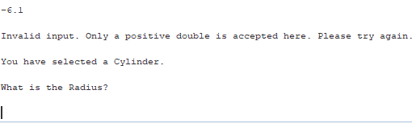

Figure 110: Test Case 99 Output. (Kucera, 2020)

**Pass or Fail?**: PASS

1. **Aspect Tested:** Cylinder radius: Input zero (Not Allowed)

**Input:** 0

**Expected Output:** Invalid input. Only a positive double is accepted here. Please try again. (Prompt for user input for radius)

**Actual Output**: See Fig. 111.

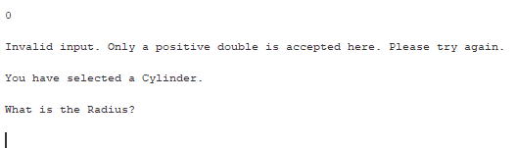

Figure 111: Test Case 100 Output. (Kucera, 2020)

**Pass or Fail?**: PASS

1. **Aspect Tested:** Cylinder radius: Input positive double with white space (Allowed)

**Input:** 1.299 (5 spaces before value)

**Expected Output:** What is the Height? (Prompt for user input for height)

**Actual Output**: See Fig. 112.

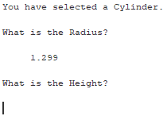

Figure 112: Test Case 101 Output. (Kucera, 2020)

**Pass or Fail?**: PASS

1. **Aspect Tested:** Cylinder radius: Input positive integer with white space (Allowed)

**Input:** 1000 (1 space before value)

**Expected Output:** What is the Height? (Prompt for user input for height)

**Actual Output**: See Fig. 113.

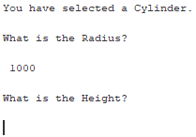

Figure 113: Test Case 102 Output. (Kucera, 2020)

**Pass or Fail?**: PASS

1. **Aspect Tested:** Cylinder height: Input non-double (Not Allowed)

**Input:** )

**Expected Output:** Invalid input. Only a positive double is accepted here. Please try again. (Prompt for user input for radius)

**Actual Output**: See Fig. 114.

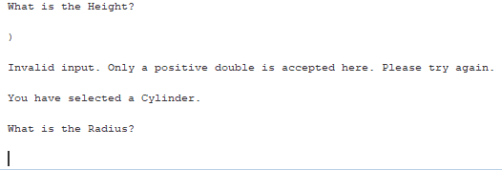

Figure 114: Test Case 103 Output. (Kucera, 2020)

**Pass or Fail?**: PASS

1. **Aspect Tested:** Cylinder height: Input negative (Not Allowed)

**Input:** -15.01

**Expected Output:** Invalid input. Only a positive double is accepted here. Please try again. (Prompt for user input for radius)

**Actual Output**: See Fig. 115.

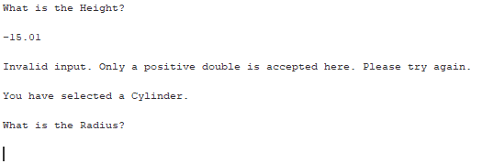

Figure 115: Test Case 104 Output. (Kucera, 2020)

**Pass or Fail?**: PASS

1. **Aspect Tested:** Cylinder height: Input zero (Not Allowed)

**Input:** 0

**Expected Output:** Invalid input. Only a positive double is accepted here. Please try again. (Prompt for user input for radius)

**Actual Output**: See Fig. 116.

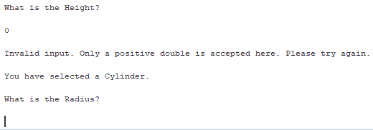

Figure 116: Test Case 105 Output. (Kucera, 2020)

**Pass or Fail?**: PASS

1. **Aspect Tested:** Cylinder height: Input positive double (Allowed)

**Input:** Radius: 99. Height: 6.339

**Expected Output:** The volume of the Cylinder is 195182.56170066696. The longest diagonal of the Cylinder is 198.10144603460117. Would you like to continue? (Y or N) (Prompt for user input)

**Actual Output**: See Fig. 117.

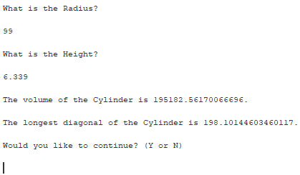

Figure 117: Test Case 106 Output. (Kucera, 2020)

**Pass or Fail?**: PASS

1. **Aspect Tested:** Cylinder height: Input positive integer (Allowed)

**Input:** Radius: 2.23. Height: 11

**Expected Output:** The volume of the Cylinder is 171.85108717740349. The longest diagonal of the Cylinder is 11.869776746004957. Would you like to continue? (Y or N) (Prompt for user input)

**Actual Output**: See Fig. 118.

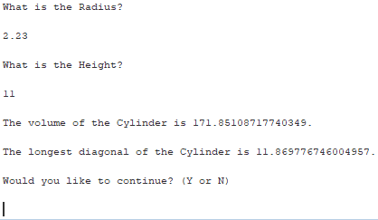

Figure 118: Test Case 107 Output. (Kucera, 2020)

**Pass or Fail?**: PASS

1. **Aspect Tested:** Menu: Input 9 (Allowed)

**Input:** 9

**Expected Output:** You have selected a Torus. What is the Minor Radius? (Prompt for user input for minor radius)

**Actual Output**: See Fig. 119.

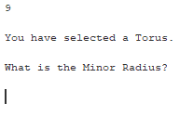

Figure 119: Test Case 108 Output. (Kucera, 2020)

**Pass or Fail?**: PASS

1. **Aspect Tested:** Torus minor radius: Input non-double (Not Allowed)

**Input:** ???

**Expected Output:** Invalid input. Only a positive double is accepted here. Please try again. (Prompt for user input for minor radius)

**Actual Output**: See Fig. 120.

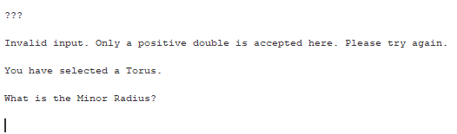

Figure 120: Test Case 109 Output. (Kucera, 2020)

**Pass or Fail?**: PASS

1. **Aspect Tested:** Torus minor radius: Input negative (Not Allowed)

**Input:** -34.0

**Expected Output:** Invalid input. Only a positive double is accepted here. Please try again. (Prompt for user input for minor radius)

**Actual Output**: See Fig. 121.

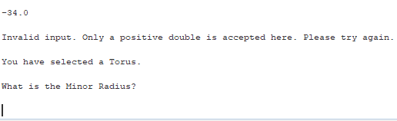

Figure 121: Test Case 110 Output. (Kucera, 2020)

**Pass or Fail?**: PASS

1. **Aspect Tested:** Torus minor radius: Input zero (Not Allowed)

**Input:** 0

**Expected Output:** Invalid input. Only a positive double is accepted here. Please try again. (Prompt for user input for minor radius)

**Actual Output**: See Fig. 122.

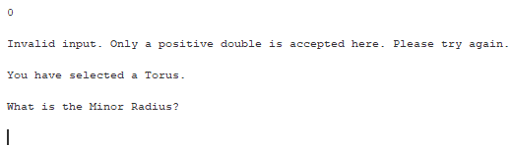

Figure 122: Test Case 111 Output. (Kucera, 2020)

**Pass or Fail?**: PASS

1. **Aspect Tested:** Torus minor radius: Input positive double with white space (Allowed)

**Input:** 99.123 (3 spaces before value)

**Expected Output:** What is the Major Radius? (Prompt for user input for major radius)

**Actual Output**: See Fig. 123.

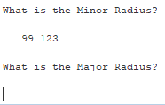

Figure 123: Test Case 112 Output. (Kucera, 2020)

**Pass or Fail?**: PASS

1. **Aspect Tested:** Torus minor radius: Input positive integer with white space (Allowed)

**Input:** 49 (7 space before value, 5 spaces after)

**Expected Output:** What is the Major Radius? (Prompt for user input for major radius)

**Actual Output**: See Fig. 124.

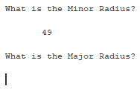

Figure 124: Test Case 113 Output. (Kucera, 2020)

**Pass or Fail?**: PASS

1. **Aspect Tested:** Torus major radius: Input non-double (Not Allowed)

**Input:** .

**Expected Output:** Invalid input. Only a positive double is accepted here. Please try again. (Prompt for user input for minor radius)

**Actual Output**: See Fig. 125.

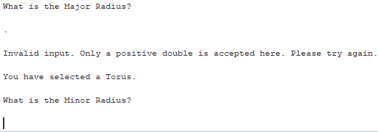

Figure 125: Test Case 114 Output. (Kucera, 2020)

**Pass or Fail?**: PASS

1. **Aspect Tested:** Torus major radius: Input negative (Not Allowed)

**Input:** -7.7

**Expected Output:** Invalid input. Only a positive double is accepted here. Please try again. (Prompt for user input for minor radius)

**Actual Output**: See Fig. 126.

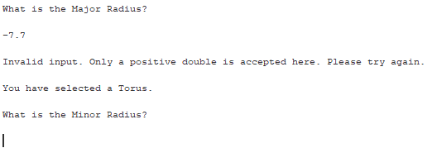

Figure 126: Test Case 115 Output. (Kucera, 2020)

**Pass or Fail?**: PASS

1. **Aspect Tested:** Torus major radius: Input zero (Not Allowed)

**Input:** 0

**Expected Output:** Invalid input. Only a positive double is accepted here. Please try again. (Prompt for user input for minor radius)

**Actual Output**: See Fig. 127.

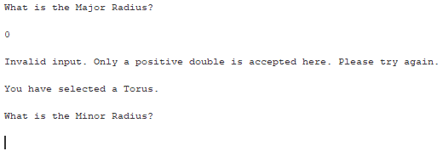

Figure 127: Test Case 116 Output. (Kucera, 2020)

**Pass or Fail?**: PASS

1. **Aspect Tested:** Torus major radius: Input positive double. Minor radius < Major radius. (Allowed)

**Input:** Minor radius: 8. Major radius: 20.1

**Expected Output:** The volume of the Torus is 25392.5182031227. This is a Ring Torus. Would you like to continue? (Y or N) (Prompt for user input)

**Actual Output**: See Fig. 128.

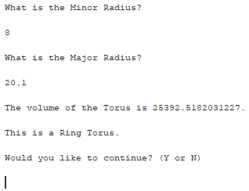

Figure 128: Test Case 117 Output. (Kucera, 2020)

**Pass or Fail?**: PASS

1. **Aspect Tested:** Torus major radius: Input positive integer. Minor radius = Major radius (Horn Torus). (Allowed)

**Input:** Minor radius: 30. Major radius: 30

**Expected Output:** The volume of the Torus is 532958.6376588253. This is a Horn Torus. Would you like to continue? (Y or N) (Prompt for user input)

**Actual Output**: See Fig. 129.

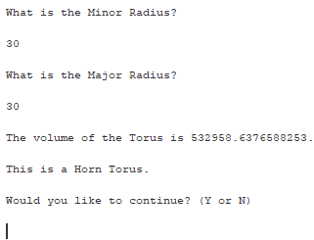

Figure 129: Test Case 118 Output. (Kucera, 2020)

**Pass or Fail?**: PASS

1. **Aspect Tested:** Torus major radius: Input positive double. Minor radius > Major radius (Spindle Torus). (Allowed)

**Input:** Minor radius: 41.143. Major radius: 33.991

**Expected Output:** The volume of the Torus cannot be calculated. This is a Spindle Torus. Would you like to continue? (Y or N) (Prompt for user input)

**Actual Output**: See Fig. 130.

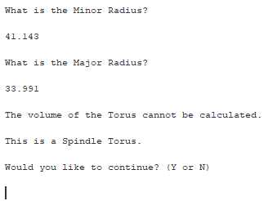

Figure 130: Test Case 119 Output. (Kucera, 2020)

**Pass or Fail?**: PASS

1. **Aspect Tested:** Menu: Input 10, with whitespace (Allowed)

**Input:** 10 (15 spaces before value, 11 spaces after)

**Expected Output:** Thanks for using the program. Today is [current date] at [current time]. (Program ends)

**Actual Output**: See Fig. 131.

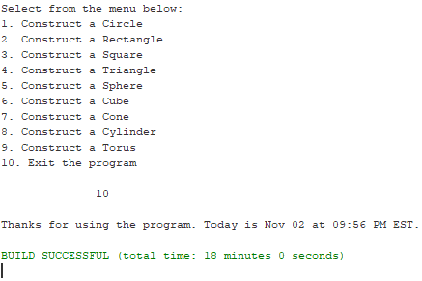

Figure 131: Test Case 120 Output. (Kucera, 2020)

**Pass or Fail?**: PASS

**Lessons learned**

I was surprised by how much I learned from this Project even though I’ve written so many like it in the past (a command-line driven menu with a big class hierarchy). One lesson I learned was understanding the bare-bones contents of Constructors. Constructors are a beginner topic, but when writing this program, I realized I was not using them correctly initially. I was stuffing too much information in the constructors, such as the formulas for area and volume. It was only until I was making the UML diagram that I realized I had barely any methods, only constructors. I went back and created proper methods, such as calculateCircleArea and determineTriangleType, and had the constructors call on those specialized methods. I now know that this is the better relationship between constructors and other class methods. At the very end of writing this program, I realized I had the same bad habit of stuffing code into the main method. I corrected this by having a Menu() constructor in Menu.java to hold the important menu information and output, then created a Menu object in the main method.

While this is not a specific lesson I learned, I found that I improved on my incremental and step-by-step programming. When starting out in this field, I tended to try and write the big chunks of the program at a time, then go back through the whole thing to see what went wrong when errors occur. I have now forced myself into the habit of saving after every few lines of code and making several test cases after each implementation. For example, after every shape construction when the application asks “Would you like to continue? (Y/N)”, I made sure to test all possible input and that errors were properly handled. I also commented as I wrote the code, rather than filling all the user-friendly comments in at the end. It even helps for me when the program is this large and I do not always remember everything I wrote.

Overall, this was an interesting program to write as it felt like a large and thorough Java review. I understand class hierarchies more now and to always think about the “is-a” and “has-a” relationships when designing the classes. I was able to review concepts that I have learned in the past but was unsure if I knew them well, such as accounting for white space input or handling all different kinds of invalid user input. I can say I feel very comfortable writing class hierarchies with user interaction now.

References

Kucera, 2020. .zip file has been unzipped.

Kucera, 2020. Creating Java Application Project in Netbeans.

Kucera, 2020. Creating Test Kucera Project 1.

Kucera, 2020. Copying Application Source Files.

Kucera, 2020. Open Menu.java, click Run Project.

Kucera, 2020. Pasted Source Files appear in IDE.

Kucera, 2020. Pasting Application Source Files in Test Project.

Kucera, 2020. Project 1 UML Class Diagram.

Kucera, 2020. Project Properties > Run, type in Main Class.

Kucera, 2020. Run project, menu displayed.

Kucera, 2020. Test Case 1 Output.

Kucera, 2020. Test Case 2 Output.

Kucera, 2020. Test Case 3 Output.

Kucera, 2020. Test Case 4 Output.

Kucera, 2020. Test Case 5 Output.

Kucera, 2020. Test Case 6 Output.

Kucera, 2020. Test Case 7 Output.

Kucera, 2020. Test Case 8 Output.

Kucera, 2020. Test Case 9 Output.

Kucera, 2020. Test Case 10 Output.

Kucera, 2020. Test Case 11 Output.

Kucera, 2020. Test Case 12 Output.

Kucera, 2020. Test Case 13 Output.

Kucera, 2020. Test Case 14 Output.

Kucera, 2020. Test Case 15 Output.

Kucera, 2020. Test Case 16 Output.

Kucera, 2020. Test Case 17 Output.

Kucera, 2020. Test Case 18 Output.

Kucera, 2020. Test Case 19 Output.

Kucera, 2020. Test Case 20 Output.

Kucera, 2020. Test Case 21 Output.

Kucera, 2020. Test Case 22 Output.

Kucera, 2020. Test Case 23 Output.

Kucera, 2020. Test Case 24 Output.

Kucera, 2020. Test Case 25 Output.

Kucera, 2020. Test Case 26 Output.

Kucera, 2020. Test Case 27 Output.

Kucera, 2020. Test Case 28 Output.

Kucera, 2020. Test Case 29 Output.

Kucera, 2020. Test Case 30 Output.

Kucera, 2020. Test Case 31 Output.

Kucera, 2020. Test Case 32 Output.

Kucera, 2020. Test Case 33 Output.

Kucera, 2020. Test Case 34 Output.

Kucera, 2020. Test Case 35 Output.

Kucera, 2020. Test Case 36 Output.

Kucera, 2020. Test Case 37 Output.

Kucera, 2020. Test Case 38 Output.

Kucera, 2020. Test Case 39 Output.

Kucera, 2020. Test Case 40 Output.

Kucera, 2020. Test Case 41 Output.

Kucera, 2020. Test Case 42 Output.

Kucera, 2020. Test Case 43 Output.

Kucera, 2020. Test Case 44 Output.

Kucera, 2020. Test Case 45 Output.

Kucera, 2020. Test Case 46 Output.

Kucera, 2020. Test Case 47 Output.

Kucera, 2020. Test Case 48 Output.

Kucera, 2020. Test Case 49 Output.

Kucera, 2020. Test Case 50 Output.

Kucera, 2020. Test Case 51 Output.

Kucera, 2020. Test Case 52 Output.

Kucera, 2020. Test Case 53 Output.

Kucera, 2020. Test Case 54 Output.

Kucera, 2020. Test Case 55 Output.

Kucera, 2020. Test Case 56 Output.

Kucera, 2020. Test Case 57 Output.

Kucera, 2020. Test Case 58 Output.

Kucera, 2020. Test Case 59 Output.

Kucera, 2020. Test Case 60 Output.

Kucera, 2020. Test Case 61 Output.

Kucera, 2020. Test Case 62 Output.

Kucera, 2020. Test Case 63 Output.

Kucera, 2020. Test Case 64 Output.

Kucera, 2020. Test Case 65 Output.

Kucera, 2020. Test Case 66 Output.

Kucera, 2020. Test Case 67 Output.

Kucera, 2020. Test Case 68 Output.

Kucera, 2020. Test Case 69 Output.

Kucera, 2020. Test Case 70 Output.

Kucera, 2020. Test Case 71 Output.

Kucera, 2020. Test Case 72 Output.

Kucera, 2020. Test Case 73 Output.

Kucera, 2020. Test Case 74 Output.

Kucera, 2020. Test Case 75 Output.

Kucera, 2020. Test Case 76 Output.

Kucera, 2020. Test Case 77 Output.

Kucera, 2020. Test Case 78 Output.

Kucera, 2020. Test Case 79 Output.

Kucera, 2020. Test Case 80 Output.

Kucera, 2020. Test Case 81 Output.

Kucera, 2020. Test Case 82 Output.

Kucera, 2020. Test Case 83 Output.

Kucera, 2020. Test Case 84 Output.

Kucera, 2020. Test Case 85 Output.

Kucera, 2020. Test Case 86 Output.

Kucera, 2020. Test Case 87 Output.

Kucera, 2020. Test Case 88 Output.

Kucera, 2020. Test Case 89 Output.

Kucera, 2020. Test Case 90 Output.

Kucera, 2020. Test Case 91 Output.

Kucera, 2020. Test Case 92 Output.

Kucera, 2020. Test Case 93 Output.

Kucera, 2020. Test Case 94 Output.

Kucera, 2020. Test Case 95 Output.

Kucera, 2020. Test Case 96 Output.

Kucera, 2020. Test Case 97 Output.

Kucera, 2020. Test Case 98 Output.

Kucera, 2020. Test Case 99 Output.

Kucera, 2020. Test Case 100 Output.

Kucera, 2020. Test Case 101 Output.

Kucera, 2020. Test Case 102 Output.

Kucera, 2020. Test Case 103 Output.

Kucera, 2020. Test Case 104 Output.

Kucera, 2020. Test Case 105 Output.

Kucera, 2020. Test Case 106 Output.

Kucera, 2020. Test Case 107 Output.

Kucera, 2020. Test Case 108 Output.

Kucera, 2020. Test Case 109 Output.

Kucera, 2020. Test Case 110 Output.

Kucera, 2020. Test Case 111 Output.

Kucera, 2020. Test Case 112 Output.

Kucera, 2020. Test Case 113 Output.

Kucera, 2020. Test Case 114 Output.

Kucera, 2020. Test Case 115 Output.

Kucera, 2020. Test Case 116 Output.

Kucera, 2020. Test Case 117 Output.

Kucera, 2020. Test Case 118 Output.

Kucera, 2020. Test Case 119 Output.

Kucera, 2020. Test Case 120 Output.

Kucera, 2020. Unzipping a .zip file.