**3D Graphics Scene with Transformations using Java OpenGL**

John Kucera

Prof. Amitava Karmaker

CMSC 405 6380 Computer Graphics (2218)

09 September 2021

**Included files**: JoglGUI.java, Shapes.java

**Purpose of program**: To create a unique 3D graphics scene using Java OpenGL that contains 6 different shapes, uses 6 different transformation methods, and is at least 640x480 pixels. In my program, 3 shapes are made using GLUT, and 3 shapes are made using arrays that hold dimension information.

**Descriptions of methods**:

* *Shapes* class:
  + Store information as doubles/integers in arrays about vertices/faces/face colors for shapes Rectangular Prism, Tetrahedron, and Rhombic Dodecahedron. This information is attached to respective *Shapes* objects which are later called in JoglGUI.java for display in the GUI. All faces have differing colors.
    - **Rectangular Prism**: Wide in x component. Translated in +Y direction.
    - **Tetrahedron**: Wide in x component. Translated in -Y direction.
    - **Rhombic Dodecahedron**: Short in y component. Translated in +X direction.
  + *Shapes*(): Class constructor. Holds array data.
* *JoglGUI* class: Extends GLJPanel as a container for 3D scene to be displayed. Implements interfaces GLEventListener (for 3D scene display) and KeyListener (for user to manually transform shapes and have panel updated each time).
  + *main()* method: Create JFrames, then label and edit properties of JFrame for proper 3D scene display. **Size is 700x500**.
  + *JoglGUI()* method: Class constructor. Adds GLCapabilities and Listeners to frame.
  + *create()* method: Uses GL to draw shape with the respective dimensions and information (about vertices/faces/face colors) from Shapes.java.
  + *display()* method: Implemented from GLEventListener interface. Using GL2, creates 6 shapes that are translated so they can be seen individually. 3 shapes are made using GLUT:
    - **Icosahedron**: Sky blue. No translation, centered.
    - **Sphere**: Orange. Translated in -Z direction.
    - **Torus**: Green. Translated in -X direction.

The other 3 shapes are made by calling create(), which uses information from Shapes.java. They are the Rectangular Prism, Tetrahedron, and Rhombic Dodecahedron.

* + *init()* method: Implemented from GLEventListener interface. Sets up GL and GL setting when panel is first created so display is proper. Also enables some Lighting settings so that shapes can look 3D when rotated.
  + *keyPressed()* method: Implemented from KeyListener interface. Sets up a listener for whenever the appropriate key is pressed for shape transformation. **User can use WASD for translation, Arrow keys for Rotation, and +/- for Scaling.**
  + *reshape*() and *dispose*() methods: Implemented/overridden methods from implementing GLEventListener Interface.
  + *keyTyped*() and *keyReleased*() methods: Implemented/overridden methods from implementing KeyListener Interface.

**Program running in Netbeans IDE**:

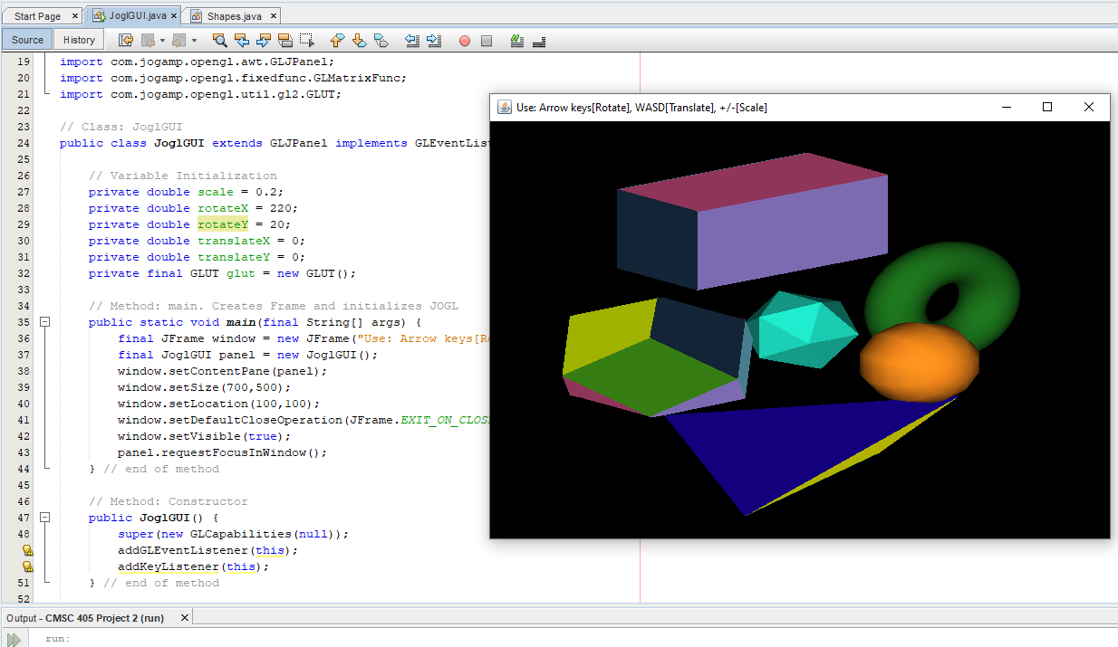

Figure : Program running in Netbeans IDE

**Test Plan & Results**

|  |  |
| --- | --- |
| **Plan** | |
| After pressing Run and the JFrame is displayed, first make sure that dimensions are 700x500 and that shapes are properly displayed in the panel. Then, use the proper keys that will allow user to perform transformations: **WASD for translation, Arrow keys for Rotation, and +/- for Scaling**. Panel should update for each transformation. | |
| **Test # + Description** | **Result** |
| **(SUCCESS)**  **Test 1: Initial panel**. Shapes are drawn, colored, and positioned perfectly, creating 6 different shapes which can all be seen in initial panel. The title of the frame contains user instructions for how to transform the shapes. Frame is 700x500. | Figure : Test 1 |
| **(SUCCESS)**  **Test 2: Translate in +X direction**. Pressed “D” key and the panel was updated to show the shapes translated in the +X direction. This screenshot on the right shows the GUI when I pressed “D” 3 times. | Figure : Test 2 |
| **(SUCCESS)**  **Test 3: Translate in -X direction.** Pressed “A” key and the panel was updated to show the shapes translated in the -X direction. This screenshot on the right shows the GUI when I pressed “A” 3 times. | Figure : Test 3 |
| **(SUCCESS)**  **Test 4: Translate in +Y direction.** Pressed “W” key and the panel was updated to show the shapes translated in the +Y direction. This screenshot on the right shows the GUI when I pressed “W” 3 times. | Figure : Test 4 |
| **(SUCCESS)**  **Test 5: Translate in -Y direction.** Pressed “S” key and the panel was updated to show the shapes translated in the -Y direction. This screenshot on the right shows the GUI when I pressed “S” 3 times. | Figure : Test 5 |
| **(SUCCESS)**  **Test 6: Rotate in +X direction.** Pressed RIGHT ARROW key and the panel was updated to show the shapes rotated in the +X direction. This screenshot on the right shows the GUI when I pressed Right Arrow Key 10 times. | Figure : Test 6 |
| **(SUCCESS)**  **Test 7: Rotate in -X direction.** Pressed LEFT ARROW key and the panel was updated to show the shapes rotated in the -X direction. This screenshot on the right shows the GUI when I pressed Left Arrow Key 10 times. | Figure 8: Test 7 |
| **(SUCCESS)**  **Test 8: Rotate in +Y direction.** Pressed UP ARROW key and the panel was updated to show the shapes rotated in the +Y direction. This screenshot on the right shows the GUI when I pressed Up Arrow Key 10 times. | Figure 9: Test 8 |
| **(SUCCESS)**  **Test 9: Rotate in -Y direction.** Pressed DOWN ARROW key and the panel was updated to show the shapes rotated in the -Y direction. This screenshot on the right shows the GUI when I pressed Down Arrow Key 10 times. | Figure 10: Test 9 |
| **(SUCCESS)**  **Test 10: Scale UP.** Pressed + key and the panel was updated to show the shapes scaled in the positive direction, enlarging them. This screenshot on the right shows the GUI when I pressed + key 3 times. | Figure 11: Test 10 |
| **(SUCCESS)**  **Test 11: Scale DOWN**. Pressed - key and the panel was updated to show the shapes scaled in the negative direction, reducing them. This screenshot on the right shows the GUI when I pressed - key 3 times. | Figure 12: Test 11 |