John Kucera

Prof. Suzanna Schmeelk

CMSC 412 Operating Systems

28 February 2021

Week 8: Final Project (TEST 1 + Other menu options/error handling)

**Demand Paging Virtual Memory Simulator (Java)**

**Main.java running in repl.it:**

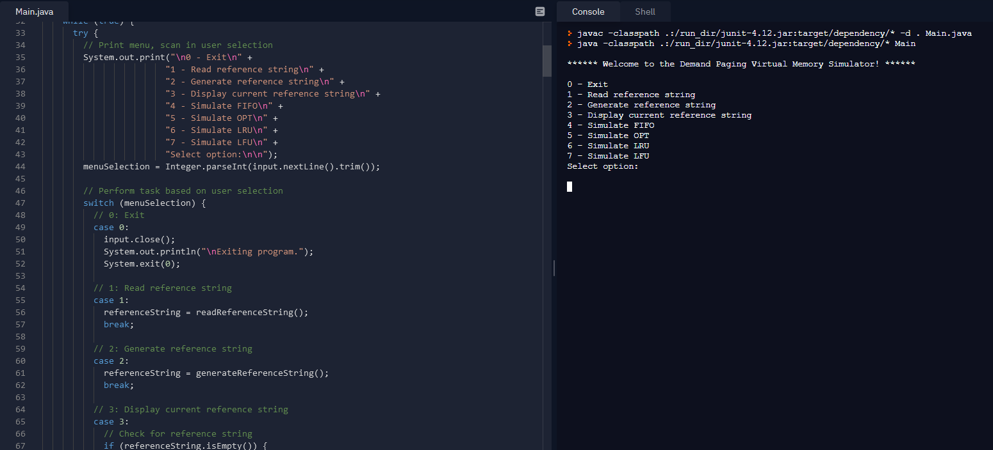

**Test Runs of execution of 4 Algorithms with inputs from HW6  
Reference String: 2 4 5 6 1 5 3 4 5 2 3 6 5 3 4 7 3 5 6. Physical Frames: N = 3.**

|  |  |  |
| --- | --- | --- |
| **Algorithm** | **Expected Output** | **Pass?** |
| **FIFO** | Total number of faults: 15. Loops back to menu when done. | **YES** |
| Beginning:   Middle:  End: | | |
| **OPT** | Total number of faults: 8. Loops back to menu when done. | **YES** |
| Beginning:   Middle:   End: | | |
| **LRU** | Total number of faults: 12. Loops back to menu when done. | **YES** |
| Beginning:   Middle:   End: | | |
| **LFU** | When there is a tie, the lowest-numbered frame becomes victim. Total number of faults: 11. Loops back to menu when done. | **YES** |
| Beginning:   Middle:   End: | | |

**Test Runs for Menu Options 0 through 3 & Error handling (Screencaps under each test)**

|  |  |  |  |  |
| --- | --- | --- | --- | --- |
| **#** | **Aspect Tested** | **Input** | **Expected Output** | **Pass?** |
| 1 | MENU: Integer outside of 0 to 7, non-integer | (at menu)  9  H | Print “Invalid input. Only integers 0 to 7 are accepted. Please try again.” then loop back to menu | **YES** |
|  | | | | |
| 2 | MENU: 0 - exit | (at menu)  0 | Print “Exiting program.”, then program ends | **YES** |
|  | | | | |
| 3 | MENU: 1, input non-integer length | (at menu)  1  (entering length)  k | Prompt for length, input invalid. Print “Invalid input. Only positive integers are accepted. Please try again.”, then prompt again | **YES** |
|  | | | | |
| 4 | 1: input valid length | (entering length)  15 | Prompt for next string value, print “Enter a value into the reference string one at a time:” | **YES** |
|  | | | | |
| 5 | 1: input invalid string value, input non-integer string value | (entering string value)  13  f | Print “Invalid input. Only integers 0 to 9 are accepted. Please try again.”, then ask again | **YES** |
|  | | | | |
| 6 | 1: input a valid string value | (entering string value)  6 | Print the current reading of reference string, then ask for next value | **YES** |
|  | | | | |
| 7 | 1: input all valid string values | (entering string values) [6, 3, 5, 1, 6, 0, 2, 9, 3, 5, 6, 8, 1, 2, 2] | Print the current reading of reference string, then loop back to menu | **YES** |
|  | | | | |
| 8 | MENU: 2, input non-integer length | (at menu)  2  (entering length)  w | Prompt for length, input invalid. Print “Invalid input. Only positive integers are accepted. Please try again.”, then prompt again | **YES** |
|  | | | | |
| 9 | 2: input valid length | (entering length)  8 | Generate and print a reference string of length 8 and only has integers 0-9. Loop back to menu | **YES** |
|  | | | | |
| 10 | MENU: 3-7, no reference string set | (at menu, no string set)  3, 4, 5, 6, 7 | Print “No reference string has been set. Please try again.” then loop back to menu | **YES** |
|  | | | | |
| 11 | MENU: 3, reference string is set | (at menu, string set)  3 | Prints current reference string, then loops back to menu | **YES** |
|  | | | | |
| 12 | MENU: 4-7, input invalid # of physical frames, input non-integer physical frames | (at menu)  4  (entering # frames)  10  y | Prompt for # of physical frames. Print “Invalid input. Only integers 1 to 8 are accepted. Please try again.” then ask again | **YES** |
|  | | | | |
| 13 | 4-7: input valid # of physical frames | (entering # frames)  4 | Print initial diagram for FIFO, then prompt user to press enter to continue | **YES** |
|  | | | | |