John Kucera

Prof. Suzanna Schmeelk

CMSC 412 Operating Systems

20 February 2021

Week 6: Homework 6 with Test Runs

**File/Directory Processing Utility (Java)**

**Solution Description**: In my Java program, I used a big switch statement nested in a while loop that would continuously prompt the user with the menu after a task is performed (until they exit the program with option 0). For each option I created a method that would perform the task after the program prompts the user for information, like directory name, file name, and/or XOR password.

The directory is treated as an array of type File, and this array is managed throughout the program to alter or view the directory’s contents. For example, option 2 lists directory content by printing the elements of the directory array. All file reading and writing has appropriate IOException in try-catch statements.

**Main.java running in repl.it:**

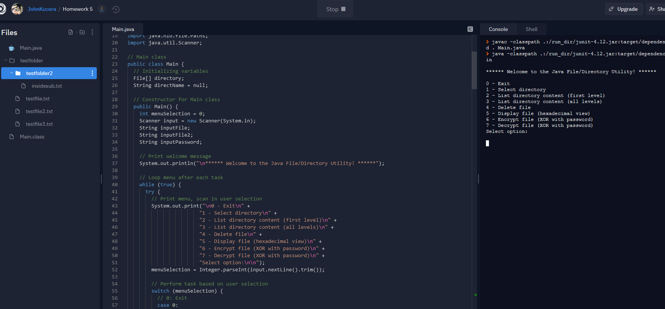

**Directory/files used during testing:**

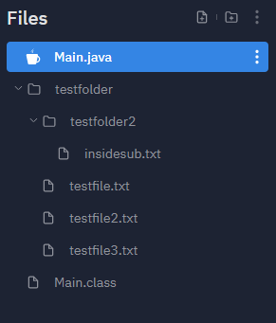

Directory: **testfolder**

>Subdirectory: **testfolder2**

>>File in subdirectory: **insidesub.txt**

>File: **testfile.txt** (contains text)

>File: **testfile2.txt** (initially empty)

>File: **testfile3.txt** (initially empty)

**testfile.txt contents:** 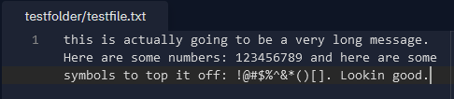

**Test Runs for error handling (Screenshots after this chart)**

|  |  |  |  |  |  |
| --- | --- | --- | --- | --- | --- |
| **#** | **Aspect Tested** | **Input** | **Expected Output** | **Actual Output** | **Pass?** |
| 1 | MENU: Integer outside of 0 to 7 | 8 | Print “Invalid input. Only integers 1 to 7 are accepted. Please try again.” then return to main menu | Print “Invalid input. Only integers 1 to 7 are accepted. Please try again.” then return to main menu | **YES** |
| 2 | MENU: Non-integer | y | Print “Invalid input. Only integers 1 to 7 are accepted. Please try again.” then return to main menu | Print “Invalid input. Only integers 1 to 7 are accepted. Please try again.” then return to main menu | **YES** |
| 3 | MENU: 0 (Exit) | 0 | Print “Exiting program.” and program ends | Print “Exiting program.” and program ends | **YES** |
| 4 | MENU: 1, select directory | 1 | Print “Please enter Directory Name:” and wait for user input | Print “Please enter Directory Name:” and wait for user input | **YES** |
| 5 | 1: nonexistent directory | noexist | Print “Directory noexist not found.” then return to main menu | Print “Directory noexist not found.” then return to main menu | **YES** |
| 6 | 1: select valid directory | testfolder | Print “Directory testfolder selected.” then return to main menu | Print “Directory testfolder selected.” then return to main menu | **YES** |
| 7 | 2: no directory selected yet | 2 | Print “No Directory Selected” then return to main menu | Print “No Directory Selected” then return to main menu | **YES** |
| 8 | 2: valid directory | 2 (testfolder) | Print “Listing files and subdirectories from first level of testfolder:” then prints the names of first level files/subdirectories, then return to main menu | Print “Listing files and subdirectories from first level of testfolder:” then prints the names of first level files/subdirectories, then return to main menu | **YES** |
| 9 | 3: no directory selected yet | 3 | Print “No Directory Selected” then return to main menu | Print “No Directory Selected” then return to main menu | **YES** |
| 10 | 3: valid directory | 3 (testfolder) | Print “Listing files and subdirectories from first level of testfolder:” then prints the names of all files/subdirectories, including files in subdirectories, then return to main menu | Print “Listing files and subdirectories from first level of testfolder:” then prints the names of all files/subdirectories, including files in subdirectories, then return to main menu | **YES** |
| 11 | 4: no directory selected yet | 4 | Print “No Directory Selected” then return to main menu | Print “No Directory Selected” then return to main menu | **YES** |
| 12 | 4: valid directory, nonexistent file | 4 (testfolder),  noexist.txt | Print “File could not be found or deleted.” then return to main menu | Print “File could not be found or deleted.” then return to main menu | **YES** |
| 13 | 4: valid directory, valid file | 4 (testfolder),  testfile.txt | Print “testfile.txt deleted.” and it is actually deleted from the directory. then return to main menu | Print “testfile.txt deleted.” and it is actually deleted from the directory. then return to main menu | **YES** |
| 14 | 5: no directory selected yet | 5 | Print “No Directory Selected” then return to main menu | Print “No Directory Selected” then return to main menu | **YES** |
| 15 | 5: valid directory, nonexistent file | 5 (testfolder),  why.txt | Print “IOException: Input File not found or unreadable.” then return to main menu | Print “IOException: Input File not found or unreadable.” then return to main menu | **YES** |
| 16 | 5: valid directory, valid file | 5 (testfolder),  testfile.txt | Print the data offset and hexadecimal view of the file contents correctly, 16 hexadecimal values at a time. return to main menu | Print the data offset and hexadecimal view of the file contents correctly, 16 hexadecimal values at a time. return to main menu | **YES** |
| 17 | 6: no directory selected yet | 6 | Print “No Directory Selected” then return to main menu | Print “No Directory Selected” then return to main menu | **YES** |
| 18 | 6: valid directory, enter password | 6 (testfolder), Qwertyuiop  [123$4$567] | Print “Please enter the Name of the File whose contents you want to Encrypt:”, wait for user input | Print “Please enter the Name of the File whose contents you want to Encrypt:”, wait for user input | **YES** |
| 19 | 6: nonexistent file | noex.txt  testfile2.txt | Allows both file names to be entered, then prints “IOException: Input File(s) not found or unreadable.” and return to main menu | Allows both file names to be entered, then prints “IOException: Input File(s) not found or unreadable.” and return to main menu | **YES** |
| 20 | 6: valid directory, password entered, valid input files | 6 (testfolder), Qwertyuiop  [123$4$567],  testfile.txt,  testfile2.txt | Prints “XOR Cipher has been performed on testfile.txt. The results have been placed in testfile2.txt.” and now testfile2.txt has encrypted content in it. return to main menu | Prints “XOR Cipher has been performed on testfile.txt. The results have been placed in testfile2.txt.” and now testfile2.txt has encrypted content in it. return to main menu | **YES** |
| 21 | 7: no directory selected yet | 7 | Print “No Directory Selected” then return to main menu | Print “No Directory Selected” then return to main menu | **YES** |
| 22 | 7: valid directory, enter password | 7 (testfolder), Qwertyuiop  [123$4$567] | Print “Please enter the Name of the File whose contents you want to Decrypt:”, wait for user input | Print “Please enter the Name of the File whose contents you want to Decrypt:”, wait for user input | **YES** |
| 23 | 7: nonexistent file | noex2.txt  testfile3.txt | Allows both file names to be entered, then prints “IOException: Input File(s) not found or unreadable.” and return to main menu | Allows both file names to be entered, then prints “IOException: Input File(s) not found or unreadable.” and return to main menu | **YES** |
| 24 | 7: valid directory, password entered, valid input files | 7 (testfolder), Qwertyuiop  [123$4$567],  testfile2.txt,  testfile3.txt | Prints “XOR Cipher has been performed on testfile2.txt. The results have been placed in testfile3.txt.” and now testfile3.txt has decrypted content in, which is a replica of what was in testfile.txt. return to main menu | Prints “XOR Cipher has been performed on testfile2.txt. The results have been placed in testfile3.txt.” and now testfile3.txt has decrypted content in, which is a replica of what was in testfile.txt. return to main menu | **YES** |

ACTUAL OUTPUT: SCREENSHOTS

1. MENU: Integer outside of 0 to 7

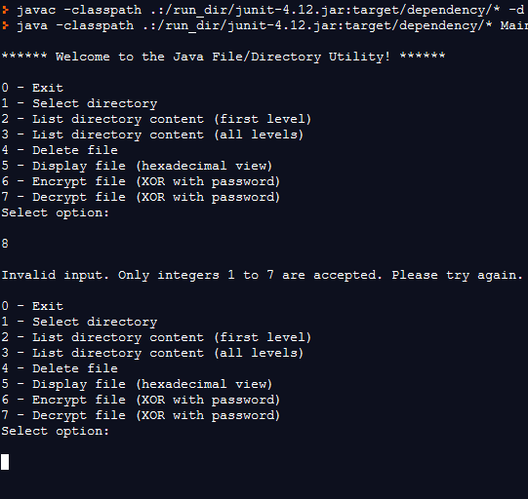

1. MENU: Non-integer

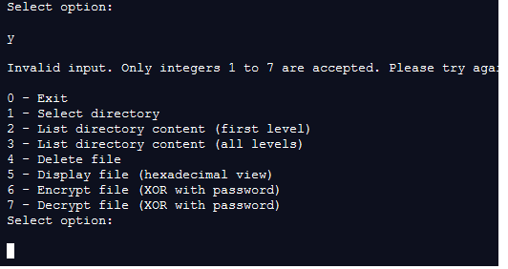

1. MENU: 0 (Exit)  
   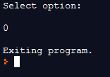
2. MENU: 1, select directory  
   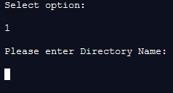
3. 1: nonexistent directory  
   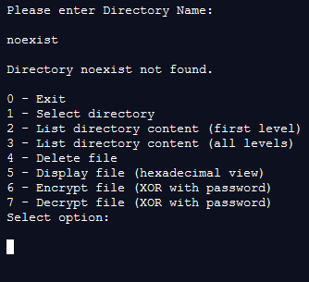
4. 1: select valid directory  
   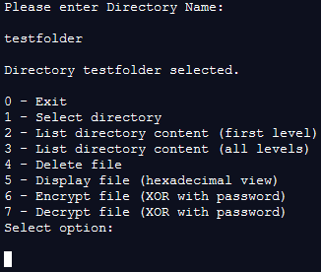
5. 2: no directory selected yet  
   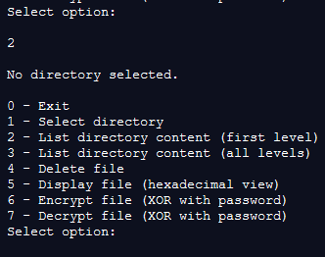
6. 2: valid directory  
   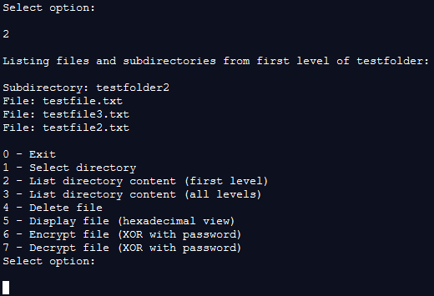
7. 3: no directory selected yet  
   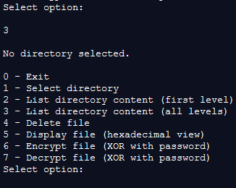
8. 3: valid directory  
   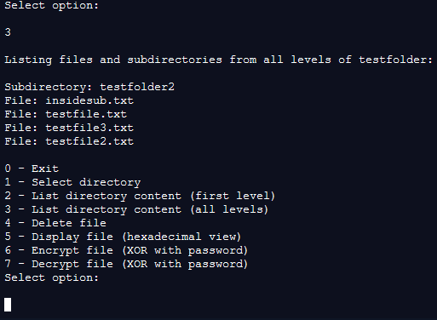
9. 4: no directory selected yet  
   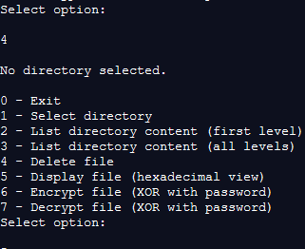
10. 4: valid directory, nonexistent file  
    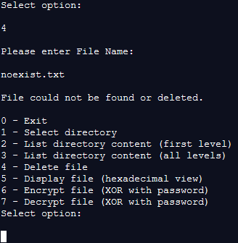
11. 4: valid directory, valid file (testfile.txt has been deleted from directory)  
    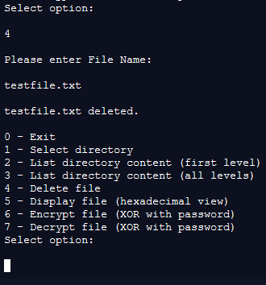

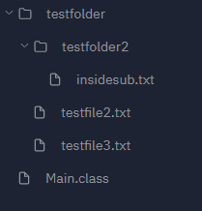

1. 5: no directory selected yet  
   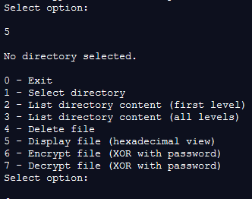
2. 5: valid directory, nonexistent file  
   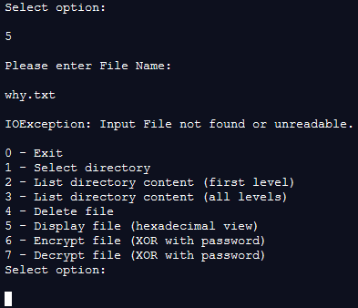
3. 5: valid directory, valid file (contents of testfile.txt correctly convert to hexadecimal here)  
     
   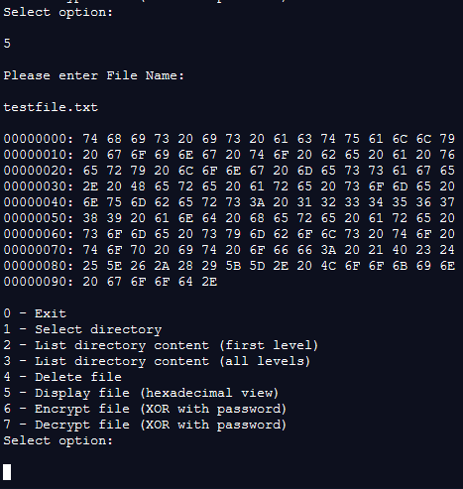
4. 6: no directory selected yet  
   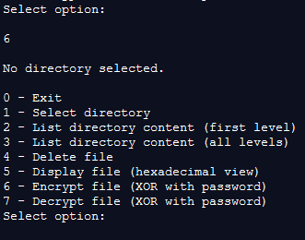
5. 6: valid directory, enter password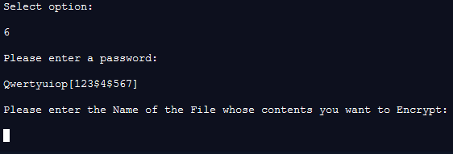
6. 6: nonexistent file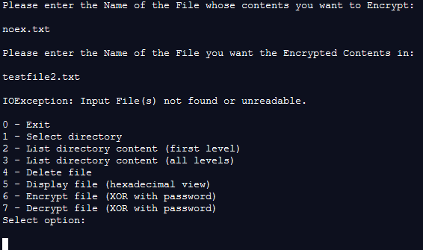
7. 6: valid directory, password entered, valid input files  
    (correctly XOR encrypted in testfile2.txt)  
   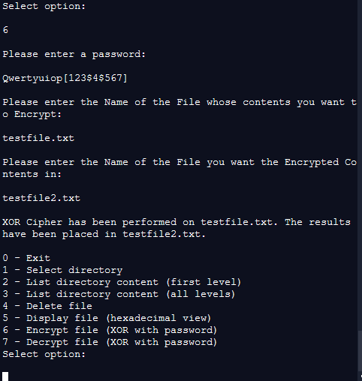

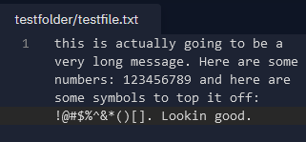  
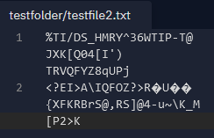

1. 7: no directory selected yet  
   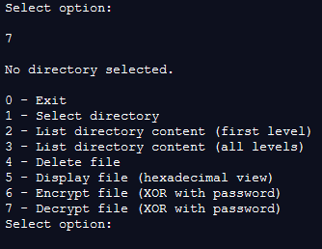
2. 7: valid directory, enter password  
   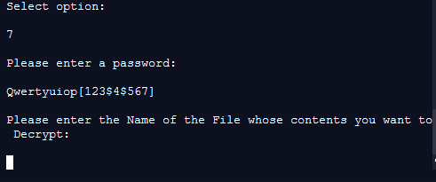
3. 7: nonexistent file  
   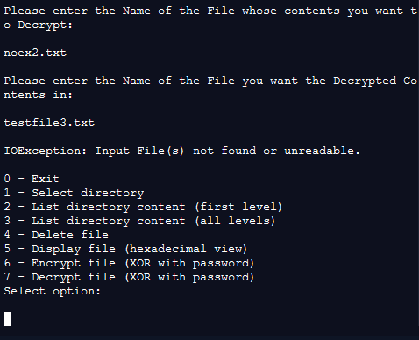
4. 7: valid directory, password entered, valid input files   
   (testfile2.txt is scorrectly decrypted with the XOR password and testfile3.txt is now a replica of testfile.txt)  
   