John Kucera

Prof. Craig Poma

SDEV 300

25 October 2019

Week 1: Lab 1

|  |  |  |  |  |
| --- | --- | --- | --- | --- |
| **Test Case** | **Input** | **Expected Output** | **Actual Output** | **Pass?** |
| 1a | 67, 3, 45, 98, 100 | Minimum = 3  Maximum = 100 | Minimum = 3  Maximum = 100 | Yes |
| 1b | -5, -34, 45, 980, -500 | Minimum = -500  Maximum = 980 | Minimum = -500  Maximum = 980 | Yes |
| 1c | g | ValueError, exits before user can continue inputting integers | ValueError, exits before user can continue inputting integers | Yes, but need to learn more about error later |
| 1d | # | ValueError, exits before user can continue inputting integers | ValueError, exits before user can continue inputting integers | Yes, but need to learn more about error later |
| 1e | 9.7 | ValueError, exits before user can continue inputting integers | ValueError, exits before user can continue inputting integers | Yes, but need to learn more about error later |
| 2a | 1, 45, 11 | Addition selected  Sum = 56 | Addition selected  Sum = 56 | Yes |
| 2b | 2, -23, 78 | Subtraction selected  Difference = -101 | Subtraction selected  Difference = -101 | Yes |
| 2c | 3, 40, 7 | Division selected  Quotient = 5.714285714286714 | Division selected  Quotient = 5.714285714286714 | Yes |
| 2d | 4, 20, 11 | Multiplication selected  Product = 220 | Multiplication selected  Product = 220 | Yes |
| 2e | 5, 34, 8 | Modulus selected  Modulus = 2 | Modulus selected  Modulus = 2 | Yes |
| 2f | 8 | “Please try again. Your selection here must be 1, 2, 3, 4, or 5.” (exits) | “Please try again. Your selection here must be 1, 2, 3, 4, or 5.” (exits) | Yes |
| 2g | -2 | “Please try again. Your selection here must be 1, 2, 3, 4, or 5.” (exits) | “Please try again. Your selection here must be 1, 2, 3, 4, or 5.” (exits) | Yes |
| 2h | john | ValueError, exits before user can continue inputting integers | ValueError, exits before user can continue inputting integers | Yes, but need to learn more about error later |
| 2i | 4.5 | ValueError, exits before user can continue inputting integers | ValueError, exits before user can continue inputting integers | Yes, but need to learn more about error later |
| 2j | 3, 5, 0 | “Division by 0 is not allowed. Please try again.” (exits) | “Division by 0 is not allowed. Please try again.” (exits) | Yes |
| 2k | 5, 8, 0 | “Division by 0 is not allowed. Please try again.” (exits) | “Division by 0 is not allowed. Please try again.” (exits) | Yes |
| 2L | 1, python | ValueError, exits before user can continue inputting integers | ValueError, exits before user can continue inputting integers | Yes, but need to learn more about error later |
| 2m | 1, 30.78 | ValueError, exits before user can continue inputting integers | ValueError, exits before user can continue inputting integers | Yes, but need to learn more about error later |

Screen Captures

pylint analysis of MinMax application: 10/10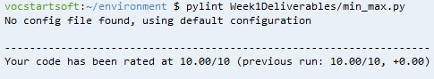

How MinMax application looks:

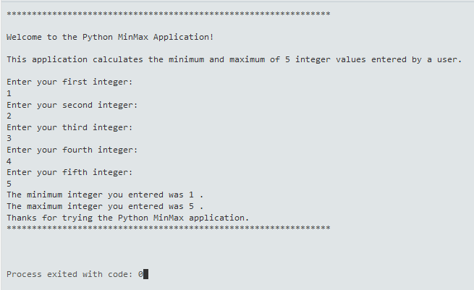

Test Case 1a:

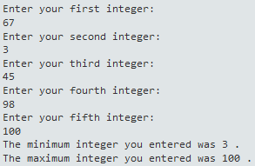  
Test Case 1b:

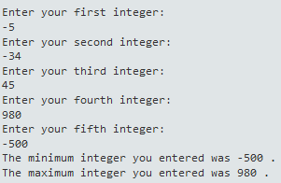

Test Case 1c:

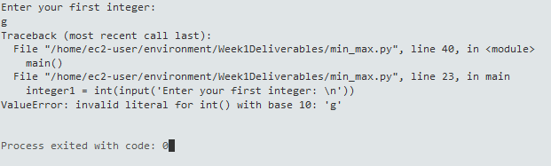

Test Case 1d: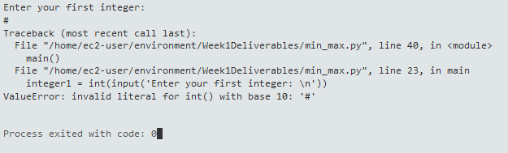

Test Case 1e:

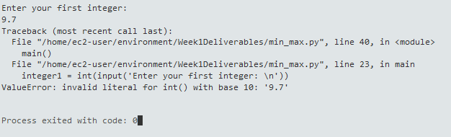

pylint analysis of Calculator application: 10/10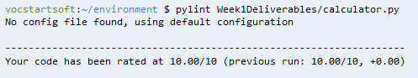

How Calculator application looks: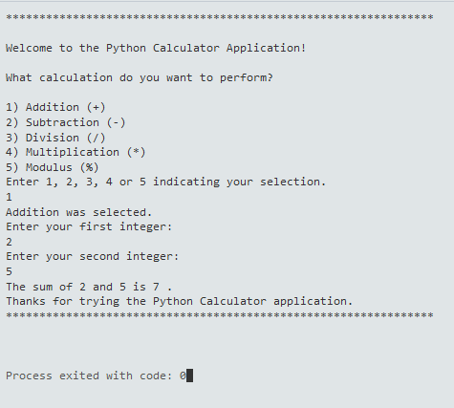

Test Case 2a:

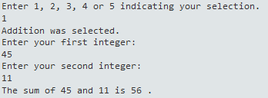

Test Case 2b:

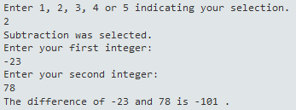

Test Case 2c:  
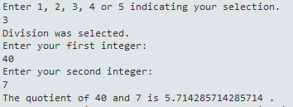

Test Case 2d:

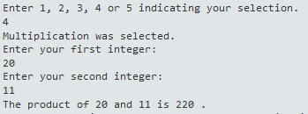

Test Case 2e:

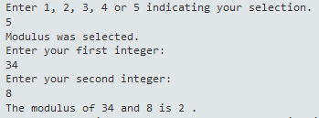

Test Case 2f:

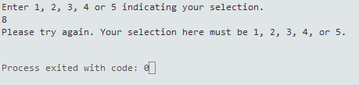

Test Case 2g:

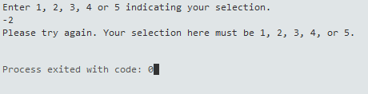

Test Case 2h: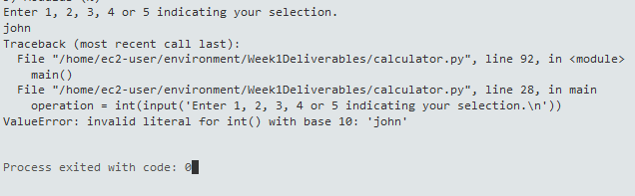

Test Case 2i:

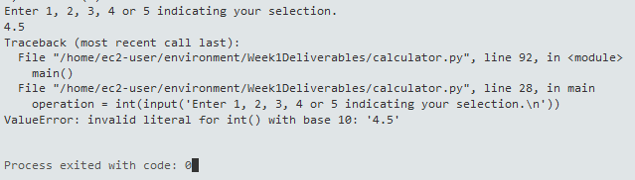

Test Case 2j:

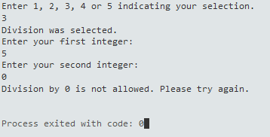

Test Case 2k:  
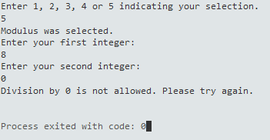

Test Case 2L: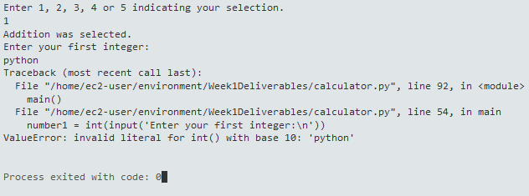

Test Case 2m:

