John Kucera

Prof. Craig Poma

SDEV 300

6 November 2019

Week 3: Lab 3

Part 1: US State Capitals and Birds

|  |  |  |  |  |
| --- | --- | --- | --- | --- |
| **Test Case** | **Input** | **Expected Output** | **Actual Output** | **Pass?** |
| 1a | (into menu) dgff | You must enter 1, 2, 3, or 4. Please try again. => (Reprint menu) | You must enter 1, 2, 3, or 4. Please try again. => (Reprint menu) | Yes |
| 1b | (into menu) 8 | You must enter 1, 2, 3, or 4. Please try again. => (Reprint menu) | You must enter 1, 2, 3, or 4. Please try again. => (Reprint menu) | Yes |
| 1c | (into menu)  1 | You selected 1. Here is a list of all U.S. States in alphabetical order along with Capital and Bird:  Alabama, Montgomery, Yellowhammer  Alaska, Juneau, Willow Ptarmigan  Arizona, Phoenix, Cactus Wren  Arkansas, Little Rock, Mockingbird  California, Sacramento, California Valley Quail  Colorado, Denver, Lark Bunting  Connecticut, Hartford, Robin  Delaware, Dover, Blue Hen  Florida, Tallahassee, Mockingbird  Georgia, Atlanta, Brown Thrasher  Hawaii, Honolulu, Nene  Idaho, Boise, Mountain Bluebird  Illinois, Springfield, Cardinal  Indiana, Indianapolis, Cardinal  Iowa, Des Moines, Eastern Goldfinch  Kansas, Topeka, Western Meadowlark  Kentucky, Frankfort, Cardinal  Louisiana, Baton Rouge, Eastern Brown Pelican  Maine, Augusta, Chickadee  Maryland, Annapolis, Baltimore Oriole  Massachusetts, Boston, Chickadee  Michigan, Lansing, Robin  Minnesota, St. Paul, Common Loon  Mississippi, Jackson, Mockingbird  Missouri, Jefferson City, Bluebird  Montana, Helena, Western Meadowlark  Nebraska, Lincoln, Western Meadowlark  Nevada, Carson City, Mountain Bluebird  New Hampshire, Concord, Purple Finch  New Jersey, Trenton, Eastern Goldfinch  New Mexico, Santa Fe, Roadrunner  New York, Albany, Bluebird  North Carolina, Raleigh, Cardinal  North Dakota, Bismarck, Western Meadowlark  Ohio, Columbus, Cardinal  Oklahoma, Oklahoma City, Scissor-Tailed Flycatcher  Oregon, Salem, Western Meadowlark  Pennsylvania, Harrisburg, Ruffed Grouse  Rhode Island, Providence, Rhode Island Red  South Carolina, Columbia, Great Carolina Wren  South Dakoda, Pierre, Ring-Necked Pheasant  Tennessee, Nashville, Mockingbird  Texas, Austin, Mockingbird  Utah, Salt Lake City, California Seagull  Vermont, Montpelier, Hermit Thrush  Virginia, Richmond, Cardinal  Washington, Olympia, Willow Goldfinch  West Virginia, Charleston, Cardinal  Wisconsin, Madison, Robin  Wyoming, Cheyenne, Western Meadowlark  => (Reprint menu) | You selected 1. Here is a list of all U.S. States in alphabetical order along with Capital and Bird:  Alabama, Montgomery, Yellowhammer  Alaska, Juneau, Willow Ptarmigan  Arizona, Phoenix, Cactus Wren  Arkansas, Little Rock, Mockingbird  California, Sacramento, California Valley Quail  Colorado, Denver, Lark Bunting  Connecticut, Hartford, Robin  Delaware, Dover, Blue Hen  Florida, Tallahassee, Mockingbird  Georgia, Atlanta, Brown Thrasher  Hawaii, Honolulu, Nene  Idaho, Boise, Mountain Bluebird  Illinois, Springfield, Cardinal  Indiana, Indianapolis, Cardinal  Iowa, Des Moines, Eastern Goldfinch  Kansas, Topeka, Western Meadowlark  Kentucky, Frankfort, Cardinal  Louisiana, Baton Rouge, Eastern Brown Pelican  Maine, Augusta, Chickadee  Maryland, Annapolis, Baltimore Oriole  Massachusetts, Boston, Chickadee  Michigan, Lansing, Robin  Minnesota, St. Paul, Common Loon  Mississippi, Jackson, Mockingbird  Missouri, Jefferson City, Bluebird  Montana, Helena, Western Meadowlark  Nebraska, Lincoln, Western Meadowlark  Nevada, Carson City, Mountain Bluebird  New Hampshire, Concord, Purple Finch  New Jersey, Trenton, Eastern Goldfinch  New Mexico, Santa Fe, Roadrunner  New York, Albany, Bluebird  North Carolina, Raleigh, Cardinal  North Dakota, Bismarck, Western Meadowlark  Ohio, Columbus, Cardinal  Oklahoma, Oklahoma City, Scissor-Tailed Flycatcher  Oregon, Salem, Western Meadowlark  Pennsylvania, Harrisburg, Ruffed Grouse  Rhode Island, Providence, Rhode Island Red  South Carolina, Columbia, Great Carolina Wren  South Dakoda, Pierre, Ring-Necked Pheasant  Tennessee, Nashville, Mockingbird  Texas, Austin, Mockingbird  Utah, Salt Lake City, California Seagull  Vermont, Montpelier, Hermit Thrush  Virginia, Richmond, Cardinal  Washington, Olympia, Willow Goldfinch  West Virginia, Charleston, Cardinal  Wisconsin, Madison, Robin  Wyoming, Cheyenne, Western Meadowlark  => (Reprint menu) | Yes |
| 1d | (into menu) 2 => (input state) asdfgf | Not a valid U.S. State. Please try again. => (Ask for State again) | Not a valid U.S. State. Please try again. => (Ask for State again) | Yes |
| 1e | (into menu) 2 => (input state) maryland | Maryland: Annapolis, Baltimore Oriole => (Reprint menu) | Maryland: Annapolis, Baltimore Oriole => (Reprint menu) | Yes |
| 1f | (into menu) 2 => (input state) washington | Washington: Olympia, Willow Goldfinch => (Reprint menu) | Washington: Olympia, Willow Goldfinch => (Reprint menu) | Yes |
| 1g | (into menu) 3 => (input state) staterino | Not a valid U.S. State. Please try again. => (Ask for State again) | Not a valid U.S. State. Please try again. => (Ask for State again) | Yes |
| 1h | (into menu) 3 => (input state) rhode island => (input bird) cool birb | What would you like to change the bird of this State to?  cool birb  The bird of Rhode Island has been changed to the Cool Birb . => (Reprint menu) | What would you like to change the bird of this State to?  cool birb  The bird of Rhode Island has been changed to the Cool Birb . => (Reprint menu) | Yes |
| 1i | checking if Rhode Island’s bird has been correctly changed with option 2 | Rhode Island: Providence, Cool Birb => (Reprint menu) | Rhode Island: Providence, Cool Birb => (Reprint menu) | Yes |
| 1j | (into menu) 4 | You selected 4.  Thank you for trying the US State Capital and Bird Database. (exit program) | You selected 4.  Thank you for trying the US State Capital and Bird Database. (exit program) | Yes |

Screen Captures (US State Capitals and Birds)

pylint analysis of US State Capitals and Birds application: 9.33/10 (Passing)

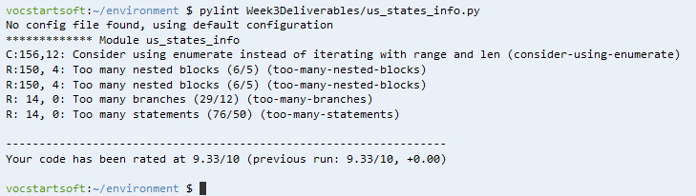

How US State Capitals and Birds application looks (with evidence of Cloud9 being used):

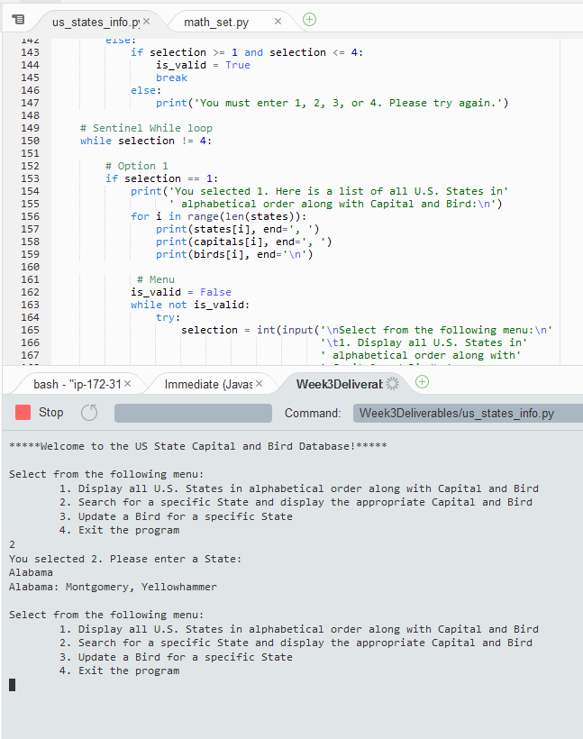

Test Case 1a:

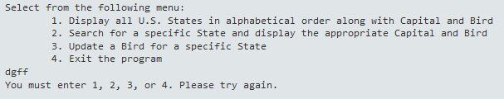

Test Case 1b:

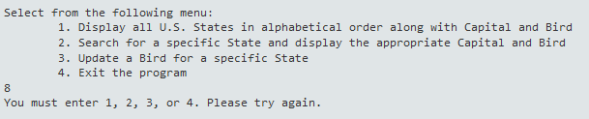

Test Case 1c (zoomed out to get a full screen capture):

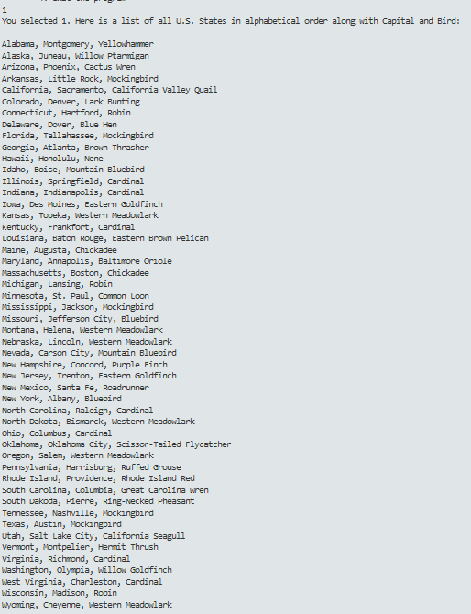

Test Case 1d:

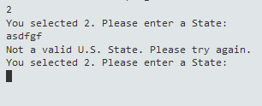

Test Case 1e:

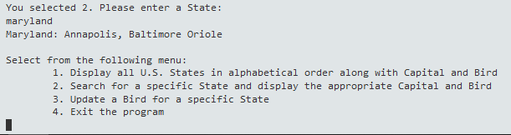

Test Case 1f:

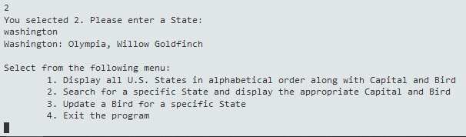

Test Case 1g:

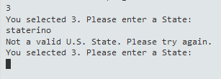

Test Case 1h:

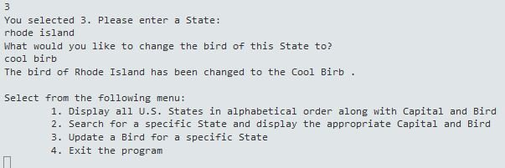

Test Case 1i:

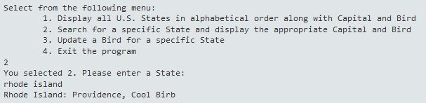

Test Case 1j:

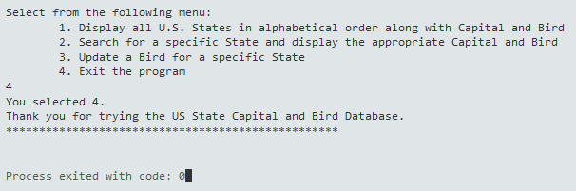

Part 2: Math Set Application

|  |  |  |  |  |
| --- | --- | --- | --- | --- |
| **Test Case** | **Input** | **Expected Output** | **Actual Output** | **Pass?** |
| 2a | (into menu) sdfgsd | You must enter 1, 2, 3, 4, 5, or 6. Please try again. => (Reprint menu) | You must enter 1, 2, 3, 4, 5, or 6. Please try again. => (Reprint menu) | Yes |
| 2b | (into menu) 34 | You must enter 1, 2, 3, 4, 5, or 6. Please try again. => (Reprint menu) | You must enter 1, 2, 3, 4, 5, or 6. Please try again. => (Reprint menu) | Yes |
| 2c | (into menu) 1 | You selected 1. Here are the Square and Cube for Integers ranging from 1 to 100:  1 =>  Square = 1 ^ 2 = 1  Cube = 1 ^ 3 = 1  2 =>  Square = 2 ^ 2 = 4  Cube = 2 ^ 3 = 8  3 =>  Square = 3 ^ 2 = 9  Cube = 3 ^ 3 = 27  4 =>  Square = 4 ^ 2 = 16  Cube = 4 ^ 3 = 64  5 =>  Square = 5 ^ 2 = 25  Cube = 5 ^ 3 = 125  6 =>  Square = 6 ^ 2 = 36  Cube = 6 ^ 3 = 216  7 =>  Square = 7 ^ 2 = 49  Cube = 7 ^ 3 = 343  8 =>  Square = 8 ^ 2 = 64  Cube = 8 ^ 3 = 512  9 =>  Square = 9 ^ 2 = 81  Cube = 9 ^ 3 = 729  10 =>  Square = 10 ^ 2 = 100  Cube = 10 ^ 3 = 1000  11 =>  Square = 11 ^ 2 = 121  Cube = 11 ^ 3 = 1331  12 =>  Square = 12 ^ 2 = 144  Cube = 12 ^ 3 = 1728  13 =>  Square = 13 ^ 2 = 169  Cube = 13 ^ 3 = 2197  14 =>  Square = 14 ^ 2 = 196  Cube = 14 ^ 3 = 2744  15 =>  Square = 15 ^ 2 = 225  Cube = 15 ^ 3 = 3375  16 =>  Square = 16 ^ 2 = 256  Cube = 16 ^ 3 = 4096  17 =>  Square = 17 ^ 2 = 289  Cube = 17 ^ 3 = 4913  18 =>  Square = 18 ^ 2 = 324  Cube = 18 ^ 3 = 5832  19 =>  Square = 19 ^ 2 = 361  Cube = 19 ^ 3 = 6859  20 =>  Square = 20 ^ 2 = 400  Cube = 20 ^ 3 = 8000  21 =>  Square = 21 ^ 2 = 441  Cube = 21 ^ 3 = 9261  22 =>  Square = 22 ^ 2 = 484  Cube = 22 ^ 3 = 10648  23 =>  Square = 23 ^ 2 = 529  Cube = 23 ^ 3 = 12167  24 =>  Square = 24 ^ 2 = 576  Cube = 24 ^ 3 = 13824  25 =>  Square = 25 ^ 2 = 625  Cube = 25 ^ 3 = 15625  26 =>  Square = 26 ^ 2 = 676  Cube = 26 ^ 3 = 17576  27 =>  Square = 27 ^ 2 = 729  Cube = 27 ^ 3 = 19683  28 =>  Square = 28 ^ 2 = 784  Cube = 28 ^ 3 = 21952  29 =>  Square = 29 ^ 2 = 841  Cube = 29 ^ 3 = 24389  30 =>  Square = 30 ^ 2 = 900  Cube = 30 ^ 3 = 27000  31 =>  Square = 31 ^ 2 = 961  Cube = 31 ^ 3 = 29791  32 =>  Square = 32 ^ 2 = 1024  Cube = 32 ^ 3 = 32768  33 =>  Square = 33 ^ 2 = 1089  Cube = 33 ^ 3 = 35937  34 =>  Square = 34 ^ 2 = 1156  Cube = 34 ^ 3 = 39304  35 =>  Square = 35 ^ 2 = 1225  Cube = 35 ^ 3 = 42875  36 =>  Square = 36 ^ 2 = 1296  Cube = 36 ^ 3 = 46656  37 =>  Square = 37 ^ 2 = 1369  Cube = 37 ^ 3 = 50653  38 =>  Square = 38 ^ 2 = 1444  Cube = 38 ^ 3 = 54872  39 =>  Square = 39 ^ 2 = 1521  Cube = 39 ^ 3 = 59319  40 =>  Square = 40 ^ 2 = 1600  Cube = 40 ^ 3 = 64000  41 =>  Square = 41 ^ 2 = 1681  Cube = 41 ^ 3 = 68921  42 =>  Square = 42 ^ 2 = 1764  Cube = 42 ^ 3 = 74088  43 =>  Square = 43 ^ 2 = 1849  Cube = 43 ^ 3 = 79507  44 =>  Square = 44 ^ 2 = 1936  Cube = 44 ^ 3 = 85184  45 =>  Square = 45 ^ 2 = 2025  Cube = 45 ^ 3 = 91125  46 =>  Square = 46 ^ 2 = 2116  Cube = 46 ^ 3 = 97336  47 =>  Square = 47 ^ 2 = 2209  Cube = 47 ^ 3 = 103823  48 =>  Square = 48 ^ 2 = 2304  Cube = 48 ^ 3 = 110592  49 =>  Square = 49 ^ 2 = 2401  Cube = 49 ^ 3 = 117649  50 =>  Square = 50 ^ 2 = 2500  Cube = 50 ^ 3 = 125000  51 =>  Square = 51 ^ 2 = 2601  Cube = 51 ^ 3 = 132651  52 =>  Square = 52 ^ 2 = 2704  Cube = 52 ^ 3 = 140608  53 =>  Square = 53 ^ 2 = 2809  Cube = 53 ^ 3 = 148877  54 =>  Square = 54 ^ 2 = 2916  Cube = 54 ^ 3 = 157464  55 =>  Square = 55 ^ 2 = 3025  Cube = 55 ^ 3 = 166375  56 =>  Square = 56 ^ 2 = 3136  Cube = 56 ^ 3 = 175616  57 =>  Square = 57 ^ 2 = 3249  Cube = 57 ^ 3 = 185193  58 =>  Square = 58 ^ 2 = 3364  Cube = 58 ^ 3 = 195112  59 =>  Square = 59 ^ 2 = 3481  Cube = 59 ^ 3 = 205379  60 =>  Square = 60 ^ 2 = 3600  Cube = 60 ^ 3 = 216000  61 =>  Square = 61 ^ 2 = 3721  Cube = 61 ^ 3 = 226981  62 =>  Square = 62 ^ 2 = 3844  Cube = 62 ^ 3 = 238328  63 =>  Square = 63 ^ 2 = 3969  Cube = 63 ^ 3 = 250047  64 =>  Square = 64 ^ 2 = 4096  Cube = 64 ^ 3 = 262144  65 =>  Square = 65 ^ 2 = 4225  Cube = 65 ^ 3 = 274625  66 =>  Square = 66 ^ 2 = 4356  Cube = 66 ^ 3 = 287496  67 =>  Square = 67 ^ 2 = 4489  Cube = 67 ^ 3 = 300763  68 =>  Square = 68 ^ 2 = 4624  Cube = 68 ^ 3 = 314432  69 =>  Square = 69 ^ 2 = 4761  Cube = 69 ^ 3 = 328509  70 =>  Square = 70 ^ 2 = 4900  Cube = 70 ^ 3 = 343000  71 =>  Square = 71 ^ 2 = 5041  Cube = 71 ^ 3 = 357911  72 =>  Square = 72 ^ 2 = 5184  Cube = 72 ^ 3 = 373248  73 =>  Square = 73 ^ 2 = 5329  Cube = 73 ^ 3 = 389017  74 =>  Square = 74 ^ 2 = 5476  Cube = 74 ^ 3 = 405224  75 =>  Square = 75 ^ 2 = 5625  Cube = 75 ^ 3 = 421875  76 =>  Square = 76 ^ 2 = 5776  Cube = 76 ^ 3 = 438976  77 =>  Square = 77 ^ 2 = 5929  Cube = 77 ^ 3 = 456533  78 =>  Square = 78 ^ 2 = 6084  Cube = 78 ^ 3 = 474552  79 =>  Square = 79 ^ 2 = 6241  Cube = 79 ^ 3 = 493039  80 =>  Square = 80 ^ 2 = 6400  Cube = 80 ^ 3 = 512000  81 =>  Square = 81 ^ 2 = 6561  Cube = 81 ^ 3 = 531441  82 =>  Square = 82 ^ 2 = 6724  Cube = 82 ^ 3 = 551368  83 =>  Square = 83 ^ 2 = 6889  Cube = 83 ^ 3 = 571787  84 =>  Square = 84 ^ 2 = 7056  Cube = 84 ^ 3 = 592704  85 =>  Square = 85 ^ 2 = 7225  Cube = 85 ^ 3 = 614125  86 =>  Square = 86 ^ 2 = 7396  Cube = 86 ^ 3 = 636056  87 =>  Square = 87 ^ 2 = 7569  Cube = 87 ^ 3 = 658503  88 =>  Square = 88 ^ 2 = 7744  Cube = 88 ^ 3 = 681472  89 =>  Square = 89 ^ 2 = 7921  Cube = 89 ^ 3 = 704969  90 =>  Square = 90 ^ 2 = 8100  Cube = 90 ^ 3 = 729000  91 =>  Square = 91 ^ 2 = 8281  Cube = 91 ^ 3 = 753571  92 =>  Square = 92 ^ 2 = 8464  Cube = 92 ^ 3 = 778688  93 =>  Square = 93 ^ 2 = 8649  Cube = 93 ^ 3 = 804357  94 =>  Square = 94 ^ 2 = 8836  Cube = 94 ^ 3 = 830584  95 =>  Square = 95 ^ 2 = 9025  Cube = 95 ^ 3 = 857375  96 =>  Square = 96 ^ 2 = 9216  Cube = 96 ^ 3 = 884736  97 =>  Square = 97 ^ 2 = 9409  Cube = 97 ^ 3 = 912673  98 =>  Square = 98 ^ 2 = 9604  Cube = 98 ^ 3 = 941192  99 =>  Square = 99 ^ 2 = 9801  Cube = 99 ^ 3 = 970299  100 =>  Square = 100 ^ 2 = 10000  Cube = 100 ^ 3 = 1000000  => (Reprint Menu) | You selected 1. Here are the Square and Cube for Integers ranging from 1 to 100:  1 =>  Square = 1 ^ 2 = 1  Cube = 1 ^ 3 = 1  2 =>  Square = 2 ^ 2 = 4  Cube = 2 ^ 3 = 8  3 =>  Square = 3 ^ 2 = 9  Cube = 3 ^ 3 = 27  4 =>  Square = 4 ^ 2 = 16  Cube = 4 ^ 3 = 64  5 =>  Square = 5 ^ 2 = 25  Cube = 5 ^ 3 = 125  6 =>  Square = 6 ^ 2 = 36  Cube = 6 ^ 3 = 216  7 =>  Square = 7 ^ 2 = 49  Cube = 7 ^ 3 = 343  8 =>  Square = 8 ^ 2 = 64  Cube = 8 ^ 3 = 512  9 =>  Square = 9 ^ 2 = 81  Cube = 9 ^ 3 = 729  10 =>  Square = 10 ^ 2 = 100  Cube = 10 ^ 3 = 1000  11 =>  Square = 11 ^ 2 = 121  Cube = 11 ^ 3 = 1331  12 =>  Square = 12 ^ 2 = 144  Cube = 12 ^ 3 = 1728  13 =>  Square = 13 ^ 2 = 169  Cube = 13 ^ 3 = 2197  14 =>  Square = 14 ^ 2 = 196  Cube = 14 ^ 3 = 2744  15 =>  Square = 15 ^ 2 = 225  Cube = 15 ^ 3 = 3375  16 =>  Square = 16 ^ 2 = 256  Cube = 16 ^ 3 = 4096  17 =>  Square = 17 ^ 2 = 289  Cube = 17 ^ 3 = 4913  18 =>  Square = 18 ^ 2 = 324  Cube = 18 ^ 3 = 5832  19 =>  Square = 19 ^ 2 = 361  Cube = 19 ^ 3 = 6859  20 =>  Square = 20 ^ 2 = 400  Cube = 20 ^ 3 = 8000  21 =>  Square = 21 ^ 2 = 441  Cube = 21 ^ 3 = 9261  22 =>  Square = 22 ^ 2 = 484  Cube = 22 ^ 3 = 10648  23 =>  Square = 23 ^ 2 = 529  Cube = 23 ^ 3 = 12167  24 =>  Square = 24 ^ 2 = 576  Cube = 24 ^ 3 = 13824  25 =>  Square = 25 ^ 2 = 625  Cube = 25 ^ 3 = 15625  26 =>  Square = 26 ^ 2 = 676  Cube = 26 ^ 3 = 17576  27 =>  Square = 27 ^ 2 = 729  Cube = 27 ^ 3 = 19683  28 =>  Square = 28 ^ 2 = 784  Cube = 28 ^ 3 = 21952  29 =>  Square = 29 ^ 2 = 841  Cube = 29 ^ 3 = 24389  30 =>  Square = 30 ^ 2 = 900  Cube = 30 ^ 3 = 27000  31 =>  Square = 31 ^ 2 = 961  Cube = 31 ^ 3 = 29791  32 =>  Square = 32 ^ 2 = 1024  Cube = 32 ^ 3 = 32768  33 =>  Square = 33 ^ 2 = 1089  Cube = 33 ^ 3 = 35937  34 =>  Square = 34 ^ 2 = 1156  Cube = 34 ^ 3 = 39304  35 =>  Square = 35 ^ 2 = 1225  Cube = 35 ^ 3 = 42875  36 =>  Square = 36 ^ 2 = 1296  Cube = 36 ^ 3 = 46656  37 =>  Square = 37 ^ 2 = 1369  Cube = 37 ^ 3 = 50653  38 =>  Square = 38 ^ 2 = 1444  Cube = 38 ^ 3 = 54872  39 =>  Square = 39 ^ 2 = 1521  Cube = 39 ^ 3 = 59319  40 =>  Square = 40 ^ 2 = 1600  Cube = 40 ^ 3 = 64000  41 =>  Square = 41 ^ 2 = 1681  Cube = 41 ^ 3 = 68921  42 =>  Square = 42 ^ 2 = 1764  Cube = 42 ^ 3 = 74088  43 =>  Square = 43 ^ 2 = 1849  Cube = 43 ^ 3 = 79507  44 =>  Square = 44 ^ 2 = 1936  Cube = 44 ^ 3 = 85184  45 =>  Square = 45 ^ 2 = 2025  Cube = 45 ^ 3 = 91125  46 =>  Square = 46 ^ 2 = 2116  Cube = 46 ^ 3 = 97336  47 =>  Square = 47 ^ 2 = 2209  Cube = 47 ^ 3 = 103823  48 =>  Square = 48 ^ 2 = 2304  Cube = 48 ^ 3 = 110592  49 =>  Square = 49 ^ 2 = 2401  Cube = 49 ^ 3 = 117649  50 =>  Square = 50 ^ 2 = 2500  Cube = 50 ^ 3 = 125000  51 =>  Square = 51 ^ 2 = 2601  Cube = 51 ^ 3 = 132651  52 =>  Square = 52 ^ 2 = 2704  Cube = 52 ^ 3 = 140608  53 =>  Square = 53 ^ 2 = 2809  Cube = 53 ^ 3 = 148877  54 =>  Square = 54 ^ 2 = 2916  Cube = 54 ^ 3 = 157464  55 =>  Square = 55 ^ 2 = 3025  Cube = 55 ^ 3 = 166375  56 =>  Square = 56 ^ 2 = 3136  Cube = 56 ^ 3 = 175616  57 =>  Square = 57 ^ 2 = 3249  Cube = 57 ^ 3 = 185193  58 =>  Square = 58 ^ 2 = 3364  Cube = 58 ^ 3 = 195112  59 =>  Square = 59 ^ 2 = 3481  Cube = 59 ^ 3 = 205379  60 =>  Square = 60 ^ 2 = 3600  Cube = 60 ^ 3 = 216000  61 =>  Square = 61 ^ 2 = 3721  Cube = 61 ^ 3 = 226981  62 =>  Square = 62 ^ 2 = 3844  Cube = 62 ^ 3 = 238328  63 =>  Square = 63 ^ 2 = 3969  Cube = 63 ^ 3 = 250047  64 =>  Square = 64 ^ 2 = 4096  Cube = 64 ^ 3 = 262144  65 =>  Square = 65 ^ 2 = 4225  Cube = 65 ^ 3 = 274625  66 =>  Square = 66 ^ 2 = 4356  Cube = 66 ^ 3 = 287496  67 =>  Square = 67 ^ 2 = 4489  Cube = 67 ^ 3 = 300763  68 =>  Square = 68 ^ 2 = 4624  Cube = 68 ^ 3 = 314432  69 =>  Square = 69 ^ 2 = 4761  Cube = 69 ^ 3 = 328509  70 =>  Square = 70 ^ 2 = 4900  Cube = 70 ^ 3 = 343000  71 =>  Square = 71 ^ 2 = 5041  Cube = 71 ^ 3 = 357911  72 =>  Square = 72 ^ 2 = 5184  Cube = 72 ^ 3 = 373248  73 =>  Square = 73 ^ 2 = 5329  Cube = 73 ^ 3 = 389017  74 =>  Square = 74 ^ 2 = 5476  Cube = 74 ^ 3 = 405224  75 =>  Square = 75 ^ 2 = 5625  Cube = 75 ^ 3 = 421875  76 =>  Square = 76 ^ 2 = 5776  Cube = 76 ^ 3 = 438976  77 =>  Square = 77 ^ 2 = 5929  Cube = 77 ^ 3 = 456533  78 =>  Square = 78 ^ 2 = 6084  Cube = 78 ^ 3 = 474552  79 =>  Square = 79 ^ 2 = 6241  Cube = 79 ^ 3 = 493039  80 =>  Square = 80 ^ 2 = 6400  Cube = 80 ^ 3 = 512000  81 =>  Square = 81 ^ 2 = 6561  Cube = 81 ^ 3 = 531441  82 =>  Square = 82 ^ 2 = 6724  Cube = 82 ^ 3 = 551368  83 =>  Square = 83 ^ 2 = 6889  Cube = 83 ^ 3 = 571787  84 =>  Square = 84 ^ 2 = 7056  Cube = 84 ^ 3 = 592704  85 =>  Square = 85 ^ 2 = 7225  Cube = 85 ^ 3 = 614125  86 =>  Square = 86 ^ 2 = 7396  Cube = 86 ^ 3 = 636056  87 =>  Square = 87 ^ 2 = 7569  Cube = 87 ^ 3 = 658503  88 =>  Square = 88 ^ 2 = 7744  Cube = 88 ^ 3 = 681472  89 =>  Square = 89 ^ 2 = 7921  Cube = 89 ^ 3 = 704969  90 =>  Square = 90 ^ 2 = 8100  Cube = 90 ^ 3 = 729000  91 =>  Square = 91 ^ 2 = 8281  Cube = 91 ^ 3 = 753571  92 =>  Square = 92 ^ 2 = 8464  Cube = 92 ^ 3 = 778688  93 =>  Square = 93 ^ 2 = 8649  Cube = 93 ^ 3 = 804357  94 =>  Square = 94 ^ 2 = 8836  Cube = 94 ^ 3 = 830584  95 =>  Square = 95 ^ 2 = 9025  Cube = 95 ^ 3 = 857375  96 =>  Square = 96 ^ 2 = 9216  Cube = 96 ^ 3 = 884736  97 =>  Square = 97 ^ 2 = 9409  Cube = 97 ^ 3 = 912673  98 =>  Square = 98 ^ 2 = 9604  Cube = 98 ^ 3 = 941192  99 =>  Square = 99 ^ 2 = 9801  Cube = 99 ^ 3 = 970299  100 =>  Square = 100 ^ 2 = 10000  Cube = 100 ^ 3 = 1000000  => (Reprint Menu) | Yes |
| 2d | (into menu) 2 => (input integer) dfg | You must enter an Integer between 1 and 100. Please try again. (Ask for Integer again) | You must enter an Integer between 1 and 100. Please try again. (Ask for Integer again) | Yes |
| 2e | (into menu) 2 => (input integer) 8.9 | You must enter an Integer between 1 and 100. Please try again. (Ask for Integer again) | You must enter an Integer between 1 and 100. Please try again. (Ask for Integer again) | Yes |
| 2f | (into menu) 2 => (input integer) 890 | You must enter an Integer between 1 and 100. Please try again. (Ask for Integer again) | You must enter an Integer between 1 and 100. Please try again. (Ask for Integer again) | Yes |
| 2g | (into menu) 2 => (input integer) 22 | 22 =>  Square = 22 ^ 2 = 484  Cube = 22 ^ 3 = 10648  => (Reprint Menu) | 22 =>  Square = 22 ^ 2 = 484  Cube = 22 ^ 3 = 10648  => (Reprint Menu) | Yes |
| 2h | (into menu) 2 => (input integer) 56 | 56 =>  Square = 56 ^ 2 = 3136  Cube = 56 ^ 3 = 175616  => (Reprint Menu) | 56 =>  Square = 56 ^ 2 = 3136  Cube = 56 ^ 3 = 175616  => (Reprint Menu) | Yes |
| 2i | (into menu) 3 | You selected 3. Here is the Union of Square and Cube sets:  [1, 4, 8, 9, 16, 25, 27, 36, 49, 64, 81, 100, 121, 125, 144, 169, 196, 216, 225, 256, 289, 324, 343, 361, 400, 441, 484, 512, 529, 576, 625, 676, 729, 784, 841, 900, 961, 1000, 1024, 1089, 1156, 1225, 1296, 1331, 1369, 1444, 1521, 1600, 1681, 1728, 1764, 1849, 1936, 2025, 2116, 2197, 2209, 2304, 2401, 2500, 2601, 2704, 2744, 2809, 2916, 3025, 3136, 3249, 3364, 3375, 3481, 3600, 3721, 3844, 3969, 4096, 4225, 4356, 4489, 4624, 4761, 4900, 4913, 5041, 5184, 5329, 5476, 5625, 5776, 5832, 5929, 6084, 6241, 6400, 6561, 6724, 6859, 6889, 7056, 7225, 7396, 7569, 7744, 7921, 8000, 8100, 8281, 8464, 8649, 8836, 9025, 9216, 9261, 9409, 9604, 9801, 10000, 10648, 12167, 13824, 15625, 17576, 19683, 21952, 24389, 27000, 29791, 32768, 35937, 39304, 42875, 46656, 50653, 54872, 59319, 64000, 68921, 74088, 79507, 85184, 91125, 97336, 103823, 110592, 117649, 125000, 132651, 140608, 148877, 157464, 166375, 175616, 185193, 195112, 205379, 216000, 226981, 238328, 250047, 262144, 274625, 287496, 300763, 314432, 328509, 343000, 357911, 373248, 389017, 405224, 421875, 438976, 456533, 474552, 493039, 512000, 531441, 551368, 571787, 592704, 614125, 636056, 658503, 681472, 704969, 729000, 753571, 778688, 804357, 830584, 857375, 884736, 912673, 941192, 970299, 1000000]  => (Reprint Menu) | You selected 3. Here is the Union of Square and Cube sets:  [1, 4, 8, 9, 16, 25, 27, 36, 49, 64, 81, 100, 121, 125, 144, 169, 196, 216, 225, 256, 289, 324, 343, 361, 400, 441, 484, 512, 529, 576, 625, 676, 729, 784, 841, 900, 961, 1000, 1024, 1089, 1156, 1225, 1296, 1331, 1369, 1444, 1521, 1600, 1681, 1728, 1764, 1849, 1936, 2025, 2116, 2197, 2209, 2304, 2401, 2500, 2601, 2704, 2744, 2809, 2916, 3025, 3136, 3249, 3364, 3375, 3481, 3600, 3721, 3844, 3969, 4096, 4225, 4356, 4489, 4624, 4761, 4900, 4913, 5041, 5184, 5329, 5476, 5625, 5776, 5832, 5929, 6084, 6241, 6400, 6561, 6724, 6859, 6889, 7056, 7225, 7396, 7569, 7744, 7921, 8000, 8100, 8281, 8464, 8649, 8836, 9025, 9216, 9261, 9409, 9604, 9801, 10000, 10648, 12167, 13824, 15625, 17576, 19683, 21952, 24389, 27000, 29791, 32768, 35937, 39304, 42875, 46656, 50653, 54872, 59319, 64000, 68921, 74088, 79507, 85184, 91125, 97336, 103823, 110592, 117649, 125000, 132651, 140608, 148877, 157464, 166375, 175616, 185193, 195112, 205379, 216000, 226981, 238328, 250047, 262144, 274625, 287496, 300763, 314432, 328509, 343000, 357911, 373248, 389017, 405224, 421875, 438976, 456533, 474552, 493039, 512000, 531441, 551368, 571787, 592704, 614125, 636056, 658503, 681472, 704969, 729000, 753571, 778688, 804357, 830584, 857375, 884736, 912673, 941192, 970299, 1000000]  => (Reprint Menu) | Yes |
| 2j | (into menu) 4 | You selected 4. Here is the Intersection of Square and Cube sets:  [1, 64, 729, 4096]  => (Reprint Menu) | You selected 4. Here is the Intersection of Square and Cube sets:  [1, 64, 729, 4096]  => (Reprint Menu) | Yes |
| 2k | (into menu) 5 | You selected 5. Here is the Difference of Square and Cube sets:  [4, 9, 16, 25, 36, 49, 81, 100, 121, 144, 169, 196, 225, 256, 289, 324, 361, 400, 441, 484, 529, 576, 625, 676, 784, 841, 900, 961, 1024, 1089, 1156, 1225, 1296, 1369, 1444, 1521, 1600, 1681, 1764, 1849, 1936, 2025, 2116, 2209, 2304, 2401, 2500, 2601, 2704, 2809, 2916, 3025, 3136, 3249, 3364, 3481, 3600, 3721, 3844, 3969, 4225, 4356, 4489, 4624, 4761, 4900, 5041, 5184, 5329, 5476, 5625, 5776, 5929, 6084, 6241, 6400, 6561, 6724, 6889, 7056, 7225, 7396, 7569, 7744, 7921, 8100, 8281, 8464, 8649, 8836, 9025, 9216, 9409, 9604, 9801, 10000]  => (Reprint Menu) | You selected 5. Here is the Difference of Square and Cube sets:  [4, 9, 16, 25, 36, 49, 81, 100, 121, 144, 169, 196, 225, 256, 289, 324, 361, 400, 441, 484, 529, 576, 625, 676, 784, 841, 900, 961, 1024, 1089, 1156, 1225, 1296, 1369, 1444, 1521, 1600, 1681, 1764, 1849, 1936, 2025, 2116, 2209, 2304, 2401, 2500, 2601, 2704, 2809, 2916, 3025, 3136, 3249, 3364, 3481, 3600, 3721, 3844, 3969, 4225, 4356, 4489, 4624, 4761, 4900, 5041, 5184, 5329, 5476, 5625, 5776, 5929, 6084, 6241, 6400, 6561, 6724, 6889, 7056, 7225, 7396, 7569, 7744, 7921, 8100, 8281, 8464, 8649, 8836, 9025, 9216, 9409, 9604, 9801, 10000]  => (Reprint Menu) | Yes |
| 2L | (into menu) 6 | You selected 6.  Thank you for trying the Math Set Application. (exit program) | You selected 6.  Thank you for trying the Math Set Application. (exit program) | Yes |

Screen Captures (Math Set Application)

pylint analysis of Math Set application: 9.65/10 (Passing)

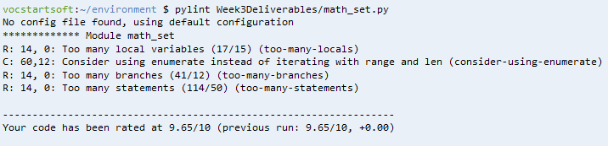

How Math Set application looks in Cloud9:

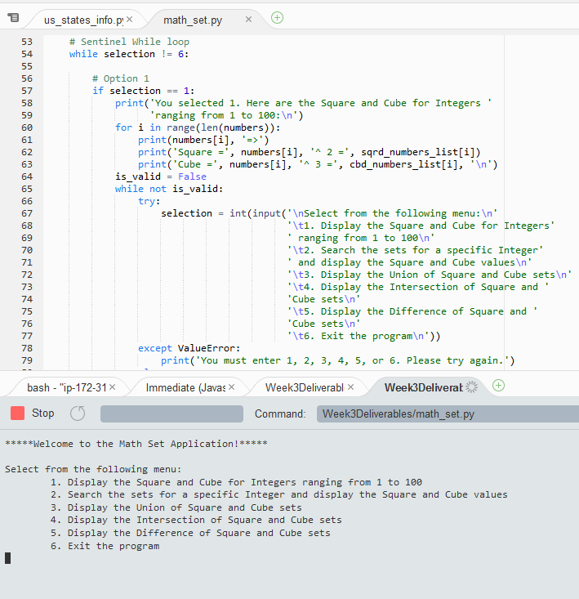

Test Case 2a:

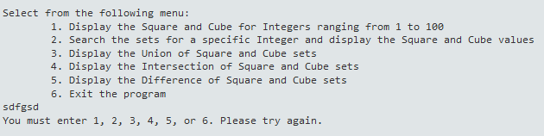

Test Case 2b:

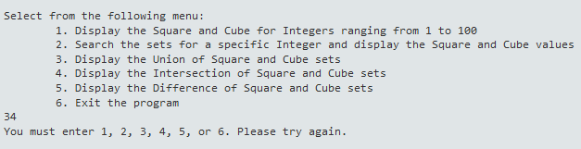

Test Case 2c:

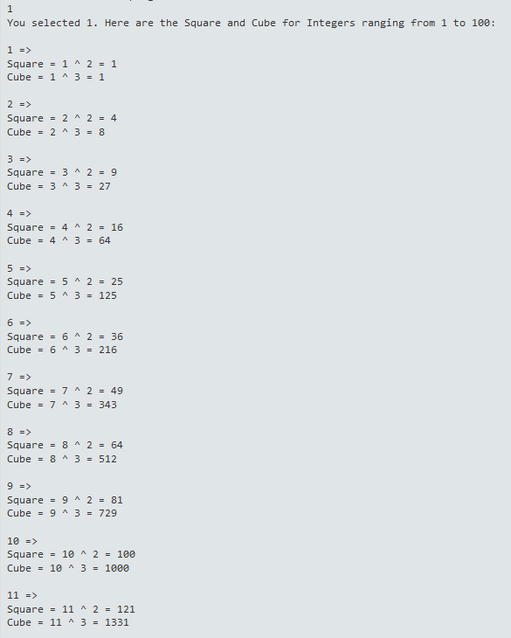

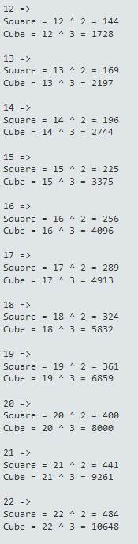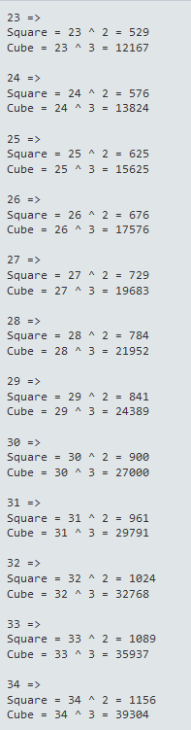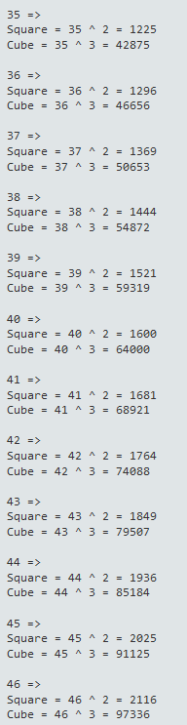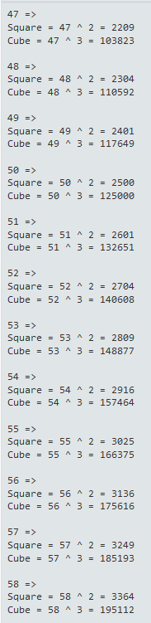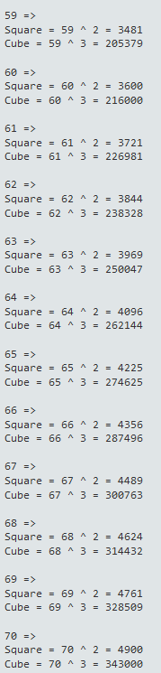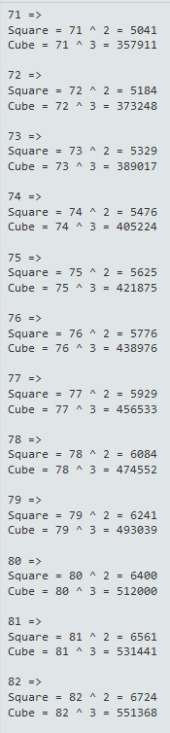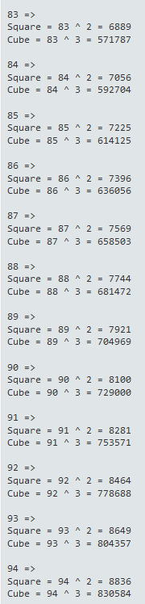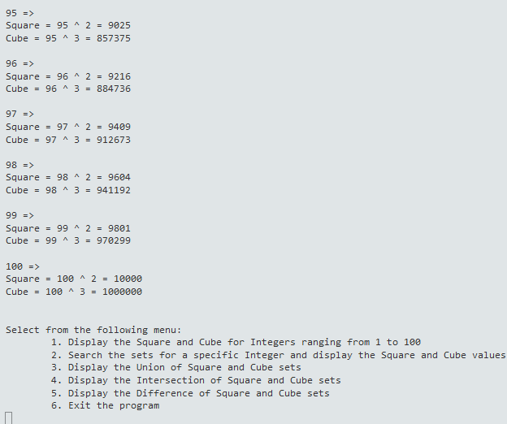

Test Case 2d:

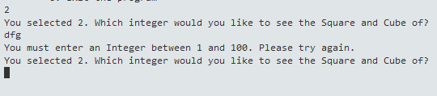

Test Case 2e:

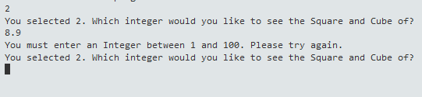

Test Case 2f:

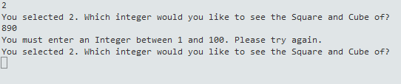

Test Case 2g:

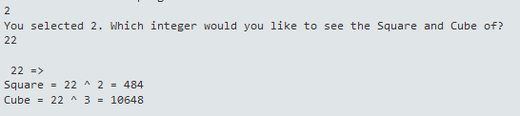

Test Case 2h: 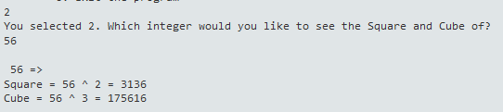

Test Case 2i:

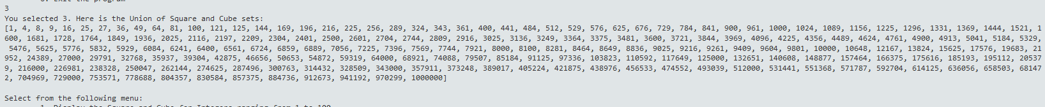

Test Case 2j:



Test Case 2k:



Test Case 2L:

