John Kucera

Prof. Craig Poma

SDEV 300

13 November 2019

Week 4: Lab 4

Part 1: Matrix Math Application

|  |  |  |  |  |
| --- | --- | --- | --- | --- |
| **Test Case** | **Input** | **Expected Output** | **Actual Output** | **Pass?** |
| 1a | (y/n) 2 | You must enter Y or N. Please try again. (wait for input again) | You must enter Y or N. Please try again. (wait for input again) | Yes |
| 1b | (y/n) g | You must enter Y or N. Please try again. (wait for input again) | You must enter Y or N. Please try again. (wait for input again) | Yes |
| 1c | (y/n) n | *****Thanks for playing the Matrix Game.***** (exit program) | *****Thanks for playing the Matrix Game.***** (exit program) | Yes |
| 1d | (y/n) y | Enter your first 3x3 Matrix:  Enter value: (wait for input) | Enter your first 3x3 Matrix:  Enter value: (wait for input) | Yes |
| 1e | (matrix value) 6.7, john | You must enter an Integer. Please try again. (wait for input again) | You must enter an Integer. Please try again. (wait for input again) | Yes |
| 1f | (matrix value) 1 2 3 4 5 6 7 8 9 | Your first 3x3 Matrix is:  [[1 2 3]  [4 5 6]  [7 8 9]]  (prompt user to input second matrix) | Your first 3x3 Matrix is:  [[1 2 3]  [4 5 6]  [7 8 9]]  (prompt user to input second matrix) | Yes |
| 1g | (second matrix value) 12 13 14 15 16 17 18 19 20 | Your second 3x3 Matrix is:  [[12 13 14]  [15 16 17]  [18 19 20]]  (prompt user to select operation) | Your second 3x3 Matrix is:  [[12 13 14]  [15 16 17]  [18 19 20]]  (prompt user to select operation) | Yes |
| 1h | (operation) h, 23 | You must enter a, b, c, or d. Please try again. (prompt user to select operation) | You must enter a, b, c, or d. Please try again. (prompt user to select operation) | Yes |
| 1i | (operation) a  (using the example matrixes in 1f and 1g) | You selected Addition. The results are:  [[13 15 17]  [19 21 23]  [25 27 29]]  The Transpose is:  [[13 19 25]  [15 21 27]  [17 23 29]]  The row and column mean values of the results are:  Row: [15.0 21.0 27.0]  Column: [19.0 21.0 23.0]  (prompt asking user if they want to play again) | You selected Addition. The results are:  [[13 15 17]  [19 21 23]  [25 27 29]]  The Transpose is:  [[13 19 25]  [15 21 27]  [17 23 29]]  The row and column mean values of the results are:  Row: [15. 21. 27.]  Column: [19. 21. 23.]  (prompt asking user if they want to play again) | Yes, but should fix the formatting for the mean values |
| 1j | (operation) b  (using the example matrixes in 1f and 1g) | You selected Subtraction. The results are:  [[-11 -11 -11]  [-11 -11 -11]  [-11 -11 -11]]  The Transpose is:  [[-11 -11 -11]  [-11 -11 -11]  [-11 -11 -11]]  The row and column mean values of the results are:  Row: [-11.0 -11.0 -11.0]  Column: [-11.0 -11.0 -11.0]  (prompt asking user if they want to play again) | You selected Subtraction. The results are:  [[-11 -11 -11]  [-11 -11 -11]  [-11 -11 -11]]  The Transpose is:  [[-11 -11 -11]  [-11 -11 -11]  [-11 -11 -11]]  The row and column mean values of the results are:  Row: [-11. -11. -11.]  Column: [-11. -11. -11.]  (prompt asking user if they want to play again) | Yes, but should fix the formatting for the mean values |
| 1k | (operation) c  (using the example matrixes in 1f and 1g) | You selected Matrix Multiplication. The results are:  [[ 96 102 108]  [231 246 261]  [366 390 414]]  The Transpose is:  [[ 96 231 366]  [102 246 390]  [108 261 414]]  The row and column mean values of the results are:  Row: [102.0 246.0 390.0]  Column: [231.0 246.0 261.0]  (prompt asking user if they want to play again) | You selected Matrix Multiplication. The results are:  [[ 96 102 108]  [231 246 261]  [366 390 414]]  The Transpose is:  [[ 96 231 366]  [102 246 390]  [108 261 414]]  The row and column mean values of the results are:  Row: [102. 246. 390.]  Column: [231. 246. 261.]  (prompt asking user if they want to play again) | Yes, but should fix the formatting for the mean values |
| 1L | (operation) D (uppercase)  (using the example matrixes in 1f and 1g) | You selected Element by Element Multiplication. The results are:  [[ 12 26 42]  [ 60 80 102]  [126 152 180]]  The Transpose is:  [[ 12 60 126]  [ 26 80 152]  [ 42 102 180]]  The row and column mean values of the results are:  Row: [ 26.66666667 80.66666667 152.66666667]  Column: [ 66.0 86.0 108.0]  (prompt asking user if they want to play again) | You selected Element by Element Multiplication. The results are:  [[ 12 26 42]  [ 60 80 102]  [126 152 180]]  The Transpose is:  [[ 12 60 126]  [ 26 80 152]  [ 42 102 180]]  The row and column mean values of the results are:  Row: [ 26.66666667 80.66666667 152.66666667]  Column: [ 66. 86. 108.]  (prompt asking user if they want to play again) | Yes, but should fix the formatting for the mean values |

Screen Captures (Matrix Math Application)

pylint analysis of Matrix Math application: 9.87/10 (Passing)

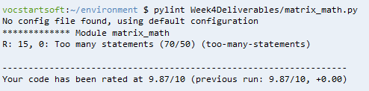

How Matrix Math application looks (with evidence of Cloud9 being used):

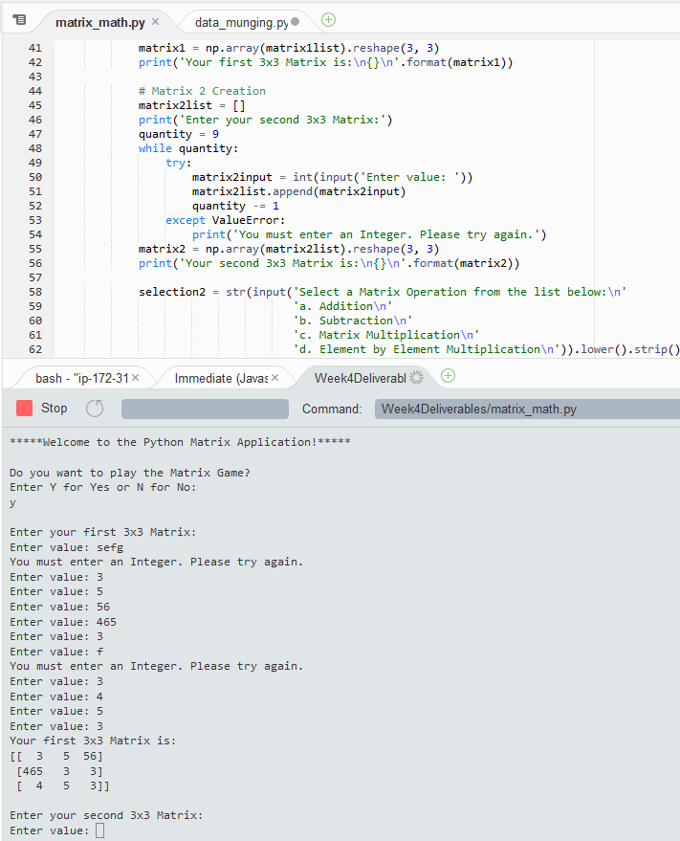

Test Case 1a:

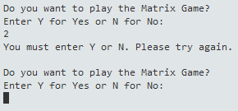

Test Case 1b:

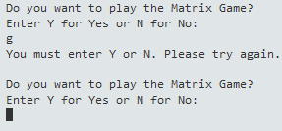

Test Case 1c:

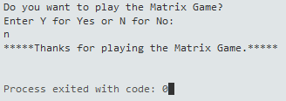

Test Case 1d:

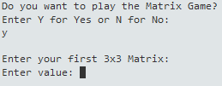

Test Case 1e:

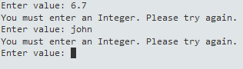

Test Case 1f:

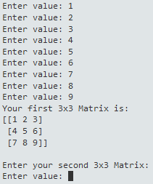

Test Case 1g:

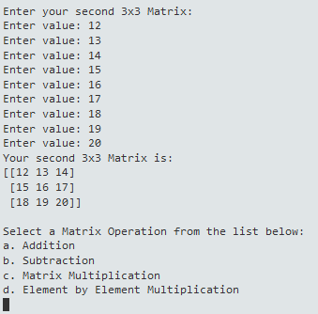

Test Case 1h:

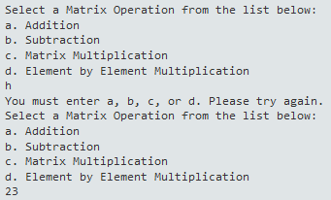

Test Case 1i:

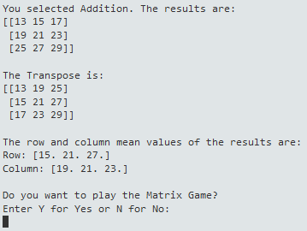

Test Case 1j:

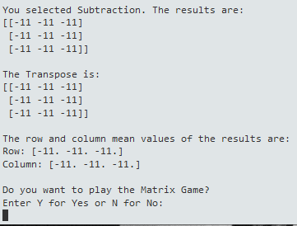

Test Case 1k:

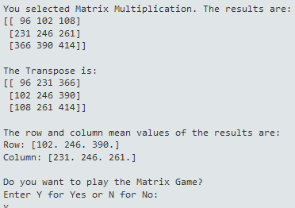

Test Case 1L:

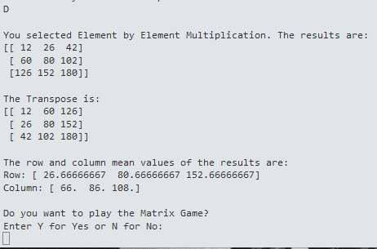

Part 2: Data Munging Application

NOTE: For the sake of testing all possibilities, each contact has something different that it tries, specified in the comments. I scattered occasional whitespace around the values to show that my strip() in the code works fine. There are also some names with odd spellings to show that my title() in the code works fine.

|  |  |  |  |  |
| --- | --- | --- | --- | --- |
| **Test Case** | **Input** | **Expected Output** (I vertically stacked each value here for readability. The real output has them in rows, as shown in the screenshot.) | **Actual Output** (I vertically stacked each value here for readability. The real output has them in rows, as shown in the screenshot.) | **Pass?** |
| 0 | ['Yui', 'Hirasawa', '92375', '253-434-1298'] | 0  Yui  Hirasawa  92375  253-434-1298 | 0  Yui  Hirasawa  92375  253-434-1298 | Yes |
| 1 | ['SATOSHI', 'Tainaka', '23452', '678-333-2222 '] | 1  Satoshi  Tainaka  23452  678-333-2222 | 1  Satoshi  Tainaka  23452  678-333-2222 | Yes |
| 2 | ['', 'Father', '28877', '111-666-3333'] | 2    Father  28877  111-666-3333 | 2    Father  28877  111-666-3333 | Yes |
| 3 | ['Keiko', 'iida', '21111', '000-333-7776'] | 3  Keiko  Iida  21111  000-333-7776 | 3  Keiko  Iida  21111  000-333-7776 | Yes |
| 4 | ['Mother', '', '34333', '324-234-7898'] | 4  Mother    34333  324-234-7898 | 4  Mother  34333  324-234-7898 | Yes |
| 5 | ['Mio', 'Akiyama', ' 25321-3452 ', '834-643-2347'] | 5  Mio  Akiyama  25321-3452  834-643-2347 | 5  Mio  Akiyama  25321-3452  834-643-2347 | Yes |
| 6 | ['Ui', 'Hirasawa', '174252345', '999-999-9999'] | 6  Ui  Hirasawa  17425-2345  999-999-9999 | 6  Ui  Hirasawa  17425-2345  999-999-9999 | Yes |
| 7 | ['Azusa', 'Nakano ', '', '2345345660'] | 7  Azusa  Nakano  234-534-5660 | 7  Azusa  Nakano  234-534-5660 | Yes |
| 8 | [' Ritsu', 'Tainaka', '555', '100-423-7989'] | 8  Ritsu  Tainaka  100-423-7989 | 8  Ritsu  Tainaka  100-423-7989 | Yes |
| 9 | ['Noboru', ' Taki', '123456', '111-222-3333'] | 9  Noboru  Taki  111-222-3333 | 9  Noboru  Taki  111-222-3333 | Yes |
| 10 | ['HazUki', 'KaTOU ', '0192933847', '000-999-2222'] | 10  Hazuki  Katou  000-999-2222 | 10  Hazuki  Katou  000-999-2222 | Yes |
| 11 | ['Nozomi ', 'Kasaki', '12340.1222', '828-949-2929'] | 11  Nozomi  Kasaki  828-949-2929 | 11  Nozomi  Kasaki  828-949-2929 | Yes |
| 12 | ['Tsumugi', 'Kotobuki', 'xd0bb', '856-132-7895'] | 12  Tsumugi  Kotobuki  856-132-7895 | 12  Tsumugi  Kotobuki  856-132-7895 | Yes |
| 13 | ['Sawako', 'YAMAnaka', '02029', '029485-7392'] | 13  Sawako  Yamanaka  02029  029-485-7392 | 13  Sawako  Yamanaka  02029  029-485-7392 | Yes |
| 14 | ['NoDoka', 'Manabe', '77555', '154-1230098'] | 14  Nodoka  Manabe  77555  154-123-0098 | 14  Nodoka  Manabe  77555  154-123-0098 | Yes |
| 15 | ['Jun', 'Suzuki', '111 45', ' 0192837465'] | 15  Jun  Suzuki  019-283-7465 | 15  Jun  Suzuki  019-283-7465 | Yes |
| 16 | ['Kumiko ', 'Oumae', '21511 ', ''] | 16  Kumiko  Oumae  21511 | 16  Kumiko  Oumae  21511 | Yes |
| 17 | ['Reina', 'Kousaka ', ' 33322', '156'] | 17  Reina  Kousaka  33322 | 17  Reina  Kousaka  33322 | Yes |
| 18 | ['SAPphire', 'Kawashima', '02354', '10101010101'] | 18  Sapphire  Kawashima  02354 | 18  Sapphire  Kawashima  02354 | Yes |
| 19 | ['Asuka', 'Tanaka', '11100', 'dnqwid9222'] | 19  Asuka  Tanaka  11100 | 19  Asuka  Tanaka  11100 | Yes |
| 20 | ['NAtSuki', 'Nakagawa', '62342', 'johnkucera'] | 20  Natsuki  Nakagawa  62342 | 20  Natsuki  Nakagawa  62342 | Yes |
| 21 | ['Shuuichi', 'Tsukamoto', '11245', '(111)5551029'] | 21  Shuuichi  Tsukamoto  11245  111-555-1029 | 21  Shuuichi  Tsukamoto  11245  111-555-1029 | Yes |
| 22 | ['End ', 'Owari', ' 23040', '(919)122-1234 '] | 22  End  Owari  23040  919-122-1234 | 22  End  Owari  23040  919-122-1234 | Yes |
| 23 | ['Mizore123', 'YorOIZuka', '', '666-202-1234'] | 23  Yoroizuka  666-202-1234 | 23  Yoroizuka  666-202-1234 | Yes |
| 24 | ['Yuuko', '44', '44444-1123 ', '1119998888'] | 24  Yuuko  44444-1123  111-999-8888 | 24  Yuuko  44444-1123  111-999-8888 | Yes |

Screen Captures (Data Munging Application)

pylint analysis of Data Munging application: 9.32/10 (Passing)

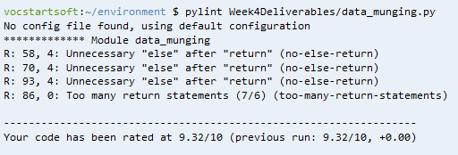

How Data Munging application looks in Cloud9:

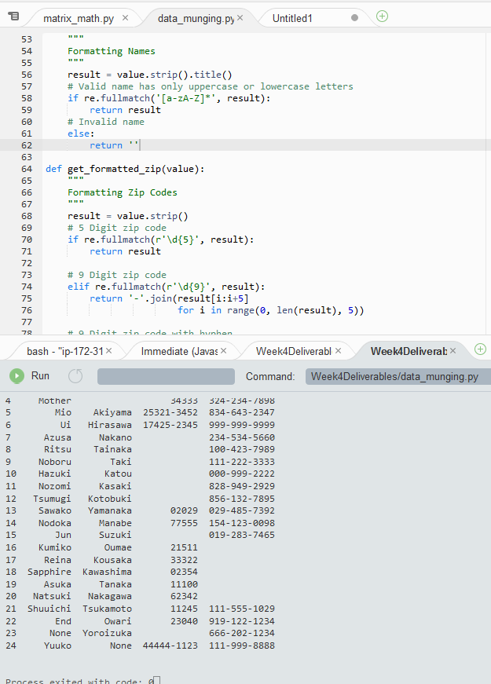

Array used in my code:

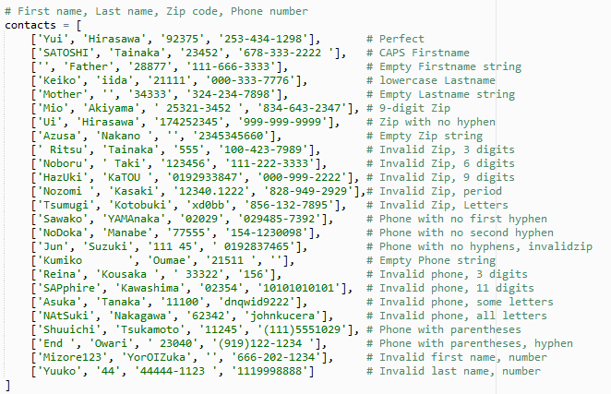

Succesful Output: Prints the Contacts in proper rows/columns, exits immediately

