John Kucera

Prof. Craig Poma

SDEV 300

22 November 2019

Week 5: Lab 5

Data Analysis Application

|  |  |  |  |  |
| --- | --- | --- | --- | --- |
| **Test Case** | **Input** | **Expected Output** | **Actual Output** | **Pass?** |
| 1 | (into file selection) 5 | You must enter 1, 2, or 3. Please try again. (ask for file selection again) | You must enter 1, 2, or 3. Please try again. (ask for file selection again) | Yes |
| 2 | (into file selection) hello | You must enter 1, 2, or 3. Please try again. (ask for file selection again) | You must enter 1, 2, or 3. Please try again. (ask for file selection again) | Yes |
| 3 | (into file selection) 1 | You have entered Population Data. (Ask for column selection) | You have entered Population Data. (Ask for column selection) | Yes |
| 4 | (into popchangecolumn selection) 2 | You must enter a, b, c, or d. Please try again. (ask for column selection again) | You must enter a, b, c, or d. Please try again. (ask for column selection again) | Yes |
| 5 | (into popchangecolumn selection) no | You must enter a, b, c, or d. Please try again. (ask for column selection again) | You must enter a, b, c, or d. Please try again. (ask for column selection again) | Yes |
| 6 | (into popchangecolumn selection) A | You selected Pop Apr 1.  The statistics for this column are:  Count = 557  Mean = 56557.314183123875  Standard Deviation = 158127.10545434814  Min = 13519  Max = 3726157  Creating image of Histogram... Please wait...  (creates Histogram properly)  The Histogram of this column can be downloaded now.  (ask for column selection again) | You selected Pop Apr 1.  The statistics for this column are:  Count = 557  Mean = 56557.314183123875  Standard Deviation = 158127.10545434814  Min = 13519  Max = 3726157  Creating image of Histogram... Please wait...  (creates Histogram properly)  The Histogram of this column can be downloaded now.  (ask for column selection again) | Yes |
| 7 | (into popchangecolumn selection) b | You selected Pop Jul 1.  The statistics for this column are:  Count = 557  Mean = 55758.48473967684  Standard Deviation = 136086.53082593964  Min = 12619  Max = 3195153  Creating image of Histogram... Please wait...  (creates Histogram properly)  The Histogram of this column can be downloaded now.  (ask for column selection again) | You selected Pop Jul 1.  The statistics for this column are:  Count = 557  Mean = 55758.48473967684  Standard Deviation = 136086.53082593964  Min = 12619  Max = 3195153  Creating image of Histogram... Please wait...  (creates Histogram properly)  The Histogram of this column can be downloaded now.  (ask for column selection again) | Yes |
| 8 | (into popchangecolumn selection) C | You selected Change Pop.  The statistics for this column are:  Count = 557  Mean = -798.8294434470376  Standard Deviation = 22711.352869824655  Min = -531004  Max = 22363  Creating image of Histogram... Please wait...  (creates Histogram properly)  The Histogram of this column can be downloaded now.  (ask for column selection again) | You selected Change Pop.  The statistics for this column are:  Count = 557  Mean = -798.8294434470376  Standard Deviation = 22711.352869824655  Min = -531004  Max = 22363  Creating image of Histogram... Please wait...  (creates Histogram properly)  The Histogram of this column can be downloaded now.  (ask for column selection again) | Yes |
| 9 | (into popchangecolumn selection) d | You selected to exit the column menu. (asks for file selection) | You selected to exit the column menu. (asks for file selection) | Yes |
| 10 | (into file selection) 2 | You have entered Housing Data. (Ask for column selection) | You have entered Housing Data. (Ask for column selection) | Yes |
| 11 | (into housing column selection) 9 | You must enter a, b, c, d, e, or f. Please try again. (ask for column selection again) | You must enter a, b, c, d, e, or f. Please try again. (ask for column selection again) | Yes |
| 12 | (into housing column selection) y | You must enter a, b, c, d, e, or f. Please try again. (ask for column selection again) | You must enter a, b, c, d, e, or f. Please try again. (ask for column selection again) | Yes |
| 13 | (into popchangecolumn selection) a | You selected Age.  The statistics for this column are:  Count = 10042  Mean = 47.2194781915953  Standard Deviation = 23.149798767083286  Min = -9.0  Max = 93.0  Creating image of Histogram... Please wait...  (creates Histogram properly)  The Histogram of this column can be downloaded now.  (ask for column selection again) | You selected Age.  The statistics for this column are:  Count = 10042  Mean = 47.2194781915953  Standard Deviation = 23.149798767083286  Min = -9.0  Max = 93.0  Creating image of Histogram... Please wait...  (creates Histogram properly)  The Histogram of this column can be downloaded now.  (ask for column selection again) | Yes |
| 14 | (into popchangecolumn selection) B | You selected Bedrooms.  The statistics for this column are:  Count = 10042  Mean = 2.7092212706632144  Standard Deviation = 1.066036225824947  Min = 0.0  Max = 7.0  Creating image of Histogram... Please wait...  (creates Histogram properly)  The Histogram of this column can be downloaded now.  (ask for column selection again) | You selected Bedrooms.  The statistics for this column are:  Count = 10042  Mean = 2.7092212706632144  Standard Deviation = 1.066036225824947  Min = 0.0  Max = 7.0  Creating image of Histogram... Please wait...  (creates Histogram properly)  The Histogram of this column can be downloaded now.  (ask for column selection again) | Yes |
| 15 | (into popchangecolumn selection) c | You selected Built Year.  The statistics for this column are:  Count = 10042  Mean = 1966.9522007568214  Standard Deviation = 26.305830515079094  Min = 1919.0  Max = 2012.0  Creating image of Histogram... Please wait...  (creates Histogram properly)  The Histogram of this column can be downloaded now.  (ask for column selection again) | You selected Built Year.  The statistics for this column are:  Count = 10042  Mean = 1966.9522007568214  Standard Deviation = 26.305830515079094  Min = 1919.0  Max = 2012.0  Creating image of Histogram... Please wait...  (creates Histogram properly)  The Histogram of this column can be downloaded now.  (ask for column selection again) | Yes |
| 16 | (into popchangecolumn selection) D | You selected Rooms.  The statistics for this column are:  Count = 10042  Mean = 5.723262298346943  Standard Deviation = 1.8762094576039545  Min = 1.0  Max = 14.0  Creating image of Histogram... Please wait...  (creates Histogram properly)  The Histogram of this column can be downloaded now.  (ask for column selection again) | You selected Rooms.  The statistics for this column are:  Count = 10042  Mean = 5.723262298346943  Standard Deviation = 1.8762094576039545  Min = 1.0  Max = 14.0  Creating image of Histogram... Please wait...  (creates Histogram properly)  The Histogram of this column can be downloaded now.  (ask for column selection again) | Yes |
| 17 | (into popchangecolumn selection) e | You selected Utility.  The statistics for this column are:  Count = 10042  Mean = 189.58596395143397  Standard Deviation = 128.92876648751212  Min = 0.0  Max = 1107.583333  Creating image of Histogram... Please wait...  (creates Histogram properly)  The Histogram of this column can be downloaded now.  (ask for column selection again) | You selected Utility.  The statistics for this column are:  Count = 10042  Mean = 189.58596395143397  Standard Deviation = 128.92876648751212  Min = 0.0  Max = 1107.583333  Creating image of Histogram... Please wait...  (creates Histogram properly)  The Histogram of this column can be downloaded now.  (ask for column selection again) | Yes |
| 18 | (into popchangecolumn selection) F | You selected to exit the column menu. (asks for file selection) | You selected to exit the column menu. (asks for file selection) | Yes |
| 19 | (into file selection) 3 | You selected 3.  ***** Thanks for using the Python Data Analysis App ***** (exits program) | You selected 3.  ***** Thanks for using the Python Data Analysis App ***** (exits program) | Yes |

Screen Captures

pylint analysis of Data Analysis application: 9.72/10 (Passing)

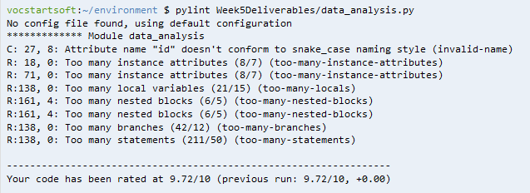

How Data Analysis application looks (with evidence of Cloud9 being used):

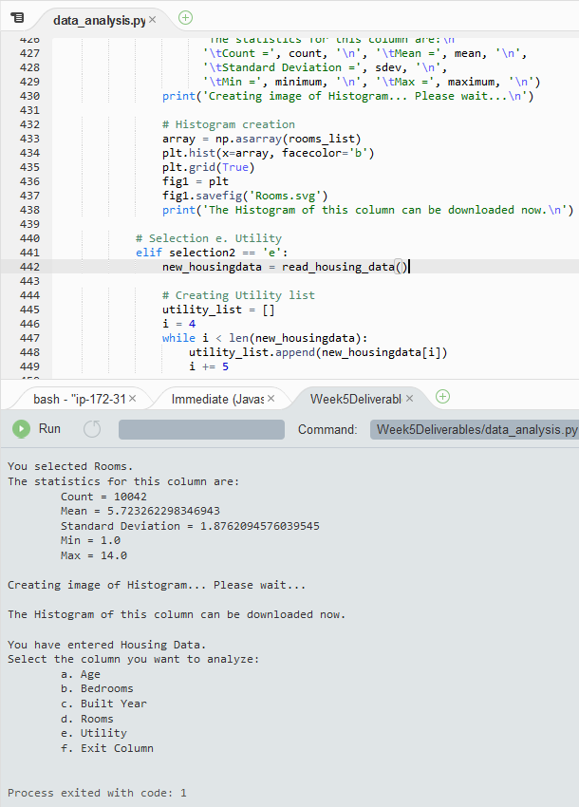

Test Case 1:

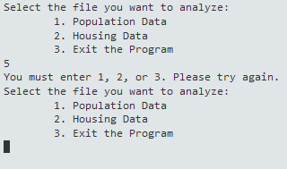

Test Case 2:

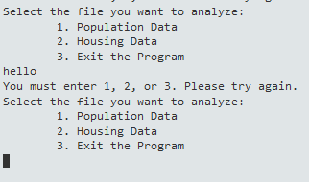

Test Case 3:

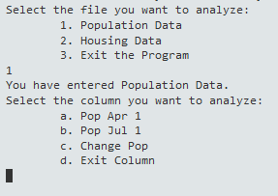

Test Case 4:

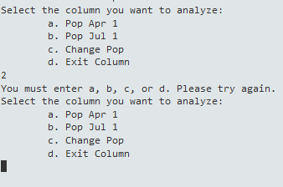

Test Case 5:

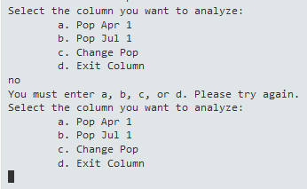

Test Case 6:

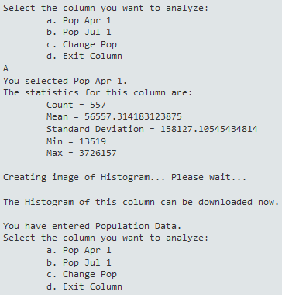

Test Case 7:

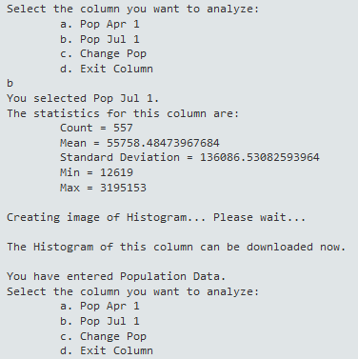

Test Case 8:

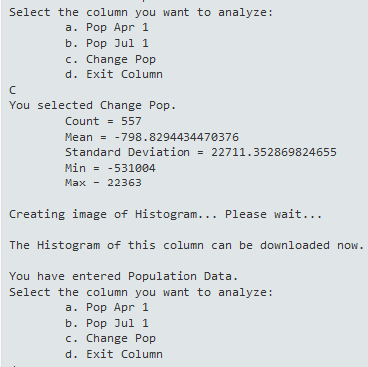

Test Case 9:

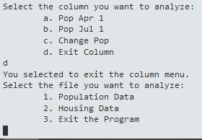

Test Case 10:

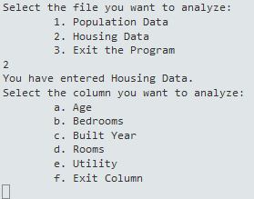

Test Case 11:

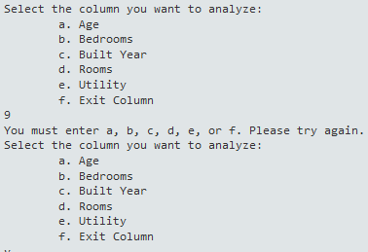

Test Case 12:

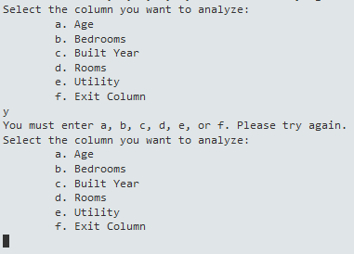

Test Case 13:

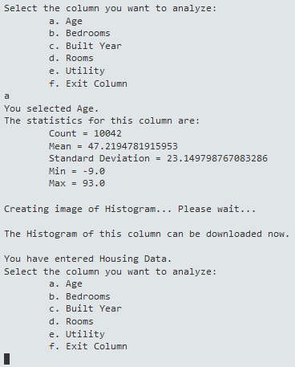

Test Case 14:

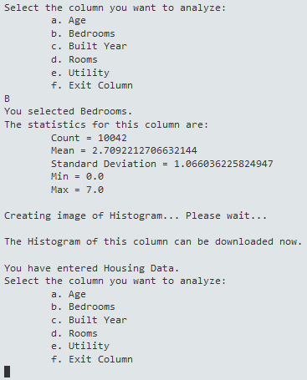

Test Case 15:

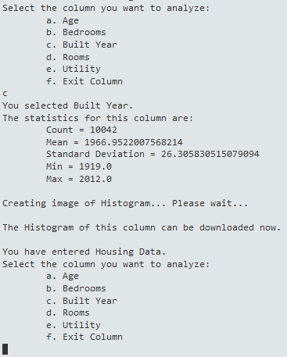

Test Case 16:

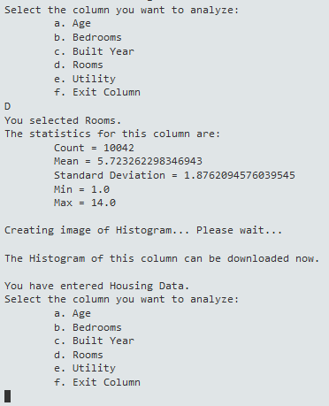

Test Case 17:

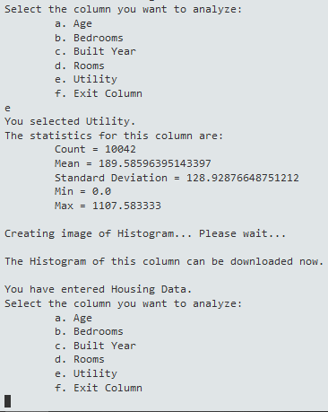

Test Case 18:

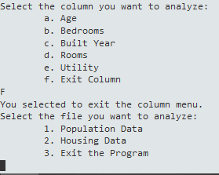

Test Case 19:

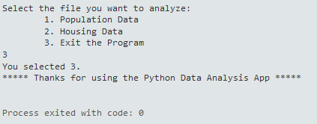

Histograms

NOTE: I tried my best to mess around with the “bin” value and other parameters when using plt.hist() to try and at least get a decent-looking Histogram. For the larger values (like in PopChange), I came to realize that the huge outliers just couldn’t be helped, and the Histograms would have to look oddly off-balance. These Histograms (and my final code) are what I thought looked best after trying out most of the parameters in plt.hist().

Histograms were created properly in Cloud 9 IDE + Histograms downloaded to desktop:

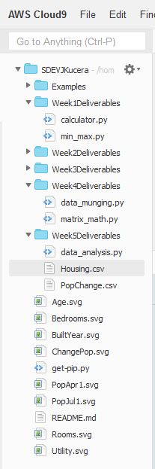

Histogram 1: Pop Apr 1

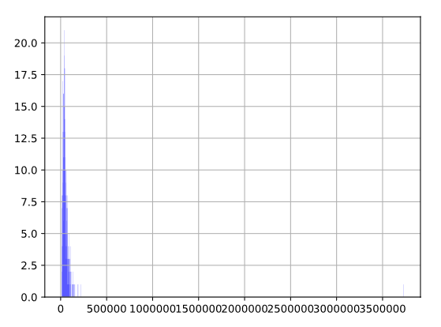

Histogram 2: Pop Jul 1

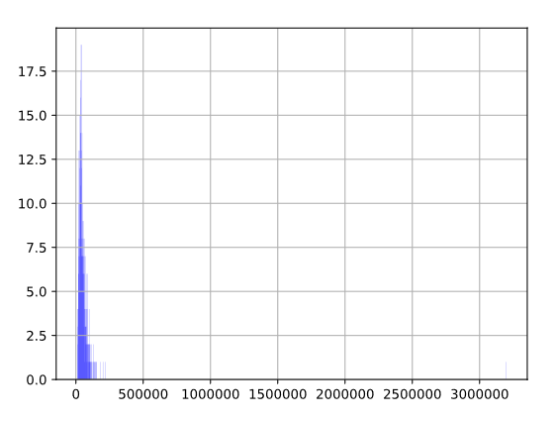

Histogram 3: Change Pop

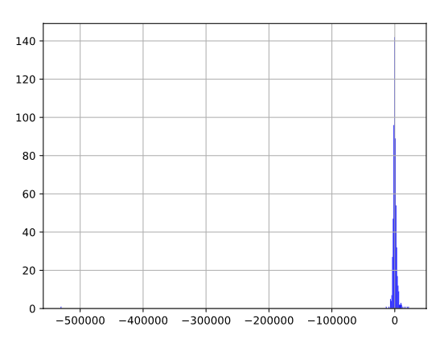

Histogram 4: Age

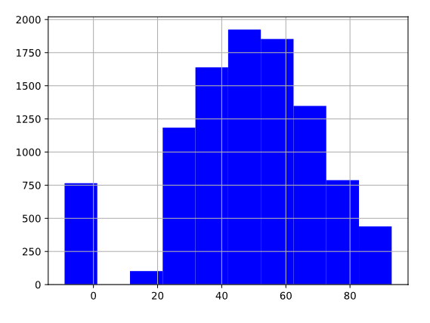

Histogram 5: Bedrooms

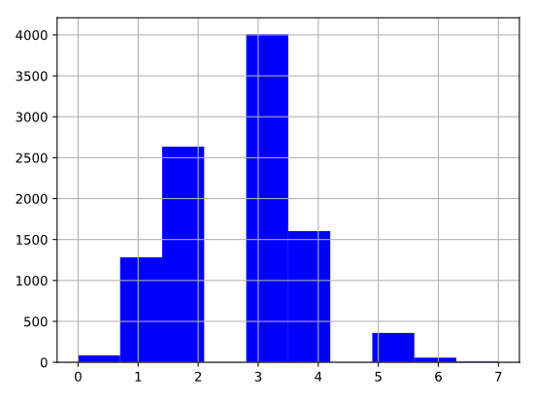

Histogram 6: Built Year

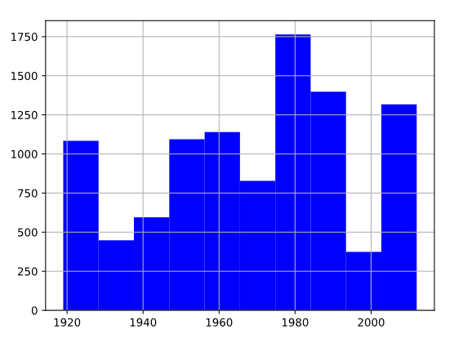

Histogram 7: Rooms

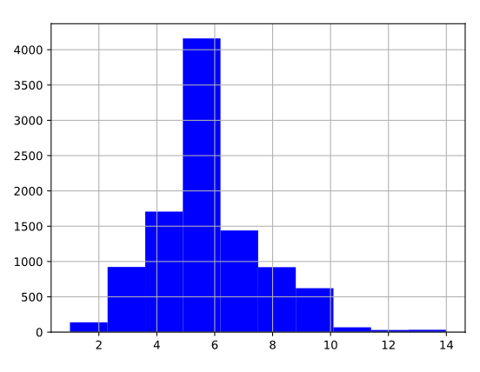

Histogram 8: Utility

