John Kucera

Prof. Craig Poma

SDEV 300

27 November 2019

Week 6: Lab 6

Python Web Page

HOW IT LOOKS (webpage in browser)

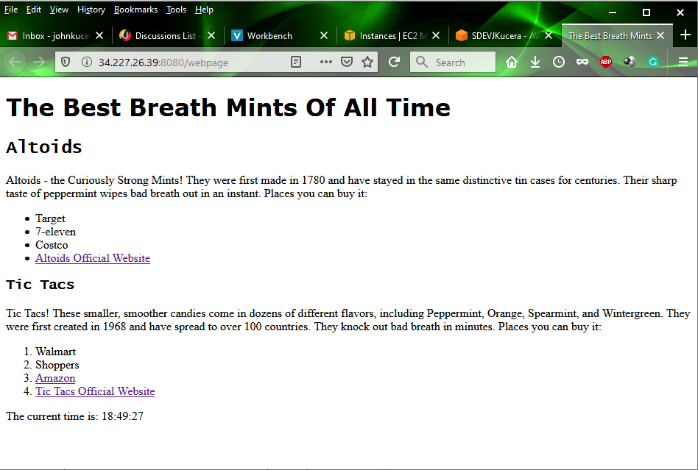

The IPv4 Public IP was 34.227.26.39, so I typed 34.227.26.39:8080/webpage into the search bar. My webpage successfully loaded in my browser.

HOW IT LOOKS (code in Cloud9 IDE)

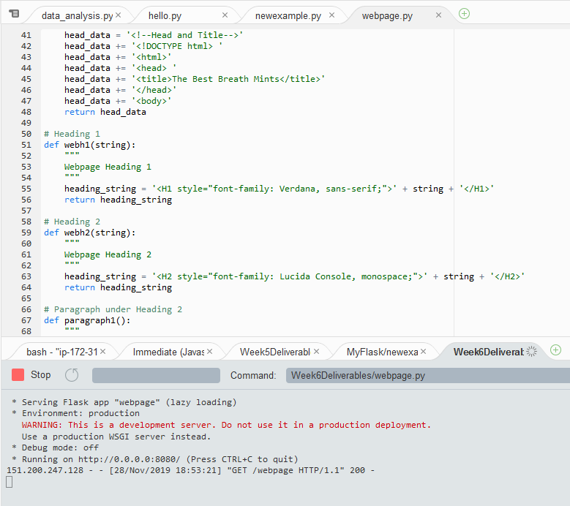

pylint analysis of Python Web Page: 10.00/10

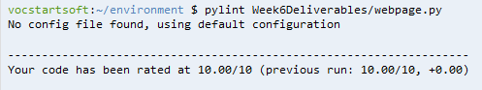

|  |  |  |
| --- | --- | --- |
| **Code** | **Webpage** | **Pass?** |
|  | All content is successfully displayed |  |
|  |  | Yes |
|  |  | Yes |
|  |  | Yes |
|  |  | Yes |
|  | (Link to external webpage was successful) | Yes |
|  |  | Yes |
|  |  | Yes |
|  | (Links to external webpages was successful) | Yes |
|  | (Time is accurate to EST. This screencap shows the time on the webpage and my PC’s EST time – matching.) | Yes |

(Note: I apologize for these individual screencaps maybe being too small. I really wanted something that would put the code and the result side-by-side, but I guess a Word table is just too small for that sometimes.)