Report
“Analyzing IPOs of startups and creating a ranking system that minimizes the risks of losses from investments in startups at the IPO stage”

By
Dzhankulaev Islam

Table of Contents
Project Description 3
Project goal 3
Subject of research 3
Object of research 3
Expected results 4
Project execution 5
Project tasks description 5
Classical evaluation methods 5
Ranking system developing 7
Data description 7
Data preprocessing 9
EDA 10
Ranking system 29
Ranking system implementation in Power BI 32
Comparison Ranking System with classical model 35
Assessment of applicability for the Russian stock market 37
Quantitative comparison 37
Qualitative comparison 39
Conclusions 42
Literature & sources 43
Additional literature & sources 44

Project Description

Project goal
The main goal of this project is to develop a ranking system that predicts the investment risks of investing in IPO companies on the American stock market, based on data for the last five years (2019-2024), as well as identifying and analyzing the critical factors that determine the degree of investment risk. Next, we need to analyze whether this system can be applied to the emerging Russian stock market.

Subject of research
The subject of the study is the process of investment risk assessment in initial public offerings (IPOs) of startups. This research analyzes classical valuation approaches (such as P/S, DCF, etc.) and compares them with a new ranking system, also developed using data set analysis and machine learning, in order to identify hidden patterns that predict high-risk IPOs.

Object of research
The object of the study is startups going public with data obtained from public sources (stockanalysis.com) on the US stock market for comparative analysis with the Russian stock market. The objects under study include companies from different sectors of the stock market showing different indicators of success and failure after going public, which should make it possible to form a representative sample for building a system of investment risk ranking.

Expected results
Developed ranking system: Creation of a system combining classical methods and methods of data analysis after comparative analysis of each separately. This system should allow investors and venture funds to more accurately assess the potential risks of equity offerings, minimize the probability of unprofitable investments, and make more informed decisions.
Research Report: Preparation of a detailed analytical report that substantiates the methodology, research stages, comparative analysis results and recommendations that will facilitate decision-making for management companies and investors.
Visualization of results: Development of an interactive dashboard in Power BI, allowing to visually demonstrate the results of the ranking system and risk forecasts, as well as displaying the sectors of the stock market in which the ranking system identifies the most unstable IPO sector.

Project execution

Project tasks description
- Data collection and processing: Collecting historical data on IPOs of startups conducted over the past 5 years from the US stock exchange cleaning them and preparing them for analysis. In addition, collection of historical data on IPOs of startups from the Moscow Exchange.
- Analysis of classical valuation methods: Study of classical approaches and their effectiveness in predicting IPO results, identifying their strengths/weaknesses.
- Development of a ranking system: Creation of a model based on ML methods (e.g., gradient boosting, random forest, etc.) to rank IPOs by investment risk level. Identification of sectors of the economy that have the (highest inherently high risk) practical value.
- Comparative analysis: Conducting a comparative analysis of the new ranking system with classical valuation methods in order to determine the most accurate criteria for predicting unprofitable IPOs.
- Reporting: Preparation of the final analytical report including the conclusions of the research and recommendations for the management company.
- Visualization of results: Creation of an interactive visualization panel using Power BI to demonstrate the results of the analysis and operation of the ranking system.

Classical evaluation methods
EV/EBITDA (Enterprise Value / EBITDA)
EV/EBITDA (Enterprise Value / Earnings Before Interest, Taxes, Depreciation, and Amortization) is used as a multiplier to assess the operating efficiency of a company, excluding the impact of capital structure, taxation, and depreciation. It is particularly useful when comparing companies in the same industry or when analyzing capital-intensive businesses where depreciation significantly distorts earnings.
Formula:
$$EV/EBITDA=\frac{Enterprice Value}{EBITDA}=\frac{Market Cap+Total Debt-Cash}{EBITDA}$$
A low EV/EBITDA value may indicate that the company is undervalued, while a high value may indicate that it is potentially overvalued. This multiple is considered to be one of the universal benchmarks of a “normal” valuation. In the context of startup IPOs, EV/EBITDA requires caution. EBITDA of such companies is often negative or fluctuates sharply due to aggressive growth investments, making the multiple either impossible to calculate or distorted.

Underpricing
Underpricing is the difference between the IPO Price and the First Day Close Price. This indicator reflects the “inefficiency” of IPO pricing and is perceived as an indicator of market interest and demand for shares. The underpricing formula is calculated as:
$$Underpricing=\frac{First Day Close Price - IPO Price}{IPO Price}×100\%$$
If the value is positive, it means that investors on the day of the IPO may have made a profit by buying shares at the offering price and selling at the end of the first day of trading. A high underpricing can indicate that the underwriters underestimated demand and can be used as a sign that the IPO is highly attractive. However, too high a value can also indicate volatility and speculative interest, which increases investment risk.

Price-to-Sales Ratio (P/S)
Price-to-Sales Ratio (P/S) is a financial multiple that measures the value of a company in relation to its revenue. It is especially useful when analyzing startups that do not yet have a profit (operating or net), since traditional multiples such as P/E (price/earnings) are not applicable. The formula for calculating P/S looks like this:
$$P/S=\frac{Market Cap}{Revenue}$$
The higher the P/S, the more volatile the security is and the more investors are willing to pay for each dollar of the company's revenue, which may indicate their expectations of strong future growth. However, a high P/S may also indicate overvaluation and speculative interest, especially if revenue growth is slow or stagnant.

Ranking system developing

Data description
Over the last five years, more than 2,000 Initial Public Offerings have taken place in the U.S. stock market, indicating a high level of activity in the primary capital market during this period. In order to obtain structured and complete data on all IPOs in the U.S., it is required to get paid access to a professional database, for example, on the StockAnalysis platform [1], which provides information on IPO dates, company characteristics, offering prices, amounts of capital raised and other relevant information.
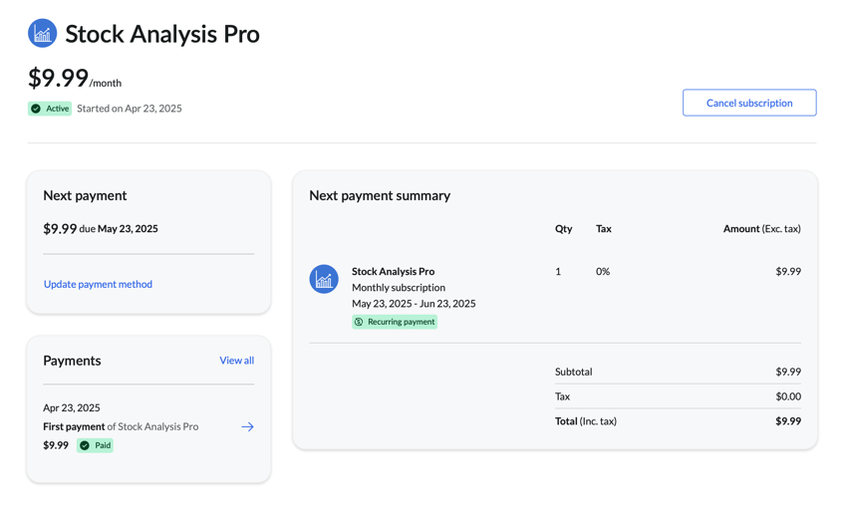
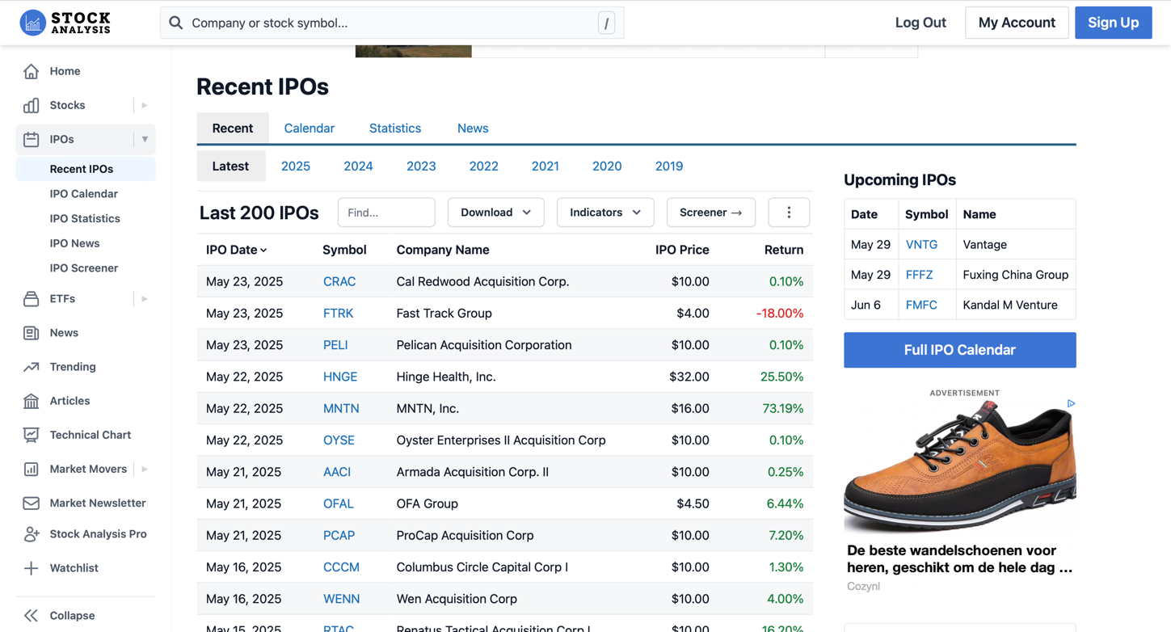
There are such columns in the dataset : 'IPO Date', 'Symbol', 'Company Name', 'IPO Price', 'Return', 'Market Cap', 'Shares Offered', 'Deal Size', 'Open Price', 'Return (Open)', 'Exchange', 'Is SPAC', 'Sector', 'Industry', 'Country', 'Employees', 'Volume', 'Rel. Volume', 'Close', '% Change', 'Premkt. Price', 'Premkt. Chg', 'Premkt. Chg%', 'Ent. Value', 'PE Ratio', 'Forward PE', 'PS Ratio', 'PB Ratio', 'P/FCF', 'ROE', 'ROA', 'ROIC', 'Rating', 'Analysts', 'Price Target', 'PT Upside (%)', 'Div. ($)', 'Div. Yield', 'Div. Growth', 'Payout Freq.', 'Payout Ratio', etc.

The analyzed dataset includes 75 variables describing both the characteristics of companies going public and their financial and market indicators before and after the offering. The data structure covers a wide range of attributes, from basic company identifiers (IPO date, ticker, name) to fundamental multiples (P/E, P/S, P/B), profitability (ROE, ROA, ROIC), market capitalization, trading volume, yield, dividend policy, and industry affiliation.
In addition, the dataset includes variables reflecting stock behavior on the offering day and subsequent periods (e.g., opening yield, pre-market volume, price change), as well as the presence of attributes such as institutional investor participation. This variety of attributes makes the dataset suitable for building investment risk assessment models and predicting IPO success using machine learning methods.

Data preprocessing
As part of the data preprocessing stage, individual features with more than 90% missing values were removed. Such a decision was due to the fact that a high proportion of omissions reduces the informativeness of a feature and may negatively affect the quality of machine learning models. In addition, columns containing financial metrics that are not applicable to the analysis of startups at the IPO stage were excluded. In particular, these are indicators related to dividend policy: “Div. ($)”, “Div. Yield”, ”Div. Growth”, ‘Payout Ratio’ and other dividends are generally not paid by young growth-oriented companies, which is confirmed both by economic theory (see, for example, Lintner, 1956) and by the actual absence of these data in more than 95% of the dataset rows.
Thus, removing these attributes reduced the sample size to 65, reduced noise, and increased the relevance of the attributes retained to analyze the investment attractiveness of startups going public.
At the next stage, the correlation matrix of numerical signs is analyzed in order to identify highly dependent variables. This is necessary for the subsequent exclusion from the model of features with pronounced multicollinearity, which can negatively affect the stability and interpretability of the results. As a rule, Pearson correlation coefficients exceeding 0.8 modulo indicate excessive linear dependence between variables and require careful consideration.

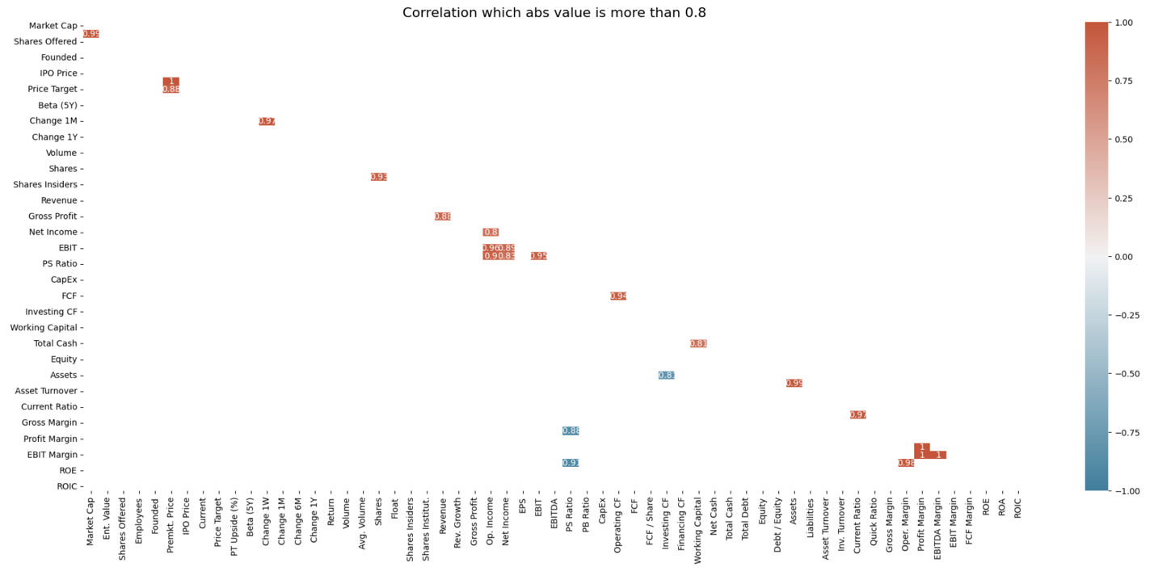

EDA
After the preliminary data cleaning is completed, we move on to the Exploratory Data Analysis (EDA) stage, which is aimed at identifying hidden patterns and building hypotheses about the risks of investing in startups at the IPO stage. Taking into account the topic of the project - “Analyzing IPOs of startups and creating a Ranking System that minimizes the risks of losses from investments in startups at the IPO stage” - the concept of high investment risk should be interpreted first of all.
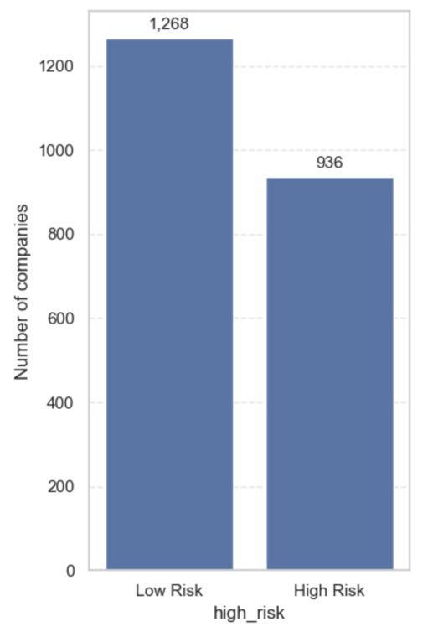
In this study, we define high risk (variable high_risk) as cases in which there is extreme volatility of IPO returns: the absolute value of the return exceeds 50% (|Return| > 50%) over the IPO period (1 year). Such cases are treated as critical in investment terms. Based on this, we create a binary variable high_risk, which takes the value 1 if the specified threshold is exceeded and 0 otherwise. Further in the study we follow the logic of analysis corresponding to the International Financial Reporting Standards (IFRS): the analysis starts with general info, then Profit and Loss, then Cash Flow, and finally Balance Sheet structure. After that, we analyze multiples and check the stability of classical valuation models for our sample set.

Section 1. General info
To build a correct picture of the IPO market on US exchanges (including the New York Stock Exchange and NASDAQ) and further analyze investment risks, it is necessary, first, to assess the scale of the market itself and its sectoral structure. This allows us to identify the sectors with the highest activity of companies going public and, accordingly, to assess their potential investment attractiveness and risk profile.
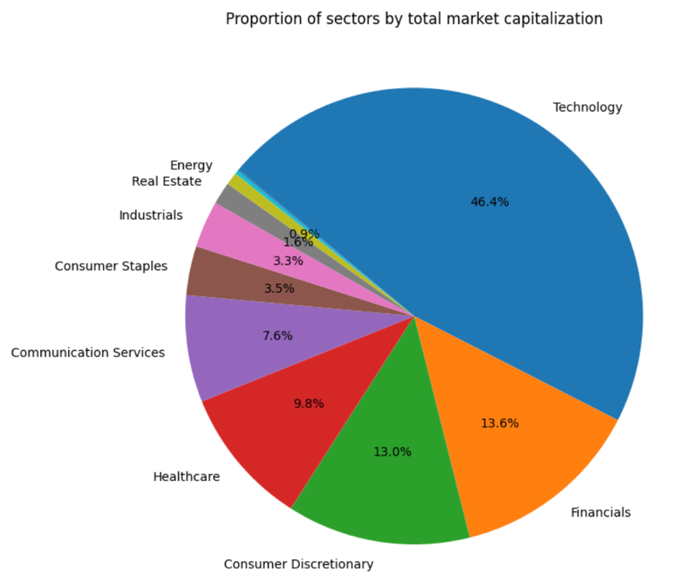
An analysis of the distribution of companies by sector, based on aggregated IPO data for the last five years, shows a clear dominance of the technology sector, which accounts for 46.4% of all offerings. This is followed by Financials (13.6%), Consumer Discretionary (13.0%), Healthcare (9.8%), and Communications Services (7.6%). Less active sectors were Energy (0.9%), Eeal Estate (1.6%), and Industrials (3.3%). This distribution emphasizes the need to pay closer attention to the analysis of technology and financial companies as the most represented and potentially volatile groups.
Obviously, the largest share of initial public offerings on the U.S. stock market is occupied by companies in the technology sector, but more interesting is the distribution of market capitalization (Market Cap) by sector, taking into account investment risk. The analysis of box plot, in which sectors are presented on the axis of categories, and the distribution of Market Cap is additionally stratified by a binary risk indicator (variable `high_risk`), indicates the presence of a tendency to a higher level of risk among technology companies with higher median capitalization.
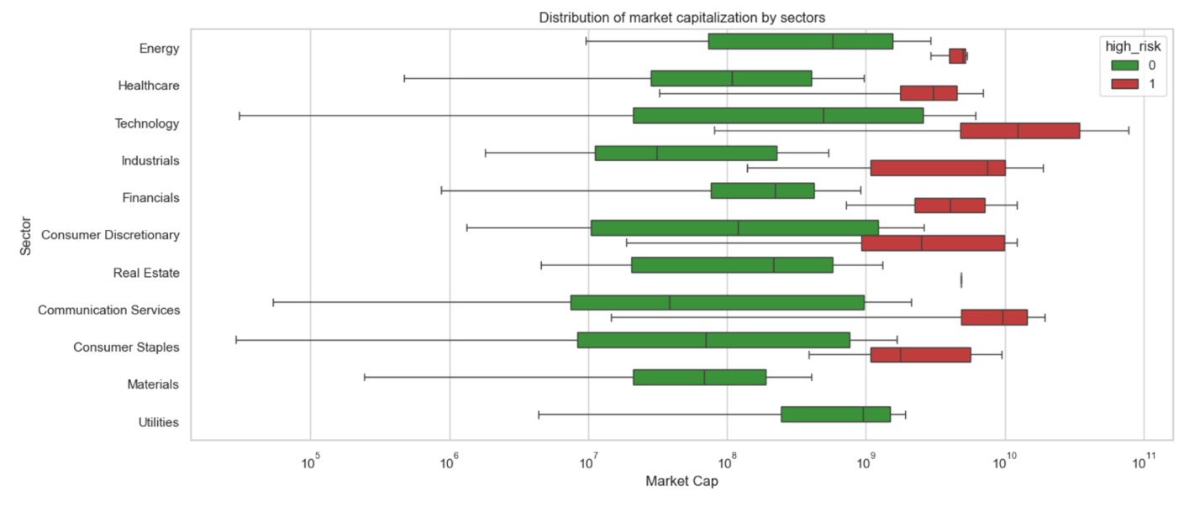
A similar trend can be seen in the Healthcare and Industrials sectors. It is important to note that the median value may not reflect the full picture of the distribution, especially when the dispersion of values is high. Therefore, this finding should be interpreted with caution as a preliminary observation rather than a statistically confirmed pattern.
Next, let's review the median ‘Return’ values by sector.
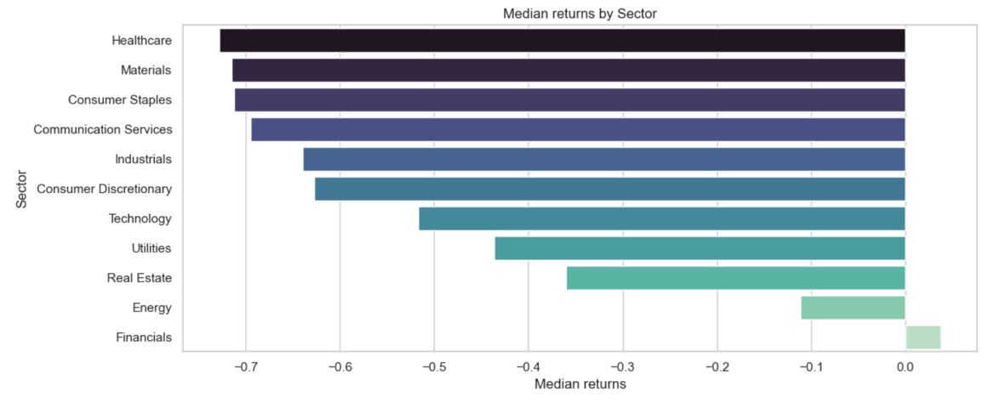
It is observed that the Healthcare sector maintains a high risk status with a median Return value exceeding -0.7, while the Technology sector shows an indicator close to -0.5, which can be interpreted as a moderate risk level. The most stable by this criterion are financial sector companies, which are the only segment with a positive median ‘Return’ value of approximately 0.04.
One of the less obvious but potentially relevant indicators to examine is the number of employees in a company. There may be a link between the number of employees and the company's risk level: for example, an increase in the number of employees may correlate with an increase in risk.

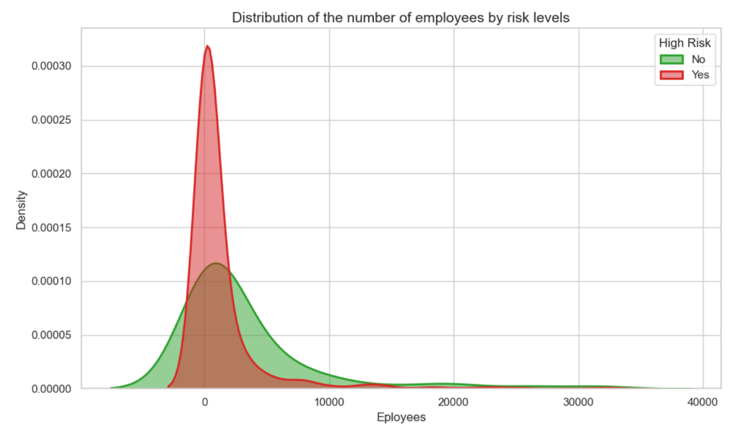
First, let's look at the Kernel Density Estimation (KDE) method of estimating the distribution of data. KDE is a non-parametric probability density estimator that approximates the sampling distribution, creating a smooth curve. Unlike a histogram based on counting frequencies in fixed intervals, KDE models each observed element using a kernel function (usually a Gaussian distribution) and sums them, resulting in a continuous and smooth density estimate. The main features of KDE are:
- The estimation is not limited to discrete data values
- Each kernel has non-zero values beyond the observed points, which ensures smoothness of the curve. For example, with only positive values in the sample (e.g., [2, 3, 5, 7]), Gaussian kernels produce tails that go even into the negative region
The KDE plot analysis for the Employees variable shows that companies with relatively small number of employees (less than 300) going public tend to have a higher level of risk.

Section 2. Stock market data
Let's move on to the next important indicator, the number of institutional investors, labeled 'Shares Institut.'. To initially analyze the distribution of this indicator, we use a barplot and then perform a comparative analysis of median values across sectors using a boxplot, since the influence of institutional investors can vary by sector.
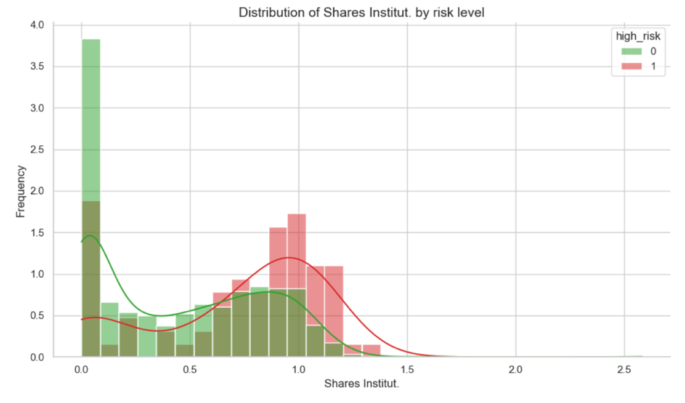
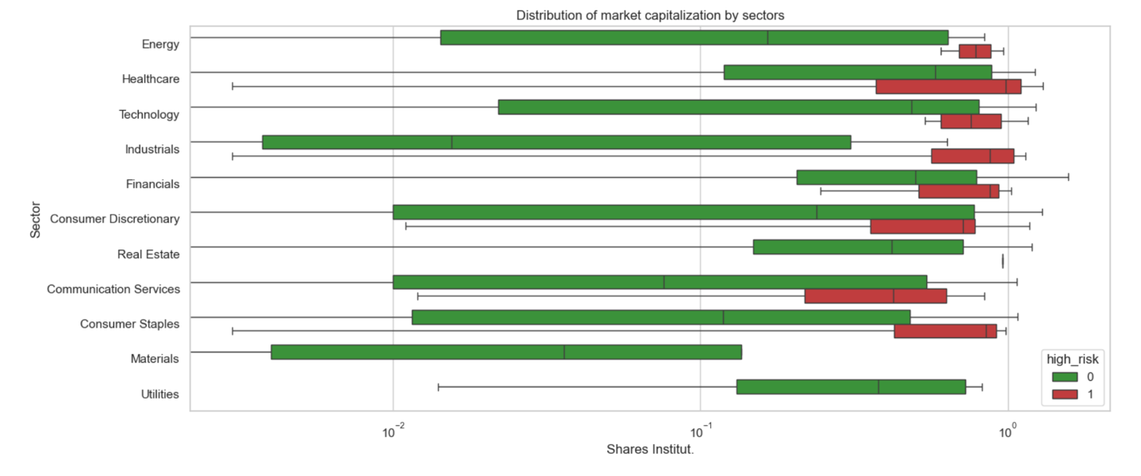
The analysis of the presented graphs demonstrates a general trend across all sectors: as the number of institutional investors increases, the share of companies with a high level of risk is growing. It should be emphasized that this is a trend, not a direct correlation.
Research shows that the presence of institutional investors in startups can have a dual effect. On the one hand, institutional investors often promote transparency and good corporate governance practices, which helps to reduce risks and increase the chances of IPO success [2]. On the other hand, their active participation may be accompanied by a more aggressive growth strategy and increased volatility, which increases risks for investors [3]. Thus, the influence of institutional investors on the risk and success of startups at the IPO stage is ambiguous and requires further in-depth analysis.

Section 3. IFRS
The most universal and generally accepted approach to the valuation of companies going public is the analysis of their financial statements in accordance with international standards - IFRS (International Financial Reporting Standards). Application of these standards ensures comparability and transparency of financial data, which is especially important when assessing investment risks.
For a systematic analysis we will select three key components of IFRS statements, which provide a comprehensive view of the company's financial condition:
- Profit and Loss Statement (Profit and Loss Statement) - reflects operational efficiency and profitability.
- Cashflow Statement - characterizes liquidity and ability to generate cash flows.
- Balance Sheet - provides data on assets, liabilities and equity, allowing to assess financial stability.
This approach will allow a comprehensive study of the financial condition of startups at the IPO stage and identify the main factors of risk and growth potential.

3.1 Profit and Loss
To start analyzing financial indicators, let's consider the income statement data presented in the dataset, namely Revenue and Net Income. To reduce the influence of scale differences and to smooth the distribution, we apply logarithmic transformation of these variables. EPS (Earnings Per Share), which reflects the profitability for investors, is also a significant indicator.
Next, we will visualize the relationships between the logarithms of Revenue and Net Income, as well as EPS and the variable of risk degree (high_risk) with the help of scatter plot. This will allow us to identify possible correlations between the company's financial results and the level of investment risk.
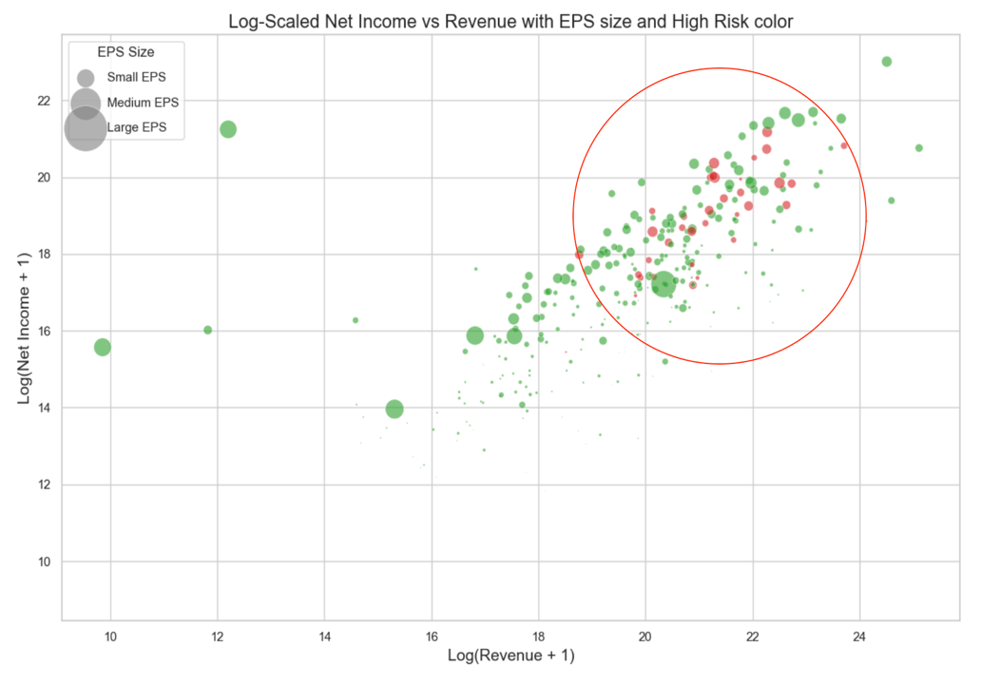
There is a certain area where companies with high volatility (high risk) are concentrated. However, it is difficult to establish an unambiguous correlation between financial performance and risk level. It is obvious that in the segment with large values of Revenue and Net Income there is a significant number of highly volatile companies, but in the same area there is a comparable number of companies with low volatility.

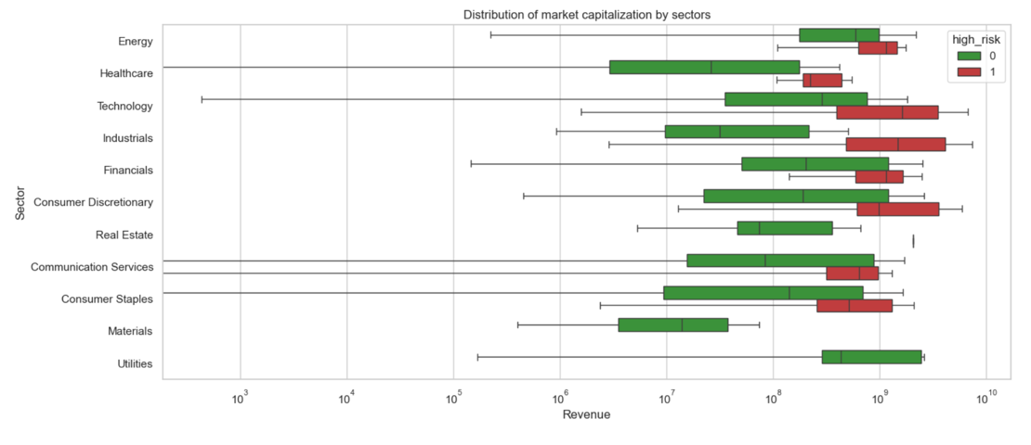

Analyzing the boxplot by sector and the corresponding median values, we can conclude that there is a trend: companies with higher revenues demonstrate a propensity for a higher level of risk at the IPO stage. In particular, technology companies have traditionally been the leaders in this indicator.
Next, let us consider two important valuation multiples - Price-to-Sales (P/S) and Price-to-Book (P/B) ratios. Let us recall the definitions of these indicators:
$$P/S=\frac{Market Cap}{Revenue} ; P/B=\frac{Market Cap}{Book Value}$$

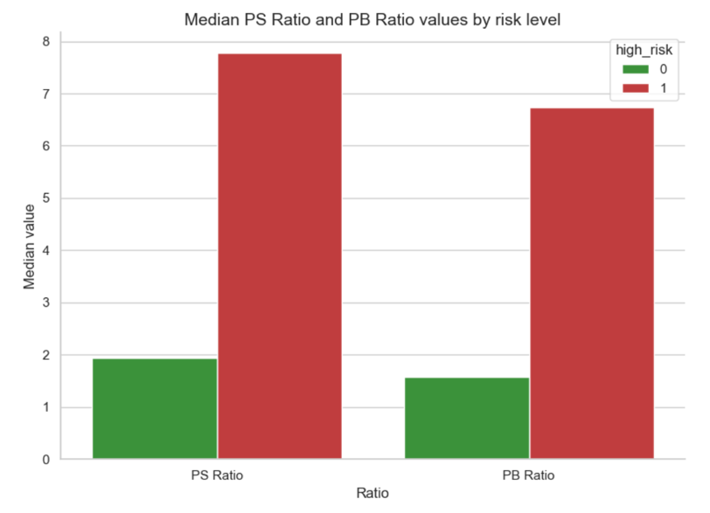
As a result of the analysis, it turned out that the median values of P/S and P/B ratios in high-risk companies are almost five times higher than in less risky companies. However, it should be emphasized that we are talking about medians, so this conclusion requires additional in-depth study. Particular attention should be paid to the P/S ratio, as it is the key indicator in classic models of startup valuation at the IPO stage.

3.2 Cashflow Statement
The next step of the analysis is to examine the Cash Flow Statement indicators. First of all, let's examine the relationships between the relevant variables using a correlation matrix.

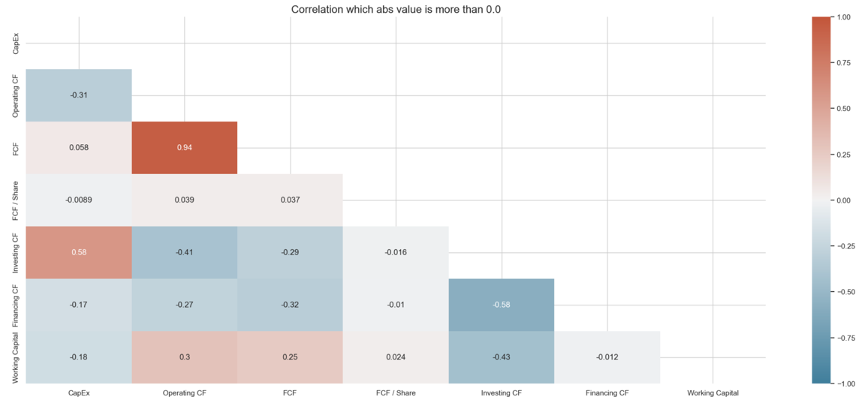
The correlation matrix of Cash Flow Statement clearly shows a high degree of correlation between Operating Cash Flow (OCF) and Free Cash Flow (FCF), with the correlation coefficient reaching 0.94. This indicates a close relationship between these two indicators. This high correlation is explained by the fact that for companies going public, the main source of revenue is their core operating activities. As a consequence, operating cash flow becomes a key component of free cash flow.
This observation is confirmed in a study published in the Journal of Accounting and Economics, where it is noted that companies going public rely heavily on operating cash flows as the main source of funding for their operations, especially when access to external capital is limited [4].
Next, we will study the Operating Cashflow and CapEx indicators. For this purpose two graphs were constructed: scatter plot and KDE plot. However, based on the visual analysis it is not possible to draw unambiguous conclusions or make reasonable hypotheses. The data distribution is scattered, and no clear clusters or patterns correlating with the degree of risk could be identified.
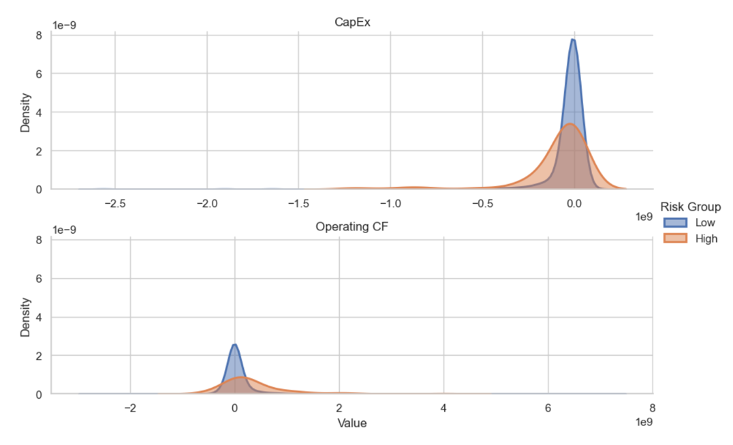
In general, it should be noted that the Cashflow Statement section turned out to be the most difficult to analyze within the framework of this study. This is explained by the specifics of the indicators themselves: cash flows, especially operating and investment cash flows, are better interpreted in dynamics, i.e. in the presence of time series. It is the changes in Operating CF, Investing CF and FCF over time that allow us to judge the stability and investment attractiveness of the company.
Since we have at our disposal only static values at the time of the company's IPO, the analysis of cash flows remains limited and does not allow us to draw in-depth conclusions. The dynamic approach to the study of Cashflow indicators seems to be a promising area for further research.

3.3 Balance Sheet
In this subsection we will analyze the main financial indicators from the balance sheet section presented in the dataset, starting with liquidity ratios, which are traditionally used to assess the company's ability to cover short-term liabilities: Current Ratio and Quick Ratio.
Current Ratio (current liquidity ratio):
$$Current Ration=\frac{Current Assets}{Current Liabilities}$$
This indicator reflects the company's ability to repay short-term liabilities from current assets. A value above 1 is generally considered a sign of stability, but in the context of start-ups and IPO companies, deviations are possible.
Quick Ratio (quick liquidity ratio):
$$Quick Ration=\frac{Current Assets-Inventory}{Current Liabilities}$$
Quick Ratio is more stringent compared to Current Ratio, as it excludes inventories, which may be difficult to realize under conditions of uncertainty. It shows how quickly a company can cover its liabilities with the most liquid assets (cash, receivables, etc.).
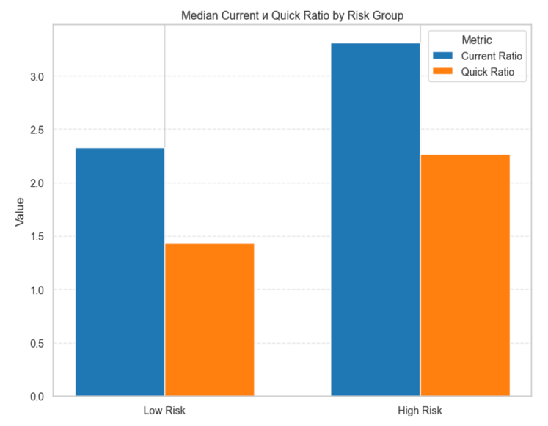

For both metrics, the median value of high-risk companies is higher than that of low-risk companies. This may be due to the fact that ... (propose several hypotheses and support them preferably with literature), but no definite conclusion can be drawn.
Perhaps it is a tendency to accumulate liquidity as a protective measure. Start-ups, especially before going public, may seek to increase their liquid assets to demonstrate financial strength and the ability to cover short-term liabilities. This may be a strategy to attract investors concerned about the risks associated with new companies. However, excess liquidity may also indicate an inefficient use of capital, potentially reducing the return on investment [5].
Let's move on to the analysis of the following parameters: the amount of debt — ‘Total Debt’ — and the debt-to-equity ratio — ‘Debt/Equity’. We will visualize these parameters using a scatter plot: we will plot the logarithm of the total debt value on one axis, and the value of the ‘Debt/Equity’ ratio on the other.
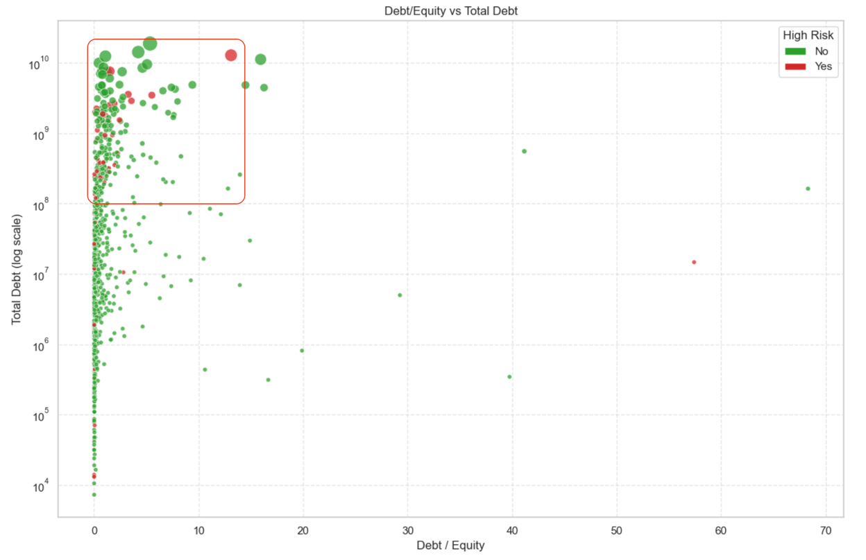
The graph clearly shows an interesting trend: starting from a certain debt load threshold (around log 10⁸), the number of companies with a high degree of risk increases significantly. This may indicate that with rapid growth of debt obligations, the level of uncertainty also increases - especially in the case where debt is used to finance aggressive expansion without an adequate income base.
This behavior is quite consistent with classical concepts in corporate finance: the higher the debt burden, the higher the financial risk, especially with unstable revenue and high market volatility [6]. Also, high Debt/Equity values ​​are often associated with difficulties in servicing debt, especially in startups, where cash flows can be unstable or negative in the first years after the IPO [7].
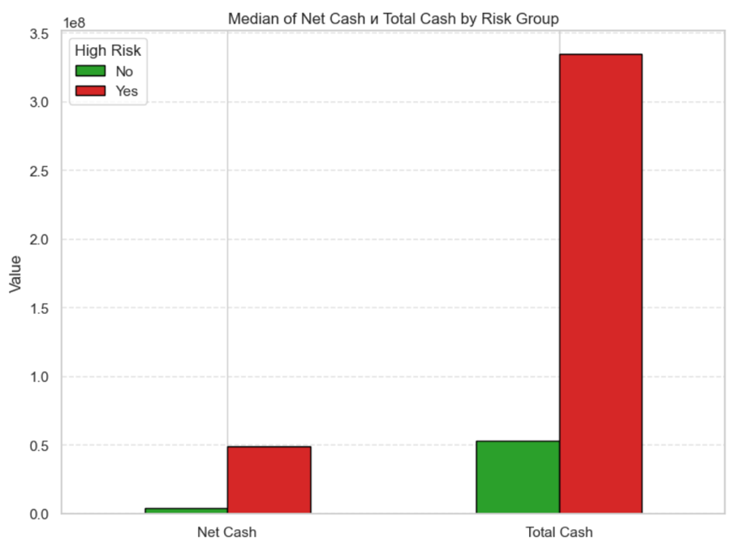
It turns out that high-risk companies have significantly higher cash balances (Total Cash and Net Cash) than low-risk companies. At first glance, this may seem contradictory - after all, having a large amount of free cash should indicate financial stability. However, upon closer examination, several explanations can be put forward for this phenomenon.
First, having too much cash in a company, especially in the early stages of growth, may indicate the absence of an effective strategy for its use – be it development, R&D or expansion. This may raise doubts among investors about the team’s ability to wisely allocate resources [8]. Second, excess cash may indicate that the company is trying to minimize future risks or is preparing for high instability. This in itself may be a marker of internal uncertainty or external instability – especially on the eve of an IPO [9].
It can therefore be assumed that having too much cash on a company's balance sheet at the IPO stage - especially in the technology sector - is not always a positive sign and may indirectly indicate increased risk.
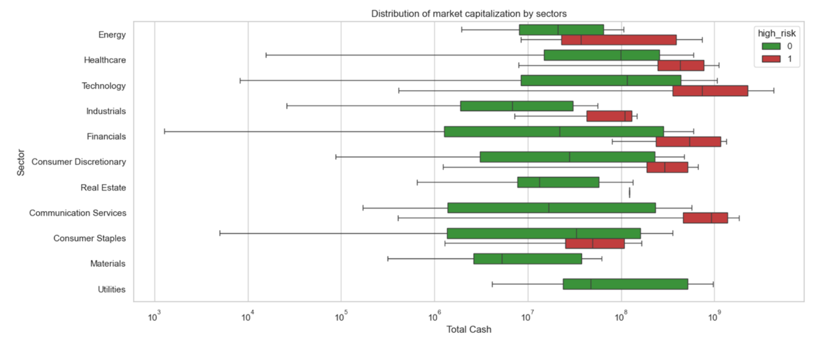
As in the previous sections, the technology sector stands out again. It is technology companies that show the highest values ​​for cash - both in absolute terms (Total Cash). This may be due to the peculiarities of financing and growth model in the technology sector: raising large rounds of investment before the IPO is often accompanied by the accumulation of a significant amount of funds on the balance sheet.
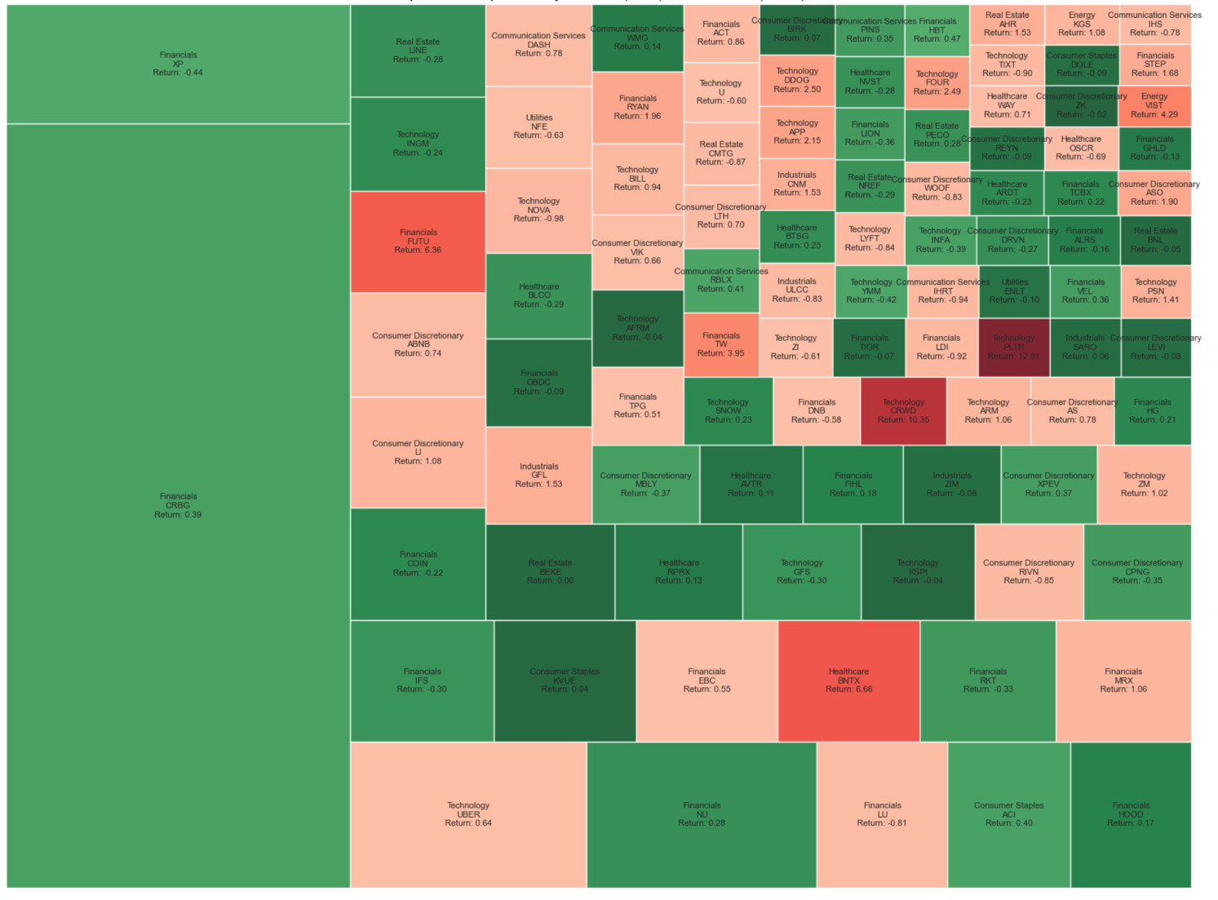
The graph clearly shows that the most stable and consistent in terms of return are primarily financial companies. These companies typically demonstrate moderate growth, but are accompanied by less volatility and risk. Their business model is based on stable income streams, is often regulated and depends on macroeconomic factors, which ensures relative predictability of results.

Section 4. Metrics and efficiency
Let's move on to the last subsection of metrics and efficiency. In this section, we will study the following key indicators: Gross Margin, Operating Margin (Oper. Margin), Profit Margin, EBITDA Margin, EBIT Margin, Free Cash Flow Margin (FCF Margin), PS Ratio, ROE, ROA, ROIC and we will start with the analysis of margins.
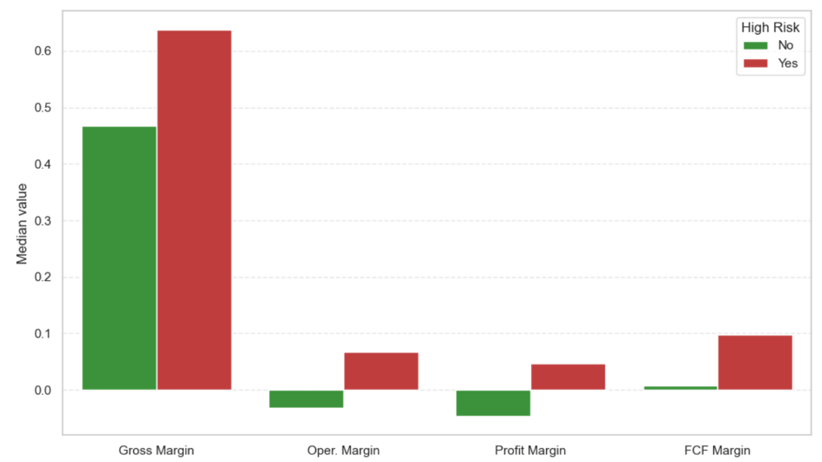
The presented barplot clearly shows that stable companies going public often have negative operating margins, in contrast to high-risk companies, where it is usually positive or higher. This may seem unexpected, but in practical cases, such a phenomenon occurs more than once. Young companies, especially in the technology sector, often demonstrate negative operating margins at the IPO stage, which is associated with a high level of investment in product growth and development, marketing and team expansion, while companies with positive operating margins are often already in a more mature phase or are focused on a faster return to profitability [10].
On the other hand, companies with high operating margins at IPO may be associated with riskier business models or aggressive pricing, which increases the volatility of their earnings and, accordingly, the risks for investors [10]. Thus, negative operating margins in stable IPO companies often indicate a conservative and sustainable approach to growth and cost management, while positive operating margins in high-risk companies may be accompanied by high business volatility.

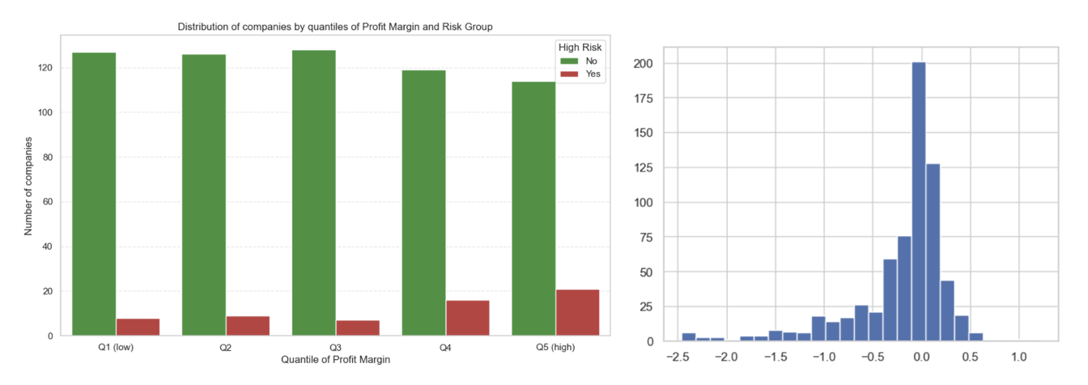
Profit Margin Risk group and Profit Margin distribution
Moreover, with the growth of Profit Margin, an increase in the share of purely high-risk companies is observed. This is explained by the fact that companies with high net profit indicators at the time of IPO often adopt more aggressive growth and financial management strategies, which increases their volatility and risk. At the same time, stable companies, often focused on long-term stability, demonstrate more conservative profit indicators, which is reflected in more modest Profit Margin values.
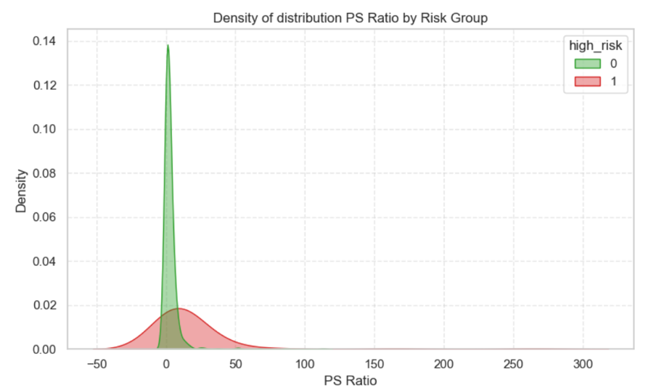
Finally, when testing the classic PS Ratio evaluation method, we clearly see that stable companies have significantly lower PS Ratio than high-risk companies. This confirms that the PS Ratio method can be effectively used for the initial assessment of a company's risk when going public. It may be worth using it in combination with new ranking methods to improve the accuracy and informativeness of the analysis.

Ranking system
IPO data from 2019 to 2024 will be used to train the model, and for prediction and testing for 2025. For modeling, parameters (columns) with high correlations were excluded to avoid multicollinearity, which spoils the model. In addition, parameters of change by week, month, half-year and year were excluded, since it is illogical to use them, since at the IPO stage this data is not yet available.
Before modeling, we will naturally use SimpleImputer to fill in the gaps in the data. In addition, since the data on Market Cap, Revenue, etc. have a strong scatter, which can interfere with modeling, we will use the StandardScaler library.
The libraries catboost and xgboost work best with financial data and predict, in addition to them, we will compare their metrics with the randomforest library, perhaps it will give better results. And of course, since we take several models at once and compare, we cannot do without the Pipeline library. The metric for evaluating models will be ROC_AUC because (write the reason why you can choose this particular model)
Another important step is to configure these models, that is, select the parameters, so we will use greedy search, that is, the GridSearchCV library. The next important step in modeling is cross-validation (write here why it is needed and how to use it well. And additionally, to make sure that the chosen model is correct, we will use VotingClassifier.
As a result, we get two predictions: the first is whether the company is stable (0) or high-risk (1), and the second is the degree of this risk or, more precisely, the probability that the given company is high-risk. The final Python code is given below:
from sklearn.pipeline import Pipeline
from sklearn.compose import ColumnTransformer
from sklearn.impute import SimpleImputer
from sklearn.preprocessing import StandardScaler, OneHotEncoder
from sklearn.ensemble import RandomForestClassifier, VotingClassifier
from xgboost import XGBClassifier
from catboost import CatBoostClassifier
from sklearn.model_selection import GridSearchCV, cross_val_score, train_test_split
from sklearn.metrics import roc_auc_score

# Prepare train and test data
X = df_train.drop(columns=['high_risk'])
y = df_train['high_risk']
X_test = df_test.copy()

# Identify numerical and categorical features
numerical_cols = X.select_dtypes(include=['float64', 'int']).columns.tolist()
categorical_cols = ['Sector']

# Preprocessing pipelines
numeric_transformer = Pipeline([
('imputer', SimpleImputer(strategy='median')),
('scaler', StandardScaler())
])
cat_transformer = Pipeline([
('imputer', SimpleImputer(strategy='constant', fill_value='missing')),
('onehot', OneHotEncoder(handle_unknown='ignore'))
])

preprocessor = ColumnTransformer([
('num', numeric_transformer, numerical_cols),
('cat', cat_transformer, categorical_cols)
])

# Define model pipelines
pipe_rf = Pipeline([
('pre', preprocessor),
('clf', RandomForestClassifier(random_state=42))
])
pipe_xgb = Pipeline([
('pre', preprocessor),
('clf', XGBClassifier(use_label_encoder=False, eval_metric='logloss', random_state=42))
])
pipe_cat = Pipeline([
('pre', preprocessor),
('clf', CatBoostClassifier(verbose=0, random_state=42))
])

# Parameter grids for GridSearchCV
param_grid_rf = {'clf__n_estimators': [100, 200], 'clf__max_depth': [None, 10]}
param_grid_xgb = {'clf__n_estimators': [100, 200], 'clf__max_depth': [3, 6], 'clf__learning_rate': [0.01, 0.1]}
param_grid_cat = {'clf__iterations': [100, 200], 'clf__depth': [3, 6], 'clf__learning_rate': [0.01, 0.1]}

# Train-test split for validation
X_train, X_val, y_train, y_val = train_test_split(X, y, stratify=y, test_size=0.2, random_state=42)

# Grid search with cross-validation
gs_rf = GridSearchCV(pipe_rf, param_grid_rf, cv=5, scoring='roc_auc', n_jobs=-1)
gs_xgb = GridSearchCV(pipe_xgb, param_grid_xgb, cv=5, scoring='roc_auc', n_jobs=-1)
gs_cat = GridSearchCV(pipe_cat, param_grid_cat, cv=5, scoring='roc_auc', n_jobs=-1)

gs_rf.fit(X_train, y_train)
gs_xgb.fit(X_train, y_train)
gs_cat.fit(X_train, y_train)

# Best estimators
best_rf = gs_rf.best_estimator_
best_xgb = gs_xgb.best_estimator_
best_cat = gs_cat.best_estimator_

# Evaluate on validation set
def eval_model(model, X_val, y_val):
proba = model.predict_proba(X_val)[:, 1]
return roc_auc_score(y_val, proba)

print('RF AUC:', eval_model(best_rf, X_val, y_val))
print('XGB AUC:', eval_model(best_xgb, X_val, y_val))
print('CAT AUC:', eval_model(best_cat, X_val, y_val))

# Voting classifier
voting = VotingClassifier(
estimators=[('rf', best_rf), ('xgb', best_xgb), ('cat', best_cat)],
voting='soft'
)
# Cross-validation for ensemble
cv_scores = cross_val_score(voting, X, y, cv=5, scoring='roc_auc')
print('Voting CV AUC scores:', cv_scores)
print('Mean CV AUC:', np.mean(cv_scores))

# Fit on full data and predict
voting.fit(X, y)
pred = voting.predict(X_test)
proba = voting.predict_proba(X_test)[:, 1]

df_test['high_risk_pred'] = pred
df_test['high_risk_proba'] = proba
Results:
RF ROC_AUC: 0.8866527008828371
XGB ROC_AUC: 0.879994014664073
CAT ROC_AUC: 0.8926629757095117

The Catboost model has proven to be the best in this case and now we will predict what the values ​​will be for companies in 2025 and show a table.
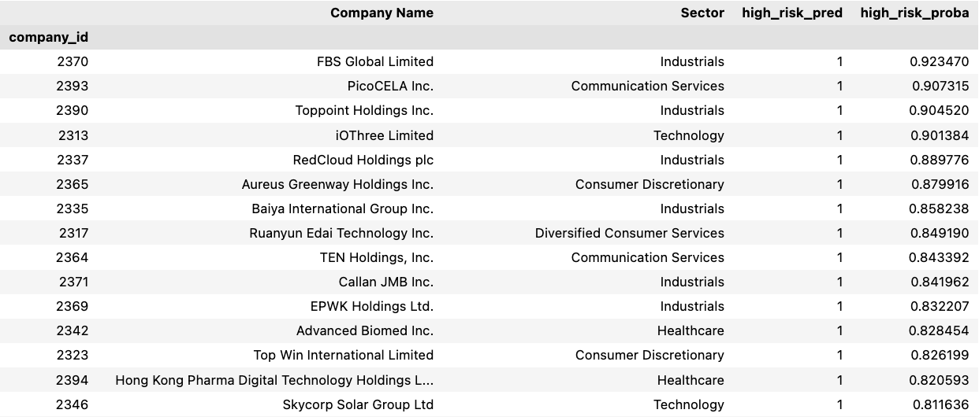

Ranking system implementation in Power BI
1. Data Preparation and Reanalysis
The Data Analyst begins re-examining the original data, including PS Ratios, financial metrics, and other key parameters. This step includes:
- Checking the quality and completeness of the data, handling missing data and outliers;
- Adjusting and scaling features to improve the quality of the model;
- Analyzing distributions and identifying correlations to clarify which parameters affect risk most significantly;
- Possibly adding new features, such as interactions or variable transformations.

2. Developing and training the ranking model
After preparing the data, the stage of developing the model begins, which, based on the selected features, predicts the company's risk level (high/low) or provides a numerical scoring. Important:
- Use historical IPO data with known results to train the model;
- Adjust hyperparameters to optimize the quality of predictions;
- Conduct cross-validation and evaluate metrics (ROC-AUC, precision, recall, etc.).

3. Automation of the training and forecasting process
After successful training, the model is integrated into the production environment. To do this:
- A Python script is created that periodically or on demand downloads new data, performs preprocessing, and starts training the model on fresh data;
- The script automatically generates forecasts for new companies entering IPO and forms their scoring;
- For sustainability and scalability, the training and inference process can be organized in a container (for example, Docker), which simplifies deployment and version management of the model.

4. Writing results to a database
Once the prediction results are received, the Python script writes the final ratings and risk scores to a database, such as PostgreSQL or SQL Server. This allows for centralized storage of up-to-date data and access via APIs and other tools.

5. Updating a dashboard in Power BI
Based on the data from the database, a dashboard is created in Power BI, which:
- Is automatically updated according to a schedule or by a data update event in the database;
- Displays the current rating of companies by risk level, their key financial indicators and the dynamics of changes;
- Allows users (analysts, investment managers) to visually monitor the state of the IPO market and make informed decisions.

6. Feedback and iterations
The ranking system is not static - when new data and investment results are received, the accuracy of the model is regularly analyzed, which allows:
- To improve features and algorithms;
- To update the model and repeat the training cycle;
- To adapt the system to changing market conditions and new trends.
This creates an automated, scalable and maintainable cycle of analysis and ranking of companies on IPO, which combines a classic indicator (PS Ratio) with modern methods of machine learning and visualization of results for ease of decision-making.
Visualization
Dashboard 1. Analyze stage
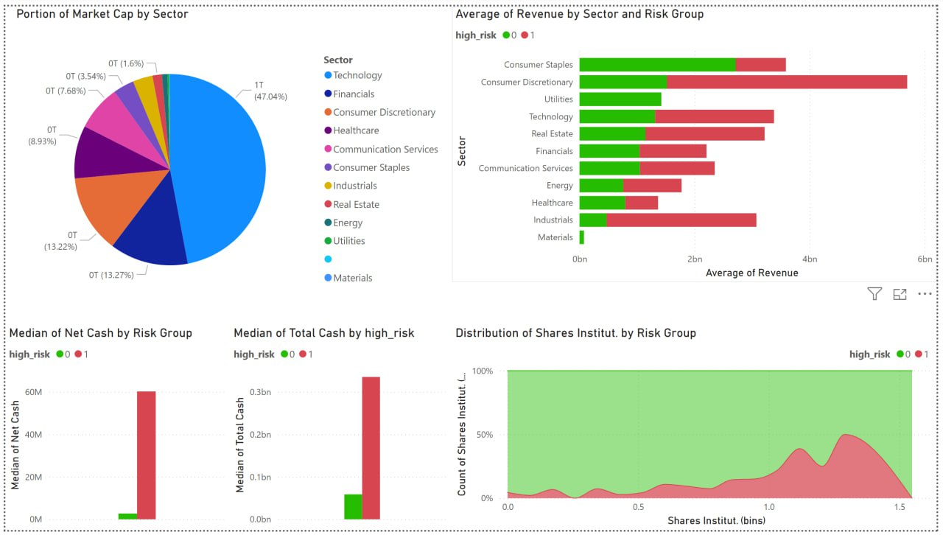
Dashboard 2. Ranking system
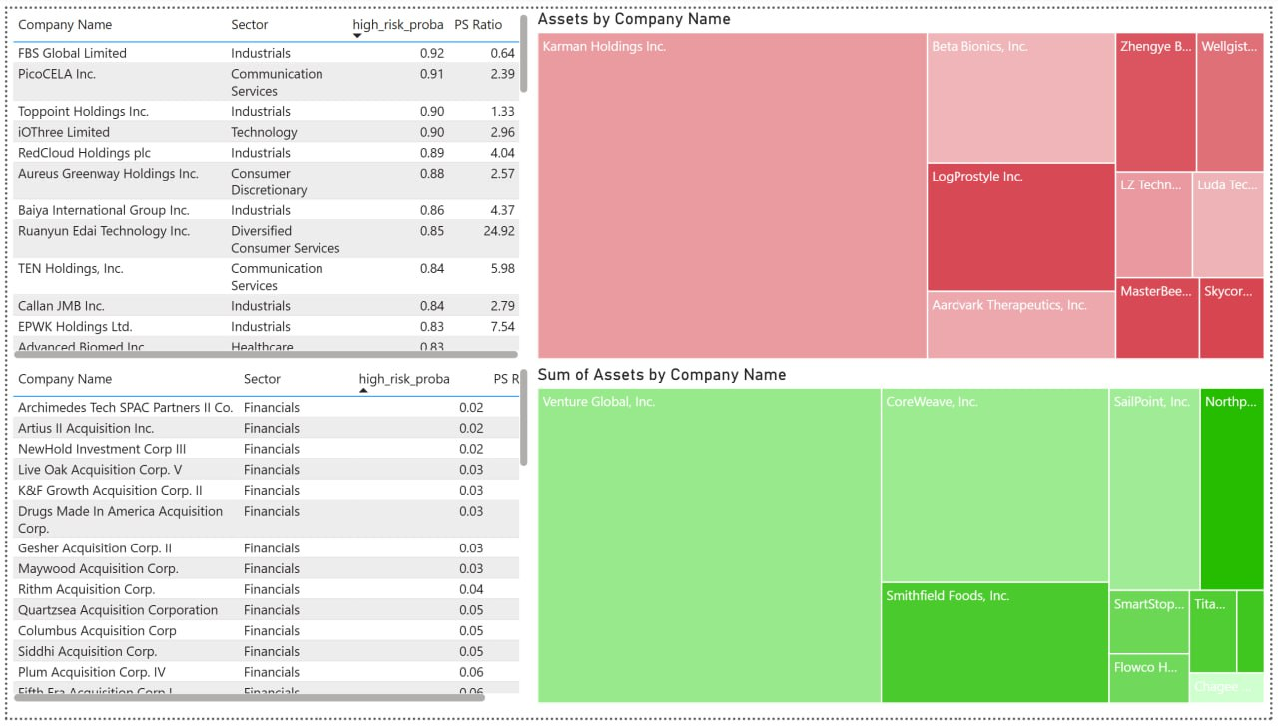
Dashboard 3. Ranking system
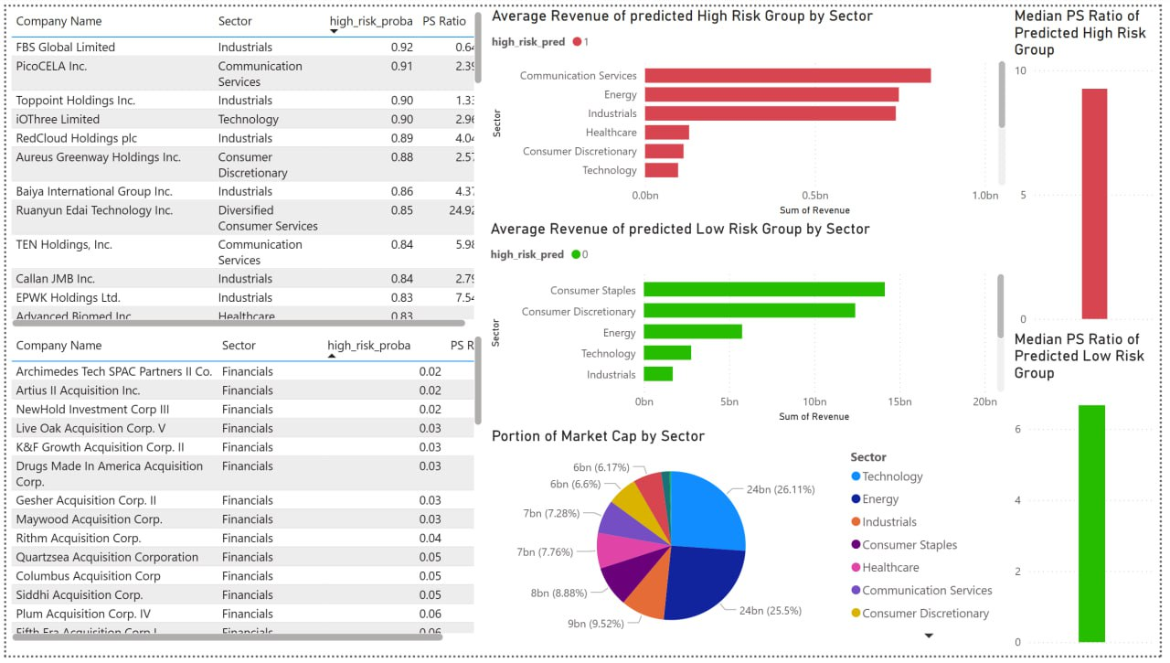

Comparison Ranking System with classical model
Of the classic IPO valuation models, our study considered the EV/EBITDA and EP Ratio indicators. The model based on the Underpricing indicator was excluded from the analysis due to the lack of data on share prices the day after the IPO, which is key to the application of this indicator.
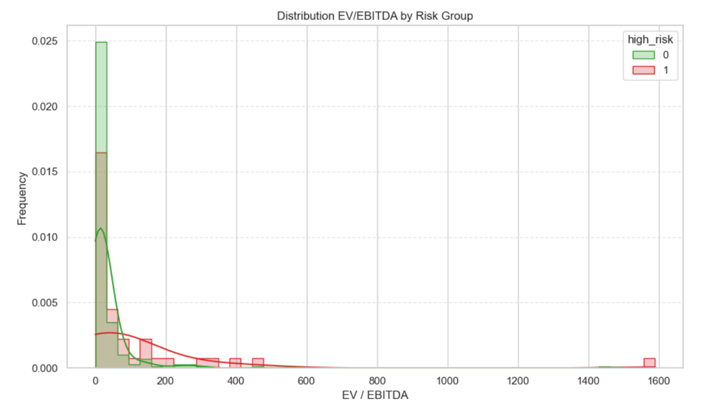
An analysis of the EV/EBITDA ratio showed that its practical applicability and sustainability in the context of the last five years of data has not been fully determined, but a trend has been identified that at EV/EBITDA values ​​exceeding 50, the probability of a company being at high risk increases significantly.
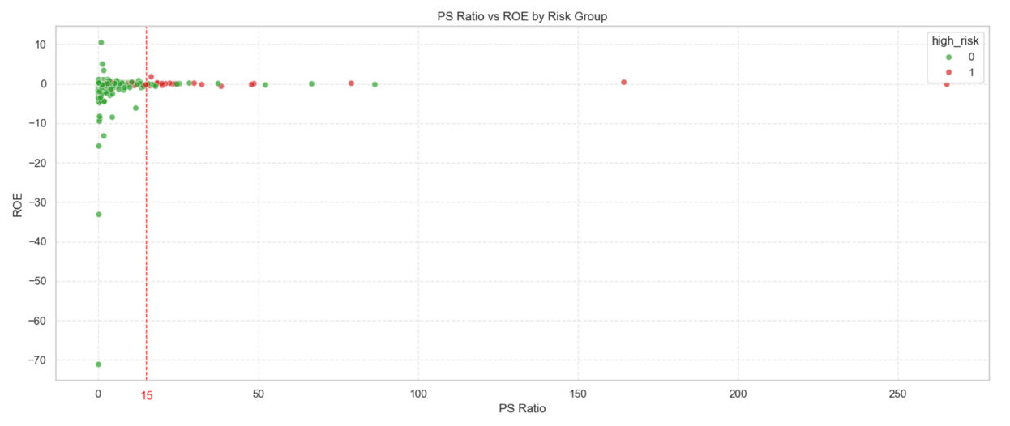
The PS Ratio (the ratio of a company's market capitalization to its revenue) has proven to be one of the most informative parameters in analyzing the risk of companies going public. Analysis of data from the last five years shows a clear trend: when the PS Ratio value exceeds the threshold of 15, the share of companies with a high degree of risk increases significantly. This may be due to the fact that an excessively high PS Ratio often indicates inflated market expectations regarding the company's future growth, which is accompanied by increased volatility and uncertainty.
Within the framework of the proposed risk ranking system, it is advisable to introduce threshold values ​​for PS Ratio taking into account the level of company revenue. Thus, for startups with relatively low revenue, a PS Ratio value above 15 will serve as a high-risk signal when going public. On the contrary, companies demonstrating a PS Ratio below 5 and a sustainable return on equity will be classified as more stable, which corresponds to their ability to generate profit and maintain financial stability.
Thus, the inclusion of PS Ratio in the IPO risk assessment system allows taking into account market expectations and the company's financial stability, which increases the accuracy and practical significance of the model. However, it should be noted that PS Ratio should not be considered in isolation - the optimal approach is a combined approach with other financial and operational indicators for a comprehensive assessment of investment attractiveness.

Assessment of applicability for the Russian stock market

Quantitative comparison
For an objective quantitative comparison, it is necessary to take into account the scale and dynamics of the IPO market in Russia and the United States. Over the past ten years (2014–2024), only 45 IPOs/DPOs have been conducted in Russia, while over the past five years in the United States, the number of such placements has reached 2,305, according to data from the StockAnalysis platform, which we used in our research and modeling.
Despite the relatively small size of the IPO market in Russia, in 2023–2024 there will be a noticeable surge in activity in terms of the number of placements. Thus, during this period, 21 IPOs/DPOs took place, which is about 47% of the total number of transactions over the past 11 years. However, this growth in the number of transactions is not accompanied by a proportional increase in the volume of funds raised. Moreover, approximately 20% of all placements account for about 70% of the total volume of investments attracted, with Fix Price, OZON and Ent among the leaders.
The average placement volume in the period 2023–2024 was RUB 5.8 billion, which is 78% lower than the average for the period 2014–2022, which was RUB 26.6 billion. The largest annual volume of funds raised was recorded in 2021 and amounted to RUB 255 billion across 8 IPOs/DPOs.
These trends indicate that, despite the growth in the number of transactions, the Russian IPO market remains less developed than the American one, and is characterized by a significant concentration of capital in the hands of a limited number of large placements. This imposes restrictions on the direct application of classical IPO valuation models developed on the basis of data from more developed markets, and emphasizes the need to adapt the models to the specifics of the Russian market.
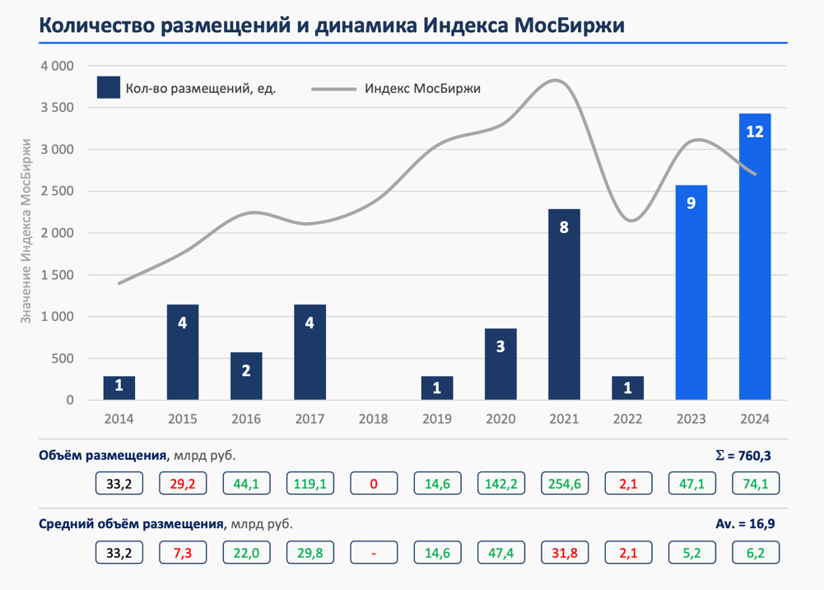
Since 2014, the largest number of initial public offerings were conducted by industry - Finance (11), Technology and IT (10) and by segments Large (12), Mid (13), Small (19).
Among companies with large capitalization (Large - more than 100 billion rubles): OZON, Lenta, Vse Instruments, FixPrice, SKF, Sovcombank, Europlan, RussNeft, EN+, Element, YUGK, SEGEZHA.
Among companies with medium capitalization (Mid - from 50 to 100 billion rubles): Detsky Mir, OVK, Renaissance Insurance, MTS Bank, MKB, SPB Exchange, Samolet, CIAN, ASTRA, Positive Technologies, EMC, PROMOMED.
Among the companies with small capitalization (SMALL – up to 50 billion rubles): OR GROUP, TRASSA, Hederson, Glogaltruck, Novorossiysk Bread Products Plant, SFI, Car Money, Zaimer, APRI, Softline, DIASOFT, IVA, Delimobil, Whoosh, HeadHunter, Genetico, Svetofor Group.
Therefore, there are clearly not enough IPOs conducted in Russia, and in terms of market size, to be able to apply the same methods and the same model that was built on the basis of IPO data in the United States.

Qualitative comparison
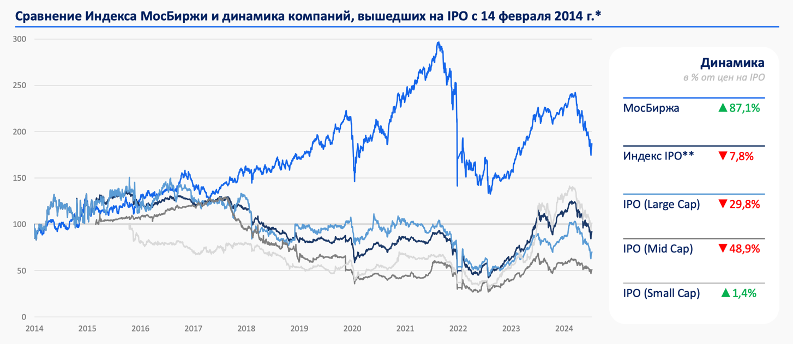
An analysis of the dynamics of the Moscow Exchange index and the overall IPO market over the past ten years demonstrates a clear advantage of the index in terms of profitability. Starting around 2017, the gap between the profitability of the Moscow Exchange index and the profitability of investments in IPOs has increased significantly. This indicates that investments in IPOs on the Russian market over the specified period were accompanied by increased risks and, as a result, significant losses compared to more stable instruments represented in the main index.
In contrast to the Russian situation, the US stock market presents a different picture. From 2015 to 2019, IPO market returns were similar to those of the S&P 500, deviating by only 10–20%. This indicates a more balanced risk-return ratio when investing in IPOs on the US market, as well as greater maturity and liquidity in this segment.
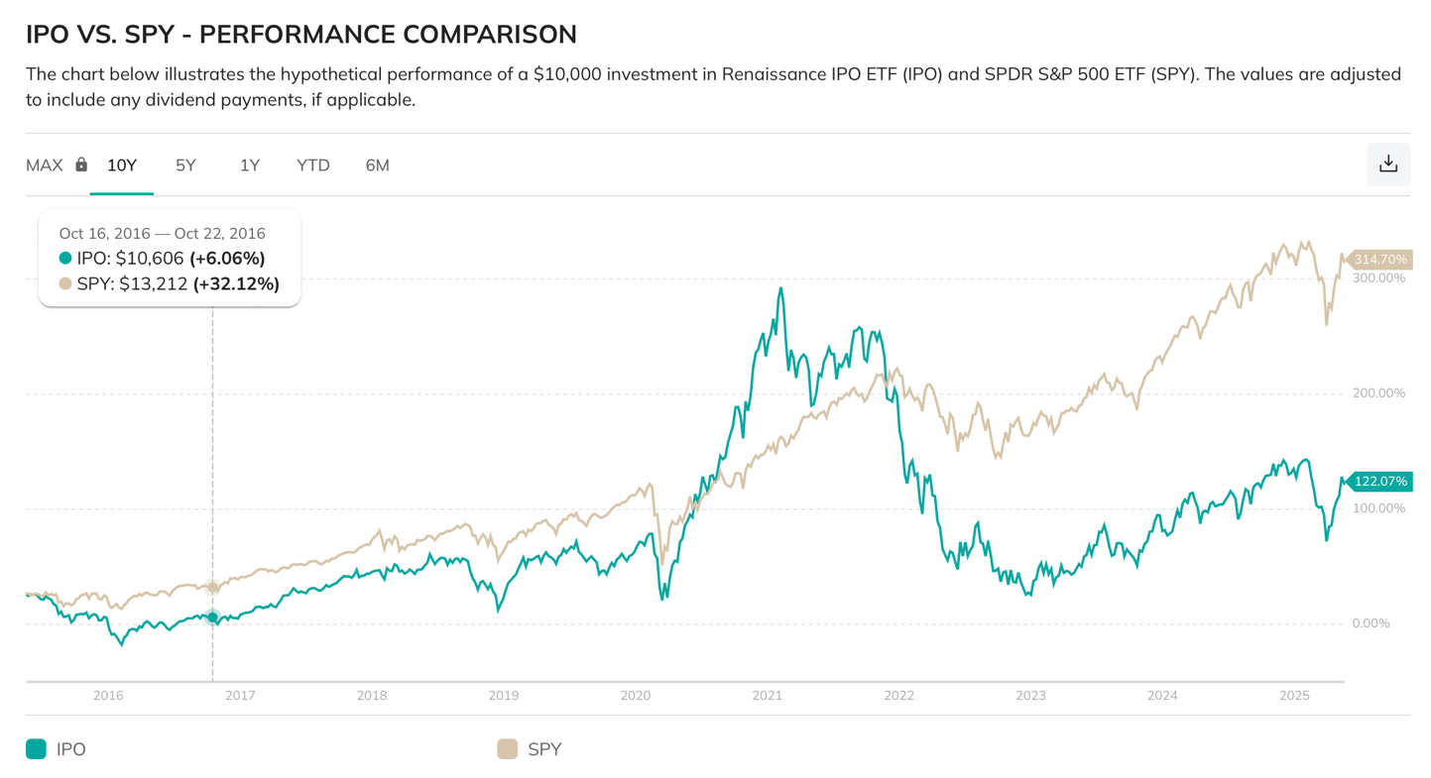
In both markets, the technology IPO segment exhibits the highest volatility and risk. For example, according to the latest data, the Russian IT sector is significantly inferior to the general market in terms of price dynamics: current share prices are close to zero, while losses of up to 4% have been observed over the past week, and a decline of up to 60% over 12 months. Such high volatility indicates significant risks associated with investing in technology companies in the Russian market, which reflects the general trend in the global high-tech IPO sector.
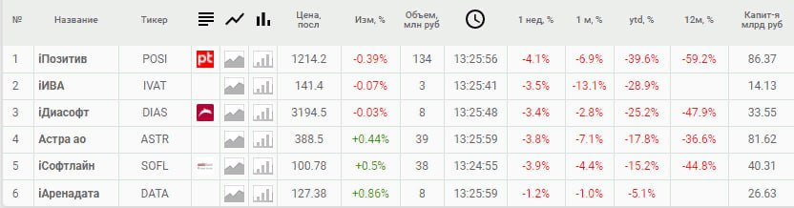
This ranking system can be effectively applied by Russian investment companies if they enter the American stock market after the sanctions are lifted. This will require additional training or retraining of the model on current data, which will allow updating and adapting the ranking system to new conditions and the market environment.
Moreover, in the future, when significantly more IPOs are conducted on the Russian stock market, and the market becomes freer, more competitive and transparent — including due to the increase in the share of the stock market in the structure of Russia's GDP — a similar risk ranking methodology can be successfully applied to assess Russian issuers. Already now, according to the Ministry of Economic Development of the Russian Federation, about 120 small Russian companies included in the register of small and medium-sized businesses with revenues of up to 2 billion rubles can receive subsidies for conducting IPOs in the period 2025-2027 [11]. This demonstrates the potential for expansion of the Russian stock market and the relevance of developing and implementing modern investment risk assessment systems.

Conclusions
Based on the analysis, it can be concluded that the riskier category of companies going public primarily includes organizations with large market capitalization (more than $1 billion), fewer than 300 employees, and Quick Ratio and Current Ratio indicators exceeding 2. At the same time, their total debt is over $100 million, and the presence of significant cash on the balance sheet is also typical for this group.
Additionally, based on classical financial multipliers, companies with a PS Ratio above 15 and a ratio are considered high-risk. In terms of economic sectors, this category mainly includes technology and industrial companies.
If a company meets at least five of the listed criteria and the ranking system predicts high risk, then such an IPO should be considered a potentially highly volatile event. This means that investors can both make significant profits and suffer significant losses, which necessitates a careful and balanced approach to investing in such issuers.

Advantages of the ranking system
- A comprehensive analysis of many factors affecting the level of risk during an IPO has been conducted, which provides a multi-faceted understanding of risk.
- A model with acceptable accuracy has been developed, allowing it to be used as a tool to support investment decisions regarding IPOs.
- A detailed visualization of the results is presented, making it possible to assess the degree of risk from various angles and improve the quality of analysis.

Disadvantages and limitations of the ranking system
- The analysis is static and trained on only 2 thousand lines, which reduces the relevance of the model over time. To improve accuracy and adaptability, it is recommended to implement dynamic analysis, especially regarding cash flows.
- The sample size of Russian IPOs is extremely limited, which makes it difficult to conduct a full comparison with the American stock market and reduces the generalizability of the results. In this regard, the current findings should be considered preliminary and require further clarification.

Literature & sources
- https://stockanalysis.com
- https://thegovernance.org/2023/03/04/the-role-of-institutional-investors-in-corporate-governance
- https://blog.trillionize.com/the-impact-of-market-volatility-on-ipos
- https://journals.sagepub.com/doi/10.1177/0148558X211046512
- https://www.investopedia.com/ask/answers/011215/it-important-company-always-have-high-liquidity-ratio.asp
- Frank & Goyal, 2009; Titman & Wessels, 1988
- https://onlinelibrary.wiley.com/doi/10.1111/j.1540-6261.1991.tb03743.x
- https://www.sciencedirect.com/science/article/abs/pii/S0304405X99000033?via%3Dihub
- https://www.sciencedirect.com/science/article/abs/pii/S0304405X09000622?via%3Dihub
- Ritter, J. R., & Welch, I. (2002). A review of IPO activity, pricing, and allocations. The journal of Finance, 57(4), 1795-1828. https://www.nber.org/system/files/working_papers/w8805/w8805.pdf
- https://smartlab.news/i/152031

Additional literature & sources
- Ibbotson R. G. Price Performance of Common Stock New Issues // Journal of Financial Economics. 1975. Vol. 2. P. 235—272
- bbotson R. G., Jeffrey F. J. Hot issue’ markets // Journal of Finance. 1975. Vol. 30. P. 1027—1042
- Ritter J. R. The Long-Run Performance of Initial Public Offerings // Journal of Finance. 1991. Vol. 46. P. 3—27
- Ritter J. R. The «hot issue» market of 1980 // Journal of Business. 1984. Vol. 57. P. 215—240
- Ritter J. R. Average First Day Return on European and non-European IPOs. University of Florida, 2009. http://bear.cba.ufl.edu/ritter

