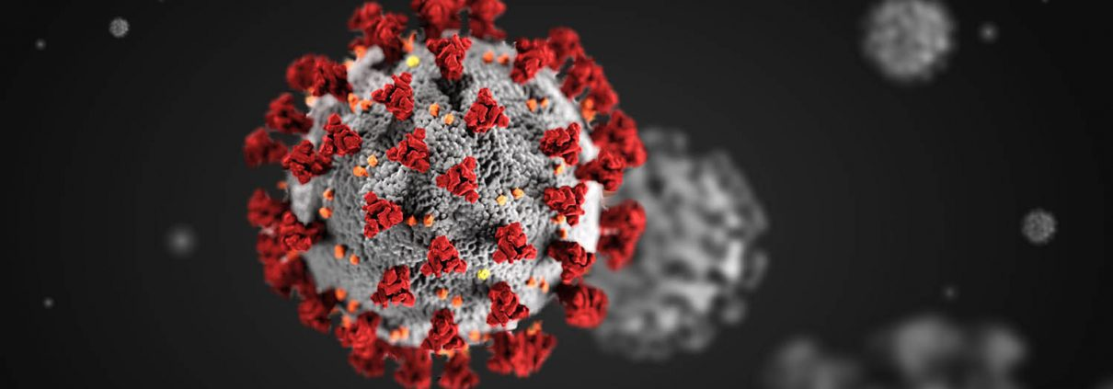
Sorry I gave you
COVID
Glad yall still alive!

