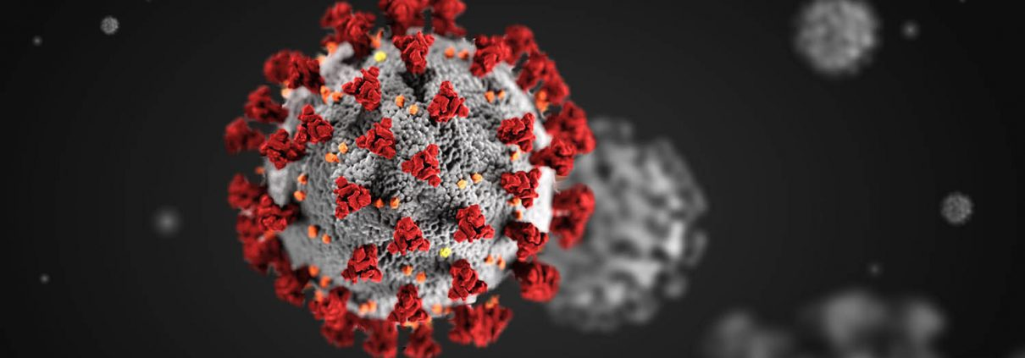
Glad yall still alive!
Sorry I gave you COVID

