PROJECT TITLE: ALM BIOMETRIC ATTENDANCE PAYROLL SYSTEM
TEAM NAME: Fronted
WEEK NUMBER: Week 5
COVERAGE PERIOD:
WEEKLY SUMMARY: Updated multiple Figma pages including Faculty, Admin, and Payroll Officer interfaces. Covered utility pages such as Dashboard, Attendance, Payroll, and Payslips. Collaborated with Mr. Wyne Prisno and received guidance from team leader Brent, while also contributing to Admin page improvements.
INDIVIDUAL REPORT
TASK TRACKER:
Task Name: Figma Pages Updated
Description: Updated Figma Pages (Admin) with the help of my hero Caren
Assigned To: Robis, Brent Kristian L.
Start Date: 4-8-26
Target Date: 4-10 26
Status: Completed
Daily Updates:
- Day 1: Started (Dashboard-Payroll)
- Day 2: Halt
- Day 3: Finished (Payroll)
Output / Proof:
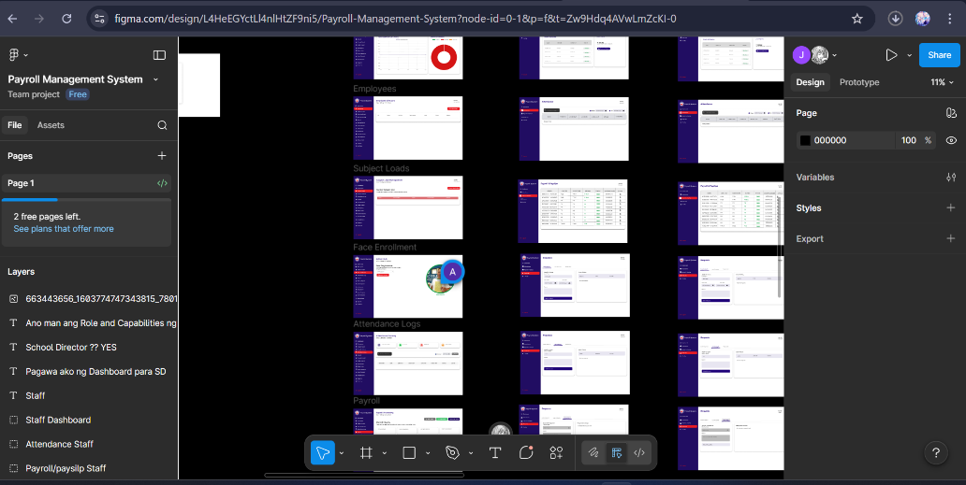
Issues: N/A
Resolution: N/A – But will update prototyping.

Task Name: Figma Pages Updated (Week 5)
Description: Updated the Admin Figma pages with the assistance from my very kind and understanding team leader, Brent.
Assigned To: Rafales, Caren A.
Start Date: 04-07-26
Target Date: 04-9-26
Status: Completed
Daily Updates:
• Day 1: Began work on Faculty and Setting sections
• Day 2: Work paused
• Day 3: Completed Setting section
Output / Proof:
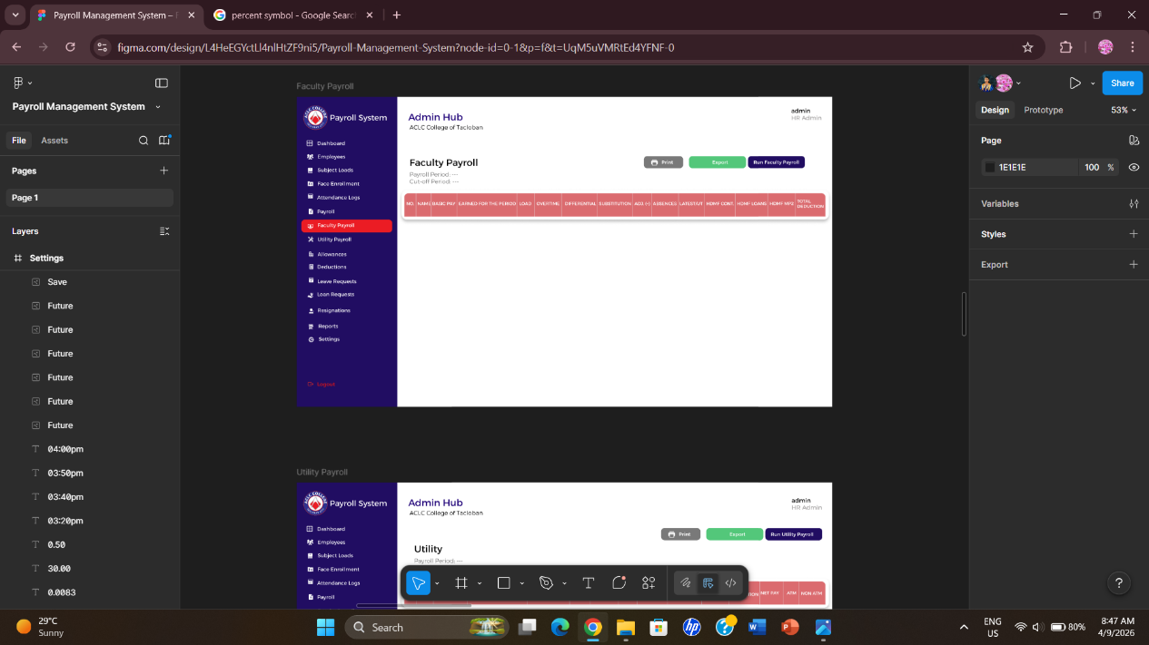
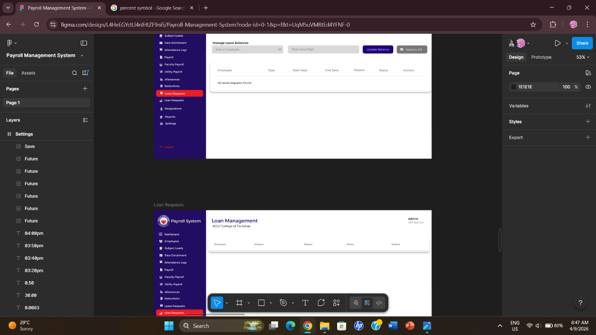
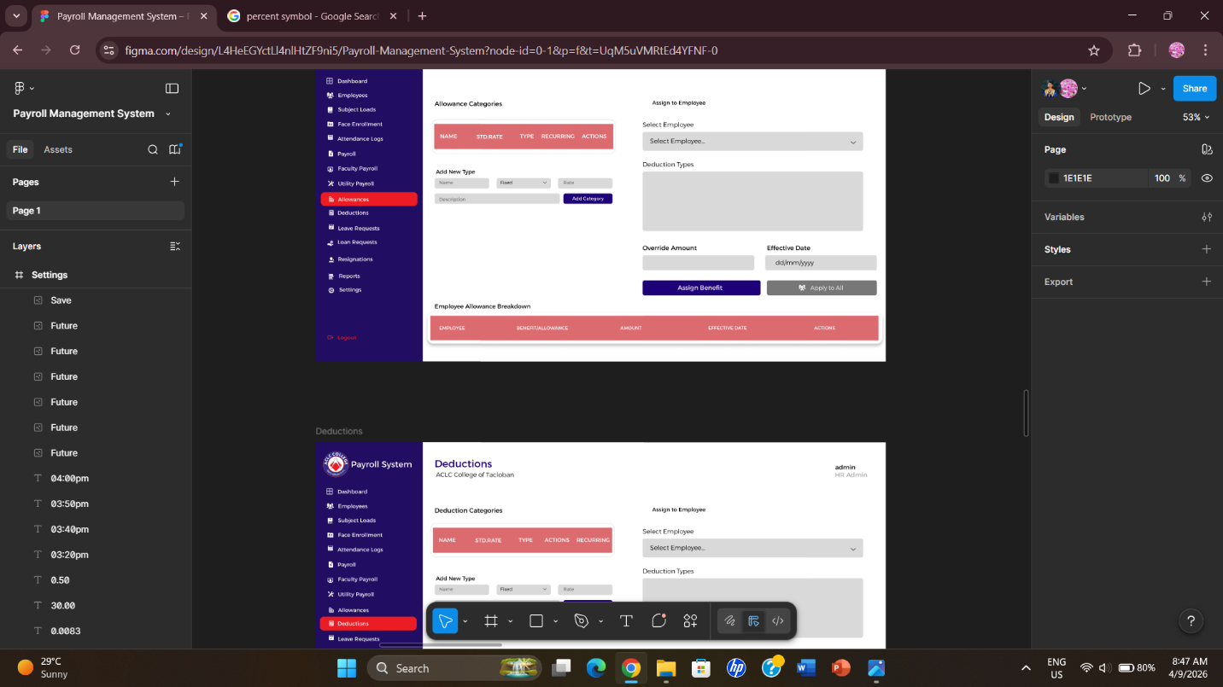
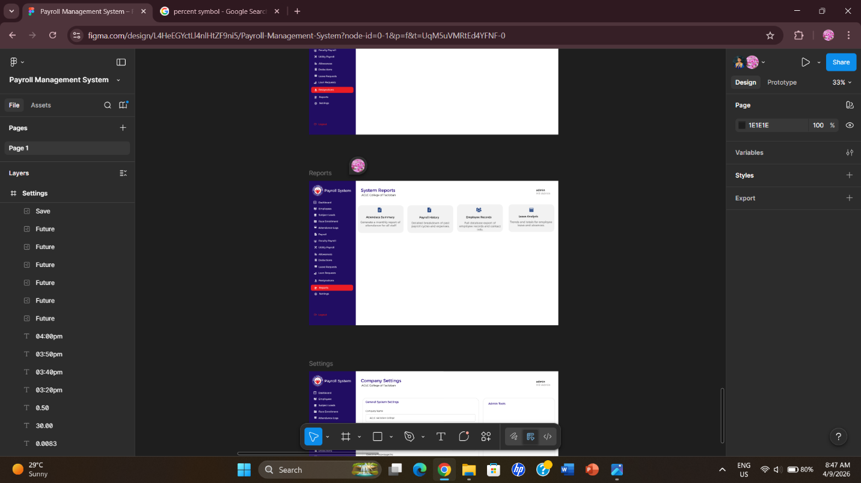
Issues:
Experienced limited internet access due to lack of mobile data, which caused delays in editing.
Resolution:
Connected to the internet through Ate Jane and Kuya Laurence to continue and complete the task.

TASK TRACKER:
Task Name: Figma Payroll Officer Pages
Description: Updated the Figma Payroll Officer Pages together with Mr. Wyne Prisno
Assigned To: Beverly Canonce
Start Date: April 8, 2026
Target Date: April 10, 2026
Status: Completed
Daily Updates:
- Day 1: .Started
- Day 2: Work Paused (Due to not having Internet)
- Day 3: Continue working
- Day 4: Wyne help me to finish the last 3 pages hehe
- Day 5: Finished
- Day 6:
Output / Proof:
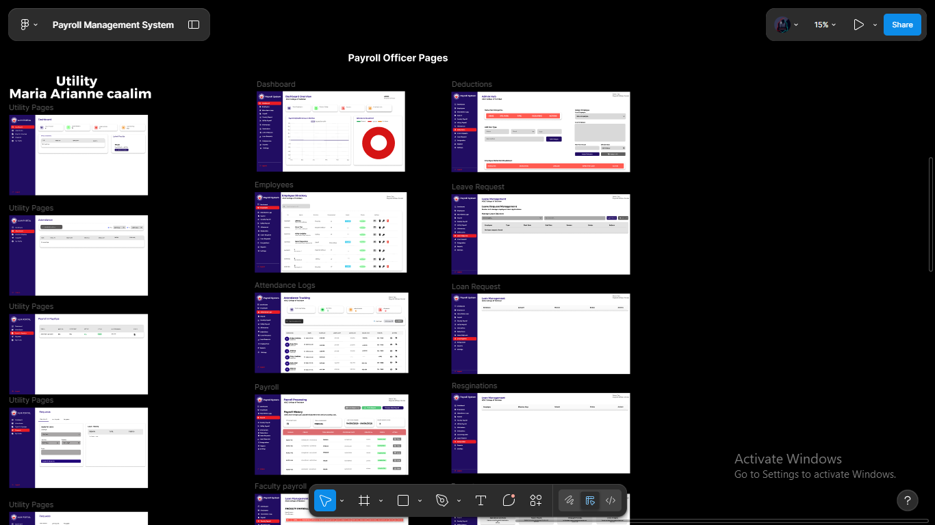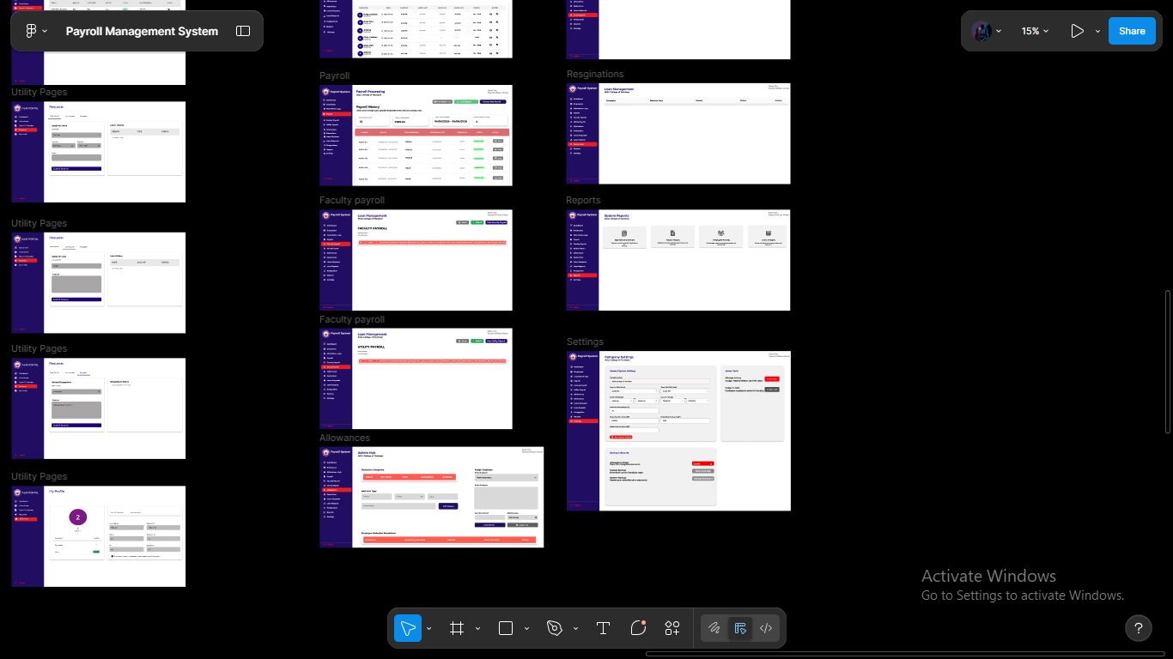
Issues: Experienced limited internet access due to lack of mobile data, which caused delays in editing.
Resolution:N/A

TASK TRACKER:
Task Name:Utility Pages
Description: Utility Pages this pages consist of dashboard, attendance, payroll &payslips, request and profile.
Assigned To:Arianne Mae Caalim
Start Date:04-06-2026
Target Date:04-10-2026
Status: (Not Started / In Progress / Completed)Completed
Daily Updates:
- Day 1: I didn’t yet start yet since I am confuse
- Day 2: Here also I am still asking what to do with the work
- Day 3: This day I start working with the Dashboard
- Day 4: This day I continuing the work until I finished
- Day 5:I am writing for report
- Day 6:
Output / Proof:
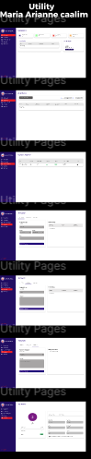

Issues: Some icons is not match
Resolution: I find alternative icon to use

TASK TRACKER:
Task Name: Figma Pages Updated
Description: Updated Figma Pages (Faculty)
Assigned To: Aucilla, Criselda Vhie O.
Start Date: 04/08/2026
Target Date: 04/09/2026
Status: Completed
Daily Updates:
- Day 1: Started (Dashboard-Faculty Page)
- Day 2: Finished (Faculty Dashboard, Attendance, Payroll & Payslips, Requests, and Profile)
Output / Proof:
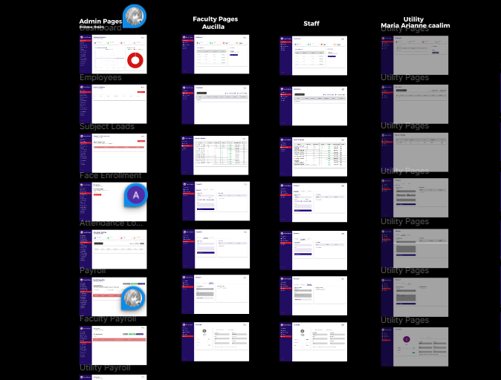
Issues: N/A
Resolution: N/A – But will update prototyping.

TEAM CONTRIBUTION:
- Robis → 1 tasks → Complete
- Rafales → 1 tasks → Complete
- Aucilla → 1 tasks → Complete
- Caalim → 1 tasks → Complete
- Canonce → 1 tasks → Complete
NEXT WEEK PLAN:
- To be Announce by the Leaders

REMARKS:
(optional)

