DOCUMENTATION REPORT

PROJECT TITLE: ALM Biometric Attendance Payroll System for ACLC College of Tacloban

TEAM NAME: BIOMETRICS INTEGRATION
TEAM MEMBERS:
- Marcellano, Jane
- Santos, Vannah Maie
- Besa, Lourence
- De Veyra, Lica Yzabelle
- Lorica, Khen
- Padel, Ruffa Mae
- Samar, Angelyn

WEEK NUMBER: Week 4
COVERAGE PERIOD: April 2 – 8, 2026

WEEKLY SUMMARY:
During Week 4, the Biometrics team concentrated on optimizing enrollment and strengthening kiosk security to improve overall system reliability. The face enrollment process was refined to address delays, with the camera preview redesigned into a circular format for better user positioning. Multi-face handling was introduced to block attendance when more than one face is detected, ensuring accurate validation. System enhancements included a Zero-Duplicate Policy with server-side checks, real-time kiosk rejection, and audit logging, alongside server-synced time and configurable buffers to resolve bugs and maintain consistent records. Additional improvements such as scanning animations, status indicators, and stricter threshold checks boosted usability and security. Finally, kiosk liveness detection was hardened through multi-step verification, randomized prompts, and anti-replay timing checks, with adjustments made to reduce latency and false rejections. These updates collectively enhanced responsiveness, accuracy, and protection against misuse across the biometric system.

TASK TRACKER (I)_________________________________________________________

Task Name: Face Enrollment Optimization
Description: Improving the face enrollment process to address delays caused by slow recognition during kiosk operations. Updating the camera preview UI.

Assigned To: Marcellano, Jane C.
Start Date: April 2, 2026 (Thursday)
Target Date: April 3, 2026 (Friday)
Status: In Progress

Daily Updates
- Day 1: Fixing the face enrollment and changed the camera preview UI to circle instead of square.
- Day 2: Face enrollment optimized due to the kiosk’s slow face recognition.

Output / Proof:
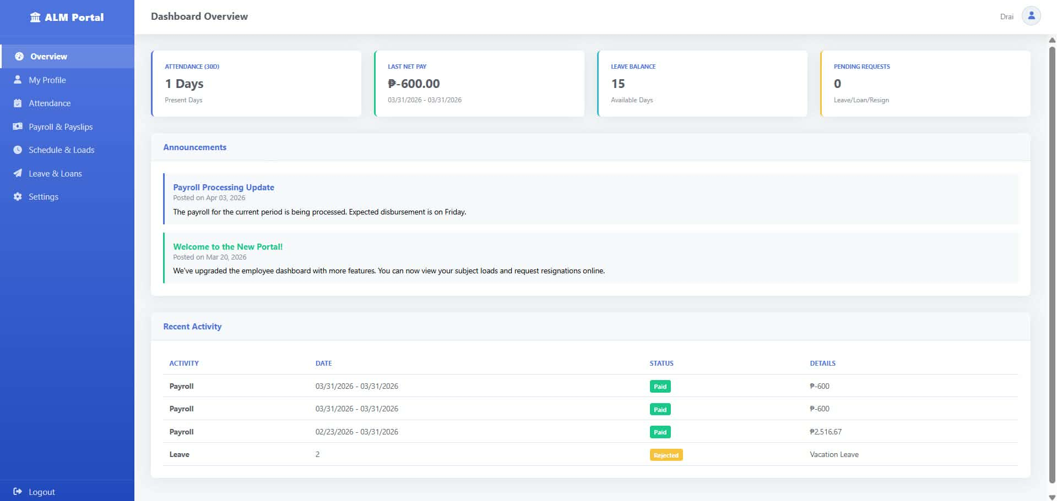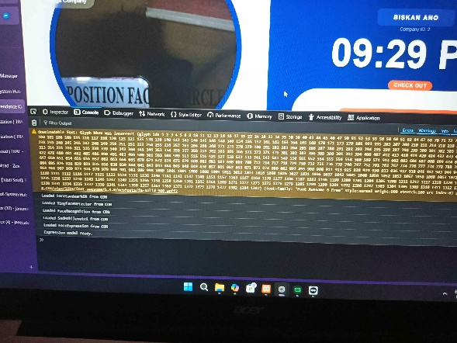
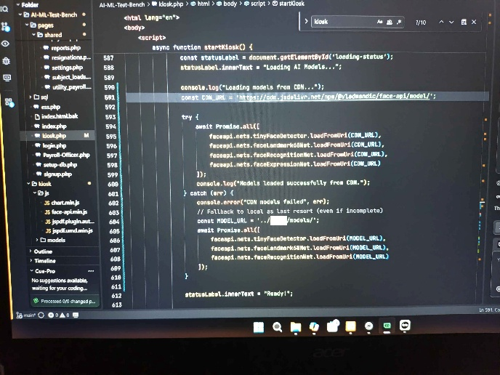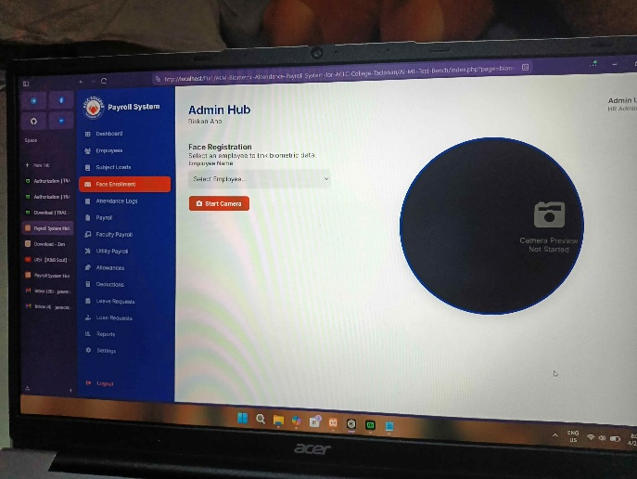

Issues:
- Struggle with slow face recognition causing delays.

Resolution:
- The face enrollment process was optimized to ensure that face recognition operates efficiently and no longer experiences delays.

TASK TRACKER (II)_________________________________________________________

Task Name: Multi-face Handling Implementation
Description: Implemented a feature that detects multiple faces using the webcam and prevents attendance recording of more than one face is detected. Displays an instruction message to ensure only one face is visible.

Assigned To: Ruffa Mae Padel
Start Date: April 5, 2026 (Sunday)
Target Date: April 6, 2026 (Monday)
Status: In Progress

Daily Updates
- Sets up face detection using the face_recognition library, added a condition to reject multiple faces, and displayed an instruction message. Tested the system with different scenarios to confirm proper functionality.

Output / Proof:
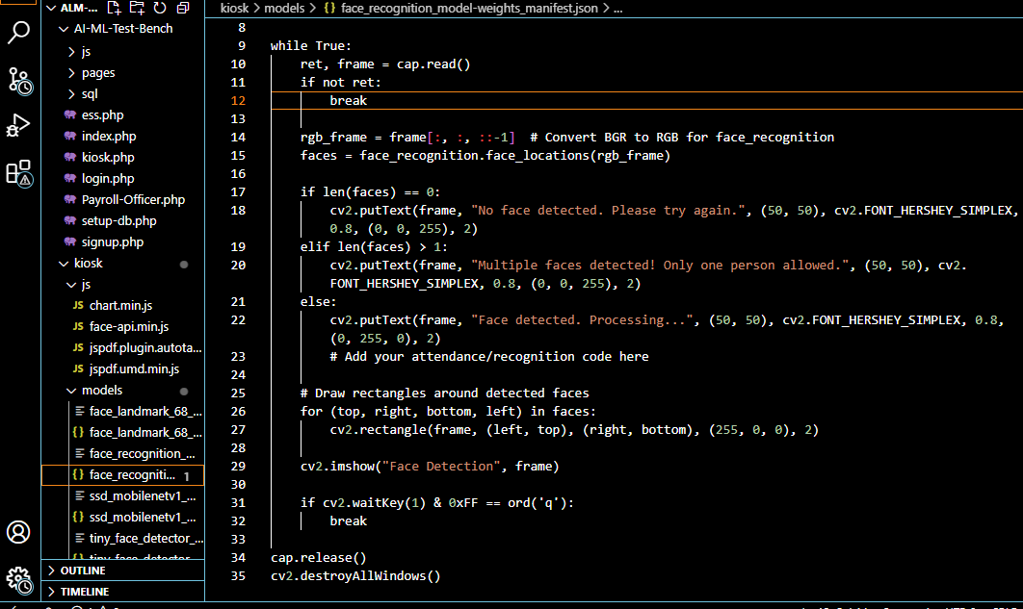

Issues:
- N/A

Resolution:
- N/A

TASK TRACKER (III)________________________________________________________

Task Name: Biometric System Enhancements & Fixes
Description: System was strengthened with Zero-Duplicate Policy through server-side checks, real-time kiosk rejection, and audit logging of blocked attempts. Server-synced kiosk time ensures consistent logs and cutoff accuracy, while configurable buffers and strict lunch ranges improve reliability and resolve critical bugs.

Assigned To: Marcellano, Jane / De Veyra, Liza Yzabelle / Lorica, Khen Mariel
Start Date: April 8, 2026 (Wednesday)
Target Date: April 8, 2026 (Wednesday)
Status: Completed

Daily Updates
- Enhanced database and backend logic with CLI-compatible scripts, added new columns, and enforced lunch/time buffers to fix sync issues, bugs, and improved auto-detection.
- Circular camera preview modernizes the UI, guiding user positioning with instant scan feedback.
- Enhanced thresholds and ambiguity checks boost security by rejecting weak or multiple-identity matches.
- CDN model fallback ensures high availability with backup AI models if local storage fails.
- Scanning animations and status indicators improve user experience with clear real-time guidance.
- Enrollment API integration enforces a one-person, one-record policy through server-side validation.
- Stability and error handling reduce false starts by requiring steady positioning, minimizing crashes.
- Implemented configurable scheduling with server-side time sync and automated late detection to ensure logs and reporting of tardiness.

Output / Proof:
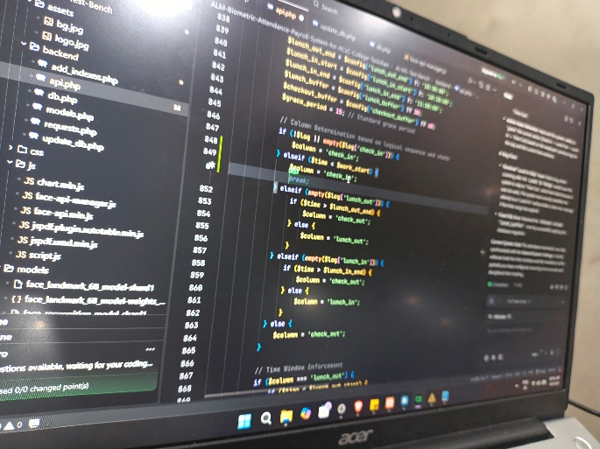
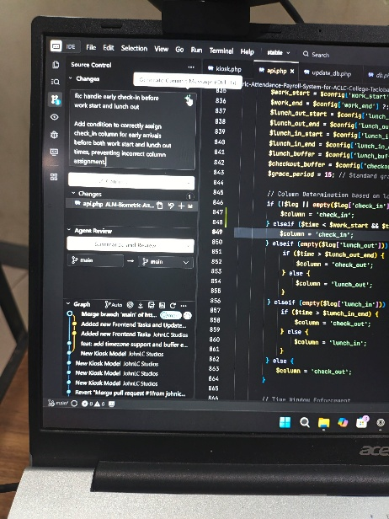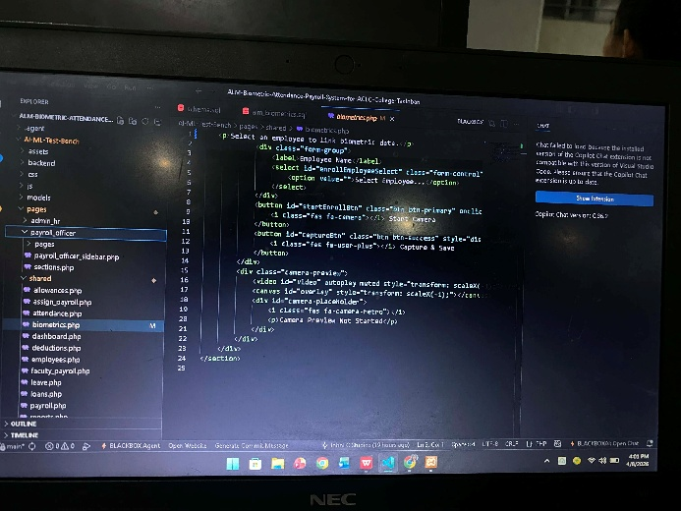
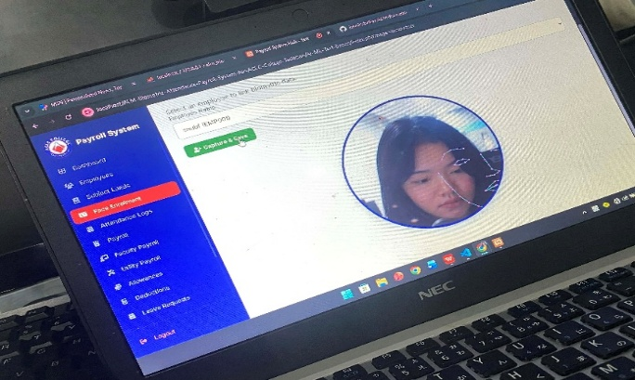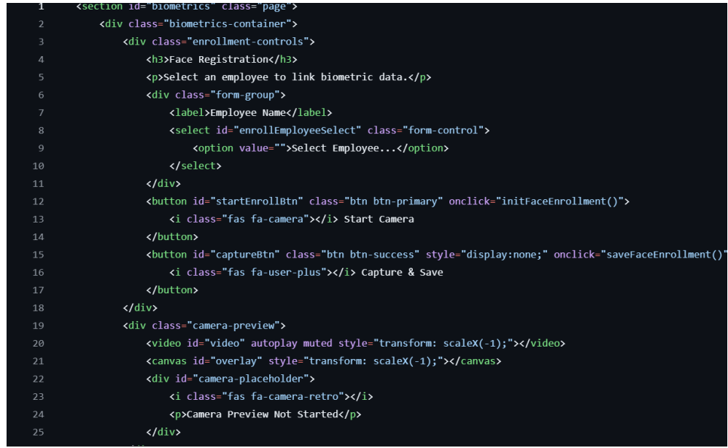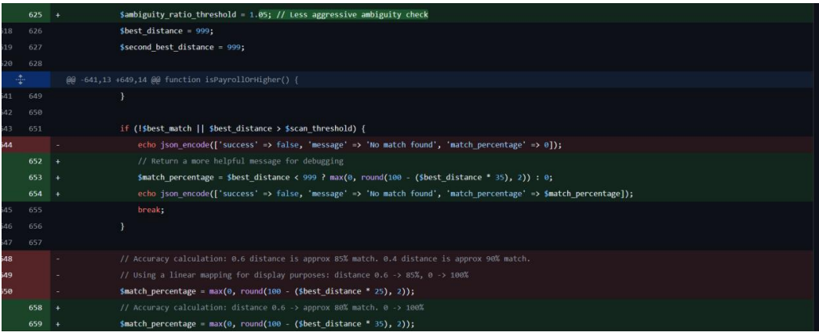

Issues:
- CLI session errors, premature Time Out skips after Lunch In, and missing lunch_buffer column having SQL issues.
- The "strictness" of the matching algorithm is set too low.
- Missing duplicate validation and ambiguity handling allowed weak or uncertain matches, real-time enrollment of supplicates, and potential security exploits through multiple identities.

Resolution:
- Updated database scripts for CLI compatibility, refined Lunch In logic with clear error messaging, and applied migrations to align terminals with system settings.
- Enhanced biometrics.php with strict duplicate-face prevention, adding server-side and kiosk-side validation to block duplicates or ambiguous matches in real time. All attempts are now logged to ensure data integrity and provide clear audit trails.

TASK TRACKER (IV)________________________________________________________

Task Name: Kiosk | P0 Liveness Hardening
Description: Enhancement of the kiosk authentication system by implementing advanced liveness detection mechanisms. This includes multi-step liveness verification, randomized user prompts, and anti-replay timing checks to prevent spoofing attacks.

Assigned To: Samar, Angelyn
Start Date: April 7, 2026 (Tuesday)
Target Date: April 8, 2026 (Wednesday)
Status: Completed

Daily Updates
- Conducted analysis of current liveness detection system. Identified vulnerabilities related to single-step verification and replay attacks.
- Designed multi-step liveness flow including facial movement prompts (e.g., blink, head turn).
- Implemented randomized prompt generator to ensure unpredictability in user actions during verification.
- Integrated anti-replay timing checks to detect delays or inconsistencies in response time.

Output / Proof:
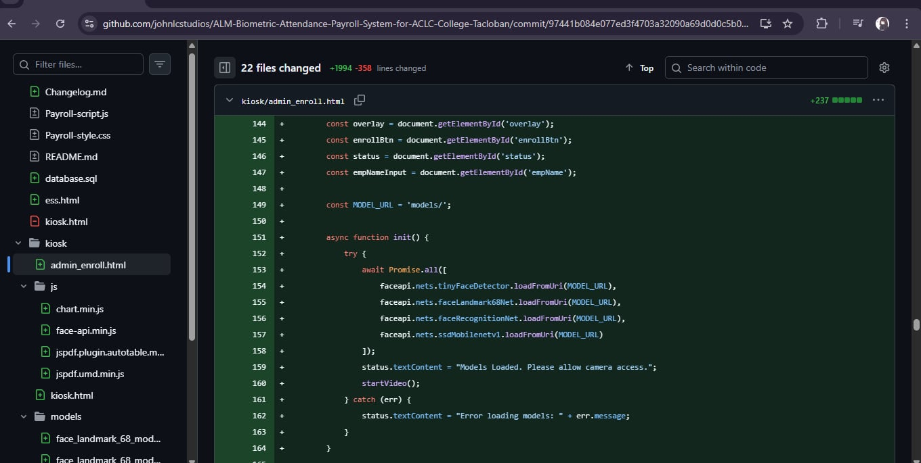
Issues:
- Slight delay in prompt-response processing affecting user experience.
- Initial delays in response time due to added liveness steps
- False rejections in low-light or unstable camera conditions

Resolution:
- Optimized processing pipeline to reduce latency.
- Adjusted sensitivity thresholds for better lighting adaptability
- Fine-tuned anti-replay timing parameters to reduce false positives
_________________________________________________________________________

TEAM CONTRIBUTION:
- Jane C. Marcellano > 2 task > 1 In progress, 1 Completed
- De Veyra, Lica Yzabelle > 1 task > Completed
- Lorica, Khen Mariel > 1 task > Completed
- Ruffa Mae Padel > 1 task > In progress
- Samar, Angelyn > 1 task > Completed

NEXT WEEK PLAN:
- General Face Enrollment
- Kiosk Functionalities 95% Finished

