DOCUMENTATION REPORT

PROJECT TITLE: ALM Biometric Attendance Payroll System for ACLC College of Tacloban

TEAM NAME: BIOMETRICS INTEGRATION
TEAM MEMBERS:
- Marcellano, Jane
- Santos, Vannah Maie
- Astacaan, Gian Lexus
- Besa, Lourence
- De Veyra, Lica Yzabelle
- Lorica, Khen Mariel
- Padel, Ruffa Mae
- Samar, Angelyn

WEEK NUMBER: Week 2
COVERAGE PERIOD: March 21, 2026 (Saturday)

WEEKLY SUMMARY:
(Note: During Week 1, the primary emphasis was placed on the Frontend Team)
The team completed the design and initial coding of the biometric kiosk. Progress was made on integrating core features like facial recognition and attendance tracking, though issues with the tacking and face models required collaborative troubleshooting. Overall, a strong foundation for the system was established.

TASK TRACKER (I) _________________________________________________________

Task Name: Biometric Kiosk Design (Figma)
Description: The team created a low-fidelity wireframe in Figma to visually present employee information such as attendance, absences, and loans.

Assigned To: Santos, Vannah Maie / Lorica, Khen Mariel
Start Date: March 21, 2026 (Saturday)
Target Date: March 21, 2026 (Saturday)
Status: Completed

Daily Updates
- Creating a design low-fidelity wireframe for the biometric kiosk using Figma, with its purpose to show employee’s/staff’s information summary that includes: attendance, absences, and loans.
Output / Proof:
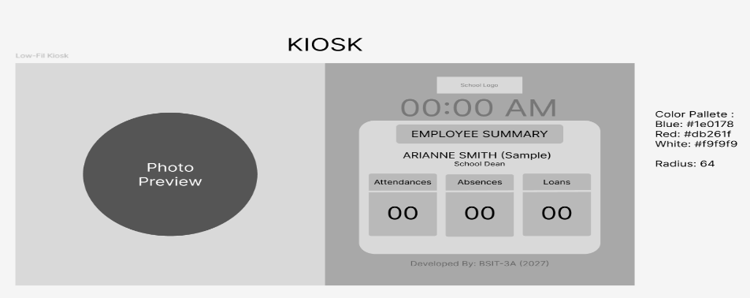

Issues:
- N/A

Resolution:
- N/A

TASK TRACKER (II)_________________________________________________________

Task Name: Implementation of Biometric Kiosk
Description: The team implemented the design into code, adding initial features such as real-time clock, facial recognition, and attendance tracking.

Assigned To: Marcellano, Jane
Start Date: March 21, 2026 (Saturday)
Target Date: March 21, 2026 (Saturday)
Status: Completed

Daily Updates
- Implementing the biometric kiosk’s design into code, with initial functionalities such as real-time clock, facial recognition, and tracking of attendance, including giving track of the number of absences, and loans. Though issues with data displays and face models required troubleshooting.

Output / Proof:
(Not Provided)

Issues:
- Could not track and display the attendance on the kiosk.
- Issues with the face model and facial recognition.

Resolution:
- Collaborative work and reviewing errors from the biometric system.
_________________________________________________________________________

TEAM CONTRIBUTION:
- Marcellano, Jane > 1 task > Completed
- Santos, Vannah Maie > 1 task > Completed
- Lorica, Khen Mariel > 1 task > Completed

NEXT WEEK PLAN:
- Fix face model and API integration
- Improve facial recognition preview

