ACCOMPLISHMENT / DOCUMENTATION REPORT
PROJECT TITLE: ALM Biometric Attendance Payroll System Management
TEAM NAME: FRONTEND
MEMBER NAME:
- Robis, Brent Kristian L.
- Prisno, Wyne C.
- Calo, Jayke Louise
- Calvo, Cherose Angela C.
- Caalim, Arianne Mae
- Canonce, Beverly
- Aucilla, Criselda Vhie O.
- Rafales, Caren A.
- Lacambra, Alfonse

WEEK NUMBER: Week 2
COVERAGE PERIOD: March 16 – March 21, 2026

SUMMARY OF THE WEEK:
During the second week, the team focused on converting the low-fidelity wireframes into high-fidelity designs using Figma. All team members actively contributed to enhancing the visual design by adding colors, typography, icons, and detailed UI elements. The wireframes were transformed into polished and realistic interfaces that closely represent the final system. By the end of the week, the team successfully completed the high-fidelity designs for all system pages.

DAILY PROGRESS LOG:
Monday: Reviewed low-fidelity wireframes and discussed improvements as a team.
Tuesday: Started converting login and dashboard pages into high-fidelity design in Figma.
Wednesday: Continued designing employee and payroll pages with detailed UI elements.
Thursday: Worked on deductions, allowances, and additional system pages.
Friday: Applied consistent colors, fonts, and design styles across all pages.
Saturday: Finalized and reviewed all high-fidelity designs as a team.

TASKS COMPLETED:
• Converted low-fidelity wireframes into high-fidelity designs
• Applied consistent UI design elements across all pages

TASKS IN PROGRESS:
• Minor revisions and design improvements
• Preparing finalized designs for frontend development

PROBLEMS ENCOUNTERED:
• Difficulty maintaining consistent design across multiple pages
• Adjusting spacing, alignment, and visual balance

SOLUTIONS APPLIED:
• Collaborated as a team to ensure consistent design decisions
• Reviewed and refined layouts multiple times for better appearance

PROOF OF WORK:
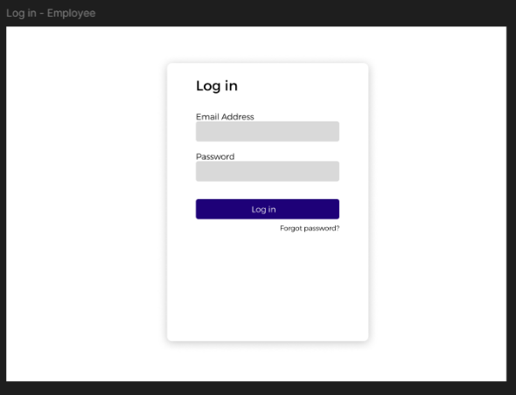

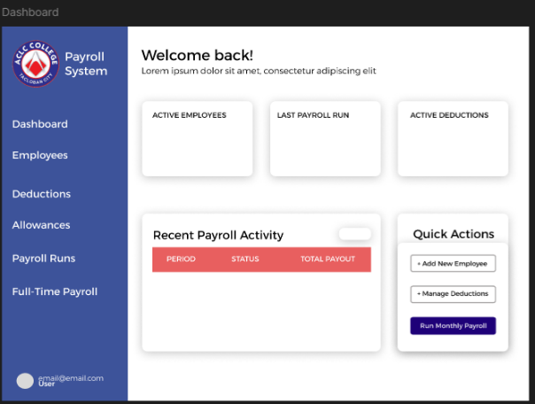

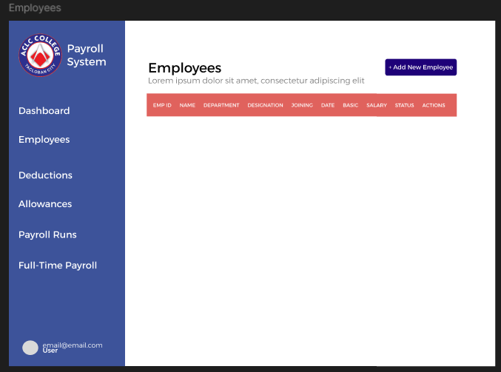

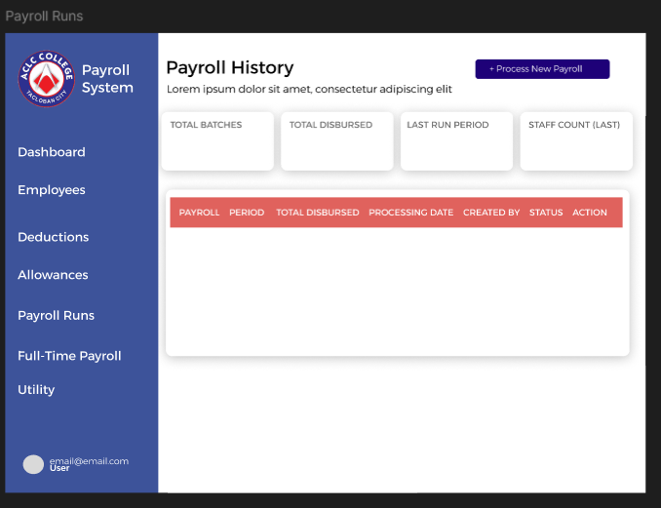

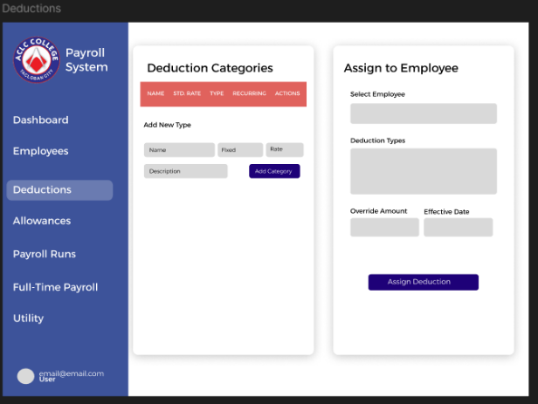

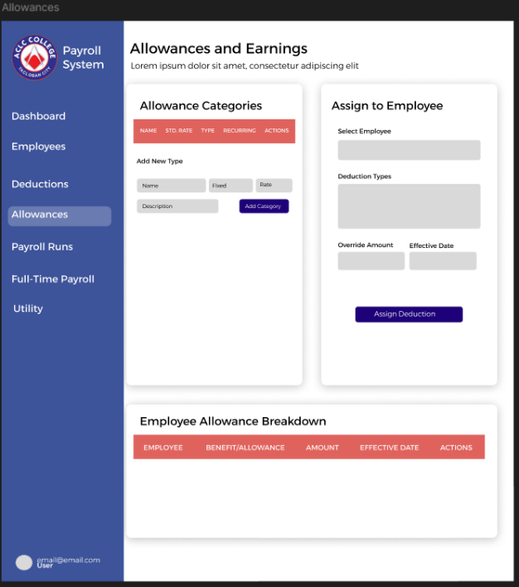

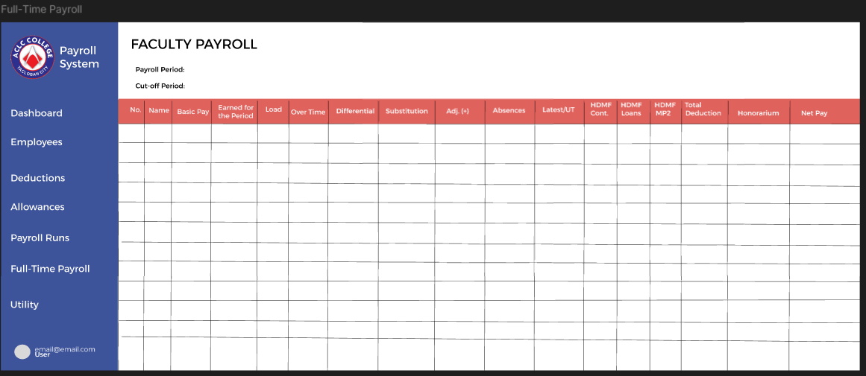

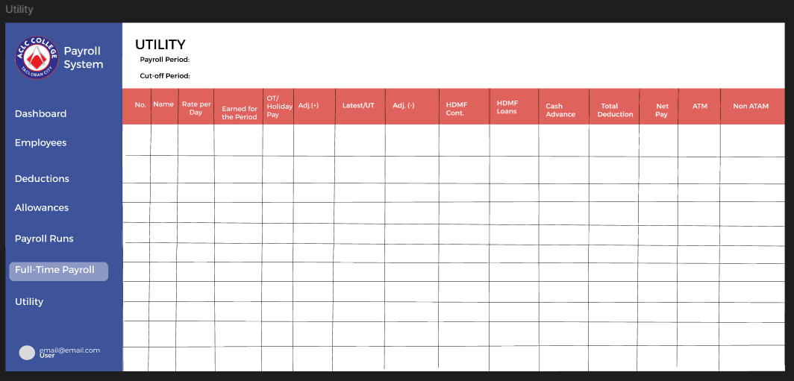

NEXT WEEK PLAN:
• Start frontend development using HTML, CSS, and JavaScript

REMARKS:
Strong teamwork and collaboration helped ensure consistency and quality in the system’s final design.

