DOCUMENTATION REPORT

PROJECT TITLE: ALM Biometric Attendance Payroll System for ACLC College of Tacloban

TEAM NAME: BIOMETRICS INTEGRATION
TEAM MEMBERS:
- Marcellano, Jane
- Santos, Vannah Maie
- Besa, Lourence
- De Veyra, Lica Yzabelle
- Lorica, Khen Mariel
- Padel, Ruffa Mae
- Samar, Angelyn

WEEK NUMBER: Week 5
COVERAGE PERIOD: April 9 – 11, 2026

WEEKLY SUMMARY:
This week focused on stabilizing payroll modules and improving biometric registration. The payroll system was refined with corrected labels, synchronized backend alerts, and enhanced feedback for deductions and allowances. The biometric enrollment process was redesigned into a clearer “Face Registration” module with improved styling and stable capture flow. The team also worked on wireframes for the biometric kiosk pages in the system, such as the “Select Company” page, and the kiosk page.

TASK TRACKER (I) _________________________________________________________

Task Name: Payroll Module Consistency, Biometrics UI Redesign & Face Blocking
Description: Improving the consistency of payroll management modules and enhancing the user interface for the biometric registration process.

Assigned To: Marcellano, Jane C.
Start Date: April 9, 2026 (Thursday)
Target Date: April 9, 2026 (Thursday)
Status: Completed

Daily Updates
- Resolved an issue where deduction and allowance categories occasionally failed to appear by updating navigation logic in script.js.
- Updated api.php to return descriptive success messages for adding, saving, and deleting deductions or allowances.
- Integrated alert notifications in script.js to provide immediate user feedback upon successful data operations.
- Fixed a labeling error in allowances.php where "Deduction Types" was incorrectly displayed in the allowance section.
- Redesigned registration instructions in biometrics.php into a prominent "box type" layout; renamed the module to “Face Registration” and removed duplicate text.
- Stabilized the enrollment flow to prevent broken states during face capture and added comprehensive styling in style.css with indigo themes and clear success/fail feedback.

Output / Proof:
- Modifies files: api.php, script.js, style.css, allowances.php, biometrics.php.
- Redesigned UI: New instruction-box.bow-type layout in the Face Registration module.
- Improved UX: Enhanced feedback mechanisms for successful and failed enrollments.
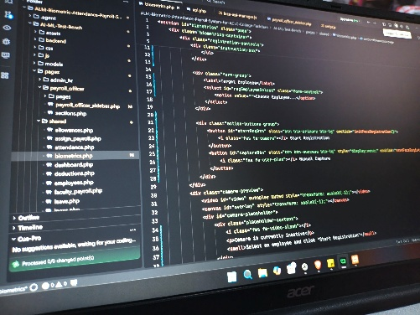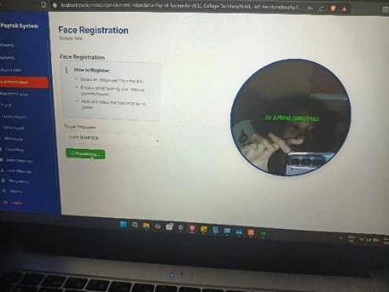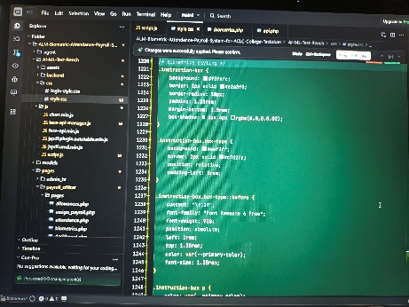

Issues:
- Deduction and allowance categories occasionally failing to render during page switches.
- Incorrect labeling in the allowance assignment section of allowances.php.
- Lack of descriptive success confirmation for backend data operations.
- Face enrollment UI redundancy: duplicate text and unclear instructions.
- Enrollment flow instability: broken states during face capture and submission.
- Poor enrollment UX: insufficient feedback for successful/failed attempts.

Resolution:
- Implemented re-rendering logic in script.js to ensure data visibility during navigation.
- Corrected UI labels to accurately reflect allowance categories.
- Synchronized backend messaging with frontend alerts to confirm successful updates.
- Fixed face enrollment UI redundancy by removing duplicate text, clarifying instructions, and renaming the process to “Face Registration”.
- Ensured enrollment flow stability to prevent broken states during capture and submission.
- Improved enrollment UX by implementing clearer feedback for successful and failed enrollment attempts.

TASK TRACKER (II)_________________________________________________________

Task Name: Kiosk Figma (High Fidelity)
Description: Created a high-fidelity wireframe kiosk interface on the “Select Company” page.

Assigned To: De Veyra, Liza Yzabelle / Samar, Angelyn
Start Date: April 10, 2026 (Friday)
Target Date: April 10, 2026 (Friday)
Status: In Progress

Daily Updates
- Initiated high-fidelity prototyping in Figma to establish a production-ready visual standard, with the focus on developing the kiosk component. Meticulously designed interactive elements to ensure precision, intuitive usability, and responsiveness, creating a professional interface aligned with system goals. This includes the “Select Company” page, where users choose between organizations. Special attention was given on the layout, guiding users clearly through the process while maintaining a clean, user-friendly design that supports reliability in a kiosk environment.

Output / Proof:
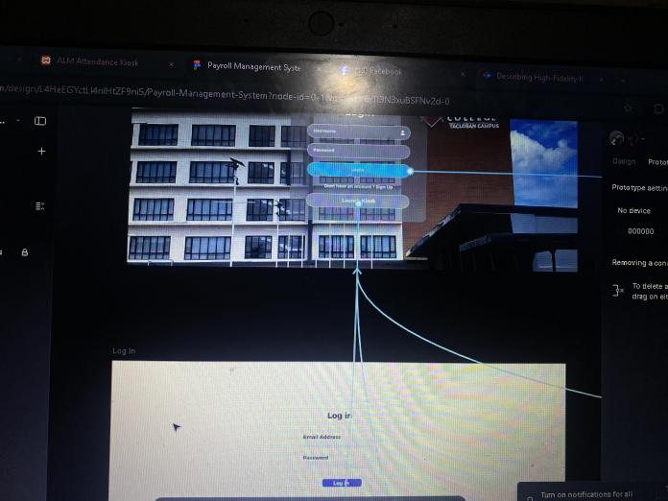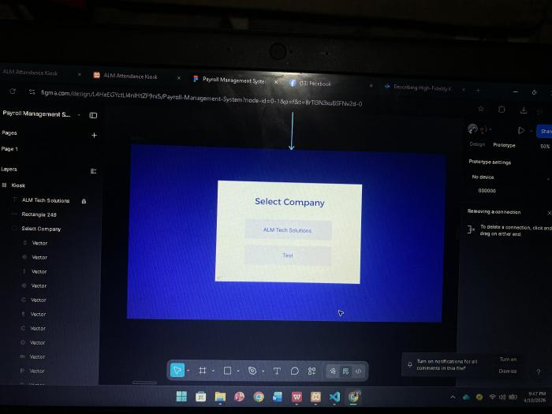
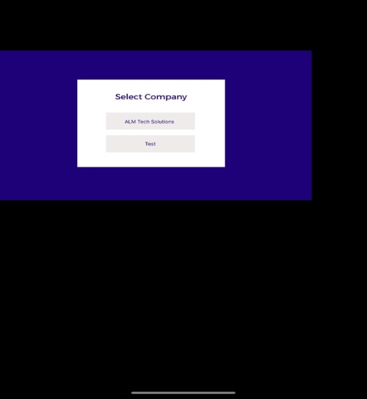

Issues:
- N/A

Resolution:
- N/A

TASK TRACKER (III)________________________________________________________

Task Name: KIOSK UI (High Fidelity)
Description: Designed a high-fidelity wireframe for the kiosk page, focusing on a split-screen layout that integrates an AI loading module with a real-time employee summary and status clock.

Assigned To: Lorica, Khen Mariel / Padel, Ruffa Mae
Start Date: April 10, 2026 (Friday)
Target Date: April 11, 2026 (Saturday)
Status: In Progress

Daily Updates
- Finalized the visual layout for the main kiosk interface, ensuring a clean separation between the biometric/AI scanning area and the data summary panel. Then, also integrated functional UI elements like the digital clock and attendance counters to improve user feedback during the check-out process.

Output / Proof:
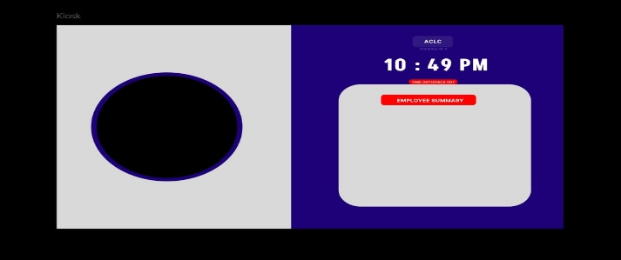

Issues:
- N/A

Resolution:
- N/A
_________________________________________________________________________

TEAM CONTRIBUTION:
- Jane, Marcellano > 1 task > Completed
- De Veyra, Lica Yzabelle > 1 task > In progress
- Lorica, Khen Mariel > 1 task > In Progress
- Samar, Angelyn > 1 task > In Progress

NEXT WEEK PLAN:
- (TBA…)

