DOCUMENTATION REPORT

PROJECT TITLE: ALM Biometric Attendance Payroll System for ACLC College of Tacloban

TEAM NAME: BIOMETRICS INTEGRATION
TEAM MEMBERS:
- Marcellano, Jane
- Santos, Vannah Maie
- Astacaan, Gian
- Besa, Lourence
- De Veyra, Lica Yzabelle
- Lorica, Khen Mariel
- Padel, Ruffa Mae
- Samar, Angelyn

WEEK NUMBER: Week 3
COVERAGE PERIOD: March 26 – 28, 2026

WEEKLY SUMMARY:
On the third week, the team focused on improving the biometric kiosk’s accuracy and stability. The team successfully integrated the API and fixed the face model, improving the accuracy of facial recognition. Progress was made on face enrollment, while challenges with attendance tracking, and inverted enrollment were addressed through system readjustments. Overall, the week strengthened the kiosk’s core functionalities and moved closer to stable performance.

TASK TRACKER (I) _________________________________________________________

Task Name: Face Model Enhancement and API Integration
Description: Enhanced facial recognition accuracy by fixing the face model and integrating the API.

Assigned To: Marcellano, Jane / Astacaan, Gian / Lorica, Khen
Start Date: March 26, 2026 (Thursday)
Target Date: March 28, 2026 (Saturday)
Status: Completed

Daily Updates
- Day 1: The team were working on fixing the face model and integrating the API, aiming the goal on system accuracy.
- Day 2: Continued on enhancing the facial recognition preview for smoother user interaction.
- Day 3: Identifying errors to further resolve, ensuring stable performance of the biometric kiosk.

Output / Proof:
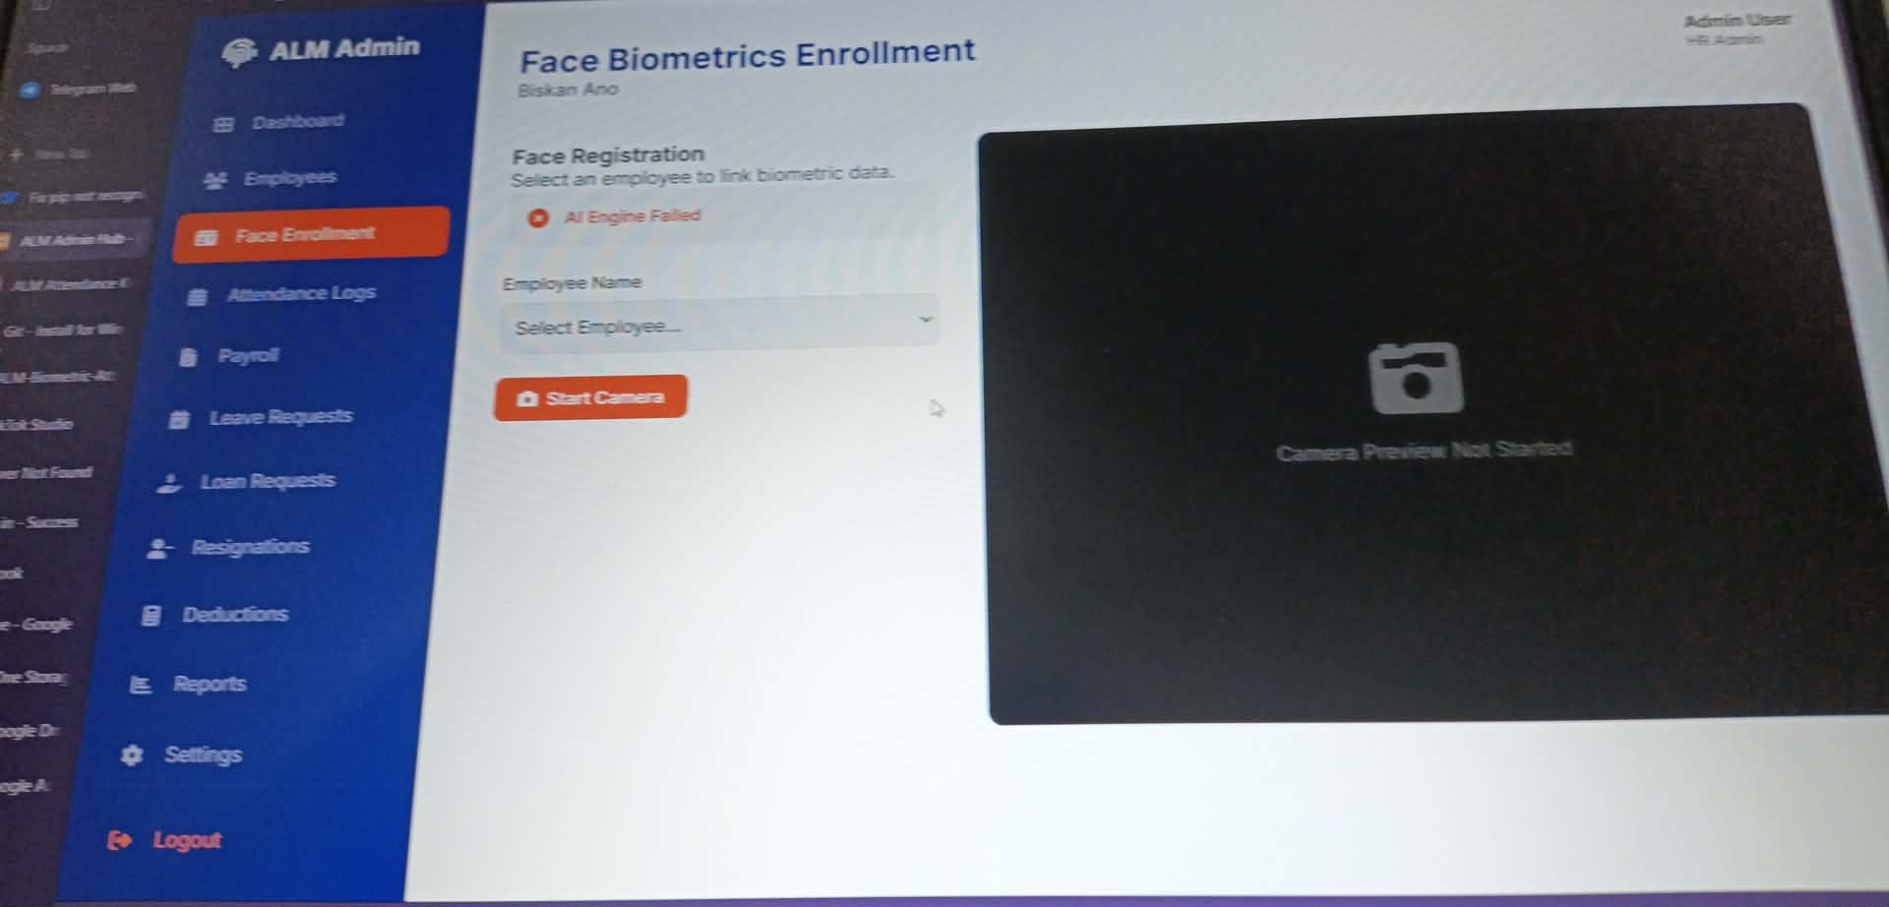
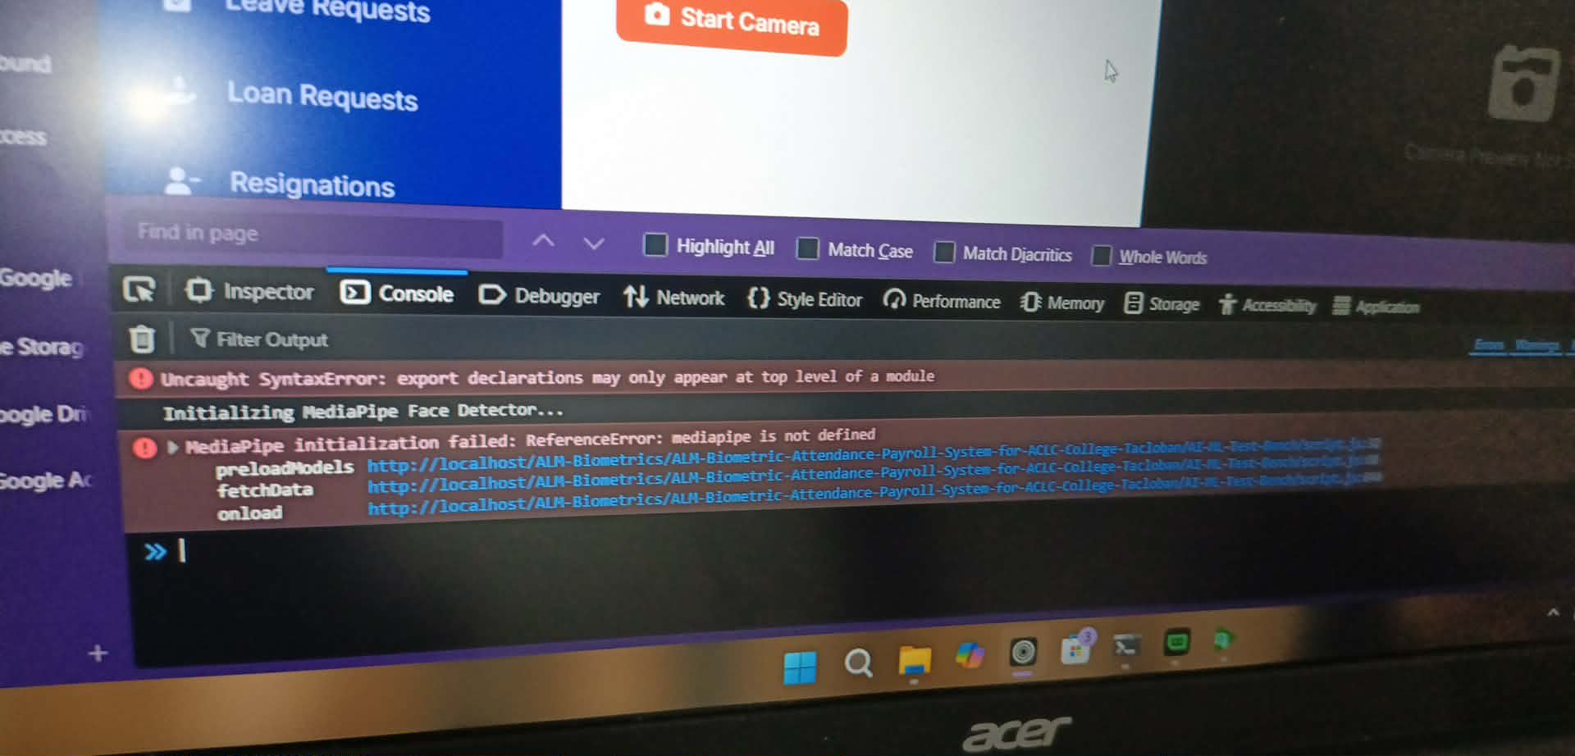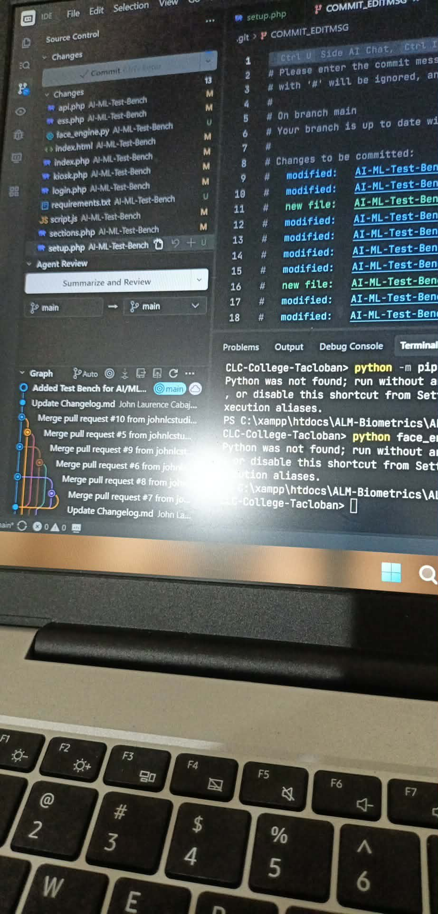

Issues:
- The attendance tracking is not tracking and displaying properly in the system again, including the lunch-In/Out, after some adjustments into the system.
- The facial scanning of the kiosk was temporarily not working.
- Face enrollment got inverted, causing errors in registering facial data properly.

Resolution:
- Finding alternatives and readjustments system to fix the issues.
_________________________________________________________________________

TEAM CONTRIBUTION:
- Marcellano, Jane > 1 task > Completed
- Astacaan, Gian > 1 task > Completed
- Lorica, Khen Mariel > 1 task > Completed

NEXT WEEK PLAN:
- Continue on the kiosk development.
- Further enhance the kiosk’s accuracy to ensure more reliable performance.
- Refine attendance tracking to provide better monitoring.
- Focus on overall system enhancements and add improvements to strengthen functionality.

