PROJECT TITLE: ALM Biometric Attendance Payroll System Management
TEAM NAME: BACKEND
WEEK NUMBER: Week 5
COVERAGE PERIOD: April 6, 2026 – April 11, 2026
WEEKLY SUMMARY:
During Week 5, the backend team worked on focusing audit logging, pagination, timezone handling, and backup/restore functionality. Progress was slowed early in the week due to repository merge delays and local Git issues, which required re-cloning before development could begin. The audit trail logging and pagination features were implemented but remain unfinished pending testing and validation. Significant progress was achieved in timezone standardization, successfully ensuring consistent UTC-based timestamp handling across all system operations. The backup and restore module still in progress, with initial functionality working but requiring fixes for query execution and file upload limitations. Overall, the team demonstrated adaptability despite technical setbacks, but several critical features still need completion and testing. The next step is to finalize unfinished tasks and transition into Week 6 development.
TASK TRACKER:
Task Name: Audit Trail Logging
Description: Implement immutable audit logs tracking who changed settings, ran payroll, enrolled face, and approved/denied leave or loans. Logs must be tamper-proof and traceable per user action.
Assigned To: Jasmine L. Guillena
Start Date: April 7, 2026
Target Date: April 11, 2026
Status: Complete
Daily Updates:
- Day 1 (Apr 7): Task was distributed and assigned. Decided to hold off on any implementation until the repository merge was finalized on April 9.
- Day 2 (Apr 8): No action taken. Continued waiting for the repository to be updated before touching any code.
- Day 3 (Apr 9): Repository was updated with all merged changes. Re-cloned the repository from GitHub due to previous local commit/merge issues to ensure a clean and stable starting point. New backend tasks were also identified and distributed on this day. No implementation started yet.
- Day 4 (Apr 10): Unable to work due to a computer access issue — the machine would not allow login. Was also experiencing a fever and could not proceed with any tasks.
- Day 5 (Apr 11): Completed the Audit Trail implementation. Immutable logs are now in place tracking user actions including settings changes, payroll runs, face enrollment, and leave/loan approvals and denials.
Output / Proof:
api.php:

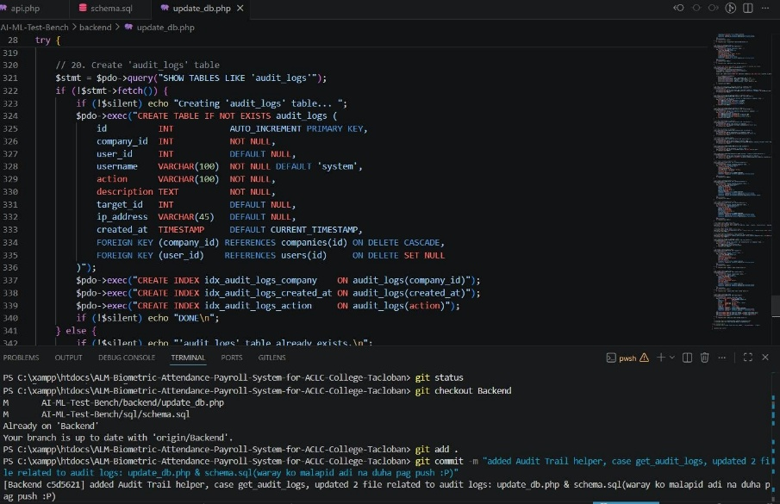
update_db.php:

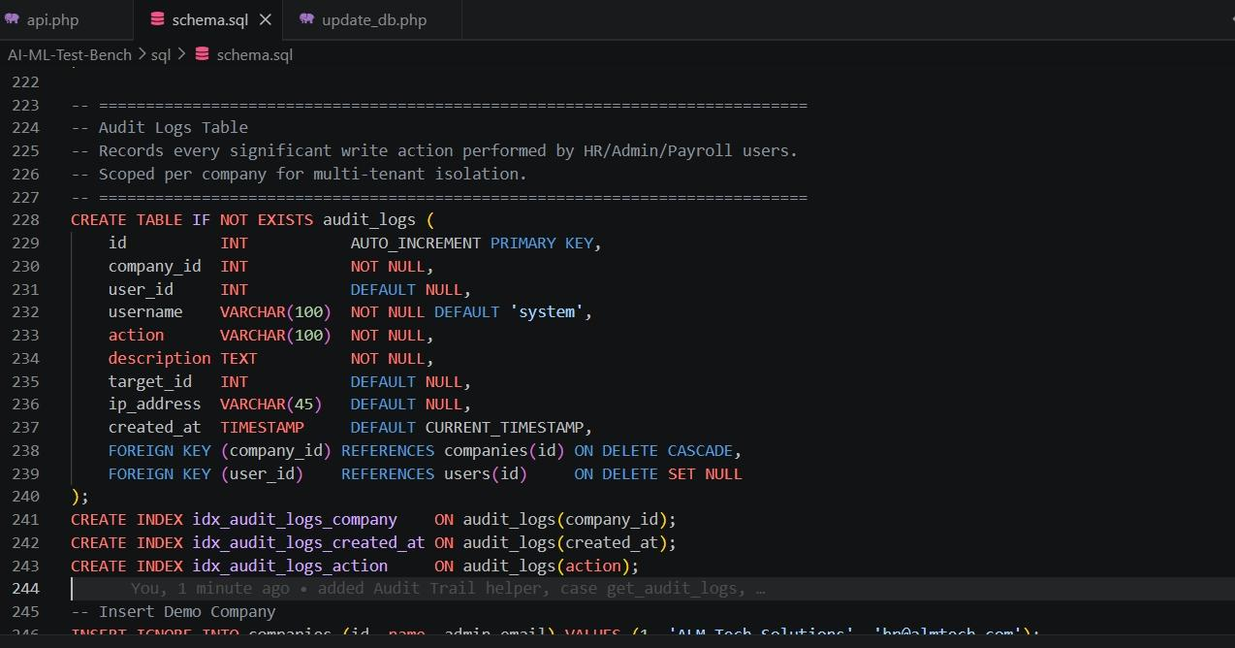
schema.sql:

Issues: Delayed start due to waiting for the repository merge on April 9. Encountered local commit/merge issues requiring a re-clone of the repository. On April 10, was unable to work due to computer login/access issues and illness (fever).
Resolution: Re-cloned the repository after the merge to ensure a stable environment. Recovered on April 11 and completed the full implementation of the audit trail feature.

TASK TRACKER:
Task Name: Pagination & Query Optimization
Description: Adding pagination & query optimization in api.php & script.js
Assigned To: CHRISTIAN KERR ABUDA
Start Date: April 9, 2026
Target Date: April 11, 2026
Status: In Progress
Daily Updates:
- Day 1 (Apr 9): Merged the updated repository to my local repository. Reviewed existing API endpoints and planned pagination structure for employee, attendance, and payroll modules. Coordinated the backend codes to finalize the query optimization approach.
- Day 2 (Apr 10): Implemented pagination logic and integrated it with the frontend display. Updated data-fetching functions to handle page navigation and record limits. Conducted initial interface testing to confirm correct data flow.
- Day 3 (Apr 11): Completed testing and validation. Verified that pagination displays accurate record counts, navigation buttons work properly, and page information updates dynamically. The task is complete, but still waiting for the rollback of the branch before pushing in backend branch.
Output / Proof:
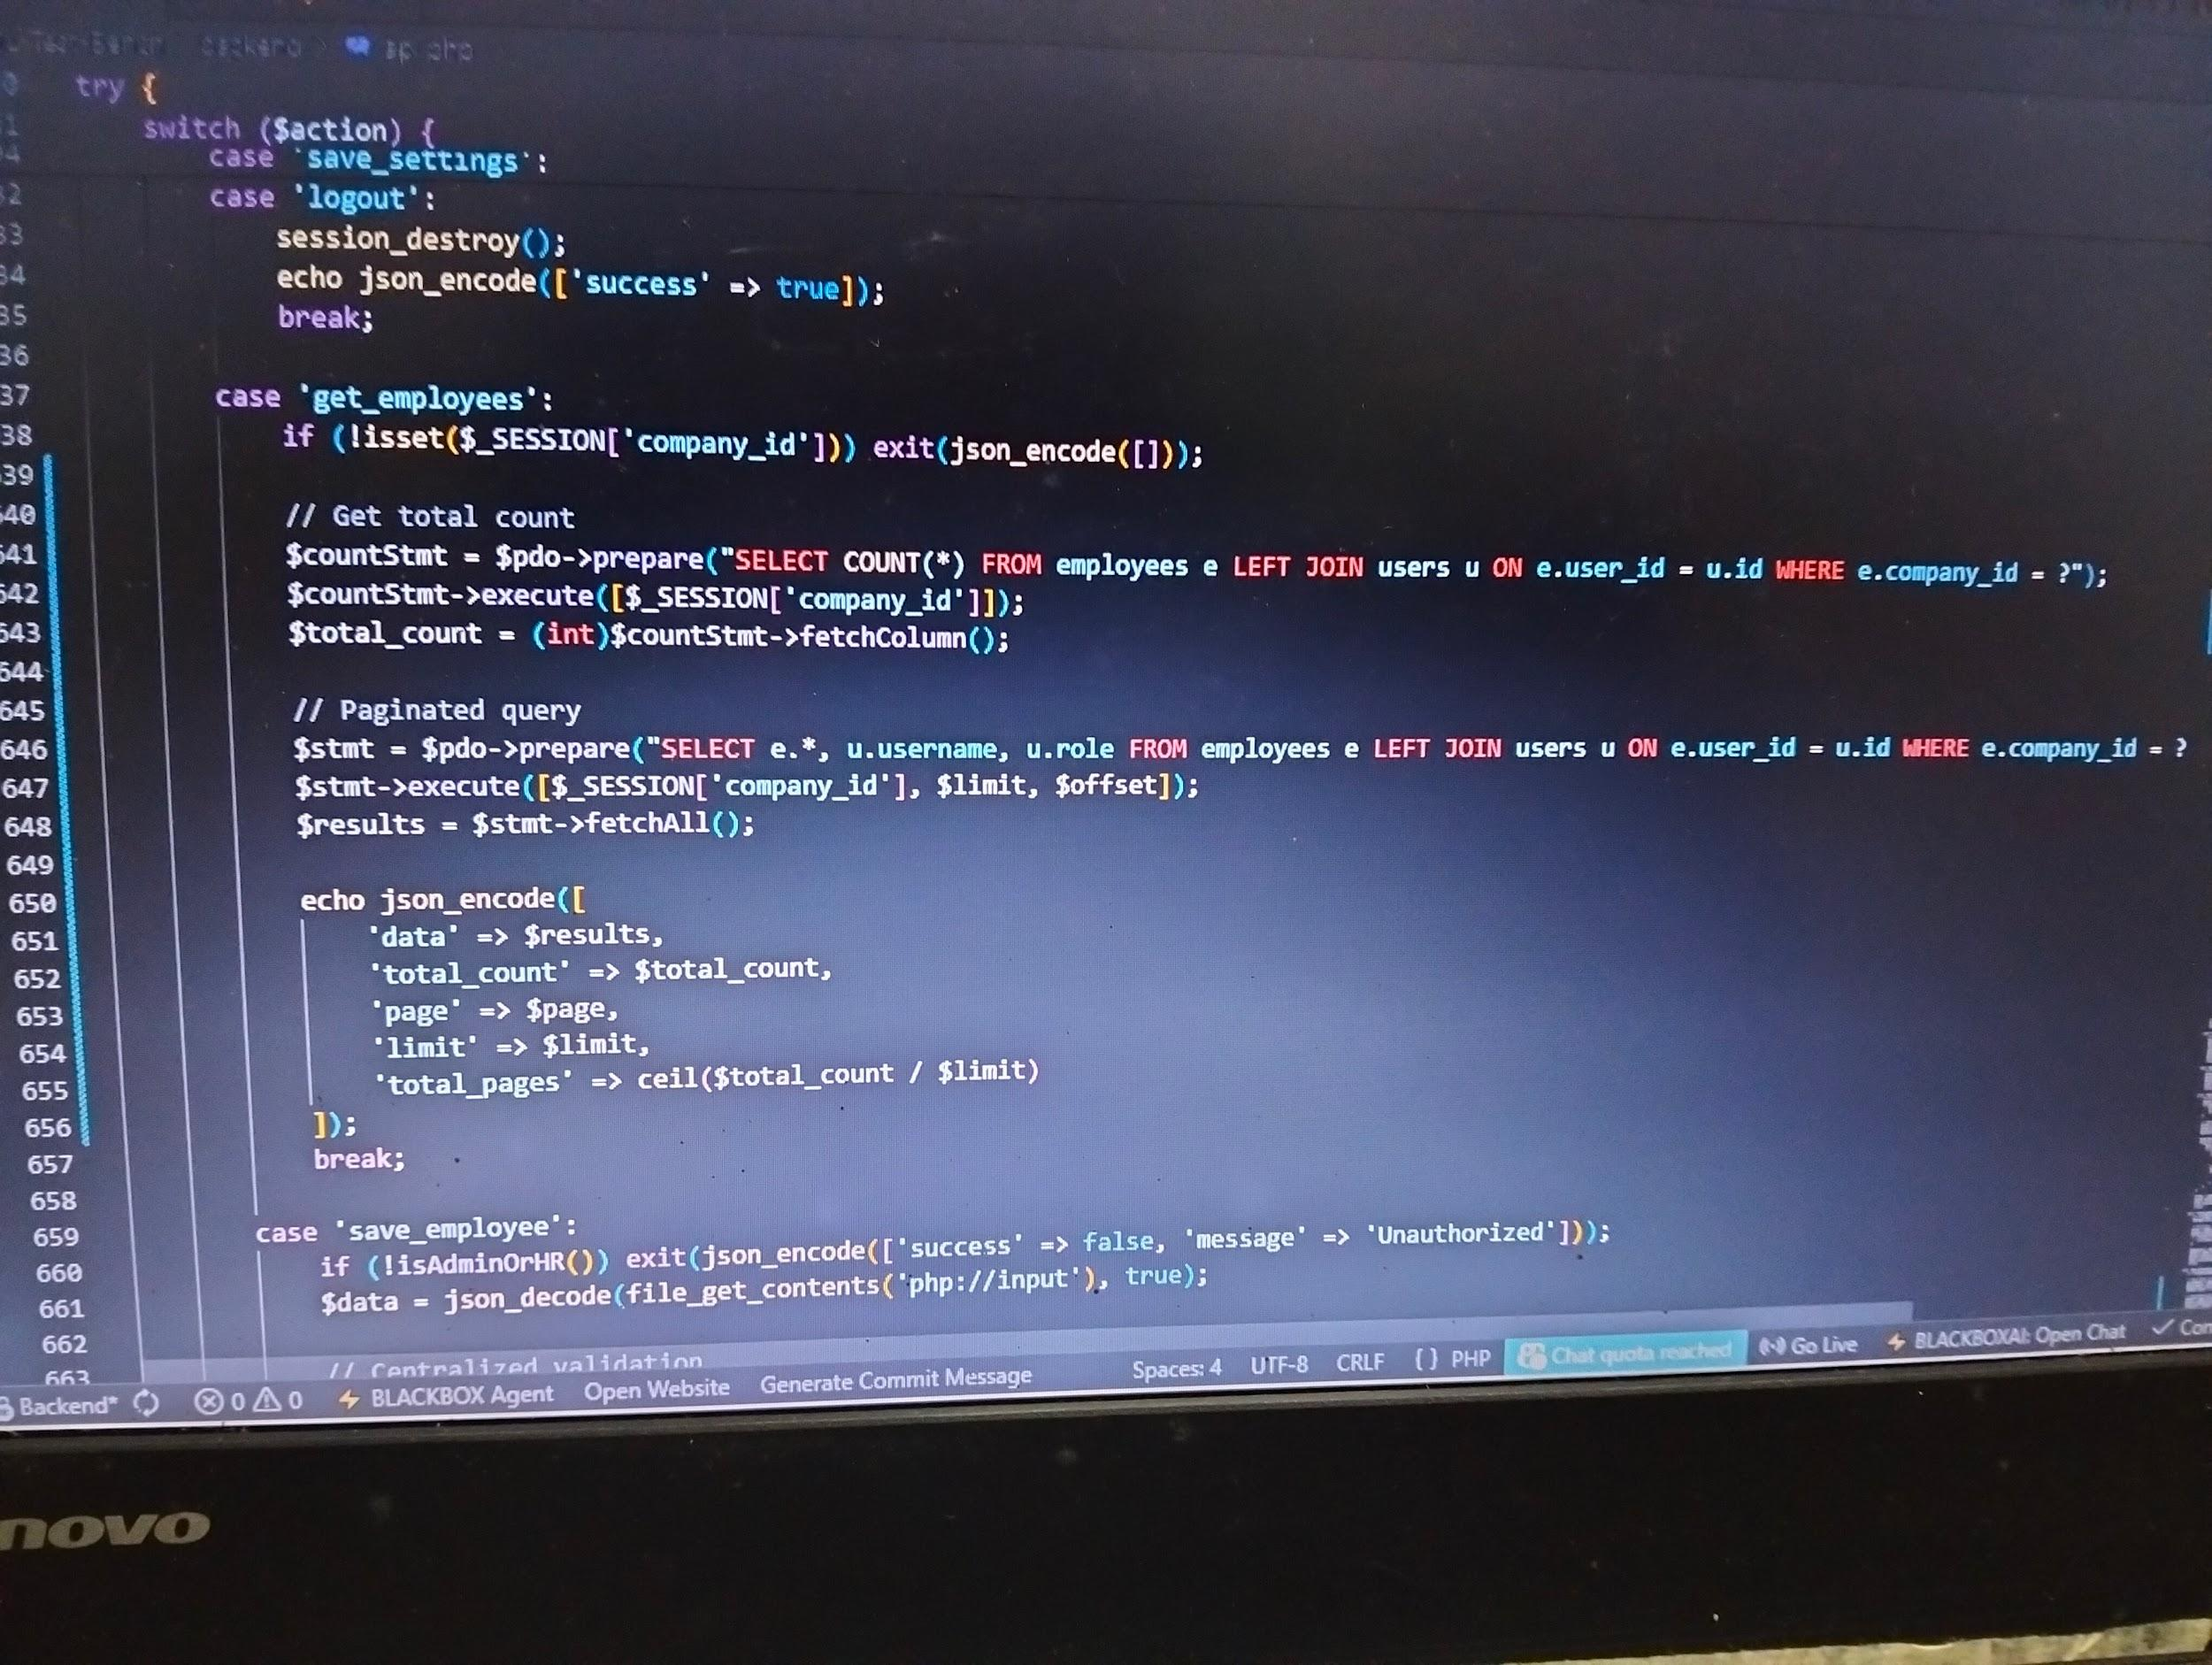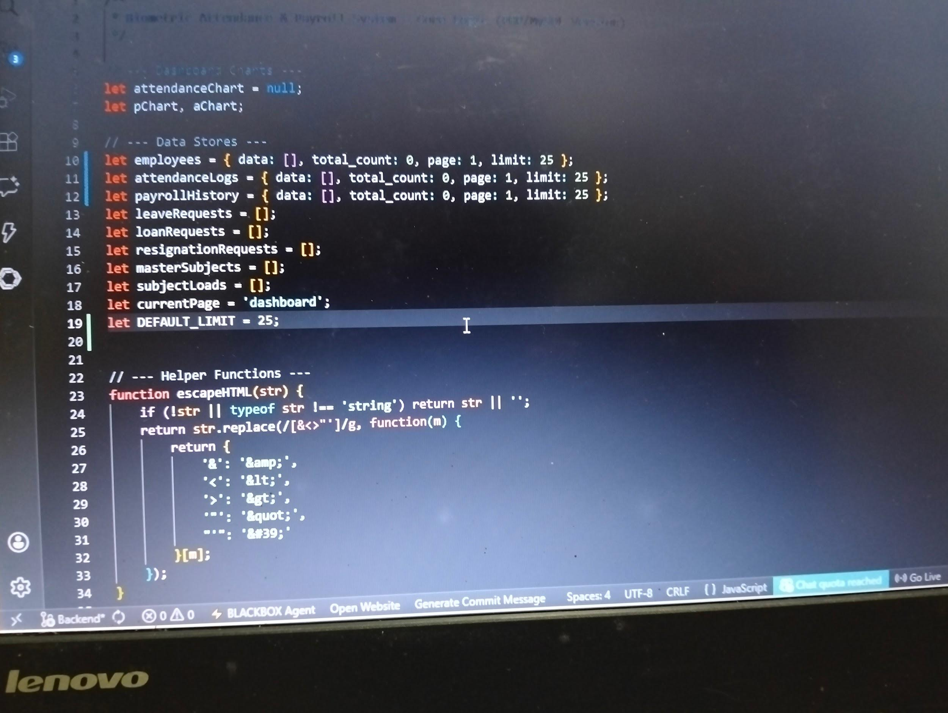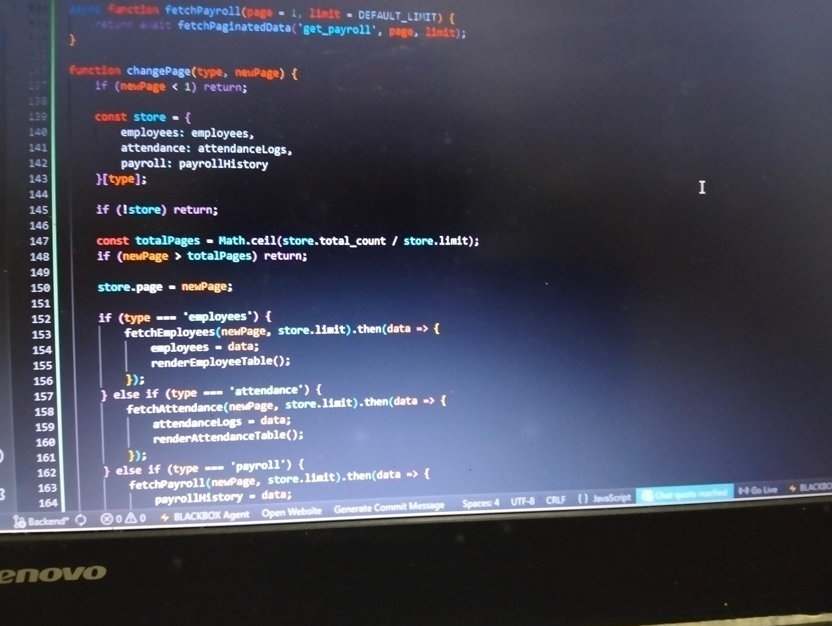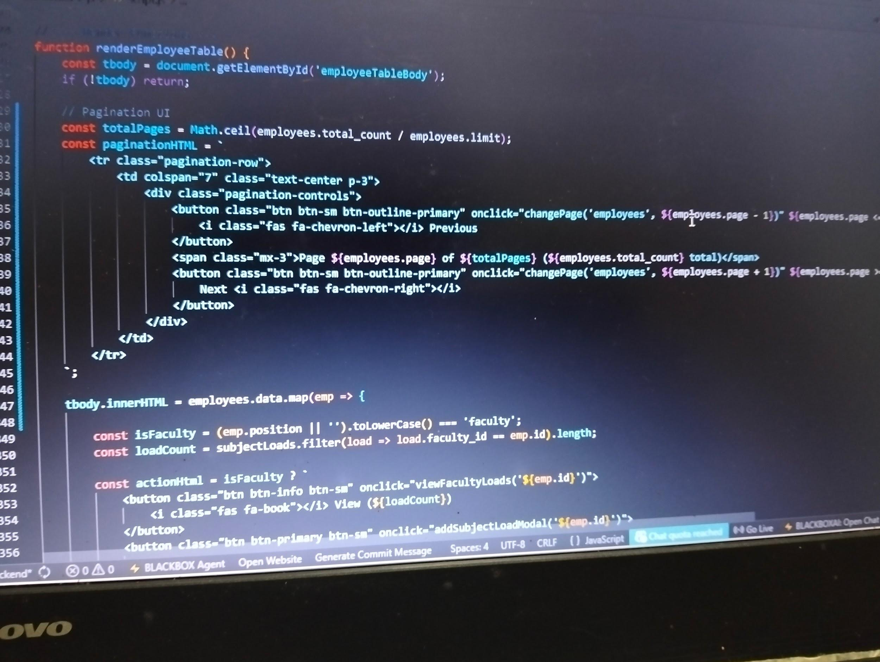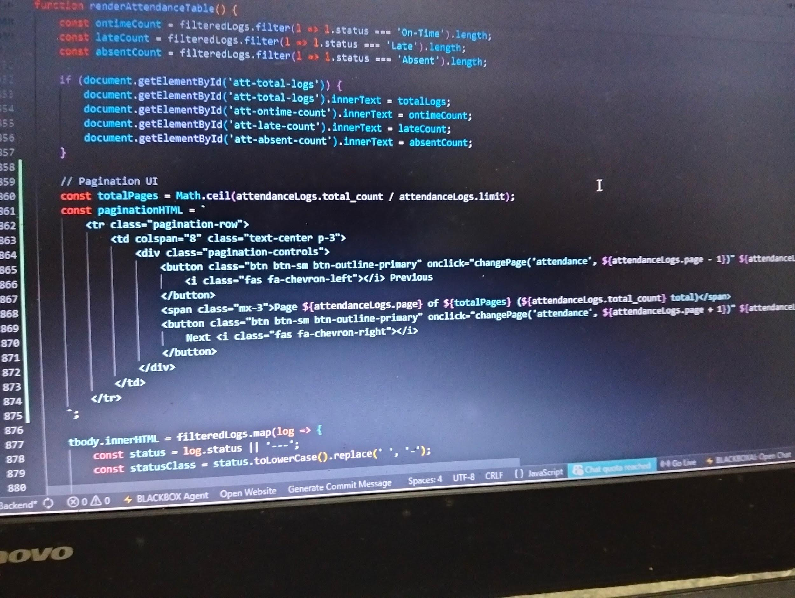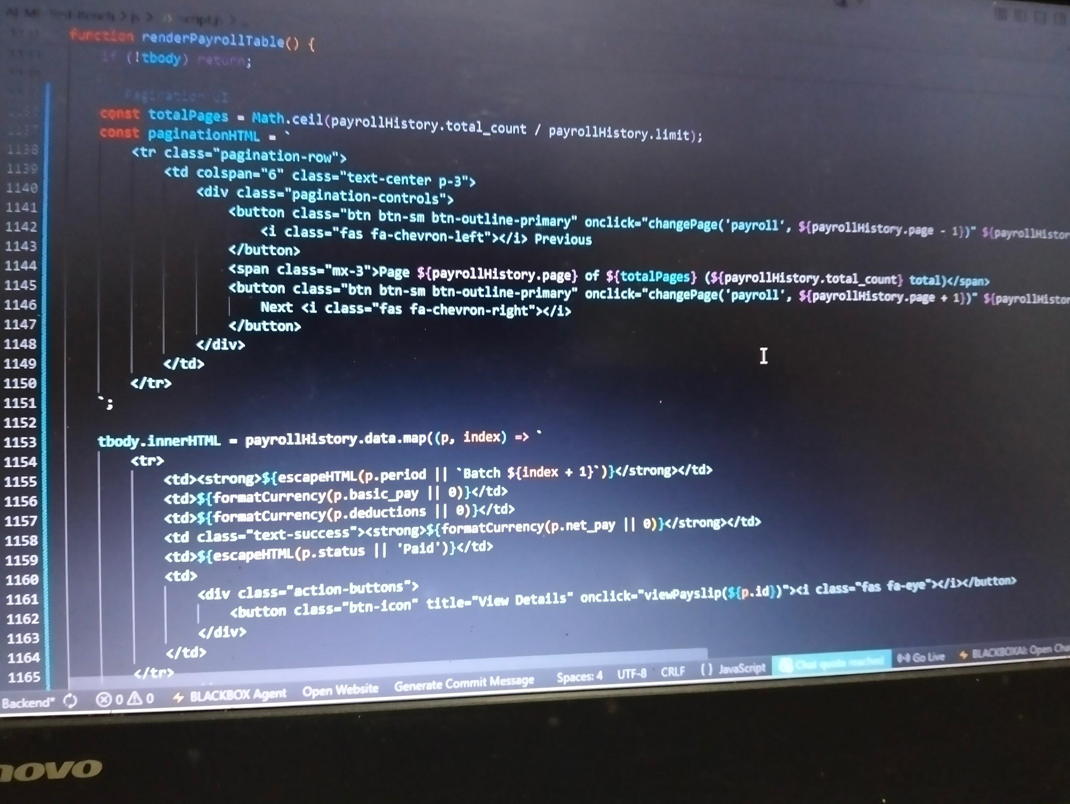
Issues: Minor confusions on testing. The task and target date initially mismatched with the start date on the documented report.
Resolution: The pagination feature for employee, attendance, and payroll modules was successfully implemented and validated, ensuring accurate data display, smooth navigation, and optimized query performance. The task is finalized and currently pending branch rollback before deployment to the backend branch.

Task Name:P1 Timezone standardization: set server timezone + store timestamps consistently; avoid client-time dependency
Description:
Timezone handling was standardized across the system by setting UTC as the global server timezone and introducing helper functions to manage conversions between UTC and company-specific timezones for accurate data storage and display. The login process now applies the company timezone to each user session, ensuring consistency, while the kiosk scan feature was enhanced to properly handle ISO-8601 timestamps, convert client times, and validate time windows correctly. Core functionalities such as payroll, allowances, deductions, dashboard statistics, and server time retrieval were also updated to use the new timezone system, eliminating dependence on client-side time, improving accuracy in attendance and payroll calculations, and enabling reliable multi-timezone support.
Assigned To: Magsanay, Christian A.
Start Date: April 9, 2026
Target Date: April 9, 2026
Status: Complete
Daily Updates:
- Day 1: Implemented UTC as the global server timezone and added helper functions for timezone conversion. Updated login session handling to apply the company timezone immediately. Modified the kiosk scan process to properly convert client timestamps and validate time windows using the company timezone. Updated related API cases (allowances, deductions, dashboard stats, and server time) to use the new helper functions and ensure consistent timestamp storage and display.

Output / Proof:
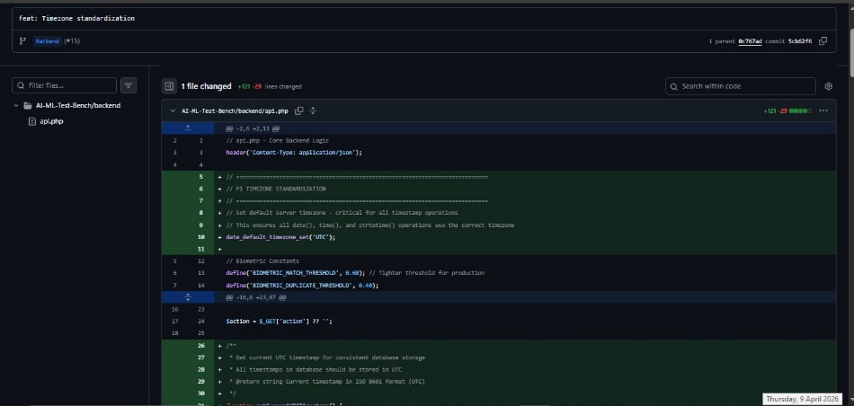
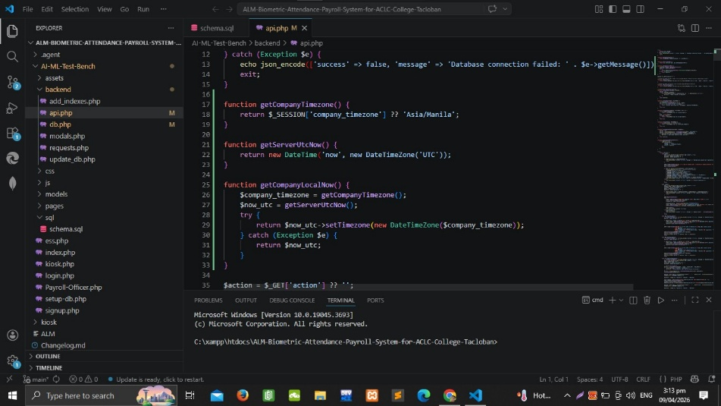
Issues: Some client devices sent timestamps in different formats (e.g., ISO 8601 with timezone offsets), which caused inconsistencies during initial processing.
Resolution: Implemented timestamp detection and conversion logic to normalize all incoming client timestamps into UTC before processing, then convert them to the company timezone when needed for validation or display.

Task Name: Backup/restore tooling: scheduled backups, download/export, restore verification
Description: A secure backend script (backup.php) is designed to automatically back up critical tables (employees, attendance, payroll) into timestamped .sql files stored in /backups/, provide admin-only endpoints for downloading/exporting backups, and support restoring uploaded .sql files with verification checks (table existence and non-zero rows), returning a clear integrity report — all restricted to authenticated administrators for controlled access.
Assigned To: Sheila Mae B. Comandao
Start Date: April 10, 2026
Target Date: April 11, 2026
Status: in progress
Daily Updates:
- Day 1: Drafted initial backup.php file with backup, download, restore, and verification endpoints.Tested basic backup creation — confirmed .sql dump file is generated and saved in /backups/.Began trial runs of download and restore endpoints to see how they behave.Still learning and experimenting with restore execution (multi_query handling, flushing results).Checking file upload limits and permissions for restore endpoint.Reviewing verification logic to ensure row counts and table existence checks are reliable.
- Day 2: Fixed code for SQL download/export handling. Implemented createBackup() function with both CLI (php backup.php or php backup.php backup) and web (?action=backup) triggers. Used SHOW TABLES to list tables, applied company_id = ? filter, and generated dump content via PDO (CREATE TABLE + INSERT statements). Configured output to save as gzipped file (../backups/backup_YYYYMMDD_HHMMSS.sql.gz). Verified filename/path return and ensured admin-only access for download/export endpoint.
- Day 3: Added db.php and session handling, enforced strict isAdminOnly() role check. Finalized createBackup() for CLI/web, saving gzipped dumps. Built Download Endpoint for .sql.gz retrieval, Restore Endpoint for uploads with transaction execution, and verifyRestore() for table/row checks. Added router for CLI vs web output and utility helpers. Edited sitting.php to include a Download SQL button linked to backup.php?action=download.
- Output / Proof:
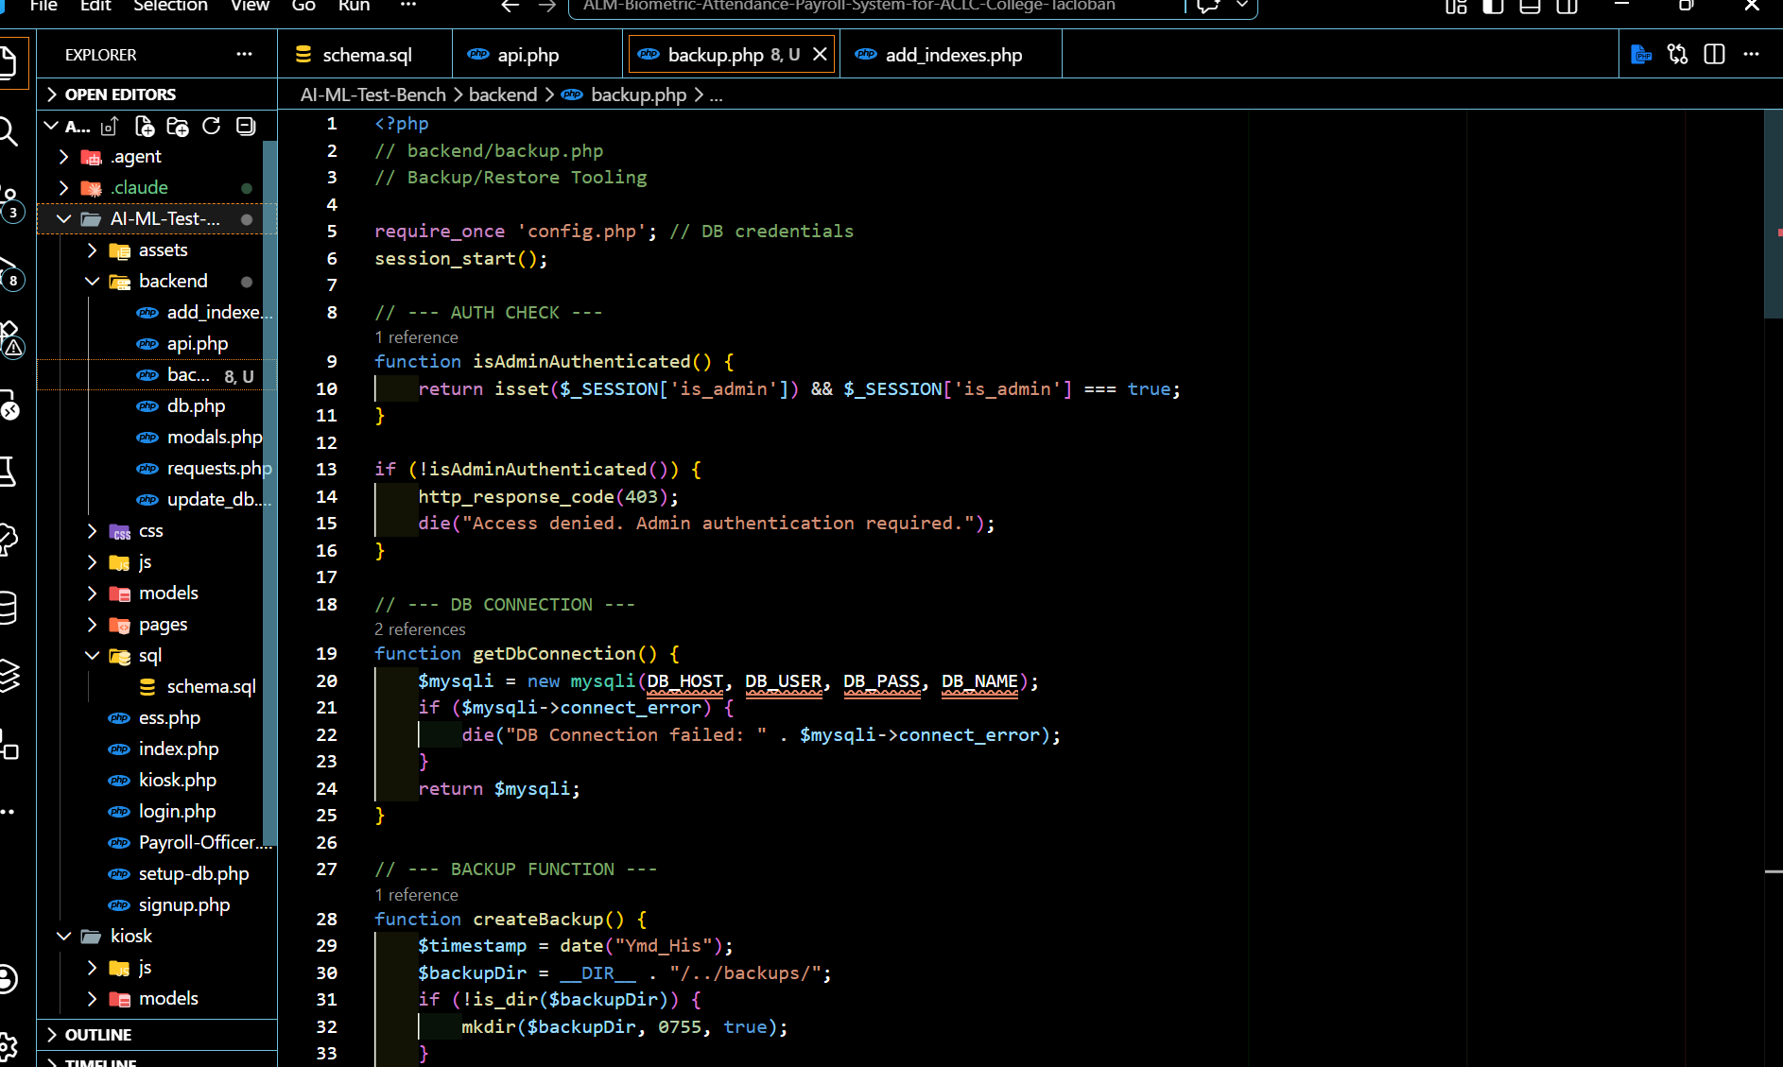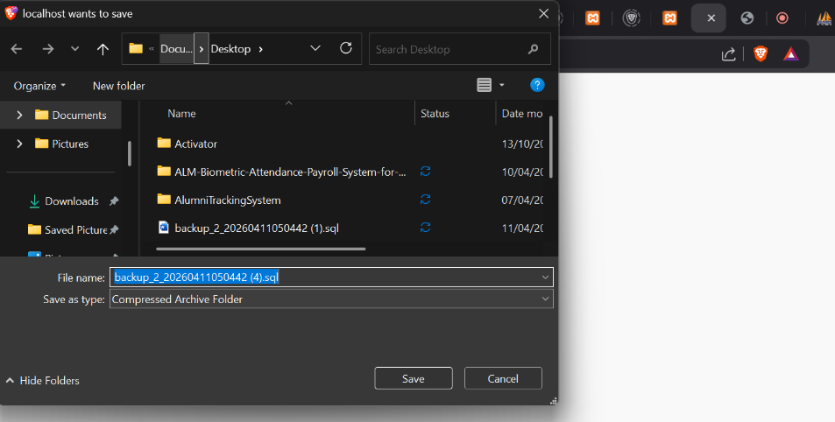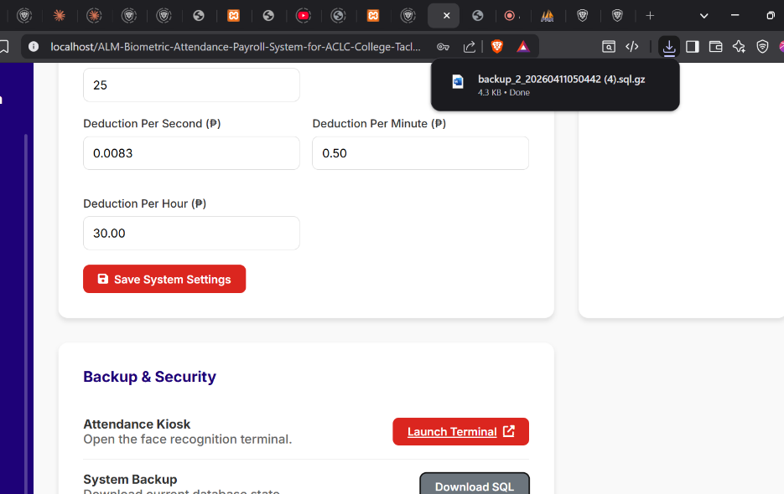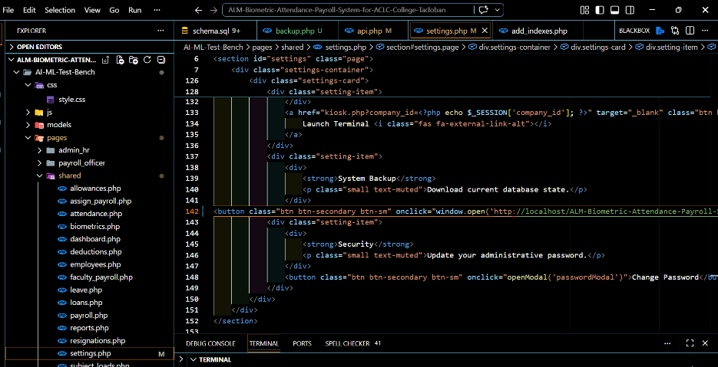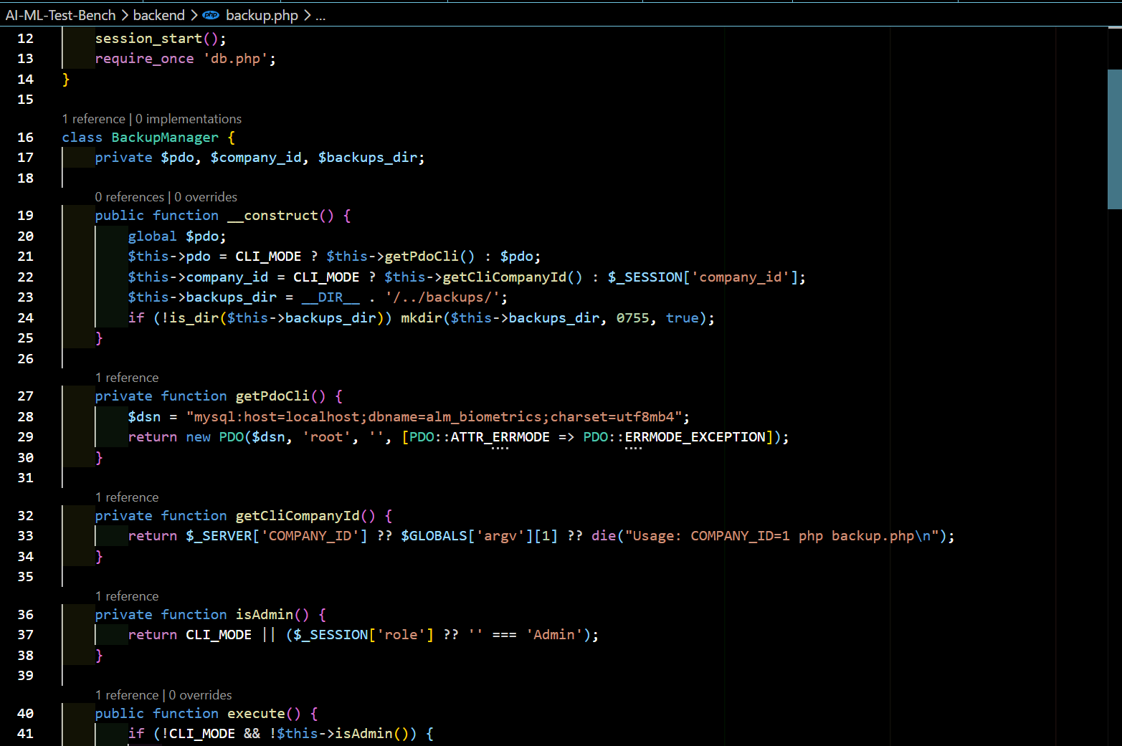
Issues Issue:
The backup/restore tooling encountered difficulties with secure restore handling. Using PDO for multi-query execution, enforcing strict role authentication, and applying company_id filtering added complexity. At the same time, safe upload validation, transaction rollback on failure, and post-restore verification checks were required to prevent corruption and ensure integrity. These combined challenges made the implementation more complex and required careful coding to maintain consistency, security, and reliability.
Resolution Resolution:
The restore and backup issues were solved by standardizing database operations with PDO, enforcing strict role checks (isAdminOrHR()), and applying company_id filters for multi-tenant isolation. Uploads were validated, restores wrapped in transactions with rollback on failure, and verification checks ensured table existence and row counts. These measures secured the endpoints and guaranteed reliable backup/restore integrity.

TEAM CONTRIBUTION:
- Guillena, Jasmine L. (Backend Team Leader) → 1 tasks → 0 completed, 1 in progress.
- Abuda, Christian Kerr → 1 tasks → 0 completed, 1 in progress.
- Magsanay, Christian A. → 1 tasks → 1 completed, 0 in progress.
- Comandao, Sheila Mae B. → 1 task → 0 completed, 1 in progress.
- Alkuino, Michael Jose P. (Document)
NEXT WEEK PLAN:
- Continuation of unfinished week 5 tasks then proceed to week 6 tasks.
REMARKS:
The backend team made steady progress despite challenges with limited internet access, showing strong collaboration and adaptability during development. However, several core functionalities are still incomplete and will require further refinement in the succeeding phase.

