PROJECT TITLE: ALM Biometric Attendance Payroll System Management
TEAM NAME: Backend
WEEK NUMBER: Week 4
COVERAGE PERIOD: March 30,2026 – April 4, 2026
WEEKLY SUMMARY:
During Week 4, the team successfully completed multiple high-priority improvements, including security audits, payroll validation, data integrity, and system reliability enhancements led by Jasmine L. Guillena, Christian Magsanay, Christian Kerr Abuda, and Shiela Mae Comandao. Following team restructuring, remaining tasks were reassigned to ensure continuity, focusing on audit trails, timezone standardization, query optimization, and backup systems. Additionally, Michael Jose Alkuino was appointed as the team documentator, responsible for reporting, issue tracking, and ensuring accountability across all members.
TASK TRACKER:
Task Name:
- **P0** Payroll correctness validation: unit-test payroll formulas (absences, late, OT, allowances, deductions, loans), consistent period handling.
- **P0** “Latest period” + filtering consistency: standardize period keys, add “latest” fetch patterns to avoid empty exports/pages.
Description:
This task focuses on improving the payroll module of the system by adding additional logic, implementing calculation validation, and ensuring that payroll-related data is handled consistently. The work involves verifying the correctness of payroll formulas and ensuring that all components such as employee attendance data, deductions, overtime, and allowances are properly calculated within the payroll system.
Another key objective is to ensure that the payroll period filtering functions correctly across different sections of the system. By standardizing the period format and implementing a mechanism to automatically retrieve the most recent payroll period, the system will avoid displaying empty results when generating payroll summaries, reports, or export files.
The task also includes modifying backend logic inside the API layer to handle payroll computations and date validation more accurately. These improvements help ensure that payroll data is reliable, calculations are accurate, and the payroll interface functions smoothly for both administrators and users.

Assigned To: Magsanay, Christian A.
Start Date: April 4, 2026
Target Date: April 4, 2026
Status: complited
Daily Updates:
- Day 1: Implemented additional logic in the payroll module of the system to improve calculation accuracy and system functionality. This involved editing and updating the api.php file to integrate payroll computation logic and ensure that formulas for absences, late penalties, overtime pay, allowances, deductions, and loan adjustments are processed correctly.
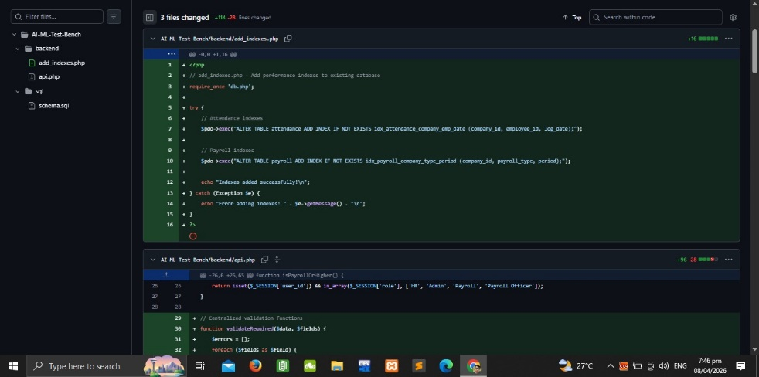
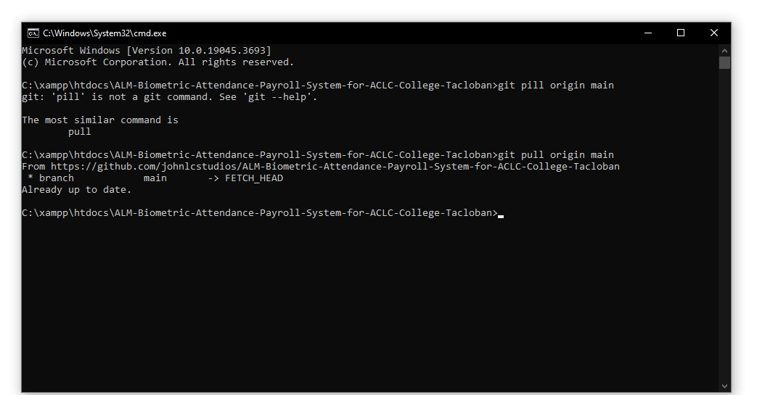
Output / Proof:

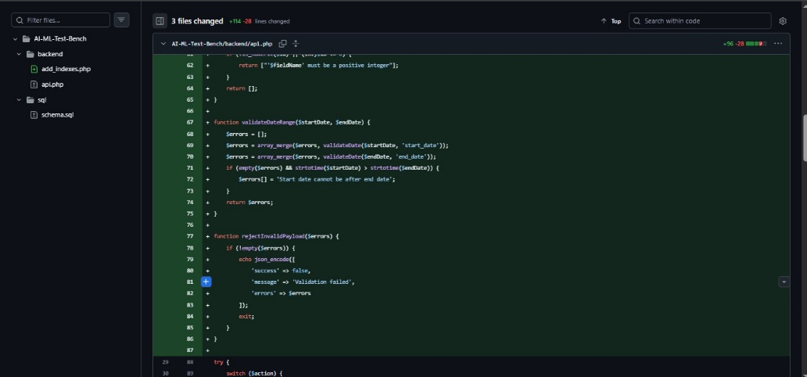

Issues: The system initially did not accept the inputted payroll date even though the date entered was valid. This caused problems when generating payroll records because the system could not properly identify or match the payroll period.

Resolution: Additional validation logic was implemented inside the api.php file to properly handle date inputs and ensure that valid dates are accepted by the system. The new logic standardizes the payroll period format and ensures that the system correctly processes and stores payroll dates. After implementing these changes, the payroll module successfully accepted valid dates and functioned as expected.
TASK TRACKER:
Task Name: Input Validation Standard & Database Indexing
Description: (1) Input validation standard: centralized validation for dates, amounts, IDs; reject invalid payloads; consistent JSON shape. (2) Database indexing: company_id + employee_id + period + log_date indexes for attendance/payroll queries.
Assigned To: CHRISTIAN KERR ABUDA
Start Date: April 3, 2026
Target Date: April 6, 2026
Status: Completed
Daily Updates:
- Day 1:
- Day 2:
- Day 3:
- Day 4:
I haven't started yet. I notified Guillena and Alkuino regarding my issues. Can't work with a laptop, still looking for urgent alternatives. The PC will arrive by next week. Horizontal Lines, Black Screen laptop.
Update: 7:35 PM - Borrowed a laptop; 7:50 PM - Started working on a task, not finished yet.
- Day 5:
Overview
The changes focus on two main areas: Input Validation and Database Indexing, as requested.

1. Input Validation Standard (api.php)
Purpose
To centralize and standardize input validation across API endpoints, ensuring consistent error handling, rejecting invalid payloads, and maintaining a uniform JSON response shape for validation failures. This prevents malformed data from entering the system and provides clear feedback to clients.

Changes Made
- New validate Helper Function: Added around lines 30-40 (after requireAccess or "$field is required").
- Accepts an array of data and validation rules.
- Support rules: required, email, date (YYYY-MM-DD), amount (numeric), int, numeric, id (positive numeric).
- Returns an array of error messages if validation fails.

- Validation Calls in Case Statements:
- case 'signup' (around line 60): Validates company_name, username, email, password.
- case 'save_employee' (around line 550): Validates fullName, dob, email, position, department, basicSalary.
- case 'save_settings' (around line 970): Validates company settings fields like companyName, workStart, workEnd, etc.
- Error Response Format: On validation failure, returns JSON: {"success": false, "message": "Validation failed", "errors": ["field is required", ...]}.
2. Database Indexing (schema.sql)
Purpose
To optimize database query performance for the multi-tenant biometric attendance and payroll system. Indexes on foreign keys, employee IDs, periods, and log dates speed up common queries like attendance lookups, payroll calculations, and employee searches.

Changes Made
- ALTER TABLE ADD INDEX Statements: Added at the end of the file (around lines 210-220, after all CREATE TABLE statements).
- Indexes added for tables: users, employees, attendance, payroll, leave_requests, loans, resignations, deductions, allowance_categories, employee_allowances, employee_deductions, subjects, subject_loads.
- Key indexes include:
  - attendance: company_id, employee_id, log_date (for attendance queries).
  - payroll: company_id, employee_id, period (for payroll processing).
  - Foreign key indexes on company_id and employee_id across tables.
  - Fixes: Corrected a trailing comma in the subject_loads table FOREIGN KEY block and ensured all indexes are properly defined.
3. Runtime Index Creation Logic (update_db.php)
Purpose
To ensure indexes are created dynamically in existing databases when the update script runs. This makes the system idempotent, allowing safe upgrades without manual SQL execution.

Changes Made
- Index Creation Block: Added around line 60 (after the resignations table creation, as no holidays table exists).
- Uses SHOW TABLES LIKE to check table existence.
- Uses SHOW INDEX to verify index presence.
- Executes ALTER TABLE ADD INDEX if the index is missing.
- Covers all indexes from schema.sql, with a focus on company_id, employee_id, period, and log_date.

Brief Conclusion

- Input Validation (api.php): Added a centralized validate() helper function that enforces data quality checks (required fields, email format, date format, numeric amounts) across critical API endpoints like signup, save_employee, and save_settings. Invalid inputs now return consistent error JSON responses.
- Database Indexing (schema.sql & update_db.php): Added strategic indexes on company_id, employee_id, log_date, and period columns across all major tables to accelerate attendance and payroll queries. The runtime update logic in update_db.php ensures indexes are created automatically during database upgrades.
Time-ended: (1:10 AM April 04, 2026)

Needs:
Need to be tested, since it needs data or to be run to be visibly known or if there's an error.
P.S. Update lang to. I haven't pushed/committed yet

- Day 6:
What Was Implemented:
Input Validation Standard: Added centralized validate() helper function in api.php with rules for required fields, email, date, amount, int, numeric, and ID validation. Applied to signup, save_employee, and save_settings endpoints with consistent JSON error responses.
Database Indexing: Added strategic indexes on company_id, employee_id, log_date, and period columns across 14 tables in schema.sql. Implemented runtime index creation logic in update_db.php for idempotent database updates.

Time: (7: 30 PM April 05, 2026)
Successfully merged and pushed to the GitHub Backend branch.
Output / Proof:
(Day 4)
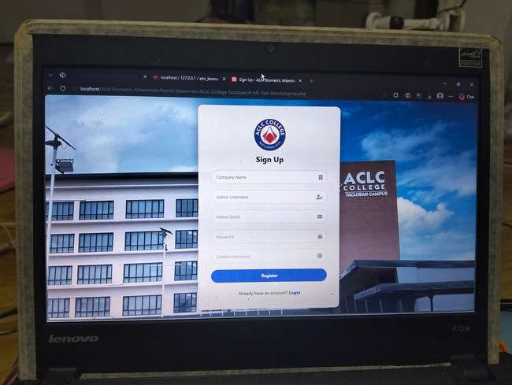
(Day 5 - 1)
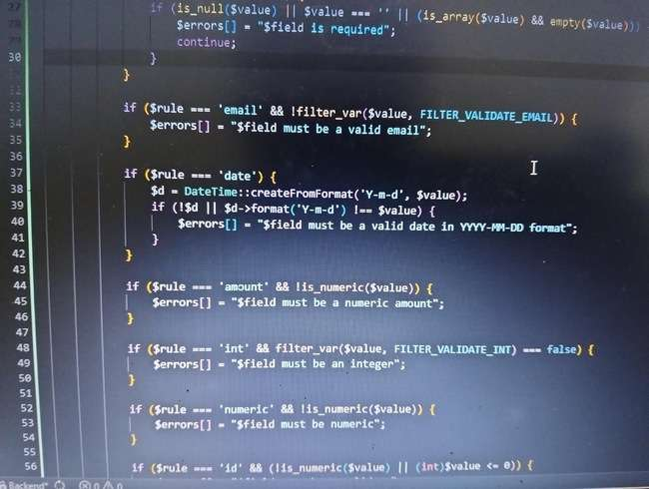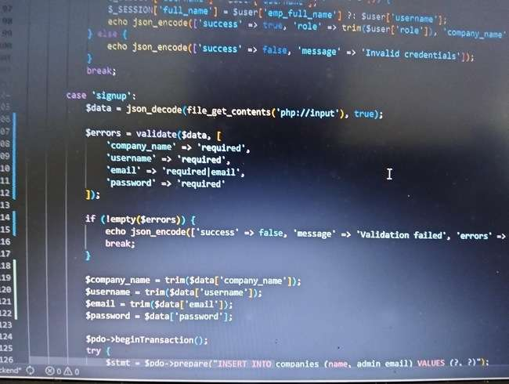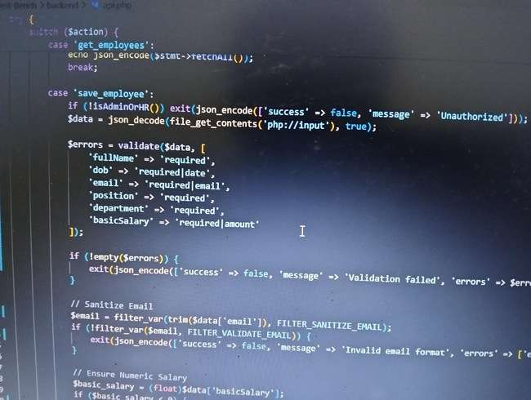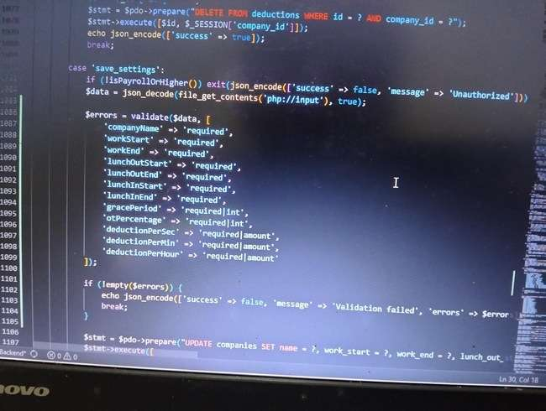
(Day 5 - 2)
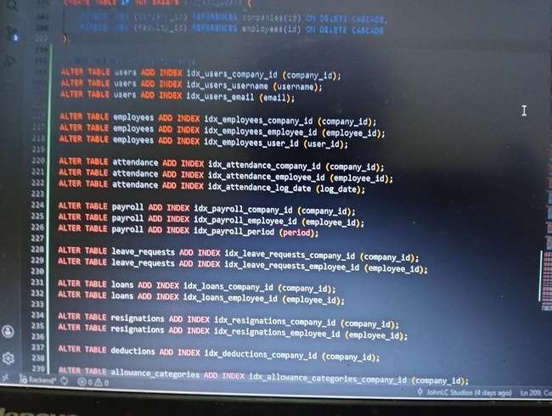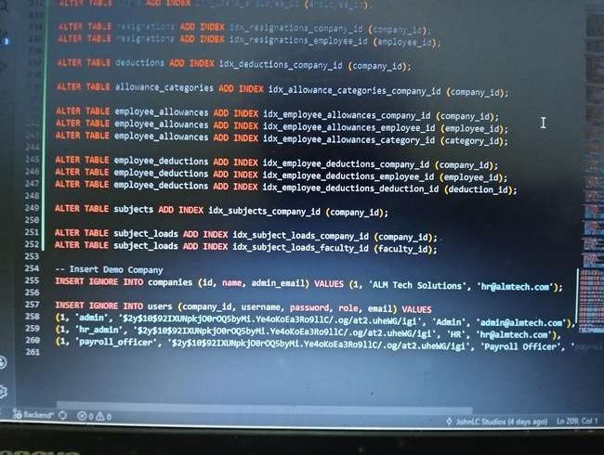
(Day 5 - 3)
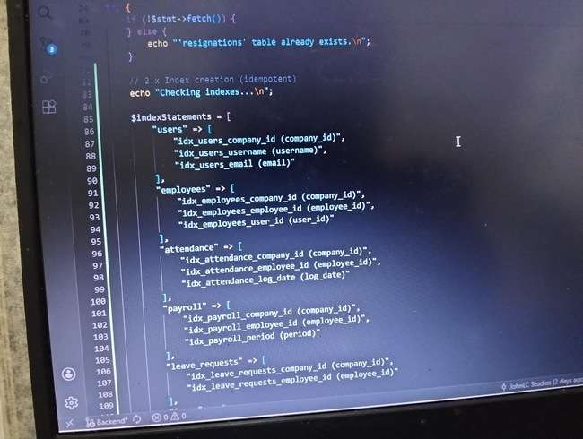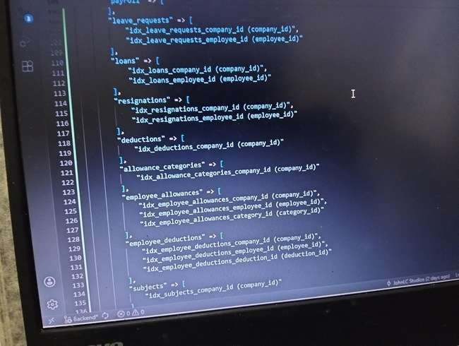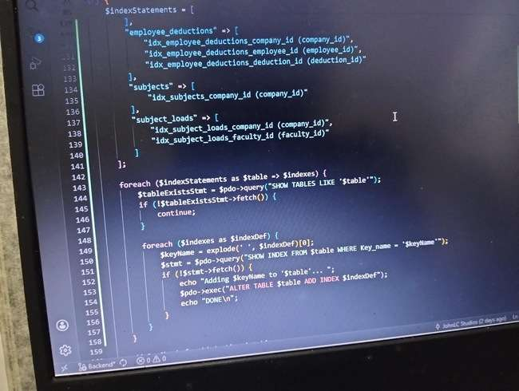
(update_db.php)
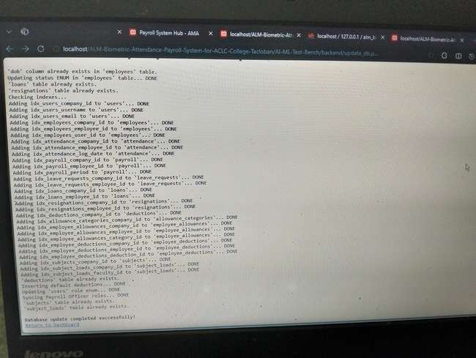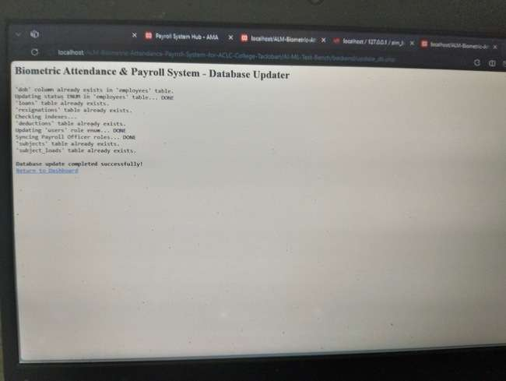

(schema.sql)
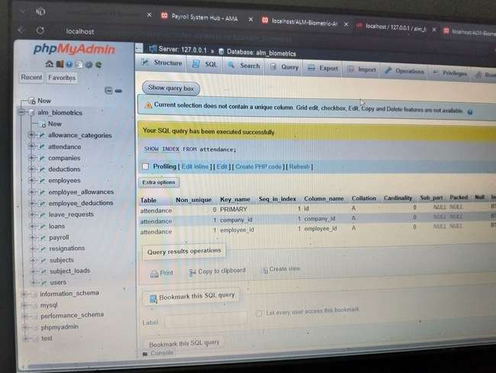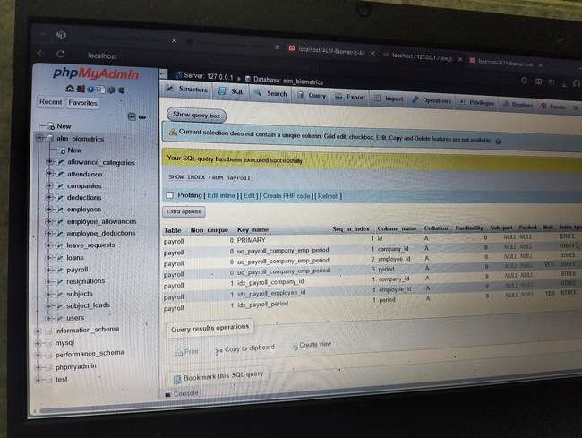

(git add. | git commit | git push origin Backend)
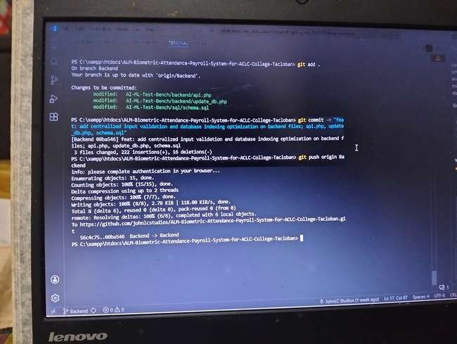
TASK TRACKER: WEEK4
Task Name: Reliability: better error messages, retry-safe idempotent endpoints for payroll runs, rate limiting for kiosk scans.
Description: Enhance backend security and user experience in AI-ML-Test-Bench/backend/api.php by implementing rate limiting and production-ready error handling.
Assigned To: Sheila Mae B. Comandao
Start Date:04-03-2026
Target Date: 04-06-2026
Status: Completed
Daily Updates:
- Day 1: Reviewed the codebase (~1400 lines). Studied the structure of api.php, identified key endpoints (login, kiosk_scan, bulk allowance/deduction, employee signup), and clarified the assigned reliability tasks.
- Day 2: Tried out code experiments and initial tests. Verified how existing error messages behaved and explored possible rate‑limiting logic. This was a trial phase before actual implementation.
- Day 3: Began implementation. Added rate limiting for login and kiosk_scan endpoints. Implemented error handling improvements for payroll bulk allowance/deduction. Finalized user‑friendly error messages. Updated catch blocks to log $e->getMessage() internally while returning generic “Internal server error” to users. Verified functionality — rate limiting confirmed in kiosk_scan (checkRateLimit('kiosk_scan', 20, 60)) and in login. Pushed changes to GitHub repository.
Output / Proof:
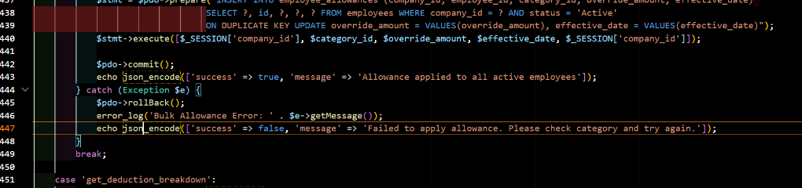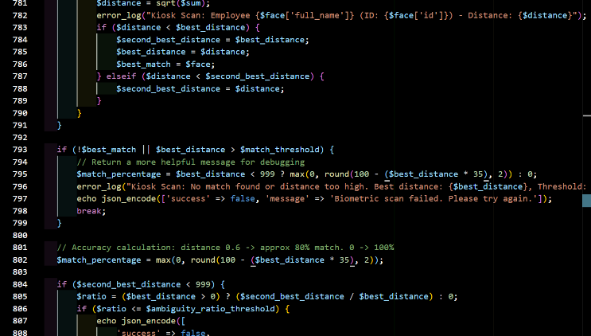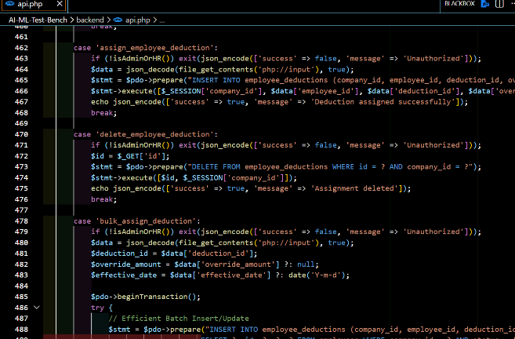
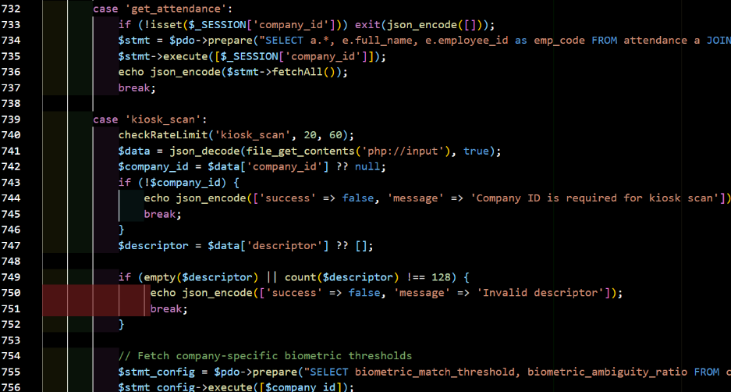
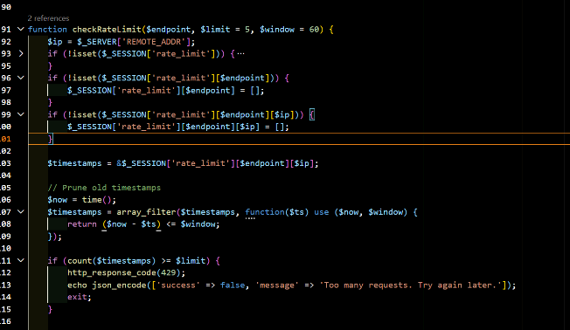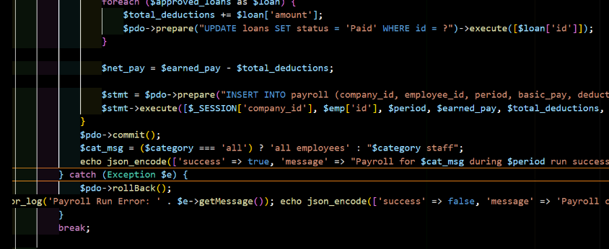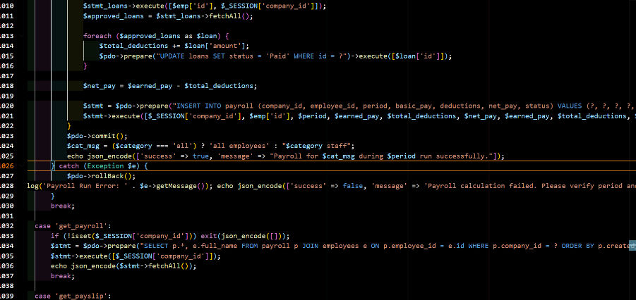
Issues: Initial linter errors when defining checkRateLimit() (resolved by adjusting function placement and syntax).Intelephense flagged undefined function until properly declared before usage.
Resolution: Function defined after helper utilities, session-safe, IP-keyed.Errors resolved, rate limiting and error handling now fully operational.API hardened against brute force and information leakage, while maintaining developer visibility through logs.Reliability improved: better error messages, retry-safe payroll runs, and rate limiting for kiosk scans.Code finalized and pushed to GitHub for version control and collaboration.

TASK TRACKER 1 : Week 4
Task Name: Authorization / RBAC Audit
Description: Implemented a new requireAccess() helper function in api.php to handle rolebased access control. Added calls to this function at the beginning of all case statements that require authorization, restricting API endpoints to authorized user roles only (e.g., Admin, HR, Payroll Officer).
Assigned To: Jasmine Guillena
Start Date: 04/03/26
Target Date: 04/04/26 Status: Completed Daily Updates:
- Day 1: Created a Discord server for the Backend Team, distributed tasks, learnt how to clone and access the files in GitHub, downloaded XAMPP for system testing and pasted schema.sql to database. Asked several questions to Cabajaan in order to further understand the task, as well as asked help form the other project leads.
- Day 2: Implemented the requireAccess() function and added authorization calls across all relevant case statements in api.php.
- Day 3: Reviewed changes and held off on pushing to the GitHub repository due to uncertainty about the process and concern about breaking existing code.
- Day 4:Successfully pushed changes to the GitHub repository after gaining confidence in the process and assistance from Project leads.
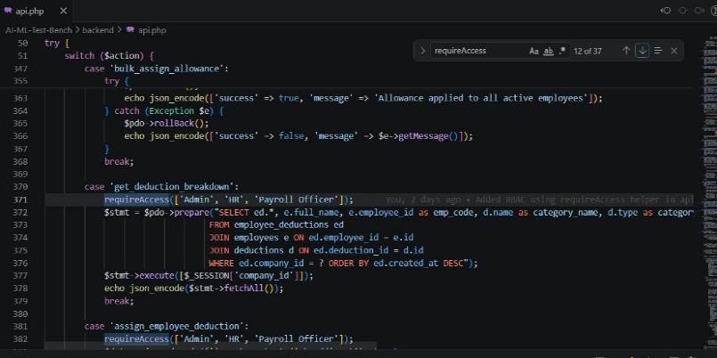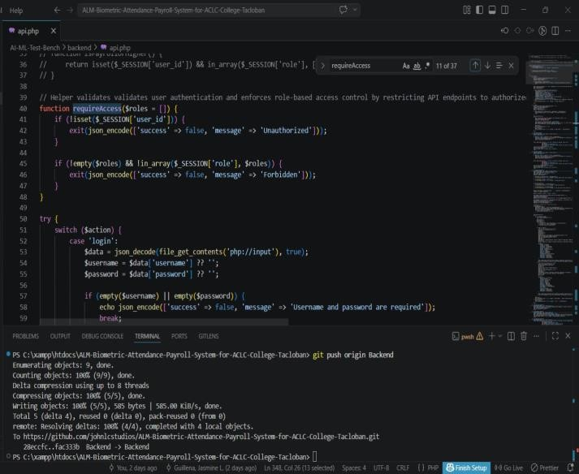
Output / Proof:

Issues: Delayed submission past the target date due to unfamiliarity with GitHub and fear of introducing errors into the shared codebase when pushing multiple changes.
Resolution: Took time to review the changes carefully before pushing. Successfully committed and pushed to the repository on 04/06/2026 with no issues.

TASK TRACKER 2 : Week 4
Task Name: Data Integrity & Transactions
Description: Added PDO transaction blocks (beginTransaction(), try…catch, commit(), rollBack()) around case statements in api.php that perform multiple write operations to ensure data integrity and automatic rollback on failure. Cases covered: signup, run_specialized_payroll, bulk_assign_allowance, bulk_assign_deduction, revoke_payroll_access, save_employee, and save_face_descriptor.
Assigned To: Jasmine Guillena
Start Date: 04/06/26
Target Date: 04/06/26 Status: Completed Daily Updates:
• Day 1: Audited all relevant case statements in api.php. Confirmed that most cases already had transaction blocks in place. Identified save_face_descriptor as the only missing implementation and applied the transaction wrapper. Pushed all changes to the GitHub repository.
Output / Proof:
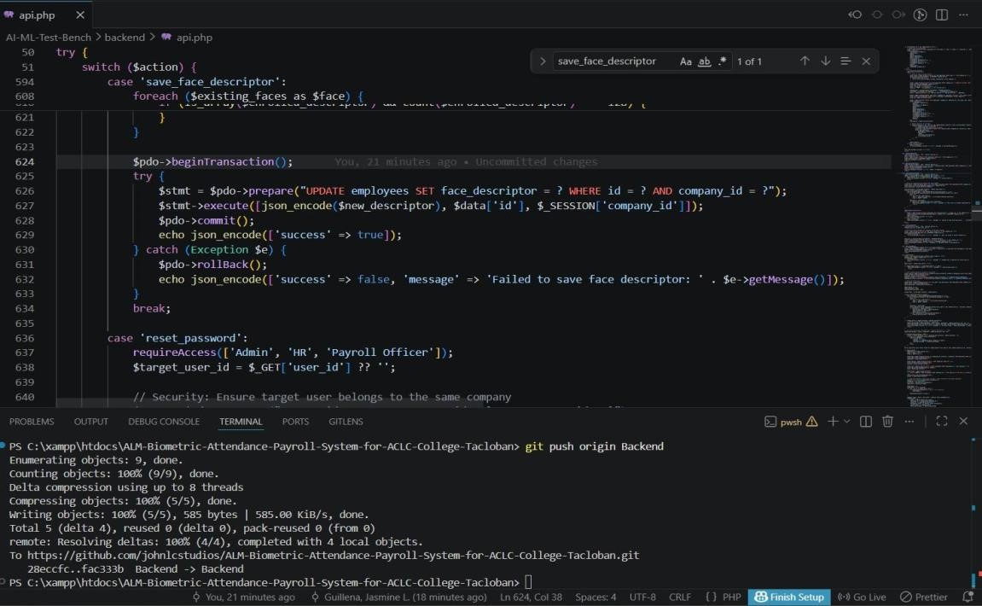

Issues: Most transaction blocks were already implemented prior to the task, requiring careful auditing to identify what was genuinely missing rather than duplicating existing work.
Resolution: Conducted a thorough case-by-case audit against the task requirements to confirm which blocks were already in place and applied only the missing transaction wrapper to save_face_descriptor.

TEAM CONTRIBUTION:
- Guillena, Jasmine L. (Backend Team Leader) → 2 tasks → 2 completed, 0 in progress.
- Abuda, Christian Kerr → 2 tasks → 2 completed, 0 in progress.
- Magsanay, Christian A. → 2 tasks → 2 completed, 0 in progress.
- Comandao, Sheila Mae B. → 2 tasks → 2 completed, 0 in progress.
NEXT WEEK PLAN:
- Proceed to given task (Week 5).
REMARKS:

(Optional)

