App Fullstack Developer Program

Work with MySQL workbench

## Instruction:

1. Please download this file to your local computer.
2. For each question, fill in your answers in the box.
3. For each checkpoint, paste a screenshot there.
4. For submission,
   * Save this document to a PDF file.
   * Upload your source code to Talentlabs Classroom. Please don’t include the node_modules folder.
   * There will be 2 submission files: code.zip and assignment.pdf

## Prepare: Setting up MySQL WorkBench

**Instruction**

1. Download from here <https://www.mysql.com/products/workbench/>
2. Install the application.
3. Create a new Database connection by clicking the “+” button:

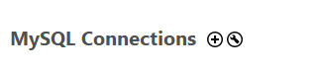

1. Fill in the connection details:

Connection Name: Any name is ok here

Hostname: student-mysql.ccttwiegufhh.us-east-2.rds.amazonaws.com

Username: studentmysql

Password: studentmysql

1. Click “Test connection” and it should work.
2. Click “OK” to store the connection.
3. Double click the connection to connect:

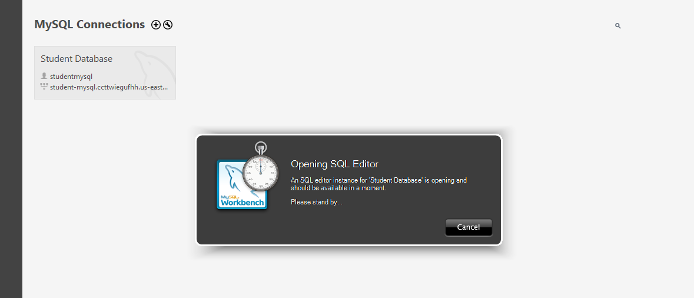

## Task: Select your own schema as the default [10~15 mins]

You should see this now in the application:

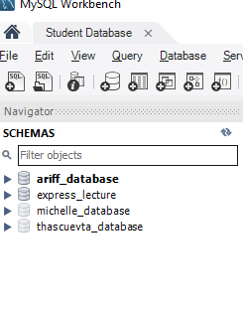

There are multiple schemas in this database, they are isolated. If it is your first time connecting to this database, you can create a new schema for your project. Please select your schema as the default. You can do it by **right-clicking and selecting “Set as Default Schema”**. Don’t access and update other people's data.

After this, the selected schema should be bold.

**Checkpoint:**

Paste a screenshot here. The assigned schema now should be bold.

## 

## Task: Execute SQL statement [10 ~ 15 mins]

Click the button shown below to create a new SQL editor.

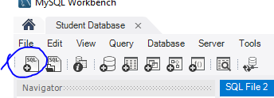

Enter the following SQL statements into the editor:

|  |
| --- |
| create table if not exists manufacturer (  id int auto_increment primary key,  name text );   create table if not exists product (  id int auto_increment primary key,  name text,  price decimal(19, 4),  manufacturer_id int,  foreign key (manufacturer_id) references manufacturer(id)  ); |

Execute the statement by clicking this button  
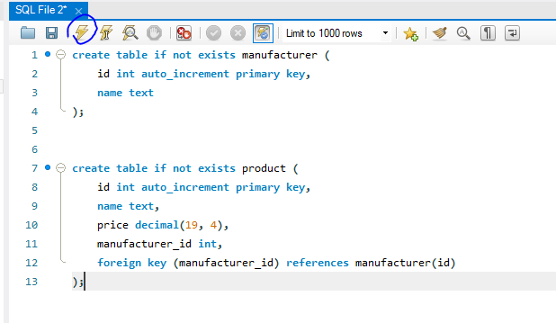

After this you should see the green check icons in the action output below:



Next let’s try to insert some data into the database by executing the following statement:

|  |
| --- |
| insert into manufacturer (id, name) values (1, "Lego"), (2, "Disney");  insert into product (id, name, price, manufacturer_id) values   (1, "Product 1", 10, 1),   (2, "Product 2", 20, 1),  (3, "Product 3", 30, 1),  (4, "Product 1", 40, 2),  (5, "Product 1", 50, 2); |

After the insertion, you should see 2 checks as well.



Let’s try to query the item out using

|  |
| --- |
| select * from product; |

and

|  |
| --- |
| select * from manufacturer; |

If you have more than one SQL statements in the editor, you can execute the selected sql statement only:

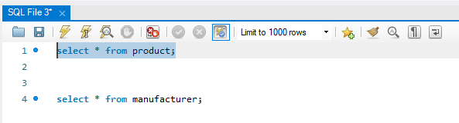

**Checkpoint**

Show the result of the above 2 select SQL statements. You should see there are 2 manufacturers and 5 products.

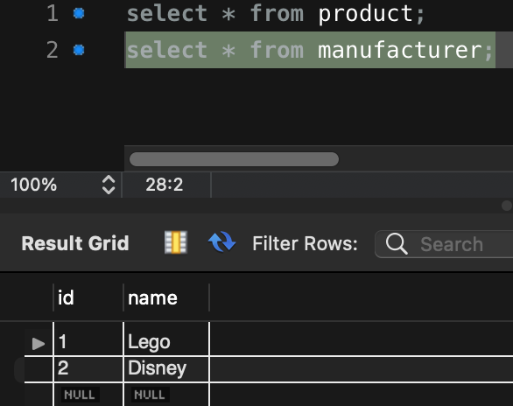 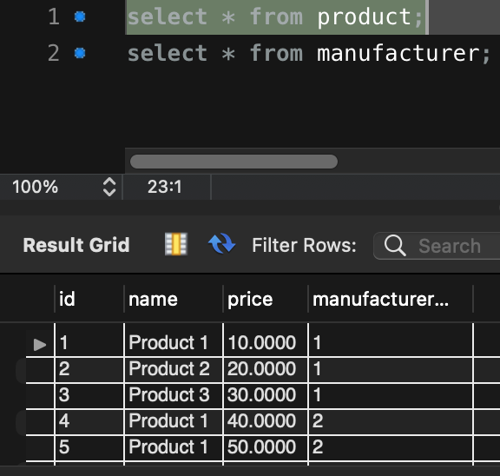

## Task: SQL Review [30 ~ 60 mins]

In this section please write the SQL statement to do the following

1. Get a product with id = 2.

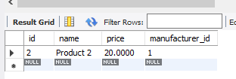

1. Get a manufacturer with id = 1.

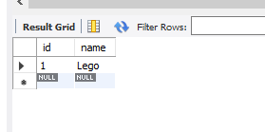

1. Get all products with manufacturer_id = 1

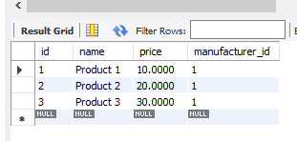

1. Get all products and in the result you should show its manufacturer’s name (Hint: Joining)

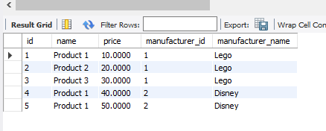

1. Get a product with id = 2 and in the result you should show its manufacturer’s name (Hint: Joining)

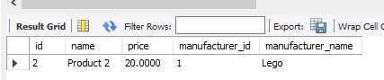

1. Get all products with manufacturer_id = 1and in the result you should show there manufacturer’s name (Hint: Joining)

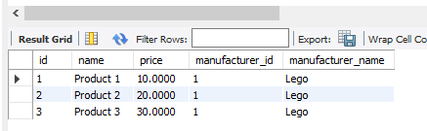

**Checkpoint**

Paste the screenshots of the results of the above 5 queries here:



