App Fullstack Developer Program

Integrate MySQL to an Express App

## Instruction:

For submission,

1. Upload your source code in a zip file to Talentlabs Classroom. Please don’t include the node_modules folder.
2. Upload this document as a PDF file as well.

## Prepare: Setting up MySQL WorkBench

**Instruction**

1. Download from here <https://www.mysql.com/products/workbench/>
2. Install the application.
3. Create a new Database connection by clicking the “+” button:

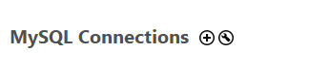

1. Fill in the connection details:

Connection Name: Any name is ok here

Hostname: student-mysql.ccttwiegufhh.us-east-2.rds.amazonaws.com

Username: studentmysql

Password: studentmysql

1. Click “Test connection” and it should work.
2. Click “OK” to store the connection.
3. Double click the connection to connect:

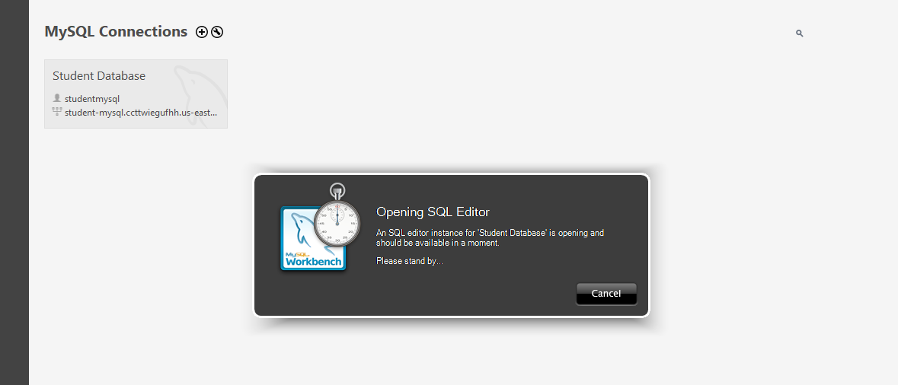

## Prepare: Express Application Generator

**Steps:**

1. Execute the command: **npx express-generator --ejs express-lab-11**
2. Change directory into that new folder: **cd express-lab-11**
3. Install all npm packages: **npm install**
4. Start the server

* Windows PowerShell:

**$env:DEBUG='express-lab-11:*'; npm start**

* Windows Command Prompt:

**set DEBUG=express-lab-11:* & npm start**

* MacOs or Linus:

**SET DEBUG=express-lab-11:* & npm start**

## Task 1: Seed Data

Before working on this, please make sure you have created the tables via MySQL workbench in lab 10.

**Steps:**

* Follow slides 3~5 to set up the **knex.js file.**
* Follow slide 7 to create the **default seed files**.
  + npx knex seed:make initial-manufacturer
  + npx knex seed:make initial-product
* Follow slides 8~10 to update the seed files to use **upsert**.
* Follow slide 11 to execute the seed files.
* Use MySQL workbench to see if the seed data is created.

## Task 2: Get the data from Express

**Steps:**

* Follow slides 15 to set up the **database.js file.**
* Follow slide 16 ~ 18 to setup the **./routes/index.js file**.
  + This should create the List manufacturers API
* Use Postman to test this API
  + GET localhost:3000/manufacturers

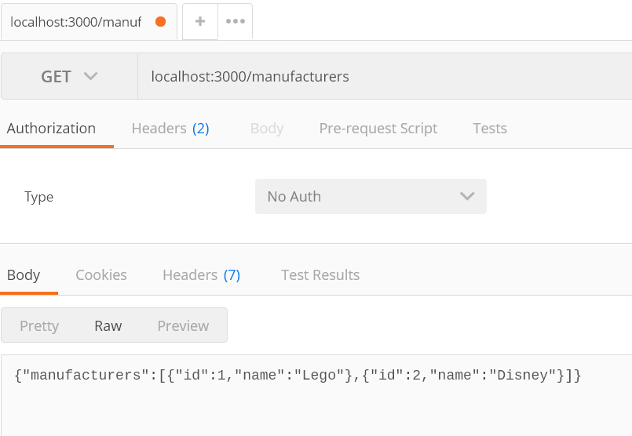

## Task 3: List, Retrieve, Create, Update, Delete

**Steps:**

* Follow slides 20 ~ 30 to set up the **rest of the manufacturers APIs**
* For each List, Retrieve, Create, Update, Delete API
  + Take a screenshot of Postman to show how you test the API.
  + Take a screenshot of MySQL workbench to show the result Manufacturers table.

For example:

List Manufacturer:



List manufacturers:

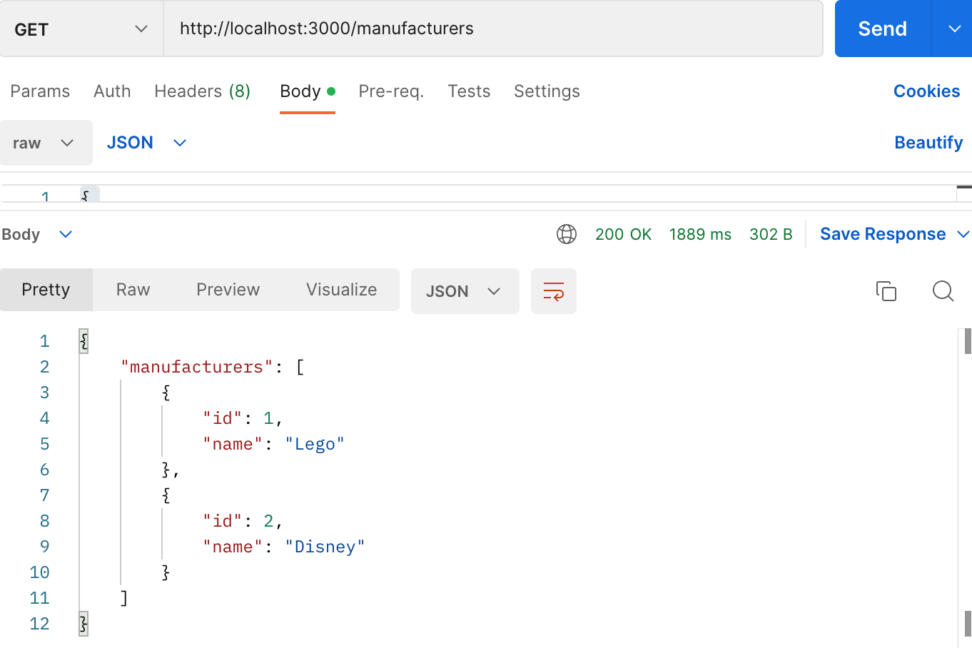

Create a manufacturer:

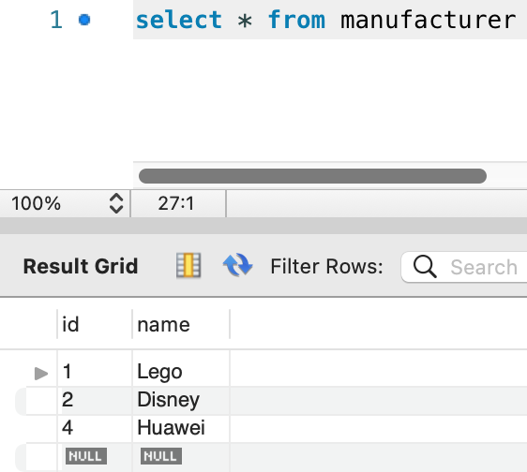

Update a manufacturer:

Delete a manufacturer:

