Fullstack Developer Program

Server-side Rendering

## Instruction:

For submission,

1. Upload your source code in a zip file to Talentlabs Classroom. Please don’t include the node_modules folder.

## Task 1 Express Application Generator:

**Steps:**

1. Execute the command: **npx express-generator --ejs express-lab-4**
2. Change directory into that new folder: **cd express-lab-4**
3. Install all npm packages: **npm install**
4. Start the server

* Windows PowerShell:

**$env:DEBUG='express-lab-4:*'; npm start**

* Windows Command Prompt:

**set DEBUG=express-lab-4:* & npm start**

* MacOs or Linus:

**SET DEBUG=express-lab-4:* & npm start**

## 

## Task 2 Reproduce the Example Application

Follow the steps shown in Slide 18 to Slide 20.

1. Hard code the data to /routes/index.js
2. Create a **route** “/products” in /routes/index.js
3. Create a **template** “products.ejs” under views

You should see this: (You need to restart the Express Application)

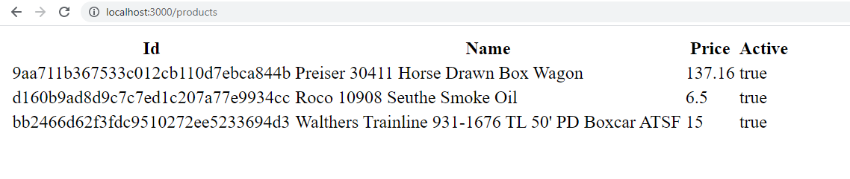

## Task 3 Understand Placeholder Rendering

Add a “madeIn” value in the products array and update the template to **show a new “Made In” Column**: (You need to restart the Express Application)

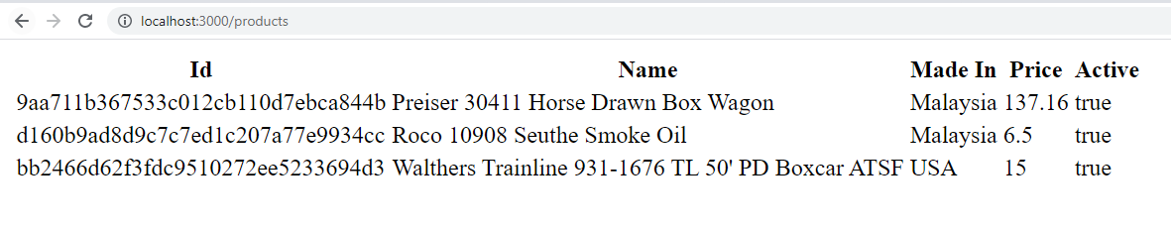

Hints:  
1. First update the value in the hard coded products array in /routes/index.js

2. Then update the HTML template to add a new HTML column to the HTML table.

## Task 4 Understand Conditional Rendering

Based on the existing EJS code in the products.ejs. Update the value in the products array to **display all products**: (You need to restart the Express Application)

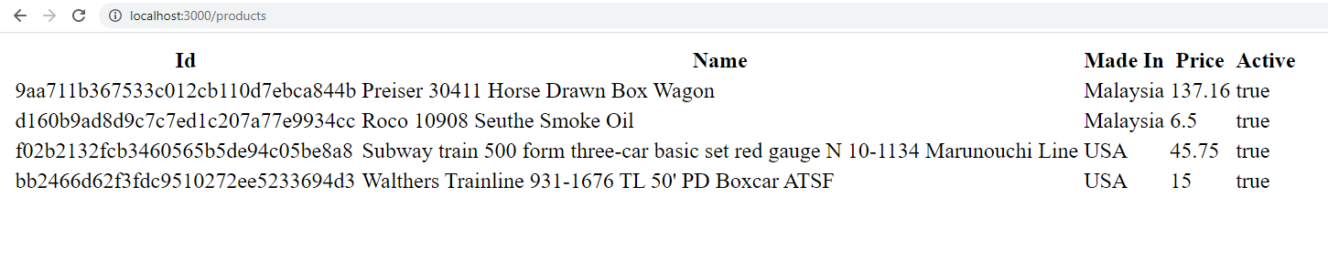

## 

## Task 4 Understand Array Rendering

Update the value in the products array to **add more products to this Application**. (You need to restart the Express Application)

Screenshot:

