Fullstack Developer Program

Basic Routing

## Instruction:

For submission,

1. Upload your source code in a zip file to Talentlabs Classroom. Please don’t include the node_modules folder.

## Task 1 Express Application Generator:

**Steps:**

1. Execute the command: **npx express-generator --ejs express-lab-5**
2. Change directory into that new folder: **cd express-lab-5**
3. Install all npm packages: **npm install**
4. Start the server

* Windows PowerShell:

**$env:DEBUG='express-lab-5:*'; npm start**

* Windows Command Prompt:

**set DEBUG=express-lab-5:* & npm start**

* MacOs or Linus:

**SET DEBUG=express-lab-5:* & npm start**

## Task 2 Reproduce Lecture Demo

Reproduce slide 18 from the lecture.

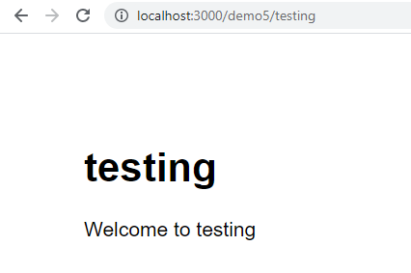

## Task 3 Calculator

1. Create a route accepting 2 Route Params.
2. Create a EJS template that display the following UI
3. In the route handler function, add 2 Route Params together.

Hints: slide 16

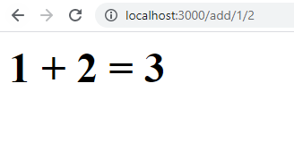

Can you do this?  
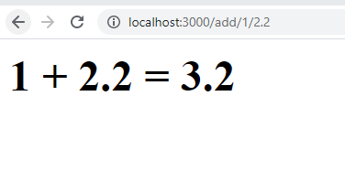

Try to add more formula:

