Fullstack Developer Program

Express Restful API Basic

## Instruction:

For submission,

1. Upload your source code in a zip file to Talentlabs Classroom. Please don’t include the node_modules folder.
2. Upload this document as a PDF file as well.

## Task 1 Express Application Generator:

**Steps:**

1. Execute the command: **npx express-generator --ejs express-lab-8**
2. Change directory into that new folder: **cd express-lab-8**
3. Install all npm packages: **npm install**
4. Start the server

* Windows PowerShell:

**$env:DEBUG='express-lab-8:*'; npm start**

* Windows Command Prompt:

**set DEBUG=express-lab-8:* & npm start**

* MacOs or Linus:

**SET DEBUG=express-lab-8:* & npm start**

## Task 2 Reproduce Lecture Demo

In the lecture we talk about this table

|  |  |  |  |  |
| --- | --- | --- | --- | --- |
| **Endpoint** | **POST** | **GET** | **PUT** | **DELETE** |
| /customers | **Bulk / Create**  new customer(s) | **Retrieve** all customers | Bulk **update** of customers | **Remove** all customers |
| /customers/1  (/customers/:id) | **Create** a new customer with id = 1 | **Retrieve** the details for customer 1 | **Update** the details of customer 1 if it exists | **Remove** customer 1 |

Try to follow the lecture slides to reproduce these 8 routes on Express.

## 

## Task 3 Test the endpoints with Postman

Download and install Postman <https://www.postman.com/>

In the Postman UI, you can see there are

* A drop down to select different HTTP methods.
* A text box to input the HTTP url.

An example of testing GET /customers/:id:

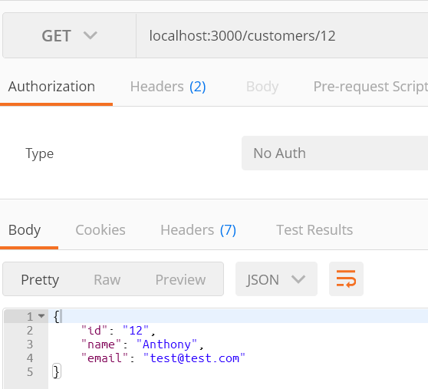

Test the all 8 endpoints with Postman and paste the screenshots here:



