Fullstack Developer Program

Express Restful API Error Handling

## Instruction:

For submission,

1. Upload your source code in a zip file to Talentlabs Classroom. Please don’t include the node_modules folder.
2. Upload this document as a PDF file as well.

## Task 1 Express Application Generator:

**Steps:**

1. Execute the command: **npx express-generator --ejs express-lab-9**
2. Change directory into that new folder: **cd express-lab-9**
3. Install all npm packages: **npm install**
4. Start the server

* Windows PowerShell:

**$env:DEBUG='express-lab-9:*'; npm start**

* Windows Command Prompt:

**set DEBUG=express-lab-9:* & npm start**

* MacOs or Linus:

**SET DEBUG=express-lab-9:* & npm start**

## Task 2 Reproduce Lecture Demo

Reproduce the slide 17 signup api:

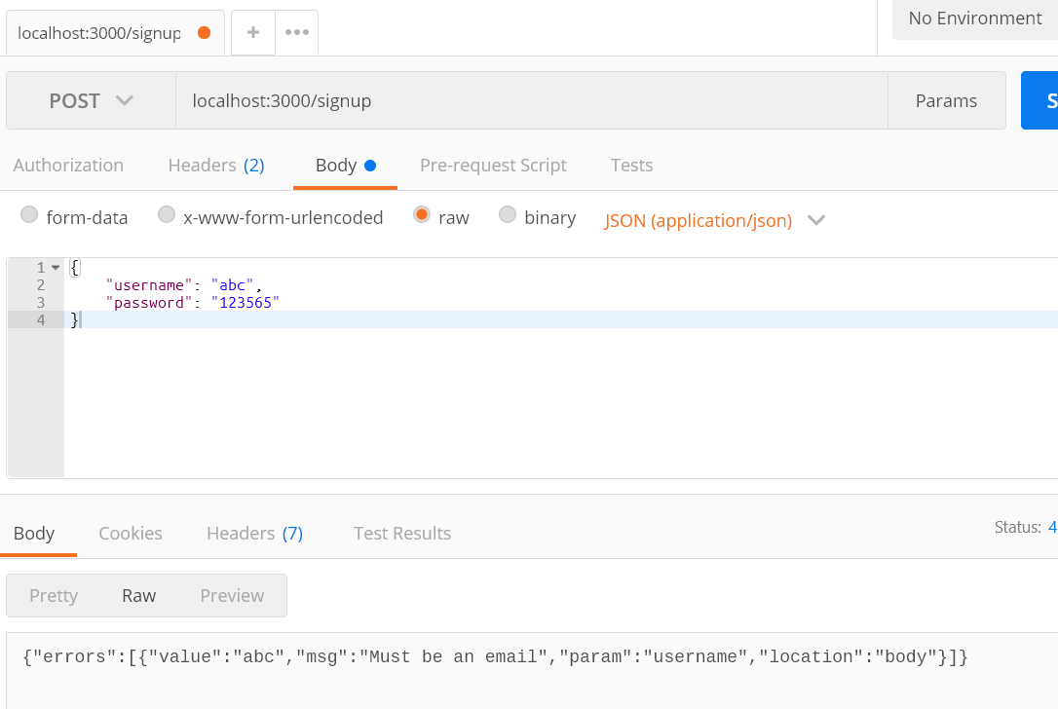

## Task 3 Understand Validation

Try to add 2 more parameters to the Signup API  
1. first_name

2. last_name

Both of them **should not be empty.**

## Task 4 Understand Validation Methods

Look at the “isLength” documentation here  
<https://github.com/validatorjs/validator.js#validators>

Try to update the rule for the “password” parameter:

1. At least 5 characters
2. At most 10 characters

## Task 5 Understand Special Validation Methods

Actually there is a “isStrongPassword” validator. Try to use this isStrongPassword validator to replace all the existing validators for the “password” field.

