- create a folder and go inside it
- run:
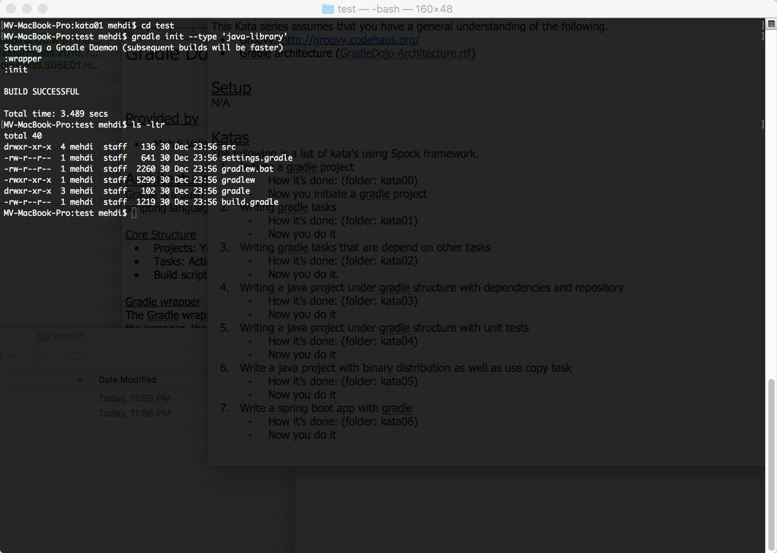
- Your root project name is always defaulted to the directory name however you can change it in setting.gradle
- Your gradlew and gradle folder are automatically created so you don’t have to rely on your installed gradle. The gradle via gradlew can be invoked on fly.

