create a folder
cd into the folder
create a file named build.gradle
create a task called kata02
create doFirst and doLast subtasks as follows:
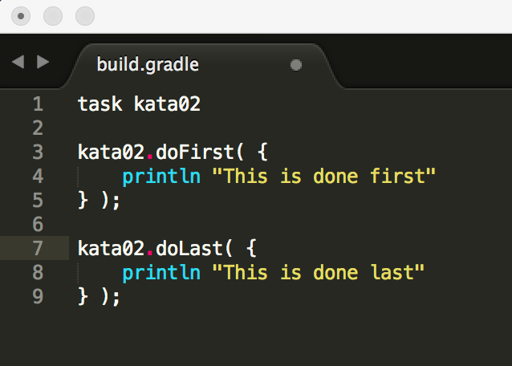
run:
gradle kata02 and you should see:
