create a folder
cd into the folder
create a file named build.gradle
create a task called kata03T01
create another task called kata03T02 that is depend on kata03T01 as follows:
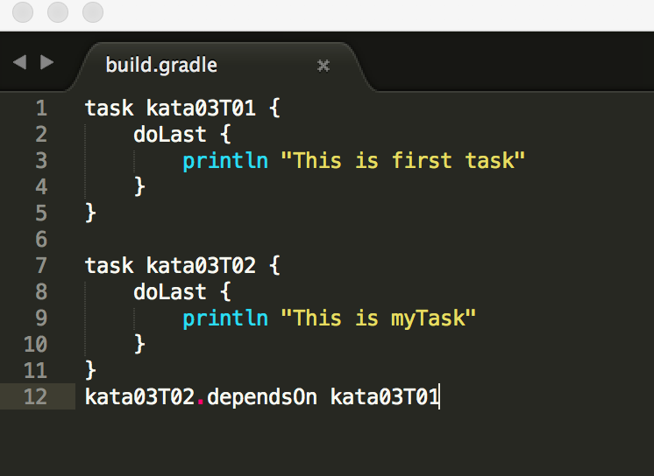
run:
gradle kata03T02 and you should see:
